Learning Outcome - Able to use basic PC hand tools effectively

After achieving this learning outcome, a student will be able to use basic PC hand tools effectively. In order to achieve this learning outcome, a student has to complete the following:

1. Remove screws using screwdriver (0.5 Hrs.)
2. Cut and Skin cables using cutting plier (0.5 Hrs.)
3. Desolder electronic components using desoldering pump, Remove electronic components using tweezers (0.5 Hrs.)
4. Solder electronic components (0.5 Hrs.)
5. Crimp CAT 6 cables using crimping tool (0.5 Hrs.)
6. Connect SATA/IDE Cables to Hard Disk Drive (0.5 Hrs.)
7. Crimp CAT 6 cable to RJ 45 connector (1 Hrs.)
8. Connect peripherals (Keyboard, Mouse, USB drive, printer) to USB port (1 Hrs.)
9. Connect SVGA/HDMI Cable to the system (1 Hrs.)
10. Connect multimedia devices to AV Port (0.5 Hrs.)

# Activity 1

**Aim:** Remove screws using screwdriver

**Learning outcome:** Able to use basic PC hand tools effectively.

**Duration:** 0.5 hour

**List of Hardware/Software requirements:**

1. Cabinet

2. Screwdriver

**Code/Program/Procedure (with comments):**

1. **Maximize the grip strength.** If you can still grip the screw head with a screwdriver, try one last time to remove it by hand. Follow these instructions first to maximize your chances:

* If the screw is fastened to metal, spray on penetrating oil, such as WD40, and let sit at least fifteen minutes.[1]
* Use the largest manual screwdriver that fits your screw.
* If possible, grip the screwdriver handle with a wrench to get more leverage.



2. **Add material for extra grip.** If the screwdriver keeps slipping out of the stripped hole, cover it with a small piece of material that gives extra grip. Press this into the hold with the screwdriver and try again. Here are some options:

* Wide rubber band, cut to form one band
* A piece of steel wool
* A piece of green abrasive from a kitchen sponge
* Duct tape, with the adhesive side against the screw head



3. **Tap the screwdriver into place with a hammer.** Tap the screwdriver in gently to avoid breaking the screw head. Skip this step if you are working with a fragile object.

* This is a good option when a Philips head screw is stripped.
* You can also take a square #1 drill bit and hammer it into the screw head. Do this until it penetrates into the stripped Philips head screw.



4. **Push down hard as you rotate.** Place your palm against the end of the screwdriver, with your arm directly behind it. Press directly down into the screw with your full forearm as you rotate the screwdriver.

● If the tool you are using is slipping, stop using it immediately. Further slippage will only continue to wear down the screw head and make it harder to remove. Definitely be sure you are going in the correct direction for removal, which is usually--but not always--counterclockwise ("lefty loosely, righty tightly"). Pressing down hard as you are unscrewing will help prevent slippage.



5. **Heat the area**. If you can heat the screw without damaging the object the screw is attached to, this will often loosen the threads. Apply a heat gun or propane torch to the screw, moving it constantly to avoid overheating. Once it is hot enough to sizzle a drop of water, let the screw cool, then try again.[2]

● This works especially well if the screw has been set in place with a bonding agent.



6. **Cut a flat-head notch with a Dremel or hacksaw.** If your screwdriver still can't get a good grip, cut a notch into the screw head. Insert a flat-head screwdriver and attempt to turn the screw.[3] You can combine this with any of the approaches above.

**Output/Results snippet:**



**References:** <https://www.wikihow.com/Remove-a-Stripped-Screw>

# Activity 2

**Aim:** Cut and Skin cables using cutting plier

**Learning outcome:** Able to use basic PC hand tools effectively.

**Duration:** 0.5 hour

**List of Hardware/Software requirements:**

1. Skin Cables

2. Cutting plier

**Code/Program/Procedure (with comments):**

1. Place the wire into the proper slot for the size wire you are. With the wire at a slight angle, push the handles of the stripper together.



2. By gently rocking the stripper blades back and forth to cut through the insulation but not into the wire.



**Output/Results snippet:**



# Activity 3

**Aim:** Desolder electronic components using desoldering pump, Remove electronic components using tweezers

**Learning outcome:** Able to use basic PC hand tools effectively.

**Duration:** 0.5 hour

**List of Hardware/Software requirements:**

1. Desoldering pump

2. Tweezers.

**Code/Program/Procedure (with comments):**

A desoldering pump also known as solder sucker is a small mechanical device which sucks the liquid/molten solder from the joint where the components are mounted. In order to desolder a component from the PCB, we first heat up the solder joint with the soldering iron till the solder liquefies/melts.



1. Locate the terminals for the component to be removed. A desoldering pump, also called a solder sucker, vacuums up melted solder to separate soldered components from a circuit board. Thoroughly examine both sides of the board to isolate the specific spots holding each component in place.

* The desoldering pump works best for through-hole connections. You can use it on surface-mounted devices as well, but it is less effective.[1] That said, it's one of the cheapest options.
* You can easily ruin a circuit board by accidentally separating the board layers during the desoldering process. Ensure that you only desolder the exact pins you need to remove a faulty component.



2. Clean the terminals. Using isopropyl alcohol on a toothbrush, gently clean the terminals of the component(s) to be removed. Ensure that you clean only the terminals on the soldered side of the board and not anything on the component side.



3. Attach a heat sink. The heat from the soldering iron can damage sensitive components such as integrated circuits or transistors. To dissipate some of the heat, clip a metal alligator clip between the component and the terminal you plan to desolder.[2]



4. Clean your soldering iron as it heats. Turn your soldering iron on and let it heat up for about three minutes. Using a wet sponge make quick passes from base to tip over your soldering iron to clean it.

* You may see a tiny bit of smoke as you pass the sponge, but it's just from the moisture in the sponge.



5. Push down on the desoldering pump. Press the end of the pump until it clicks into place. This compresses a spring, and latches it in the depressed position.



6. Heat the old solder with your soldering iron. Using the tip of your soldering iron, heat the old solder until it melts. You can push the terminal with the soldering iron tip at the same time to help free the component as the old solder melts.

* Use an old soldering iron if you have one, since pushing with the iron can wear the iron down.



7. Vacuum up the melted solder. Touch the tip of the desoldering pump to the solder pad and melted solder, without applying pressure.[3] Release the spring (usually by pushing a button on the side) and the piston will shoot back quickly. This creates a vacuum which pulls the melted solder up into the pump.[4]

* The tip of the pump may melt a little during use. Most pumps either have replaceable tips or are cheap to begin with, but you can try to reduce the damage by pausing for a moment after melting the solder.
* Melted solder can harden again quickly. Work with only one terminal at a time. For the greatest efficiency, hold the soldering iron in one hand and keep the desoldering pump ready in the other.



8. Empty the desoldering pump into the trash. After each use, push the pump down again over a trash can to re-arm it and to clear out the solder. If you leave the old solder inside, it can leak back out as you go to vacuum the next terminal.



9. Troubleshoot difficult connections. It often takes multiple passes with the soldering iron

and pump before the component is free. If you're not making progress after a few tries, try any or all of these adjustments:

* Apply flux first to help the melted solder flow.
* Melt a little new solder to mix in with the old, hardened solder.
* For through-hole connections, use the tip of the soldering iron to gently wiggle the terminal from side to side. This breaks the connection to the sides of the hole.[5]



10. Clean the board. You may notice brown resin stuck around the solder pad, since this can melt when heated. You can remove this with a commercial resin cleaner, or scrape it away very carefully with a small, flat-head screwdriver or steel wool. Finish by cleaning the area with a toothbrush dampened with isopropyl alcohol.

* Sometimes, the pressure from the iron or pump will shift the solder pad slightly. It should still work as long as the traces connecting the pad to other components are still intact. If the traces are broken, you will need to solder on new ones.[6]
* If there are still traces of solder on the pad, it's easy to pick these up using a desoldering braid, described below.



**Remove electronic components using tweezers**

1. Take the Tweezer wick and place it over the solder you want to remove

2. With the soldering iron, lightly press on the wick, to ensure the heat is transferred

through to the solder.

**Output/Results snippet:**





**References:** <https://www.wikihow.com/Desolder>

# Activity 4

**Aim:** Solder electronic components

**Learning outcome:** Able to use basic PC hand tools effectively.

**Duration:** 0.5 hour

**List of Hardware/Software requirements:**

1. A soldering iron

2. Rosin core solder

3. Stand on which to hold the hot soldering iron

4. Sponge

**Code/Program/Procedure (with comments):**



1. Start with the smallest components working up to the taller components, soldering any interconnecting wires last.

2. Place the component into the board, making sure it goes in the right way around and the part sits flush against the board.

3. Bend the legs slightly to secure the part. Place the board so you can access the pads with a soldering iron.



4. Make sure the soldering iron has warmed up. If necessary, use a brass soldering iron cleaner or damp sponge to clean the tip.



5. Pick up the Soldering Iron in one hand, and the solder in the other hand.



6. Place a soldering iron tip on the pad.



7. Feed a small amount of solder into the joint. The solder should melt on the pad and flow around the component leg.



8. Remove the solder, then remove the soldering iron.



9. Leave the joint to cool for a few seconds, then using a pair of cutters trim the excess component lead.



10. Some connections are made with stranded wire. It is usual to ‘tin’ wire to make it easier to place through the holes in the PCB, and to help it solder successfully. To tin wire firstly strip a small length of the insulation off. The twist the strands together to form a single neat core. With the soldering iron in one hand, and solder in the other place the soldering iron tip at the end of the twisted core. This will heat the wire. ' Wipe' the end of the solder down the twists. This will melt when the wire is hot enough and apply a small amount of solder.



A well tinned wire only has a small amount of solder on it, just enough to hold the twist together. It should be possible to see the twisted strands through the solder.

**References:** <https://kitronik.co.uk/blogs/resources/how-to-solder-in-ten-easy-steps>

# Activity 5

**Aim:** Crimp CAT 6 cables using crimping tool

**Learning outcome:** Able to use basic PC hand tools effectively.

**Duration:** 0.5 hour

**List of Hardware/Software requirements:**

1. CAT 6 Cables

2. Crimping Tool

3. Connectors

**Code/Program/Procedure (with comments):**

**Step 1**

* This procedure generally applies to Cat 6 RJ45 connectors.
* An alternate method is given for connectors utilizing a "load bar".

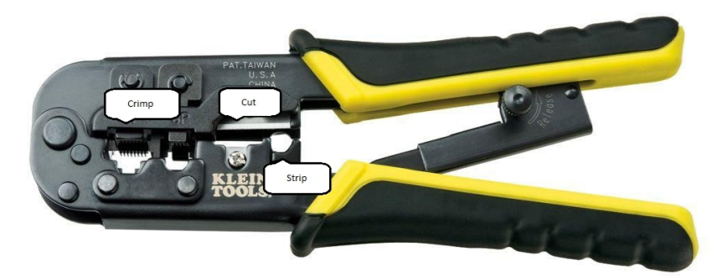

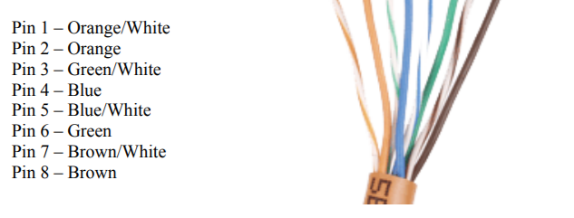

**Step 2**

* Cut the cable to the length needed.
* If you plan to use snag less boots, this would be a good time to slide them on.
* Be sure the boots will be facing "out" towards the connector.

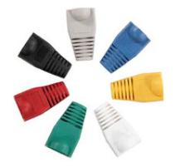

Snaggle boots

**Step 3**

* Strip back the cable jacket approximately 1 inch.
* Use the cutter provided with the crimping tool or strip by hand.
* Be careful not to nick the individual wires.
* Un-twist each of the 4 pairs and straighten each wire as much as possible between the fingers.

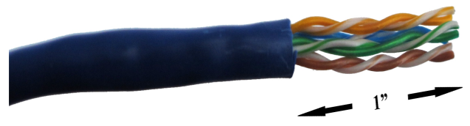

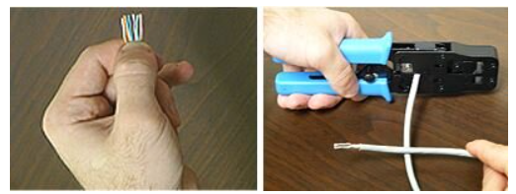

**Step 4**

* Use the 568-B wiring scheme on both ends for a standard patch cable.

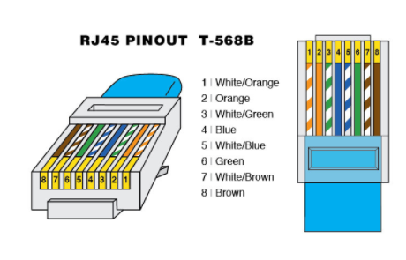

**Step 5**

* Bring all of the wires together as closely as possible.
* Hold the grouped (and sorted) wires together tightly between the thumb, and the forefinger.
* Cut all of the wires at a perfect 90-degree angle from the cable,
* 1/2 inch from the end of the cable jacket.
* Use a sharp cutting tool so as not to "squash" the wire ends.

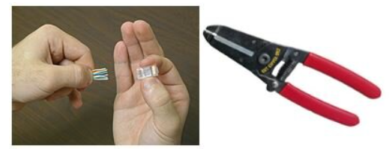

**Step 6**

* With the connector pins facing up, carefully insert the wires into the connector.
* Apply a moderate amount of force in order to properly seat the wires against the contacts in the connector.

Alternate for "load bar" Type Connectors

**A.**

* Note that the load bar has slots on one side with a flanged edge on one end.
* The slotted side should face the pins inside the connector.
* The wires are inserted into the flanged end.

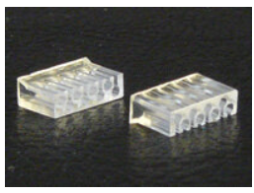

**B.**

* Hold the grouped (and sorted) wires together tightly, between the thumb, and forefinger.
* Cut all of the wires at a sharp angle from the cable.
* Use a sharp cutting tool so as not to "squash" the wire ends.

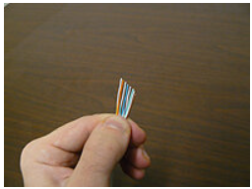

**C.**

* Hold the load bar so the staggered holes face toward the cable.
* Insert the wires through the load bar, one at a time, carefully observing the orientation.
* Slide the load bar as far down as possible.



**D.**

* Cut off the excess wire ends with a straight cut about 0.25" past the load bar.
* With the connector pins facing up, slide the load bar assembly into the connector.
* Ensure that the wires are firmly seated to the end of the connector.

The brown pair wires should be on the right side.

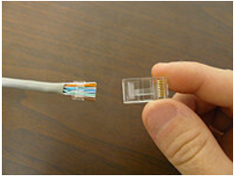

**Step 7**

* Observe the tip of the connector to confirm that all the wires are fully inserted.
* The end of each wire you should be in full view.
* There should be enough of the cable jacket inside the connector to crimp against.
* Tip: Slide the load bar forward as necessary to provide the ideal placement.



**Step 8**

* Place the connector into the crimp tool, and squeeze hard so that the handle reaches its

full swing.

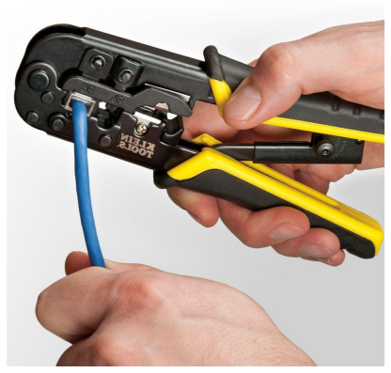

**Step 9**

* Repeat the process on the other end using the desired wiring scheme.
* Be sure to slide the snag less boots snugly over the connectors when finished.

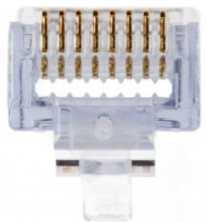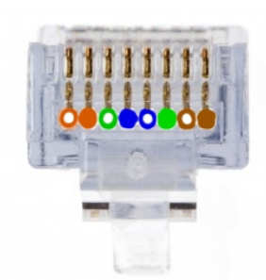

Before Crimping After Crimping

**Step 10**

* Always use a cable tester to check for continuity, opens and shorts.

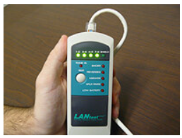

**Step 11**

* Building patch cables takes practice so keep at it until you master your technique!

**Output/Results snippet:**



**References:**

* <https://www.warehousecables.com/how-to-make-a-cat6-patch-cable>
* http://watcherprotect.net/wp-content/uploads/2016/02/Crimping-Guide.pdf

# Activity 6

**Aim:** Connect SATA/IDE Cables to Hard Disk Drive

Learning outcome: Able to work with different cables, connectors and its Crimping techniques for PC.

**Duration:** 0.5 hour

**List of Hardware/Software requirements:**

* HDD drive
* SATA/IDE cables

**Code/Program/Procedure (with comments):**

**Step 1: Identification of the drive interface type.**

Most modern PCs use the SATA interface for physical connection of hard drives to the computer’s system bus, while the IDE (PATA) standard may be found on older machines. To identify the interface type, you should disassemble the device and examine the drive:

* Open the case to access the hard drive. If the device uses removable hard drives in special bays, simply eject the drive from the bay;
* Examine the holder of the hard drive: if the back panel is covered with an enclosure, remove it and then check the back panel.

The following examples will acquaint you with what different hard drive interfaces look like:

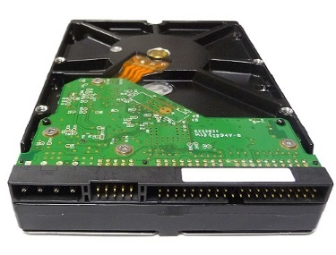

Pic. 1. Back panel of an IDE (PATA) drive.

In this picture:

1. IDE data port. Please pay attention to the small hollow in the top center. It is used as an index for correct cable connection. Incorrect cable connection can damage the connector and the drive.

2. Power supply port. It also has a "key" form for correct connection of the power cable.

Incorrect cable connection can damage the connector and the drive.

3. These are used for identification of the order of the drives in a paired IDE cable as well as for additional IDE settings.

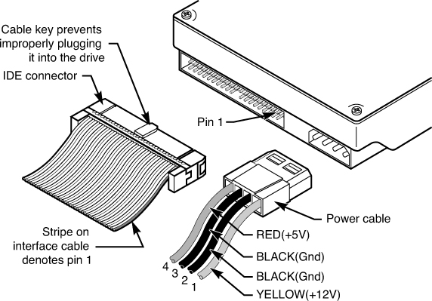

Pic. 2. IDE (PATA) data cable.

In this picture, the blue connector is used to connect the cable to the mainboard of the computer/device, while the black one is used to connect the drive. Please pay attention to the "key" on the cable connector that matches the slot of the drive.

IDE cables usually have two drive connectors: a "master" connector (at the end of the cable) and a "slave" connector (in the middle of the cable, closer to the "master" connector).

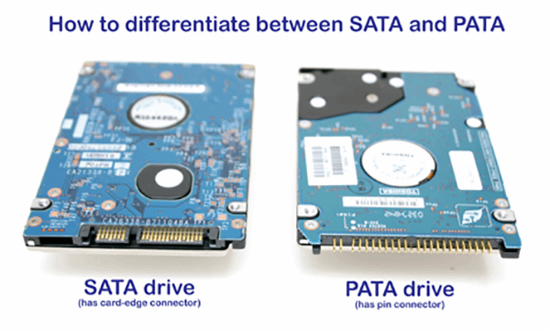

Pic. 3. Back panel of a SATA drive.

In this picture:

1. SATA data port. Please pay attention to the "key" form of the slot.

2. SATA power supply port. In contrast to IDE, a SATA power cable is wider than a SATA data cable. It has a "key" form as well.



Pic. 4. SATA data cable connector.

A SATA cable consists of two equal endpoints on a thin data cable. It makes no difference which of the ends will be used to connect the drive. Please pay attention to the form of the connector that matches the "key" form of the SATA drive data slot.

Step 2. Choosing the method of connection to the host computer.

Main connection methods include:

* External adapters
* Mainboard connectors
* PCI/PCI-Express expansion

External adapters

This is the safest but at the same time the most expensive method. You need USB/Firewire adapters for each drive to connect them to the host PC.

* If the host computer provides enough disk space, you can create an image of your disk and avoid using an adapter for this disk.

You can find external adapters for both SATA and IDE hard drives; some of them fit both interfaces:



Pic. 5. USB to IDE hard disk adapter with an external power supply.

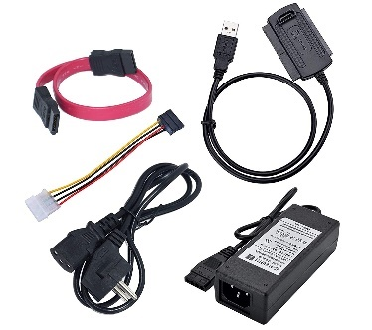

Pic. 6. USB to SATA hard disk adapter with an external power supply.

Please note that some USB to SATA adapters have a pair of SATA interfaces, thus, to connect two SATA drives you need only one adapter.

Pay attention to the external power supply: some adapters are powered via USB and don't match 3.5" hard drives used in NAS and desktop computers.

Mainboard connectors - This is the cheapest but not the safest method to connect the drives. Besides, the mainboard is able to place a very limited number of drives.

Before choosing this method, make sure that the computer power supply provides at least 15 Watts of additional power per drive.

Also, see to it that you have a sufficient number of data cables: one cable per two IDE drives and one SATA data cable per one SATA drive.

To check if the method is suitable, examine your motherboard connectors. To do this:

* Remove the screws from the back panel of your computer that hold the Removing two screws that hold the left-side cover is enough (for a tower-type computer);
* Open the left cover panel: pull it a little back and put it aside;
* Examine the expansion slots on the mainboard.

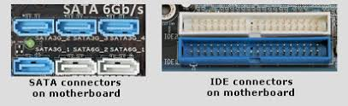

Pic. 7. IDE connectors.

In this picture, you can see two IDE connectors marked as IDE 1 and IDE 2 at the right bottom. As a rule, IDE 1 is colored while IDE 2 is usually black or white. Each IDE connector is capable of hosting two IDE hard drives.

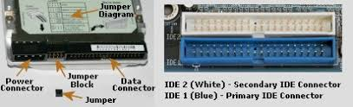

Make sure that the mainboard provides enough free slots. For example, for four disks of your NAS with IDE hard drives you need two free IDE slots on the mainboard: two drives per interface. For four drives with a SATA interface four free SATA slots are needed. If the mainboard doesn't provide a sufficient number of free slots, use external adapters or expansion cards. If you decide to free up some mainboard slots for extra drives, make sure you don't unplug the system boot drive or RAID.

Expansion cards.

This method of connection is quite efficient, however, is not 100% safe. Before choosing this method make ensure that the computer power supply is capable of providing at least 15 Watts of additional power per drive plus about 10 Watts for the expansion card. Expansion cards are available for both SATA and IDE drives.

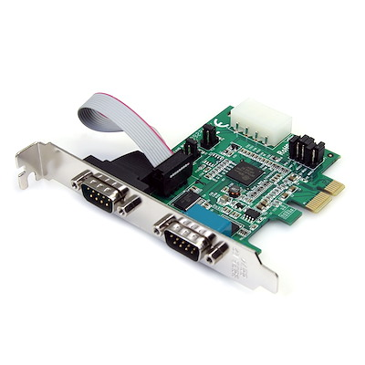

Pic. 9. PCI IDE expansion card with two IDE channels.

Please note that IDE expansion cards have one or more IDE channels. Each channel is capable of hosting two IDE drives. It is recommended to use one card for all the drives.

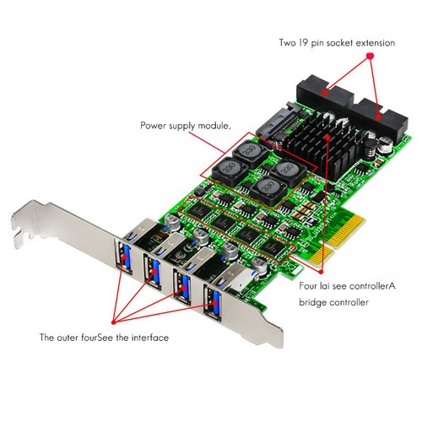

Pic. 10. PCI SATA expansion card with four SATA channels.

SATA expansion cards have two or more SATA channels. Each channel is capable of hosting one SATA drive. It's recommended to use one card for all the drives. But as multi-port cards are more expensive, you may consider using several cards to save costs. Besides, there are no requirements to expansion cards for hardware RAID, thus, you can choose an inexpensive one. Expansion cards can be installed to any free PCI (or PCI Express) slots on the mainboard.

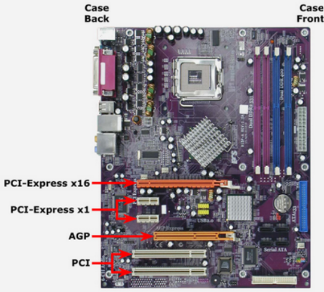

Pic. 11. PCI slots on the mainboard.

Please refer to the expansion card installation manual for more details. Make sure that the expansion card kit contains a sufficient number of data cables: one cable per 2 IDE drives and one SATA data cable per one SATA drive. You might need additional cables.

Step 3. Powering the drives.

There are different ways to power the disks for different types of connection:

* For external USB adapters use an external power supply from an external adapter kit;

The mainboard or an expansion card require that the computer power supply:

* Supports extra 15 Watts per each extra drive;
* Has enough cables to power all the drives.

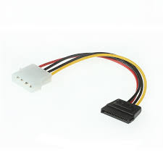

Pic. 12. SATA (left) and IDE (right) power cables.

If you need more power connectors for an IDE drive, use power splitters:

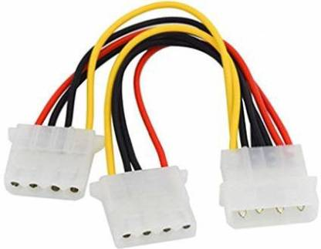

Pic. 13. IDE power cable splitter.

For extra SATA power connectors, it's recommended to use IDE to SATA power adapters/splitters:

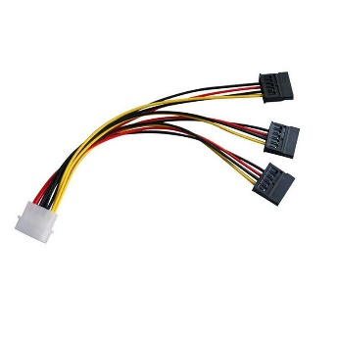

Pic. 14. IDE to SATA power cable adapter/splitter.

Step 4. Connecting the drives to the host PC.

Before connecting the drives, make sure they are not damaged. Otherwise, you may face the risk of permanent data damage on the failing drive or cause damage to the hardware interface.

* Connecting the drives to external adapters:
  + Connect the data interface of each drive to the data interface of the adapter.
  + Connector "keys" must be matched: key slots must combine with key lugs;
  + Connect external power supplies to the drives; pay attention to the "keys";
  + Ensure sufficient airflow to cool the drives; it's not recommended to put the drives on each other or use a soft surface with good thermal isolation because this can cause the drives to If the drives get hot, it's recommended to use air coolers;
  + Charge external power supplies. The disks must start spinning. Wait until the initialization of the drives is completed (this may take about 5-10 seconds);
  + Connect adapter USB cables to the host PC; follow the order of the drives
* Connecting the drives to the mainboard/expansion card:
  + Power off the computer and unplug it from the power source;
  + Open the left-side cover of the computer case (for tower-type computers);
  + If you use an expansion card, install it to a spare PCI/PCI-Express slot. Read the card installation manual for more details;
  + Connect the data cables to mainboard/card IDE/SATA expansion slots. Connect power splitters/adapters if needed;
  + ○ For IDE drives: make sure that the drive jumper (Pic.1) is set to the "cable select" (CS) mode. The table of valid jumper positions is available on the drive sticker;
  + Connect data cables to the drives. While connecting RAID drives, you should
  + preserve the correct order of the drives. To connect data cables, you must:
* For IDE drives: connect the first drive as the "master" of the first IDE channel, the second drive as the "slave" of the first IDE channel, the third drive as the "master" of the second IDE channel and so on (see description under Pic. 2). The "Cable Select" jumper position ensures correct identification of the drives depending on the position on the cable.
* For SATA drives: connect the first drive to the first free SATA port (for example, SATA3), the second drive – to the next free SATA port and so on.
* Pay attention to connector key elements: key holes must match key lugs.
  + Connect power cables to the drives;
  + Ensure sufficient airflow to cool the drives; it's not recommended to put the drives on each other or to use a soft surface with good thermal isolation because this can cause the drives to If the drives get hot, it's recommended to use air coolers;
  + Plug in and start the computer. Make sure that the operating system is able to boot. Otherwise, revise BIOS configuration for boot device sequence. Read the motherboard BIOS manual for details.

After installation of additional drivers for external adapters, expansion cards, hard disk drives, etc. the system is ready for logical data recovery.

**Activity 7**

**Aim:** Crimp CAT 6 cable to RJ 45 connector

**Learning outcome:** Able to work with different cables, connectors and its Crimping techniques for PC.

**Duration:** 1 hour

**List of Hardware/Software requirements:**

* CAT 6 cable
* RJ 45 connector
* Connector/Cable tool

**Code/Program/Procedure (with comments):**

**Step 1**

This procedure generally applies to Cat 6 RJ45 connectors.

An alternate method is given for connectors utilizing a "load bar".

**Step 2**

Cut the cable to the length needed.

If you plan to use snag less boots, this would be a good time to slide them on.

Be sure the boots will be facing "out" towards the connect

**Step 3**

Strip back the cable jacket approximately 1 inch.

Use the cutter provided with the crimping tool or strip by hand.

Be careful not to nick the individual wires.

Un-twist each of the 4 pairs and straighten each wire as much as possible between the fingers.

**Step 4**

Use the 568-B wiring scheme on both ends for a standard patch cable.

**Step 5**

* Bring all of the wires together as closely as possible.
* Hold the grouped (and sorted) wires together tightly between the thumb, and the forefinger.
* Cut all of the wires at a perfect 90-degree angle from the cable,
* 1/2 inch from the end of the cable jacket.
* Use a sharp cutting tool so as not to "squash" the wire ends.

**Step 6**

With the connector pins facing up, carefully insert the wires into the connector.

Apply a moderate amount of force in order to properly seat the wires against the contacts in the connector.

Alternate for "load bar" Type Connectors

**A.**

Note that the load bar has slots on one side with a flanged edge on one end.

The slotted side should face the pins inside the connector.

The wires are inserted into the flanged end.

**B.**

Hold the grouped (and sorted) wires together tightly, between the thumb, and forefinger.

Cut all of the wires at a sharp angle from the cable.

Use a sharp cutting tool so as not to "squash" the wire ends.

**C.**

Hold the load bar so the staggered holes face toward the cable.

Insert the wires through the load bar, one at a time, carefully observing the orientation.

Slide the load bar as far down as possible.

**D.**

Cut off the excess wire ends with a straight cut about 0.25" past the load bar.

With the connector pins facing up, slide the load bar assembly into the connector.

Ensure that the wires are firmly seated to the end of the connector.

The brown pair wires should be on the right side.

Step 7

Observe the tip of the connector to confirm that all the wires are fully inserted.

The end of each wire you should be in full view.

There should be enough of the cable jacket inside the connector to crimp against.

Tip: Slide the load bar forward as necessary to provide the ideal placement.

**Step 8**

Place the connector into the crimp tool, and squeeze hard so that the handle reaches its full

swing.

**Step 9**

Repeat the process on the other end using the desired wiring scheme.

Be sure to slide the snagless boots snugly over the connectors when finished.

**Step 10**

Always use a cable tester to check for continuity, opens and shorts

**Step 11**

Building patch cables takes practice so keep at it until you master your technique!

**Activity 8**

**Aim:** Connect peripherals (Keyboard, Mouse, USB drive, printer) to USB port, Connect SVGA/HDMI Cable to the system (1 Hrs.)

**Learning outcome:** Able to work with different cables, connectors and its Crimping techniques for PC.

**Duration:** 1 hour

**List of Hardware/Software requirements:**

* Keyborad, Mouse, USB drives
* Printer
* Power cables
* Crimping tool

**Code/Program/Procedure (with comments):**

**Input/Output, Input Devices, and Peripherals**

To take advantage of a computer, the appropriate input/output devices and peripherals must be connected to the proper input/output (I/O) ports. Keyboards, mice, and multimedia devices can be connected to a variety of ports. This section briefly describes those devices and the ports they connect to.

**I/O Ports**

I/O ports enable a user to input information by way of keyboard, mouse, or microphone; plus they enable the output of information to printers, monitors, USB devices, and so on. The CompTIA A+ exams require you to describe USB, IEEE 1394 (FireWire), and Thunderbolt ports, as well as Bluetooth technology. The most common of these by far is USB.

**USB**

length. USB version 1.1 cables are limited to 3 meters in length (a little less than 10 feet), and USB version 2.0 cables can be a maximum length of 5 meters (a little more than 16 feet). Maximum recommended USB 3.0/3.1 length is 3 meters. The standard USB cable has four pins: a +5 V pin for power, a positive data pin, a negative data pin, and a ground pin. Most USB connections are half-duplex, meaning that the device can send or receive data but cannot send and receive data simultaneously.

There are various plugs used for the different types of USB connections. The most common are Type A and Type B, which are 4-pin connectors, but there are also mini- and micro-connectors, which are 5-pin. Type A connectors are the type you see on the baUSB ports are used by many

devices, including keyboards, mice, printers, flash drives, cameras, and much more. The USB port enables data transfer between the device and the computer and usually powers the device as well. The speed of a USB device’s data transfer depends on the version of the USB port A computer can have a maximum of 127 USB devices. However, most computers are limited to a maximum of a dozen ports or so. To add devices beyond this, a USB hub can be used, but no more than five hubs can be in a series of USB devices. All cables connecting USB devices must comply with their standard’s maximum ck of a computer or on the side of a laptop.displays an illustration of these connectors.

Type A and Type B connectors are commonly used for printers and other larger devices. Mini and micro-connectors are often used for handheld computers, smartphones, mice, digital cameras, portable music players, and cell phones. However, some companies create proprietary cables and connectors for their devices based off of the USB specifications. These devices will not connect properly to Type A, Type B, and mini- or micro-connectors.

**Code/Program/Procedure (with comments):**

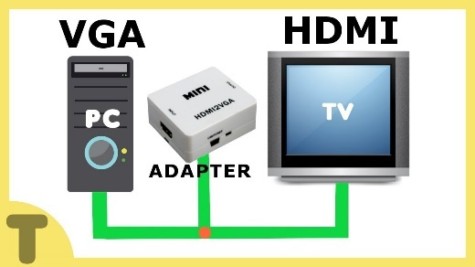

There’s a good chance that someday you’ll want to connect your computer to your big-screen TV to make it easier to share either photos you’ve taken or Internet video with guests. HDMI has become the standard type of high-definition connector found on modern TV sets, and many new computers include an HDMI output. The problem is that older computers don’t feature HDMI. We’ll approach this problem with two assumptions: one, that you have a desktop computer; and two, that you have a notebook computer.

If you have a desktop computer that does not have an HDMI output, you can install a new graphics card that has an HDMI output. But things will get complicated if the new graphics card doesn’t have an output that matches your monitor (presumably VGA), in which case you’ll simply be swapping one problem for another. To avoid the problem, you’ll have to find a graphics card that has both HDMI and VGA outputs, and preferably an inexpensive one. Because if you set your sights on an expensive graphics card, and if you have to pay someone to install it, you might be better off just buying a new desktop system that already has an HDMI output.

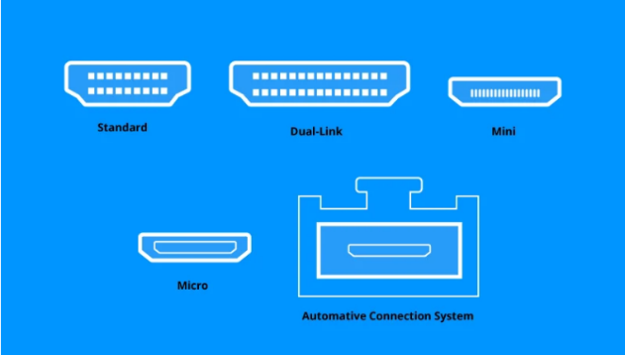 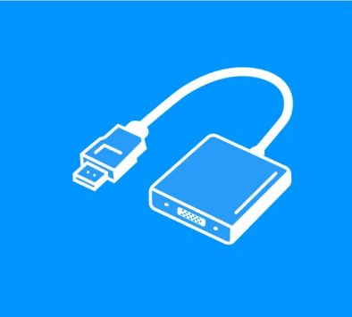

Another way to connect an older desktop computer to the HDMI input of a TV is with an adapter. If your computer has just a VGA output, you’ll need a VGA to HDMI connectors This type of converter combines a VGA input and a stereo audio input into a single HDMI output that’s compatible with your HDTV set. To use this converter, you’ll need a male VGA to male VGA connectors and an audio cable; either a male stereo mini to male RCA or a male RCA to male RCA, depending on the output of your sound card. Of course, you’ll also need an HDMI cable to connect the adapter to your HDTV. If your computer has a DVI output you’ll need a DVI to HDMI cable; either that or a DVI to HDMI adapter and a standard HDMI cable.

Your options are more limited if you have a notebook computer that doesn’t have an HDMI output because you can’t change the graphics card, and even if you could, you wouldn’t be able to add the HDMI output to the notebook’s chassis.

**Activity 9**

**Aim:** Connect multimedia devices to AV Port (1 Hr)

**Learning outcome:** Able to work with different cables, connectors and its Crimping techniques for PC.

**Duration:** 1 hour

**List of Hardware/Software requirements:**

* AV cables
* Multimedia devices

**Code/Program/Procedure (with comments):**

**How to connect an AV Receiver**

If you’ve ever tried to connect an AV receiver, it’s fair to say you’ve probably got a bit lost. While the front of any device can seem pretty straightforward to navigate, the back is where the puzzle begins. Only one thing is clear, all cables have to be connected to the receiver. The receiver then transforms the audio and video data and sends it the loudspeaker or TV. But now comes the question, which cables belong to which ports? Read on as we explain the multiple setups for various devices and ports.

**Connecting a TV to a receiver via HDMI**

When it comes to home entertainment HDMI (High-Definition Multimedia Interface) is often the go-to. The transmission standard offers the necessary bandwidth for high-resolution images and transmits video and audio data. The first question when connecting an AV receiver is if both devices support HDMI. If yes, then the AC receiver’s monitor output should be simply connected to the TV input for HDMI.

It’s vital that with HDMI to know if ARC is supported. With modern TV sets that should be the case. The abbreviation means “Audio Return Channel” – and this feature makes it possible for the TV to transmit audio data via HDMI and not just receive it. In various connection scenarios, for example, an additional (previously often optical S/PDIF) audio cable becomes unnecessary, for example, when …

* the audio signal is to be sent to the AV receiver via a DVB-T receiver integrated in the TV set so that a sound system can output the sound.
* a TV cable is connected to the television and the audio data for 5.1 surround sound is transmitted to the receiver.
* a hard disk is connected to the TV set via USB or content can be played back via a USB stick, but you want to enjoy the high-quality sound of a surround sound system
* one likes to playback the sound of a game console connected to the TV externally.

Without ARC the additional cables running between the receiver and the TV set must be laid. Usually, a COAX-CABLE or TOSLINK is used. The HDMI ports that support ARC are often labelled accordingly. When there are more HDMI ports of your TV, usually only one supports reverse channel transmission.

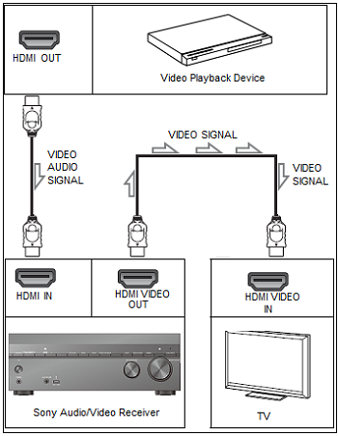

**Connecting your TV and receiver without HDMI**

When the TV or receiver don’t support HDMI, there’s a Plan B. Many older TV models don’t support HDMI, but in most cases have an analogue port. The disadvantage is that they can’t achieve HD quality. These are the possible ports:

* Component-Video: this carries the signal via three separate cinch cables. The colour of the socket is Green (Y) Blue (Pb/Cb) and Red (Pr/Cr). The standard supports analogue signals for HD playback.
* S-Video: Color and brightness values are transmitted via the cable. The quality of the transmitted signals is significantly lower than that of component video.
* Composite-Video: This method of signal transmission happens via a SCART cable, as well as via a cinch port. The signals are only in PAL quality.

Analogue Plan B may also work if older input devices – such as a video recorder – are connected to the receiver. If the receiver cannot convert the analogue video signals into digital signals, these must be transmitted analogue to the television.

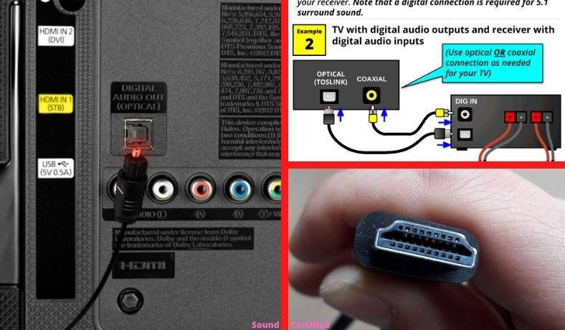

**Connecting playback devices to a receiver**

The same rule normally applies to Blu-ray and DVD players as it does by TVs. In the ideal situation, you would be able to connect via HDMI. The same for projectors or computer consoles. Whoever uses a DVD player or play a computer without HDMI has to connect to the receiver via analogue. By multiple playback devices, it can happen that there aren’t enough HDMI ports on the receiver. In this case, it’s possible to connect the video signal directly to the TV and connect just the audio via an audio cable to the receiver. The disadvantage of this setup is that more cables are needed. When the receiver has a USB port, you can connect external hard drivers, iPods and MP3 players.

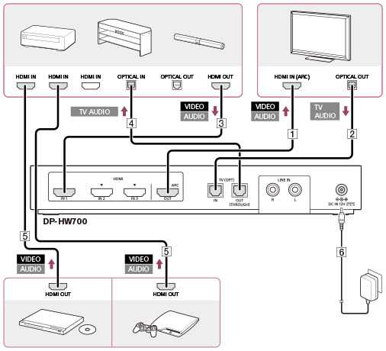

**Connecting a loudspeaker to a receiver**

When it comes to surround-sound systems multiple speakers must all be simultaneously connected to the receiver. Each loudspeaker contains a cable with two wires (one for + and the other for -) that leads to the receiver. Small clamps attach the wires to the receiver. So newcomers shouldn’t have any worries – the setup is not too technical.

It’s just important that the copper cables are clean and that the copper ends are not frayed. As well as this, you must ensure that the plus and minus are correctly connected, nothing major happens when it’s incorrectly connected, but the sound quality would be compromised. The labels on the receiver clearly state where each loudspeaker port is. Watch the video below to more about connecting to AV receiver.

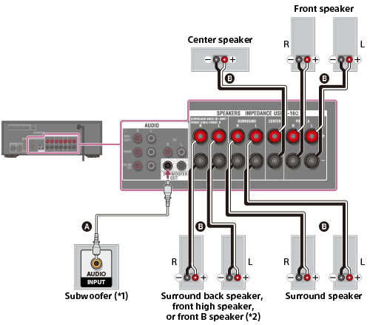

**References:**

* <https://www.ufsexplorer.com/articles/how-to/connect-sata-disks-instruction.php>
* <https://www.youtube.com/watch?v=7-2O6egqgSk>
* <https://www.make-it.ca/technical-notes/how-to-crimp-rj45-connector/>
* <https://www.groundcontrol.com/galileo/ch5-ethernet.htm>
* <https://www.pearsonitcertification.com/articles/article.aspx?p=2475566>
* <https://www.bhphotovideo.com/explora/computers/tips-and-solutions/how-connect-pc-hdmi-tv>

**Learning Outcome - Able to disassemble a PC**

**After achieving this learning outcome, a student will be able to disassemble and assemble a**

**PC. In order to achieve this learning outcome, a student has to complete the following:**

1. Remove power cords and peripheral cables (0.5 Hrs.)

2. Remove the cabinet and identify the components, slots, sockets, and connectors of

motherboards. (0.5 Hrs.)

3. Remove the SMPS (0.5 Hrs.)

4. Remove Hard disk Drive, RAM, CMOS Battery, coolant fan and DVD/BD Drive (1 Hrs.)

5. Remove add on cords Remove and clean the motherboard (0.5 Hrs.)

**Activity 1**

**Aim:** Remove power cords and peripheral cables

**Learning outcome:** Able to disassemble and assemble a PC.

**Duration:** 1 hour

**List of Hardware/Software requirements:**

1. AC power cable

2. Screwdriver

**Code/Program/Procedure (with comments):**

**Step 1**

Turn off the computer, unplug the power cord and unplug any peripheral items attached to the computer, such as the keyboard, mouse, monitor, headphones, and any external drives.

* To unlock an AC power cable, push down or lift the retaining clip.
* The arrangement of the clips alternates. To remove the first and third cables (counting from the left) push down on the clip. To remove the second and fourth cables lift up the clips.



* To remove the cable, pull it out of the socket.

Wear a grounding strap or touch an unpainted metal part of the computer to discharge any static electricity. If you walk across a carpet at any point, touch an unpainted metal part of the computer again to discharge the built-up static electricity. Person's finger touching an unpainted metal surface within a computer to discharge static electricity

**Step 2**

Remove at least one of the side covers, usually the right side as you face the front of the computer. You might find it easier to access all the parts if you remove both side covers; there are sometimes thumb screws on the covers to make access easier.

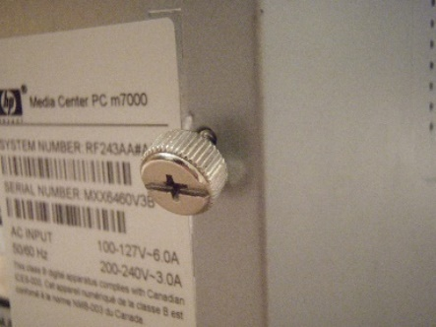

**Step 3**

Disconnect all the connectors, then remove any card readers and internal DVD players.

These are usually screwed into place.

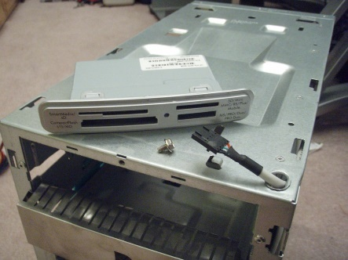

**Step 4**

Remove any standalone fans. This is a good time to remove any dust, lint, and pet hair from the fans if you’re planning on reusing them.

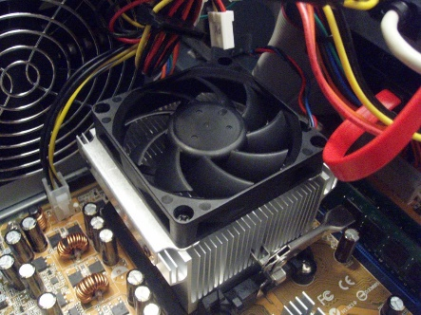

**Step 5**

Disconnect the cables and remove the storage drive. Generally, storage drives are held in place by multiple screws. If you have a hard drive, be gentle when moving the drive as hard bumps can damage the internal parts.

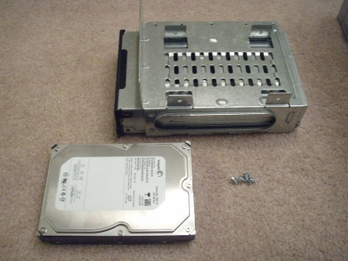

**Step 6**

Remove the memory (RAM) modules by pushing the clips on both ends of the module down. This will cause the module to pop up for easy removal. Do not touch the gold connectors on the chips if you’re reusing the modules. If you're not reusing the RAM, find out how it can be used in other applications.

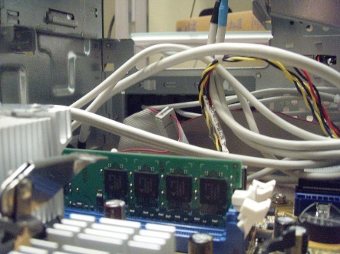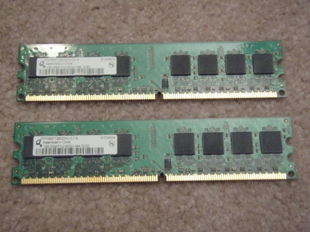

**Step 7**

Remove the power supply unit by unplugging the remaining connectors, then unscrewing the unit from the frame.

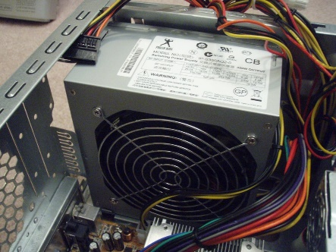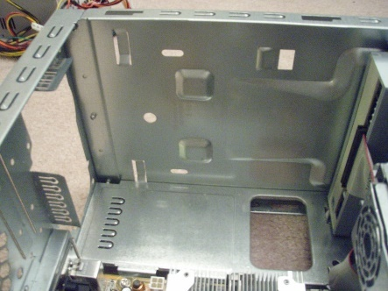

**Step 8**

Remove any adapter or expansion cards from the motherboard. Although these cards usually slide into preconfigured slots, there can be screws. Do not touch the gold connectors on the cards if you’re reinstalling the cards.

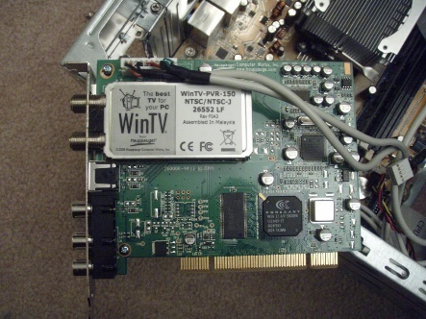 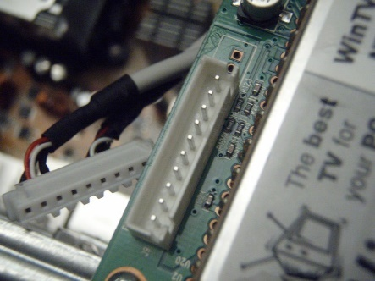

**Step 9**

Disconnect all the cables from the motherboard, then unscrew it from the frame by loosening each screw a little bit before going around again to loosen each screw properly. This prevents any potential warping of the motherboard by gradually releasing the tension on it.

All the components should now be out of the computer case. If you’re reusing the case, this is a good time to get rid of all the dust and lint that might have collected.

**Output/Results snippet:**

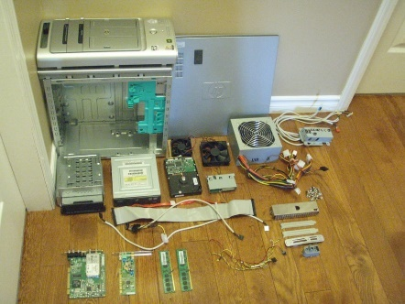

**References:**

* <https://www.instructables.com/id/Disassemble-a-Computer/>

**Activity 2**

**Aim:** Remove the cabinet and identify the components, slots, sockets, and connectors of motherboards

**Learning outcome:** Able to disassemble and assemble a PC.

**Duration:** 1 hour

**List of Hardware/Software requirements:**

1. Cabinet

2. Screwdriver

**Code/Program/Procedure (with comments):**

**Remove the Cabinet**

**Remove the Side Panel Retaining Screws**

Remove the outermost screws from the case—the ones that are holding the side panels to the rest of the case. You'll likely need a Phillips-head screwdriver to remove these screws but some cases have screws you can turn by hand.

Set these screws aside, or unscrew them as far as you can if this case doesn't have fully removable screws. You'll need to use them to secure the side panels to the case again when you're through working inside your computer.

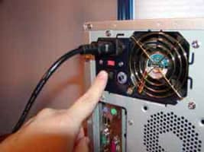

**Remove the Case Side Panel**

The case side panel can now be removed.

Sometimes the panel can simply be lifted off while other times it may be attached to the case in a slide-lock manner. No matter the mechanism, you should be able to easily jar the panel loose.

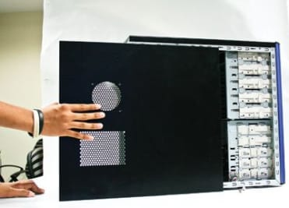

**Remove the adapter cards:**

Make sure if the card has any cables or wires that might be attached and decide if it would be easier to remove them before or after you remove the card. Remove the screw if any, that holds the card in place. Grab the card by its edges, front and back, and gently rock it lengthwise to release it.

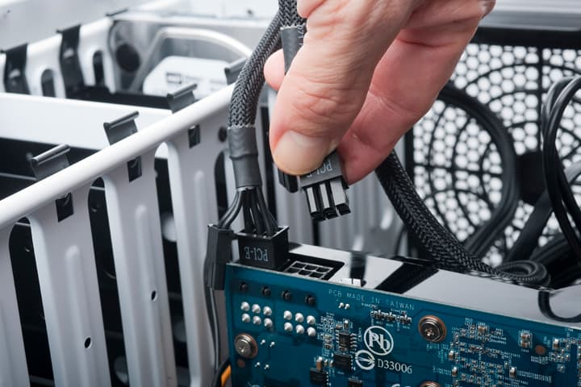

**Remove the drives:**

Removing drives is easier. There are possibly three types of drives present in your computer system, Hard disk drive, CD/DVD/Blue-ray drives, floppy disk drives (almost absolute now a day). They usually have a power connector and a data cable attached from the device to a controller card or a connector on the motherboard. CD/DVD/Blue Ray drive may have an analog cable connected to the sound card for direct audio output.

The power may be attached using one of two connectors, a Molex connector or a Berg connector for the drive. The Molex connector may require to be wiggled slightly from side to side and apply gentle pressure outwards. The Berg connector may just pull out or it may have a small tab which has to be lifted with a screwdriver.

Now Pull data cables off from the drive as well as the motherboard connector. The hard disk drive and CD/DVD drives have two types of data cables. IDE and SATA cables. The IDE cables need better care while being removed as it may cause the damage to drive connector pins. Gently wiggle the cable sideways and remove it. The SATA cables can be removed easily by pressing the tab and pulling the connector straight back.

Now remove the screws and slide the drive out the back of the bay.

**Remove the memory module:**

Memory modules are mounted on the motherboard as the chips that can be damaged by manual force if applied improperly. Be careful and handle the chip only by the edges.

SIMMs and DIMMs are removed in a different way:

* SIMM - gently push back the metal tabs while holding the SIMM chips in the socket. Tilt the SIMM chip away from the tabs until a 45% angle. It will now lift out of the socket. Put SIMM in a safe place.
* DIMM- There are plastic tabs on the end of the DIMM sockets. Press the tabs down and away from the socket. The DIMM will lift slightly. Now grab it by the edges and place it safely. Do not let the chips get dust at all.

**Output/Results snippet:**

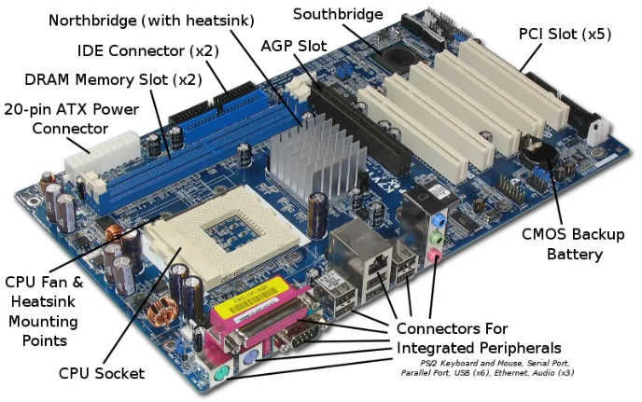

**References:**

* <https://turbofuture.com/computers/Dissassembling-and-Assembling-the-computer-system>

**Activity 3**

**Aim:** Remove the SMPS

**Learning outcome:** Able to disassemble and assemble a PC.

**Duration:** 1 hour

**List of Hardware/Software requirements:**

1. Cabinet

2. Screwdriver

**Code/Program/Procedure (with comments):**

The power supply is a large metal box located at the upper-back part of the computer. They sometimes come with an on/off switch that is accessible from the back of the computer.

The main power cord also plugs into the back of the power supply.

The power supply supplies power to every component in a computer; therefore it has the most wires out of every other component in the computer. The first thing I will do is unplug every wire coming from the power supply. The list below is everything that I had to disconnect:

* Motherboard (very large connector/plug)
* CD/DVD drive[s] power
* Internal hard drive power
* Portable hard drive slot power

Once everything is unplugged, unscrew the four screws holding the power supply in place, on the back of the computer. Next, push the power supply from the outside, then lift it out.

**Output/Results snippet:**



**References:**

* <https://www.instructables.com/id/Disassemble-a-Computer/>

**Activity 4**

**Aim:** Remove Hard disk Drive, RAM, CMOS Battery, coolant fan and DVD/BD Drive

**Learning outcome:** Able to disassemble and assemble a PC.

**Duration:** 1 hour

**List of Hardware/Software requirements:**

1. Cabinet

2. Screwdriver

**Code/Program/Procedure (with comments):**

**Removable Hard Disk Drive**

**Open your machine**

First, you need to remove the side panel from the computer case. The side panel is usually held in place by several screws, or may be held in place with a bracket or clamp. Remove the fasteners securing the side panel, and carefully pull it off. Once the panel is removed, you can see the inside of the computer. The next step is to locate the hard drive inside the case. In most computer cases, it's located towards the front at the bottom of the case, as indicated in the image below.

**Hard drive removal**

Once you've found the hard drive, disconnect the power supply cable from the back of it. Also, disconnect the IDE or SATA cable, which is located next to the power connector. The hard drive is secured in place by two to four screws, as is shown in the picture below.

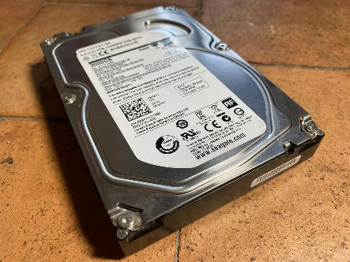

Otherwise, it will be held by a mounting bracket with a clamp. With the securing mechanism loosened, gently remove the hard drive.

**Remove RAM**

So pretty much, the more RAM you have, the faster your computer runs. Most computers have 4 RAM slots, and two RAM chips.

* It is time now to mount the memory modules on the motherboard by aligning the RAM to its socket on the motherboard and press it downward. Make sure the side tabs are fixed into the RAM notch. If not, you may still have to press a bit.
* To remove the RAM, push down on both tabs holding the RAM in place, which are located at both ends of the RAM.

**Remove CMOS Battery**

* Remove the power cord to make sure that your computer receives no power.
* Make sure you’re grounded. Static discharges can damage your computer.
* Find the battery on your motherboard
* Remove it.

**Remove Cooling Fan**

* Release the retention clips on each side of the heatsink from the motherboard socket mounting lugs.
* Lightly twist the CPU cooler clockwise and counterclockwise to loosen the seal between the heatsink and the lid of the CPU.
* Carefully lift the CPU cooler from the CPU

**Remove DVD/BD Drive**

* The CD/DVD drive is one of the easiest components to remove. First, unplug the ribbon from the back of the drive. Once that is completed, pull on the tab securing the drive-in place, then push it out from the inside.
* If you don't have a second drive, there should be a flat piece of metal covering the drive slot.
* Follow the inscribed instructions to remove it.

**Output/Results snippet:**



**References:**

* <https://turbofuture.com/computers/Dissassembling-and-Assembling-the-computer-system>

**Activity 5**

**Aim:** Remove add on cords Remove and clean the motherboard

**Learning outcome:** Able to disassemble and assemble a PC.

**Duration:** 1 hour

**List of Hardware/Software requirements:**

1. Screwdriver

2. Compressed Air, Makeup Brush, Vacuum with attachments

3. Cotton

4. Isopropyl Alcohol 99% (or any 90%+)

**Code/Program/Procedure (with comments):**

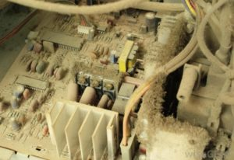

Expansion cards give a computer new capability, once installed. Different examples are:

* Bluetooth
* Wireless Internet
* Ethernet
* TV

Different computers come stock with different cards. My computer came stock with a TV and Ethernet card. If you only have one, remove that one. If you have two, remove the two!

There should be a single screw on top of each expansion card slot, whether it's occupied, or empty. Remove the screws on the occupied card slots. Once the screws are removed, you

should be able to remove the cards by pulling them carefully upward. Some expansion cards have cables leading to other parts of the computer, for example, my TV card is connected to the connectivity center on the front of my computer. You will have to unplug any cables attached to an expansion card.

Make sure if the card has any cables or wires that might be attached and decide if it would be easier to remove them before or after you remove the card. Remove the screw if any, that holds the card in place. Grab the card by its edges, front and back, and gently rock it lengthwise to release it.

**Clean the motherboard**

**Step 1:** Power off the PC: The first and foremost thing you should do to clean the motherboard is to turn off your system completely. Once you have turned off the PC, the next task is to unplug the entire power source from the desktop PC.

**Step 2:** Remove the case and disassemble the PC: Now remove the case from the back side of the processor using the screwdrivers. Take out the motherboard from there and then place it on a flat clean surface. Best is to keep it on a clean cloth. You can also use the vacuum first if you found some heavy dirt all over it.

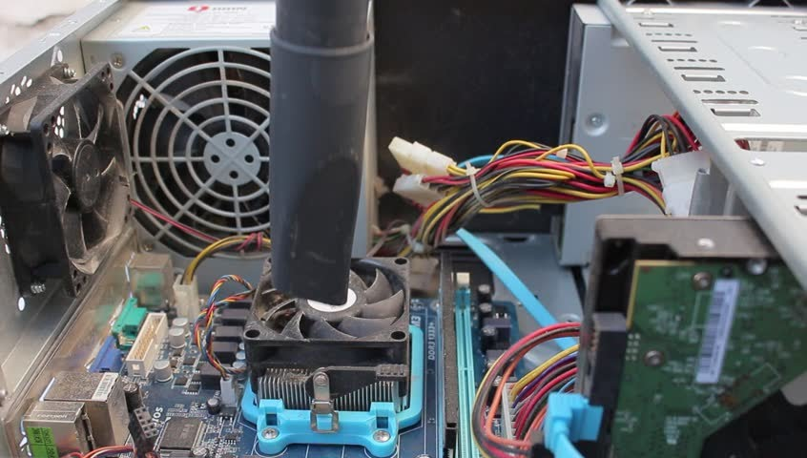

**Step 3:** Clean: Now the cleaning task starts off! First, go for a basic cleaning. Use the compressed Air to remove the dust and dirt from the motherboard. You can also use a vacuum attachment to get rid of stubborn dust. But if you are using the vacuum attachment, ensure to keep them a few inches away for the best result. Next use the

Makeup Brush & Compressed Air Can for the best cleaning results.

**Step 4:** Deep clean (Only try when your motherboard is faulty or dead): If you feel that basic clean is not enough to clean your motherboard then go for a deep clean. It requires you

use the 99% Isopropyl Alcohol. In case the motherboard is filled with sticky substances and solders junks, a cleaning with alcohol is the best solution for that. Take a 1L bottle of Isopropyl Alcohol 99% in a small container and then gently put the motherboard in it to give a proper alcohol bath (try to shake it slowly when it’s dipped properly). The stubborn and sticky particles will eventually go off to leave the motherboard as a new one.

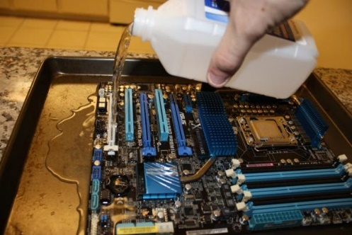

**Step 5:** Assemble back: Once the cleaning process is done, allow the motherboard to dry completely after the alcohol bath. This step is highly required to prevent any further damage. Anyways, alcohol will get dried easily as it is evaporated. Now, reinstall the motherboard on the proper area and attach the case properly with the screwdrivers. Power the unit again and turn it on to check if it is working.

**References:**

* <https://www.instructables.com/id/Disassemble-a-Computer/>
* <https://www.deskdecode.com/how-to-fully-clean-a-desktop-pc-motherboard-isopropyl-alcohol-bath/>

**Learning Outcome - Able to assemble a PC**

**After achieving this learning outcome, a student will be able to disassemble and assemble a**

**PC. In order to achieve this learning outcome, a student has to complete the following:**

1. Mount the motherboard on cabinet (0.5 Hrs.)

2. Connect Hard disk Drive, RAM, coolant fan, DVD/BD Drive and fix CMOS Battery (0.5 Hrs.)

3. Connect the SMPS and add on cords (0.5 Hrs.)

4. Assemble the cabinet. And connect the peripherals (1 Hrs.)

5. Connect power cords and switch on power supply and run the PC (0.5 Hrs.)

**Activity 1**

**Aim:** Mount the motherboard on cabinet

**Learning outcome:** Able to disassemble and assemble a PC.

**Duration:** 0.5 hour

**List of Hardware/Software requirements:**

1. Cabinet

2. Screwdriver

**Code/Program/Procedure (with comments):**

1. Verify that you are as static free as possible.

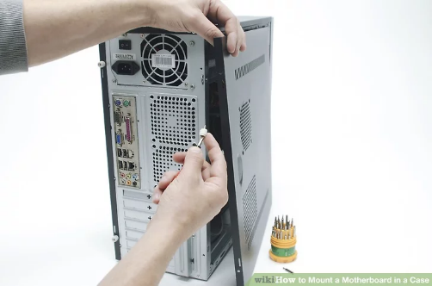

1. Open the case you want to mount the motherboard in

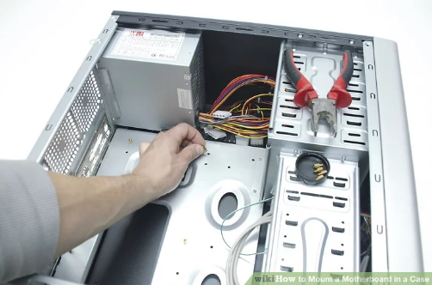

1. Verify all metal hex nuts are in place to fit the new board. Make sure none will short any solder points on the board.

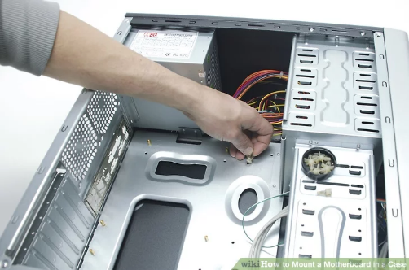

1. Verify all plastic spacers are in place to accommodate the new motherboard.

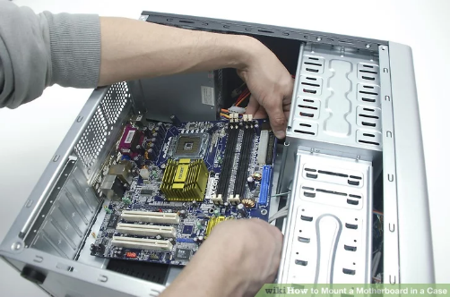

1. Place the motherboard into the case.

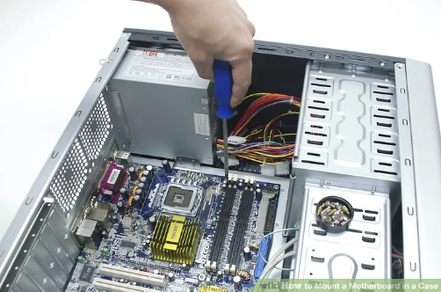

6. Screw the screws in place to hold the board in place. Make sure they are the only thing that lines up with the hex nuts.

**References:**

* <https://www.wikihow.com/Mount-a-Motherboard-in-a-Case>

**Activity 2**

**Aim:** Connect Hard disk Drive, RAM, coolant fan, DVD/BD Drive and fix CMOS Battery

**Learning outcome:** Able to disassemble and assemble a PC.

**Duration:** 0.5 hour

**List of Hardware/Software requirements:**

1. Cabinet

2. Screwdriver

3. Hard disk Drive (PATA or SATA)

4. RAM

5. coolant fan

6. CMOS Battery

7. DVD/BD Drive

**Code/Program/Procedure (with comments):**

**Connect Hard Disk Drive**

The general procedures for installing any hard drive are similar, but the exact steps and the sequence of steps vary depending on the type of drive you are installing PATA or SATA and the particulars of your case. The basic steps required to install a hard drive are:

1. Configure the drive as a master or slave device (PATA only).
2. Mount the drive in the chassis.
3. Connect the data cable to the drive and to the PATA or SATA interface.
4. Connect a power cable to the drive. Before you remove the case panels to install the hard drive:
5. Restart the system and run BIOS Setup. Note the current configuration which ATA and SATA ports are in use and the descriptions of the devices that are connected to them. Alternatively, use a diagnostic program such as Everest Home Edition to determine the current configuration of your drives and interfaces.
6. If you are also installing a PATA or SATA interface card or RAID adapter, configure that card per the maker's instructions and attach the cables to it. If that card will replace some or all of the embedded PATA or SATA interfaces, use CMOS Setup to disable those interfaces.

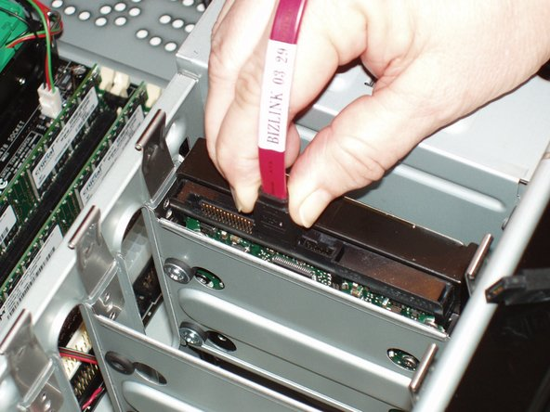

**Connect RAM:**

If your computer uses more than one stick like mine, refer to the manual for which slot to install the stick. If only one stick is going to be inserted, place it in the slot closest to the CPU.

The slots are keyed as are the RAM sticks, so make sure the notch is lined up. Even correctly lined up it will take considerable force; this is where having those standoffs in the correct spots pays off. Having done this for several computers, I still get uneasy pushing so hard on electronics.

You will know when they are set firmly as the locking tabs will snap into place and hold the RAM firmly in the slot.

**Connect Coolant Fan:**

1. Before opening your computer, make sure that it is unplugged and in a non-static surface.

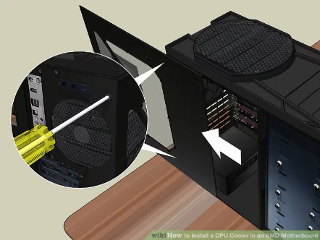

1. Turn off the computer and move it to the non-static surface. Use your screw-driver to open the case panel.

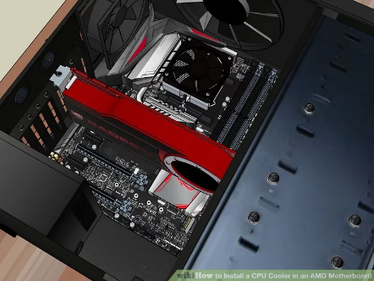

1. Remove the panel and take a look at the motherboard. It should look similar to the image.

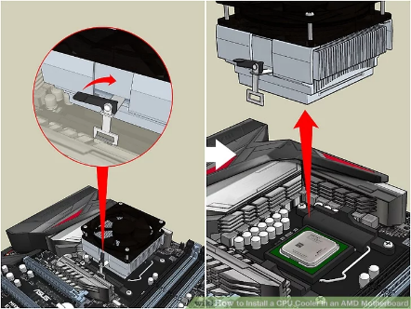

1. Now proceed to remove your previous CPU heatsink. In order to do this, you need to undo the lever on the right side. Do this by gently pulling up on the lever until it becomes unhinged and loose. The CPU should come off with ease.

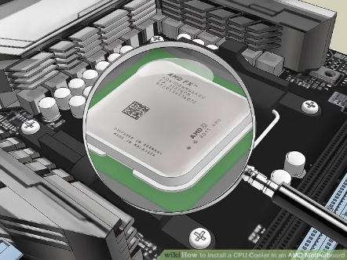

1. Check that all the components are in correctly so that there are no complications in the install process. The CPU should be perfectly flat.

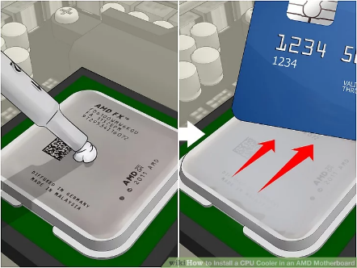

1. Apply the thermal paste onto the CPU. The amount of paste used should be about the size of a grain of rice.

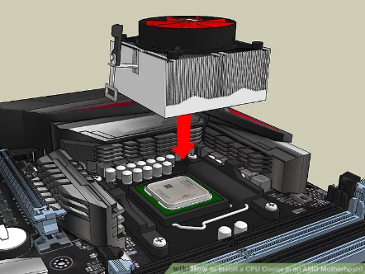

1. Take the replacement heat sink and line it up correctly with the lever facing the PCI ports.

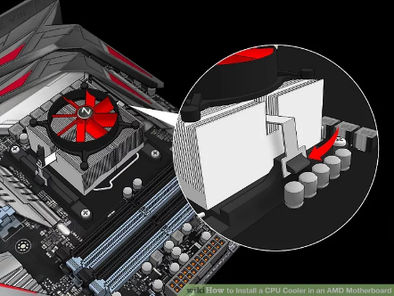

1. Connect the left connector bracket to the left side. This is important because it allows the lever to lock in the CPU heat sink so that it does not move.

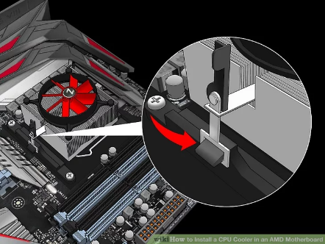

1. Connect the right side. Pull the lever all the way back and push the bracket down until it clicks into place.

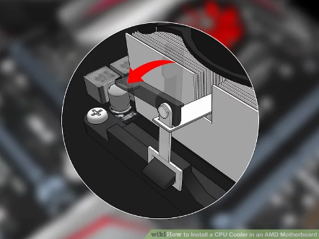

1. Take the lever and push it forward until it clicks into place. If the lever does not lock, stop pushing the lever. Just pull the lever back and repeat the last two steps over again.

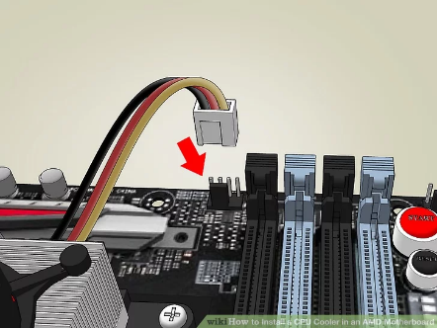

1. Plug in the wire. There will be a wire that is not connected which is located on the heatsink fan. Take the wire and plug it into the CPU fan socket. It is located near the CPU and has several metal prongs.

**Connect DVD/BD Drive**

The optical drive for this computer is a DVD/CD read/write combo. Some people prefer to only connect an optical drive when installing items but one being in place at all times comes in handy when something comes up and you do not want to open the case and connect the drive.

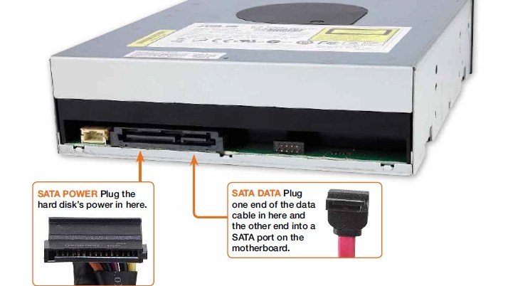

**Fix CMOS Battery:**

Open the computer case and find the battery on the motherboard. Verify it is accessible and can be removed. Today, most computers use a coin cell CMOS battery, like the CR2032 battery shown in the picture.

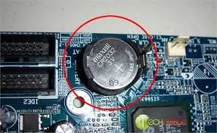

**References:**

* <https://www.wikihow.com/Install-a-CPU-Cooler-in-an-AMD-Motherboard>
* <https://www.ifixit.com/Wiki/Installing_a_Hard_Drive>

**Activity 3**

**Aim:** Connect the SMPS and add on cords

**Learning outcome:** Able to disassemble and assemble a PC.

**Duration:** 0.5 hour

**List of Hardware/Software requirements:**

1. Cabinet
2. Screwdriver
3. SMPS
4. Cables

**Code/Program/Procedure (with comments):**

1. Find a power supply for your computer. The power supply that you buy depends on the computer's motherboard and housing size, meaning that you'll need to research your motherboard model to see which power supplies will fit.

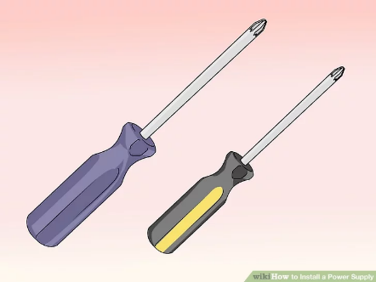

1. Assemble your tools. You'll need at least one screwdriver (typically a Phillips head) to open the CPU housing, which is usually the right-hand side of the CPU box when looking at the back of the box. You may need a different screwdriver for your power supply as well—look at the screws that came with the power supply to determine whether or not this is the case.

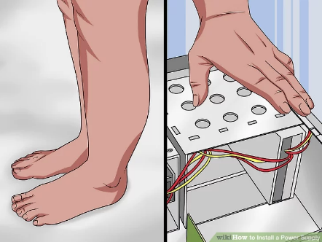

1. Ground yourself. This will help prevent you from accidentally damaging the internal components of your computer with static electricity.

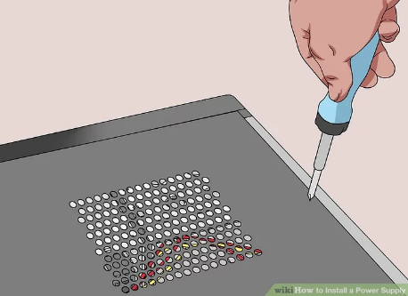

You can buy a grounding strap to help keep you grounded while working.

1. Open the computer case. You should be looking at the computer's internals at this point.

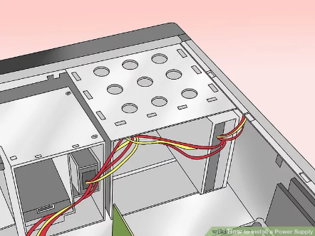

1. Lay the computer case on its side, with the exposed side facing up.

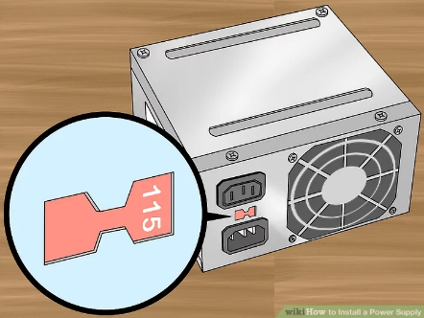

1. Set the power supply's voltage switch. If there's a voltage switch on the power supply, switch it to the 110v or 115v setting. This will ensure that your power supply provides ample power without damaging the components to which it's connected.

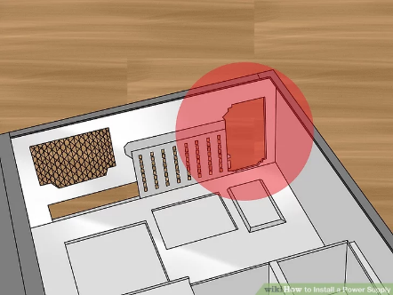

Not all power supplies have voltage switches, and those that do normally have the switch set to the standard of the region for which they were purchased.

1. Find the power supply's intended location. Power supply units (PSUs) typically sit at the top of the case; this is why the computer's power cable usually plugs into the top-back section of the case.

* Refer to your computer's instruction manual for the proper placement of the power supply unit, or look for a rectangular cut-out on the back of the case.
* If you're removing an old power supply, look for a power plug on the back of the case to find the power supply.

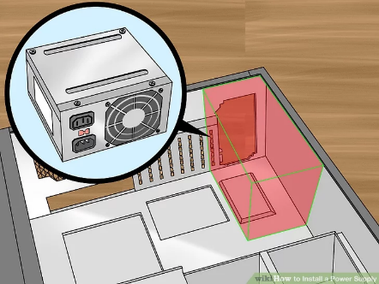

1. Insert the power supply. The power supply should have a distinct "back" with plugs and a fan, as well as a "bottom" with a fan on it. The "back" should face the back of the case, while the "bottom" should face the internal part of the case.

If you have an old power supply in your computer, remove it first.

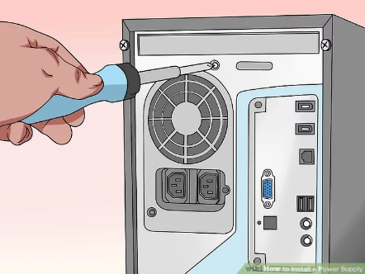

1. Screw the power supply into place. With the "back" of the power supply unit pressed against the back of the case, insert the included screws to lock the power supply into place.

Many CPU housings have shelves on which the power supply will rest.

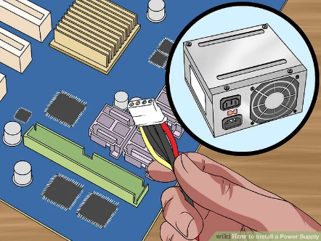

1. Attach the power supply to the motherboard. Find the main power cable on the power supply (usually the one with the largest plug) and attach it to the long, rectangular port on the motherboard, then attach the secondary power cable to the motherboard.

* Depending on your power supply and motherboard, you may not have a secondary power cable.
* The plug used to attach the power supply to the motherboard is usually a 20- or 24-pin connector.

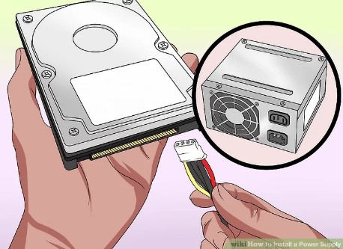

1. Connect the power supply to other computer components. Using the smaller cables, connect the power supply to your computer's hard drive, CD drive, and graphics card. If you have other components in your case (e.g., a lighting system), you may need to plug these in as well.[1]

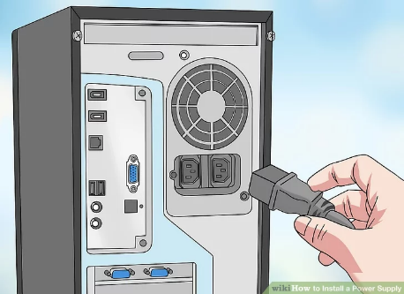

1. Close and plug back in your PC. Place the cover back on the PC, then stand it up and plug it back into the wall and your monitor.
2. Turn on your computer. If everything is connected and powered properly, the fan on the power supply should turn on and your computer will boot like usual. If you hear a beep and nothing happens, then something inside is not connected correctly, or the power supply is not providing enough power to your components.[2]

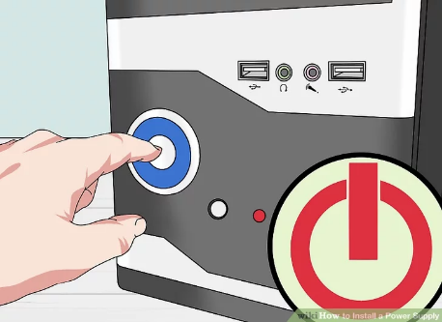

**References:**

* <https://www.wikihow.com/Install-a-Power-Supply>

**Activity 4**

**Aim:** Assemble the cabinet. And connect the peripherals

**Learning outcome:** Able to disassemble and assemble a PC.

**Duration:** 1 hour

**List of Hardware/Software requirements:**

**Code/Program/Procedure (with comments):**

1. Processor (CPU)
2. Computer Case
3. Optical Drive (DVD RW and SATA capable)
4. Memory (RAM)
5. Power Supply
6. SATA Cables
7. Motherboard (SATA Capable)
8. Processor Fan
9. Case Fan
10. Hard Drive (SATA Capable)
11. Assortment of case and drive screws

**Step 1: Remove Side Panels on Case**

After removing the case from the box, the panels are removed from this case with thumb screws. Your specific model's manual will have more information if you are unsure for your case.

Included were standoffs for mounting the motherboard, following the included template, thread into the corresponding holes in the case.

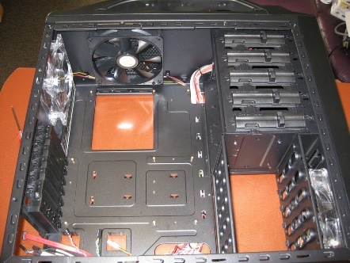

**Step 2: Insert Motherboard**

In my assembly process, as I was just transferring the parts from one case to another, leaving the CPU cooler installed was the easiest option. Depending on the motherboard, case, CPU and CPU fan, this might need to be done before installing or once in place.

Before setting the board in, the I/O panel faceplate needs to be snapped into the location in the back of the case. Be sure to orient it to the board.

Once the board is resting in the case, line up the first hole, I suggest a corner. Do not tighten all the way down until all screws are started so that the others will line up.

After all are in and tightened, there should be little or no deflection of the board if you gently press on it. It is advisable that any place there is a mounting location for the board, that it is screwed into a standoff. This will provide support while installing the components into the motherboard.

This case has a cutout for access to the back of the motherboard for the massive CPU coolers that have brackets that attach to the back of the board.

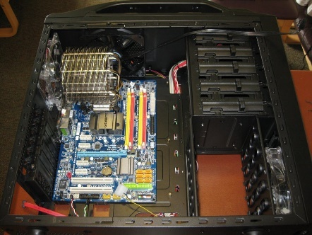

**Step 3: Check Clearances**

Being that this computer includes high performance components, some of them are large enough that clearance can become an issue. For this reason, once the board was installed, I fitted the graphics card so there would not be more surprises later in the process.

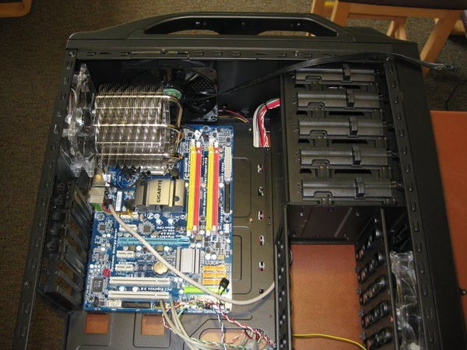 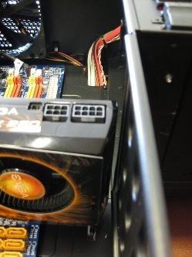

**Step 4: Front Panel Connections**

Once the graphics card was removed again, it was time to attach the connections for the buttons, lights, USB ports and audio connections. As every case and motherboard differ slightly, it is best to refer to the manual for the placement and orientation of connections.

Some of these connections are made to only work in one direction so be careful when using force, it might be in an incorrect orientation.

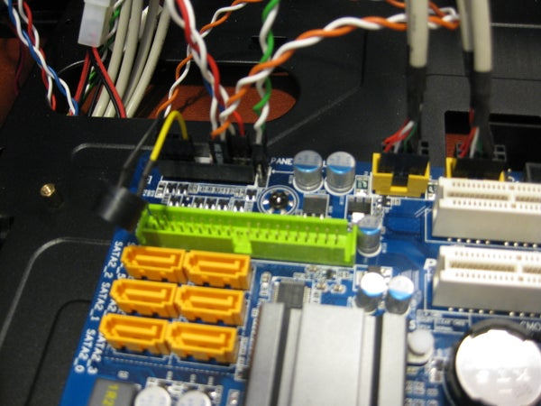

**Step 5: Install Power Supply**

The power supply from the previous case was modular so only the cables that are needed are plugged into the unit. As well this makes cable management cleaner in the end.

Normally the supply is screwed into the back panel by 4 screws, though some cases include a clamp to hold it down that way.

The second picture shows all of the cables that my computer needs to function properly.

Not pictured, below the supply there is a hole with a filter for the power supply to circulate air independent of the case fans.

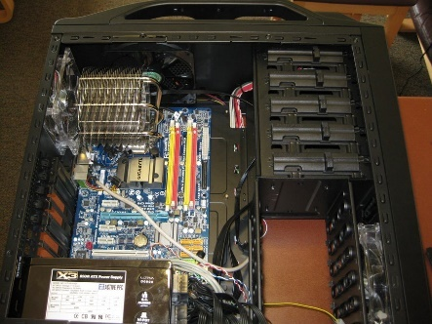 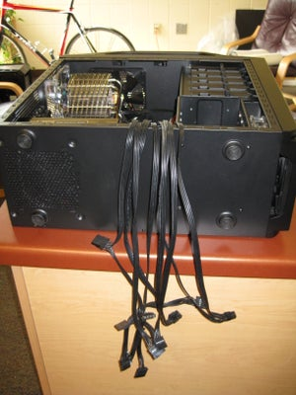

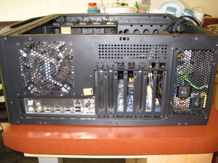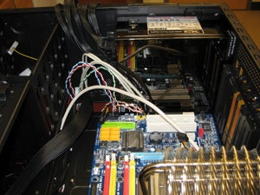

**Step 6: Power Motherboard**

With the motherboard power being the largest cable and sometimes just long enough, I suggest running this cable first and plugging it into the board, if there is a second cable for the CPU remember to connect it as well.

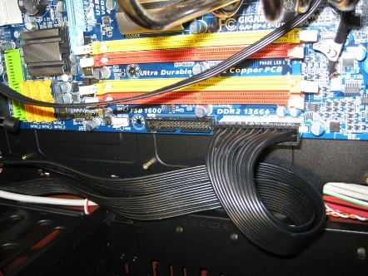

**Step 7: Installing Optical Drive**

The optical drive for this computer is a DVD/CD read/write combo. Some people prefer to only connect an optical drive when installing items but one being in place at all times comes in handy when something comes up and you do not want to open the case and connect the drive.

The second picture shows the tool-less design of the case to hold the drive-in place.

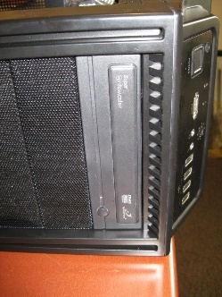 

**Step 8: Installing the Hard Drives**

The size and number of hard drives your computer contains is completely dependent on your style of use and storage needs. This computer uses 4 drives, two in raid and the rest for a main drive and miscellaneous storage.

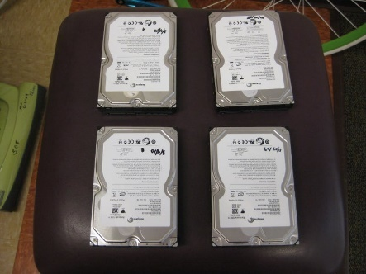

Picture 2 shows the location for the drives in the case, this model has a cross mounted design, others might have them in the same direction as the optical drive installed previously.

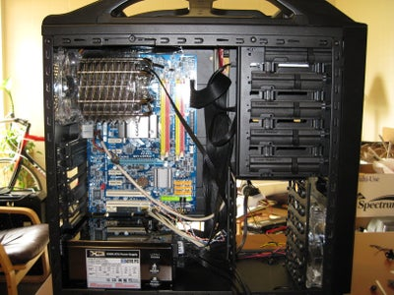

Picture 3 is an example of possible tool-less drive mounting hardware, these clips allow the drive to be just slid in and locked into place.

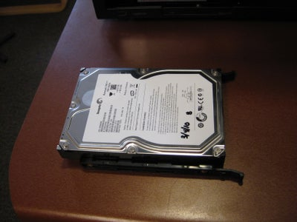

Picture 4 depicts the drives installed and spaced out for air flow. This is very important to extend the lifespan of the drive key when you are making a long term investment or run your computer continuously.

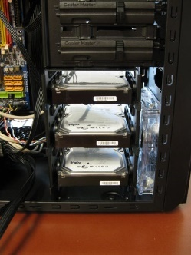

Picture 5 shows the back of the drives where the connections for power and signal are made.

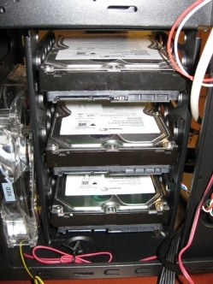

Picture 6 shows the cables attached.

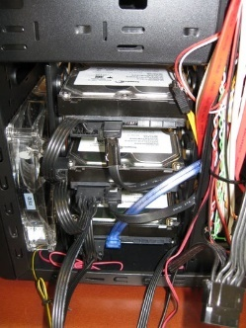

**Step 9: Connect Cables**

It is time to connect the cables for the hard drives and optical drives. The cables are keyed so they will only fit in one direction into the board, don't forget the cable that is attached to the optical drive. This computer does not use the IDE cable but if you are connecting an older optical or hard drive, they might require it.

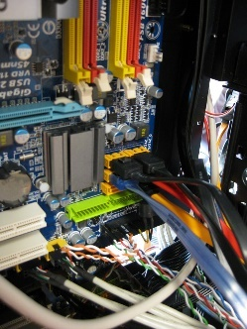

**Step 10: Install RAM**

It is time for the ram to be inserted. If your computer uses more than one stick like mine, refer to the manual for which slot to install the stick. If only one stick is going to be inserted, place it in the slot closest to the CPU.

The slots are keyed as are the RAM sticks, so make sure the notch is lined up. Even correctly lined up it will take considerable force; this is where having those standoffs in the correct spots pays off. Having done this for several computers, I still get uneasy pushing so hard on electronics.

You will know when they are set firmly as the locking tabs will snap into place and hold the RAM firmly in the slot.

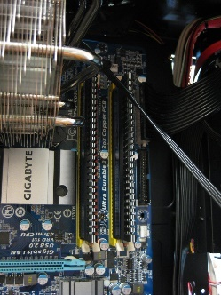

**Step 11: Install Graphics Card and Expansion Cards**

If your computer does not come with a graphics card integrated into the motherboard or you are adding an additional card, this is the time to do so.

With some high-performance cards, additional power cables might need to be installed. The manual for the card should tell you how many cables are needed. In my case it is a 6-pin and an 8-pin.

After that is in place and secured with screws in place (a time where tool-less is not enough), the network card and audio card for the computer are connected into the slots below the graphics card.

 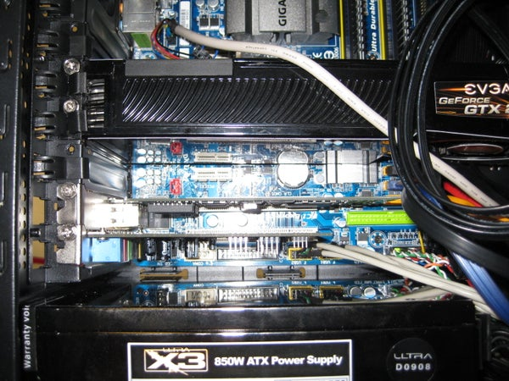

**Step 12: Cable Management**

With all components in place, it is time to make your hard work look like a work of art. Hiding cables and organizing them will help in the future if you are looking for high airflow through the case or to light it up.

Small steps taken throughout the process of installing the components can pay off huge at this point by not needing to re-run the cables around brackets or through holes in the frame. Some of the management was done out of the box for this model being that the front panel and fan cables were already secured ahead of time. Another thing to think of is that the back panel does not leave a large space if you have several cables running over the top of others.

A few trial-and-error steps later this will look and perform with ease. Also, it is a nice point to brag once you call up your friends to show off the system you assembled with your own hands.

This step is also when fans and lights can be connected.

The assembly of a brand-new computer can take several hours. Just to remove and mount in a new case with no other modifications took me 3 hours, 2.5 of that just the re-installing time. With the job complete it is time to fire it up and enjoy your creation. From here you can add your operating system and software as you see fit.

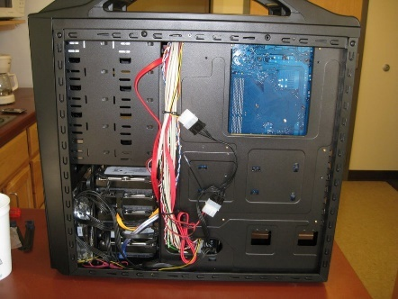

**Output/Results snippet:**

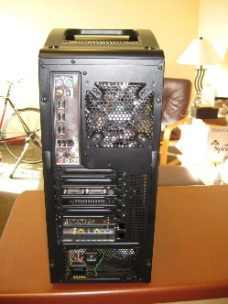

**References:** <https://www.instructables.com/id/Computer-Assembly/>

**Activity 5**

**Aim:** Connect power cords and switch on power supply and run the PC

**Learning outcome:** Able to disassemble and assemble a PC.

**Duration:** 0.5 hour

**List of Hardware/Software requirements:**

1. Power Cables
2. 24-pin power to motherboard (always required)
3. 4/8-pin EPS12V power to CPU (always required)
4. 6/8-pin power to video card (normally required)
5. SATA power to storage devices (normally required)
6. MOLEX power to accessories (optional)
7. CPU fan & case fan power (required)
8. Power cable to system’s power supply (always required)
9. Data Cables
10. SATA data to storage (normally required)
11. USB2.0 front panel headers (normally required)
12. USB3.0 front panel header (normally required)
13. HD Audio front panel header (normally required)
14. Signaling Cables
15. Power switch [PWR_SW]
16. Reset switch [RESET]
17. Power LEDs [PWR_LED]
18. Hard Drive LEDs [HDD_LED]

**Code/Program/Procedure (with comments):**

1. Connect your power supply cables beginning with the 24-Pin Motherboard connector.

2. Next, connect the 8-Pin CPU/ Motherboard cable. Some motherboards will only require a 4-Pin connector.

3. Next, connect the 6 or 8-Pin PCI power cable to your video card. Some video cards do not require additional power from the power supply. Some video cards will require two 6 or 8-Pin PCI power cables.

4. Next, connect your storage or disk device such as your HDD, SSD, or DVD Drive.

Connect the SATA data cables that were included with your motherboard. Connect one end to the hard drive or disk drive and the other end into the appropriate SATA slot on your motherboard. Consult the manual for additional instructions on which slot to use.

5. Connect the SATA power cable from the power supply to the drives.

6. Connect any USB headers from your accessories such as the GRID+ or Aperture M Card Reader.

7. Connect the SATA or MOLEX power for any of your accessories or coolers such as the SATA power connector in the Kraken™ liquid cooler.

8. Connect the USB 3.0 connector to enable the USB 3.0 slots on the outside of your case. (If there are any)

9. Connect the HD Audio and USB headers to enable the USB 2.0 and Headset / Mic ports on the outside of your case.

10. Connect the Power SW, Reset SW and LED indicator headers into the motherboard to enable the activity LEDs and power / reset buttons on your case.

**References:**

* <https://blog.nzxt.com/psu-cable-connections/>

**Learning Outcome – Software Installation**

**After achieving this learning outcome, a student will be able to disassemble and assemble a**

**PC. In order to achieve this learning outcome, a student has to complete the following:**

1. Prepare Hard disk for OS installation by making partitions (2 Hrs.)

2. Install Operating System Windows and Linux in two different partitions (2 Hrs.)

3. Install Device Drivers.

4. Install/Uninstall Application software (Office, Multimedia and Antivirus) (2 Hrs.)

**Activity 1**

**Aim:** Prepare Hard disk for OS installation by making partitions

**Duration:** 2 hours

1. Reboot your computer with the OS installation disc inserted into a USB slot or DVD drive.
2. Click “Next” on the “Install…” screen after selecting the appropriate localization options.
3. Select a “Custom” install from the next screen and click "Next."
4. Select “Drive Options” on the “Custom Install” screen and click "Next."
5. Select the Partition you wish to format and click "Next."
6. Select either a full or quick format. A quick format marks all data as cleared, but does not eliminate the data. A full format overwrites existing data on the drive with blank "data."

**Windows 10 and 11**  
To create a partition from unpartitioned space follow these steps:

1. Right-click **This PC**and select **Manage.**
2. Open **Disk Management**
3. Select the disk from which you want to make a partition.
4. Right-click the Unpartitioned space in the bottom pane and select **New Simple Volume.**
5. Enter the size and click next, and you are done.

**Windows 8 and 8.1**  
To create a partition from unpartitioned space follow these steps:

1. Hold the **Windows key** on your keyboard and press **R.**
2. This launches the Run the utility. Type **diskmgmt.msc** inside the text box and press **Enter**. This opens the Windows Disk Management utility.
3. To create unallocated space, you need to shrink your hard drive. When you shrink your hard disk, the remaining space becomes unallocated.
4. To do this,**right-click** your main drive and select **Shrink Volume**
5. Now you need to enter the amount you want to shrink the hard disk by in megabytes
6. After the Shrink is done, you will then see the region of unallocated space (shaded black). Remember, this space is not yet usable.
7. **Right-click** the region of unallocated space and select **New Simple Volume.**
8. This launches the New Simple Volume Wizard. This guides you through the installation process.
9. Assign the disk a drive letter. You can choose any drive letter that is not currently in use.
10. Select a file system for the disk. The file system is basically the type of format or foundation “the storage device has. If you plan on installing a Windows operating system to the partition select the **NTFS**file system.
11. Name the partition in the **Volume Label** text box. You can choose any name for your partition.
12. Now click **Finish** to create the new partition.

**Activity 2**

**Aim:** Install Operating System Windows and Linux in two different partitions

**Duration:** 2 hours

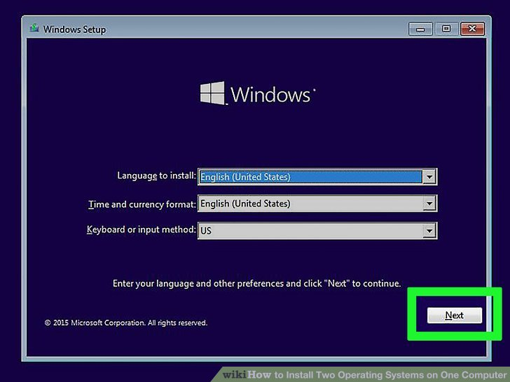

[**Install Windows**](https://www.wikihow.com/Install-Windows-10)**.** If you haven't already done so, you should install Windows before installing any other operating systems. Other operating systems, such as Linux are designed so they can work alongside Windows. If you have not installed an operating system on your PC, make sure you install Windows first.[[1]](https://www.wikihow.com/Install-Two-Operating-Systems-on-One-Computer#_note-1)

* The exception is if you are trying to [dual-boot Windows alongside macOS on a Mac](https://www.wikihow.com/Install-Windows-10-on-a-Mac). Macs are built a little different than most standard PCs and generally come with macOS already installed.



**2 Navigate to**[**https://rufus.ie/**](https://rufus.ie/)**in a web browser.** This is the web page to download Rufus which is a tool used to create a USB install drive that you can use to install an operating system on your computer.

* + You can also use an official install CD or DVD.

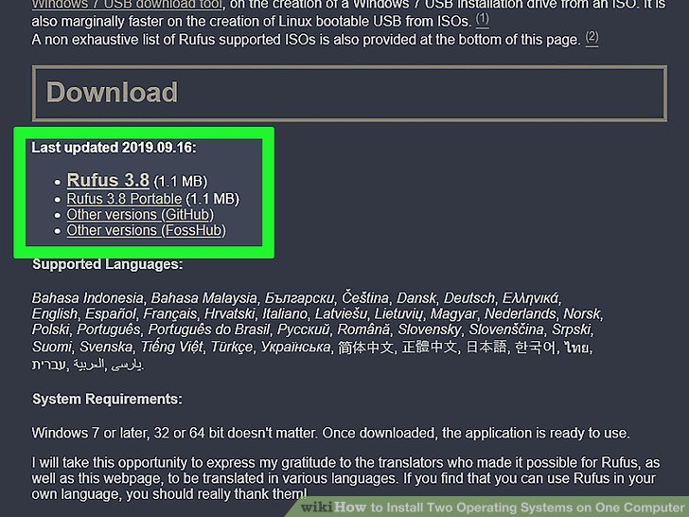

**3 Download and install Rufus.** Use the following steps to download and install Rufus from the download page.

* Scroll down and click **Rufus 3.8**
* Run the "Rufus-3.8.exe" from within your web browser or Downloads folder.

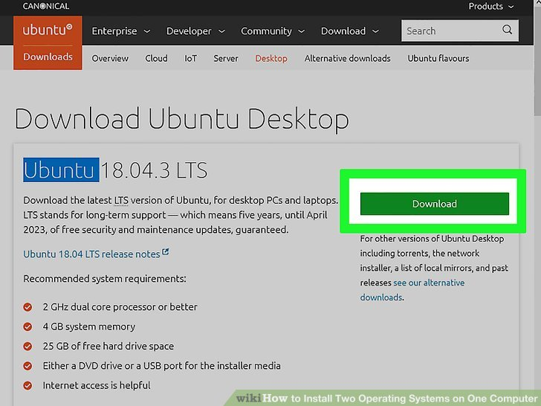

**4 Download a disk image (ISO) for the operating system you want to install.** A disk image is data that goes on an install disk, DVD or USB drive. You will need to go to the website of the operating system you want to download and download the ISO file from that website. The following links contain operating system ISO images you can download:

* [Windows 10](https://www.microsoft.com/en-us/software-download/windows10)
* [Windows 8](https://www.microsoft.com/en-us/software-download/windows8ISO)
* [Windows 7](https://www.microsoft.com/en-us/software-download/windows7)
* [Ubuntu](https://ubuntu.com/download/desktop)
* [Linux Mint](https://linuxmint.com/download.php)
* [Debian](https://www.debian.org/distrib/)
* [Installing macOS](https://www.wikihow.com/Build-a-Hackintosh) on a non-Apple computer is more complicated than installing other operating systems, but it is possible.

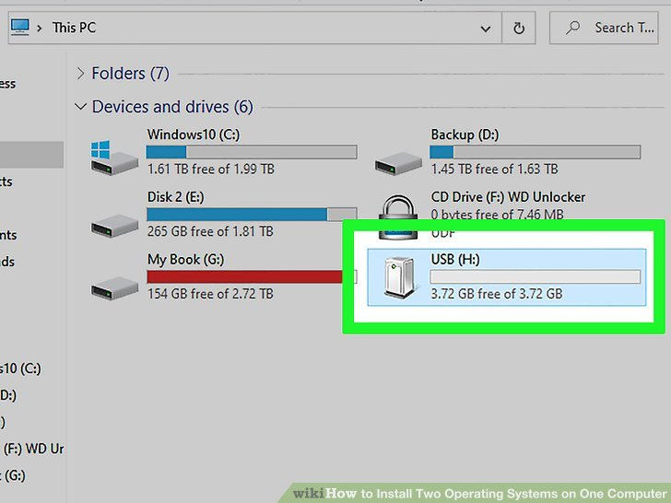

**5 Insert a blank USB flash drive.** Make sure the USB drive has enough space for the operating system you want to install. Also, make sure the USB drive you use doesn't have any important data that you don't want to lose. Insert the USB drive into an open USB port on your computer.

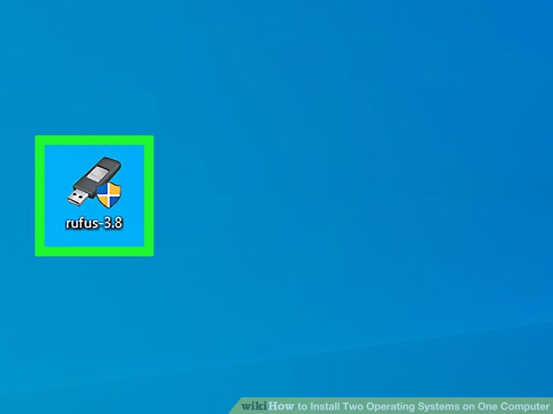

**6 Open Rufus.** It has an icon that resembles a USB flash drive. Click the Rufus icon in your Windows Start menu to open Rufus.

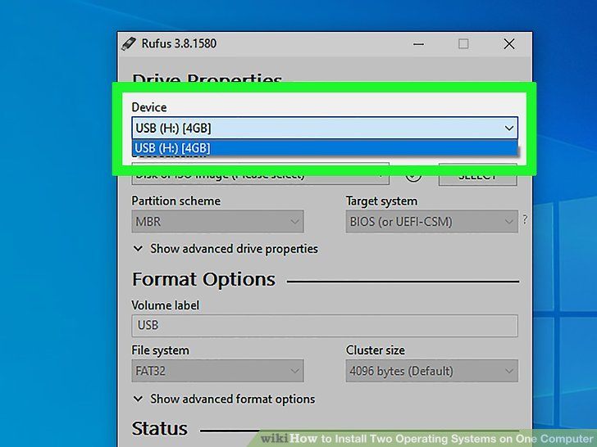

**7 Select your USB flash drive.** Use the drop-down menu below "Devices" to select your USB flash drive.

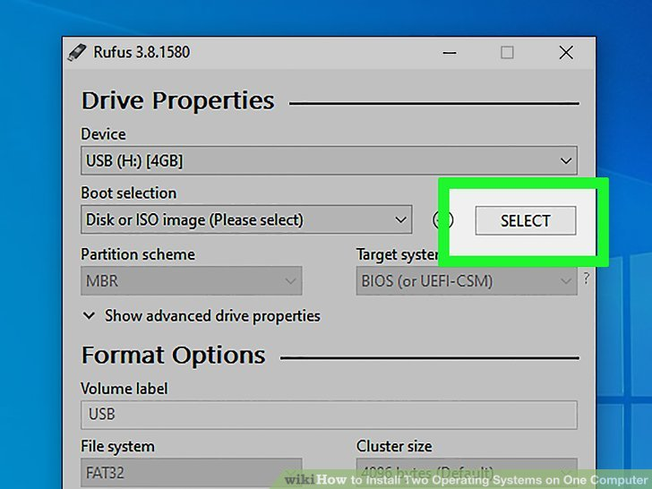

**8 Click Select.** It's the button to the right of "Boot Selection" in Rufus. This opens a file browser you can use to select the ISO file for the operating system you want to install.

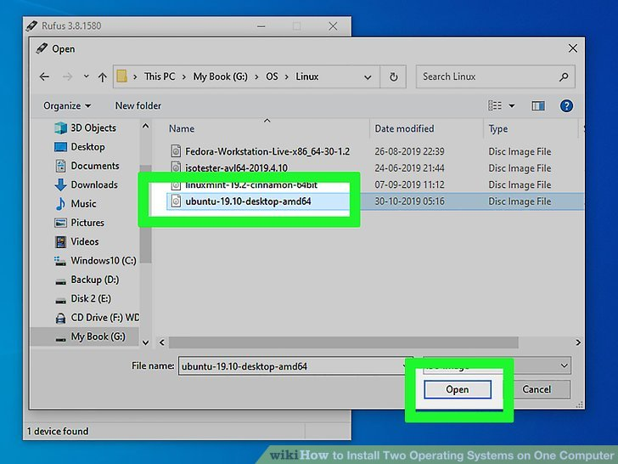

**9 Select the operating system ISO file and click Open.** This loads the ISO file into Rufus.

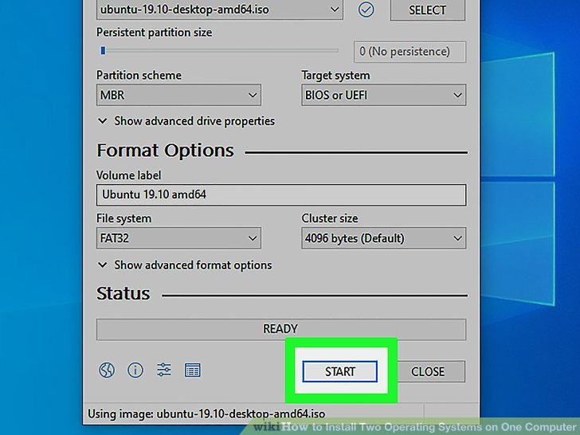

**10 Click Start.** It's at the bottom of Rufus on the right. This starts the process of righting the ISO file to the USB drive. This may take a while to complete.

**Part2 Creating a Disk Partition**

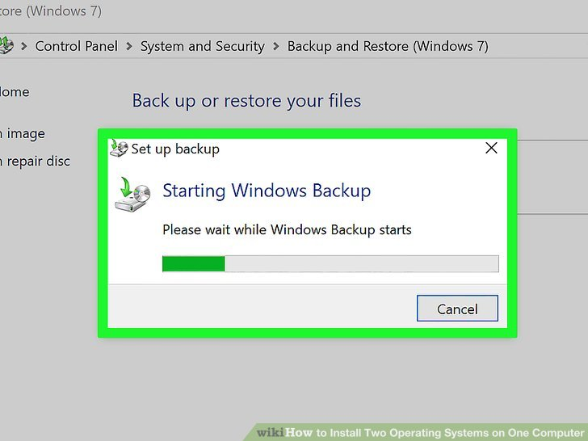

**1** [**Make a backup**](https://www.wikihow.com/Back-Up-Data)**of any important data files.** You can usually partition a disk drive and install a new operating system without losing any important data. However, it's a good idea to backup any important data on your disk drive before you start partitioning and installing a new operating.

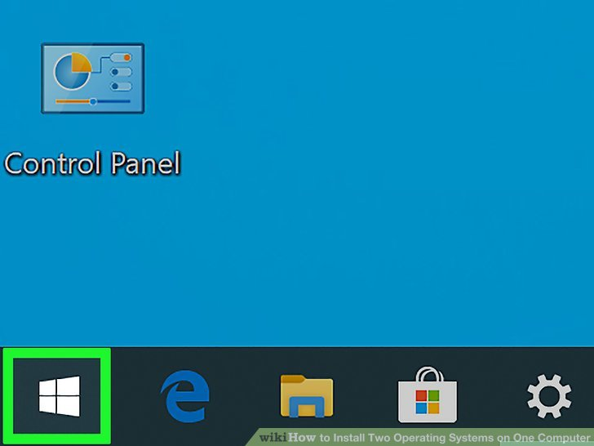

**2 Right-click the Windows Start menu  [](https://www.wikihow.com/Install-Two-Operating-Systems-on-One-Computer#/Image:Windowsstart.png).** It's the icon with the Windows logo. By default, it's in the lower-left corner in the taskbar.

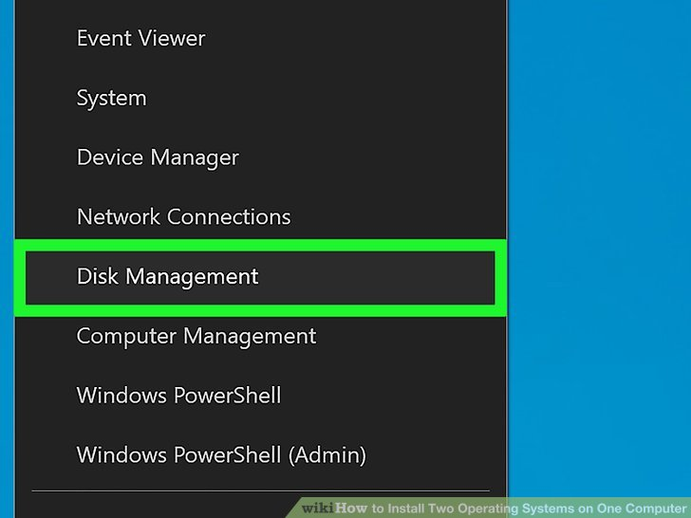

**3 Click Disk Management.** It's in the menu that appears when you right-click on the Windows Start menu. This opens the Disk Management window.

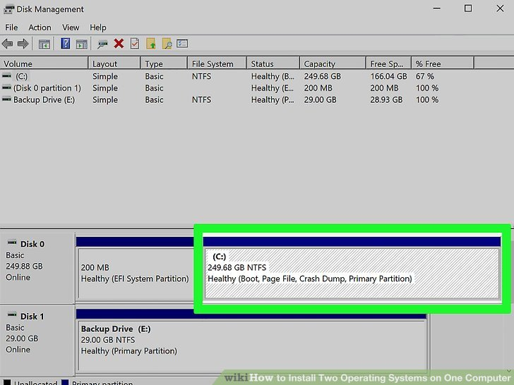

**4 Right-click your Windows installation drive.** This is the drive that Windows is installed on. Usually, this is the "C:" drive.

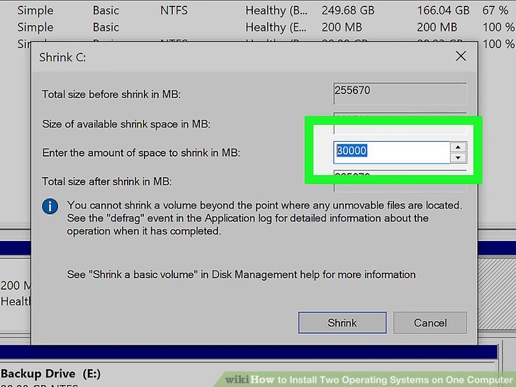

**5 Click Shrink Volume.** It's in the window the menu that pops up when you right-click on a disk drive in Disk Management.

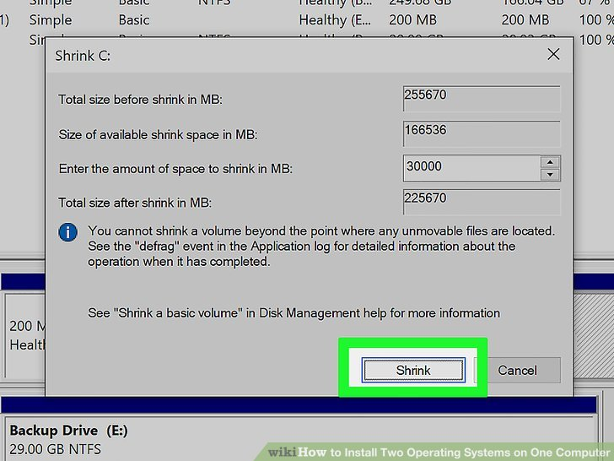

**6 Enter the amount of space you want to allocate to the new operating system installation.** Type the number of megabytes (MB) you want to partition from the disk drive in the field next to "Enter the amount of space to shrink in MB". Make sure you enter the minimum space required to install the new operating system.[[2]](https://www.wikihow.com/Install-Two-Operating-Systems-on-One-Computer#_note-2)

* + To convert GB to MB, simply multiply by 1000. For example, 40 GB is equivalent to 40,000 MB.

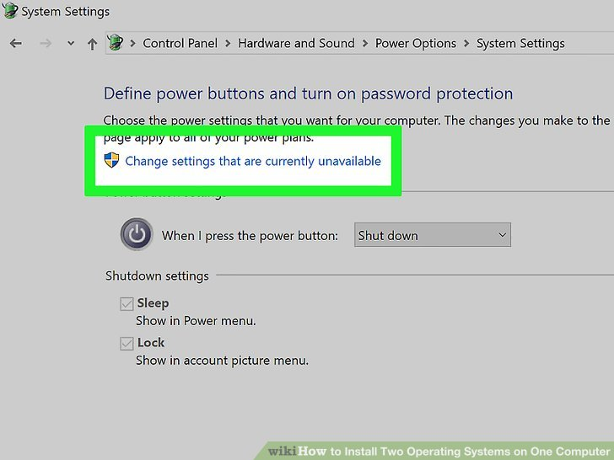

**7 Click Shrink.** This creates a new partition of unallocated space on your hard drive.

**Part3 Preparing Your Computer**



**1 Turn off Fast Boot.** The following steps allow you to turn off Fast Boot on Windows.

* Click the Windows Start menu.
* Type Control Panel and click the Control Panel icon
* Type Power Options in the search bar in the upper-right corner.
* Click "Choose what the power button does".
* Click "Change settings that are currently unavailable".
* Make sure the box that says "Turn on fast startup (Recommended)" at the bottom is not checked.
* Click **Save changes**.

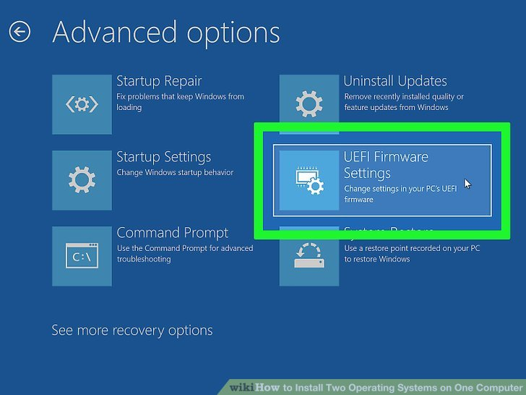

**2** [**Enter your computer BIOS**](https://www.wikihow.com/Enter-BIOS)**.** You'll need to make some changes to the BIOS in order to install a second operating system. The method for entering the BIOS is different from one computer make and model to the next. On some computers, you can enter the BIOS by pressing one of the functions keys (F1, F2, F9, F12), Esc, or Delete while your computer boots up. You can also use the following steps to reboot into the BIOS from within Windows:

* + Click the Windows Start menu.
  + Click the Power icon.
  + Hold "Shift" and click **Restart**.
  + Click **Troubleshoot**.
  + Click **Advanced Options: UEFI Firmware Settings**
  + Click **Restart**.

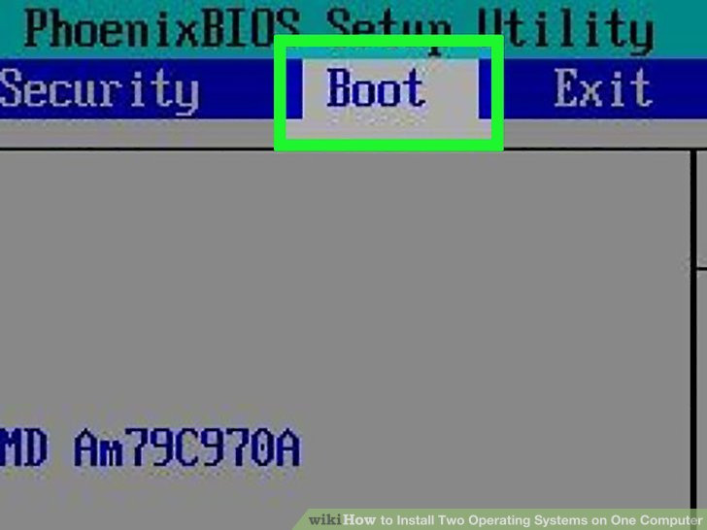

**3 Disable Secure Boot.** The BIOS menu is different from one computer make and model to the next. Use the arrow keys on your keyboard to navigate the BIOS menu. Secure Boot is usually found in the Security, Boot, or Authentication menu. Locate Secure Boot and set it to "Disabled".

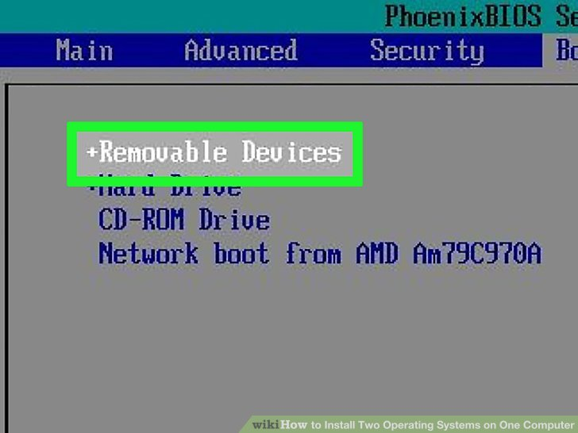

**4** [**Set the Boot order to boot from a USB drive first**](https://www.wikihow.com/Set-Your-Computer-to-Boot-from-USB-Flash-Drive)**.** This is usually found in the Boot menu. Locate the boot order menu and set it so it boots from a USB drive first.

* + If you are using an install CD or DVD, set it to install from the CD/DVD-Rom

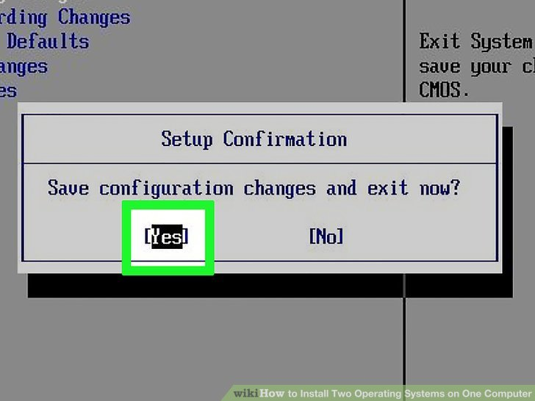

**5 Save your settings.** After making the necessary changes to your BIOS system, locate the option to save your settings. Select the option to save and exit the BIOS to save and reboot your computer.

**Part4 Installing a Second Operating System**

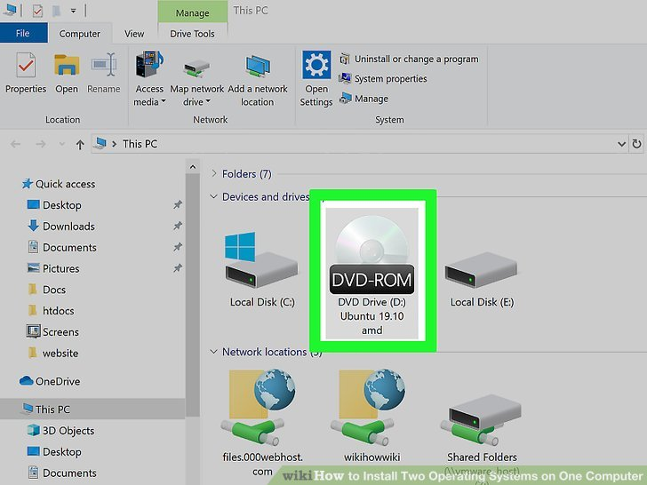

**1 Insert the install disk.** If you used Rufus to create a USB install disk, insert the USB flash drive into an open USB port on your computer. If you are using a CD or DVD install disk, insert it into your CD/DVD Rom drive.

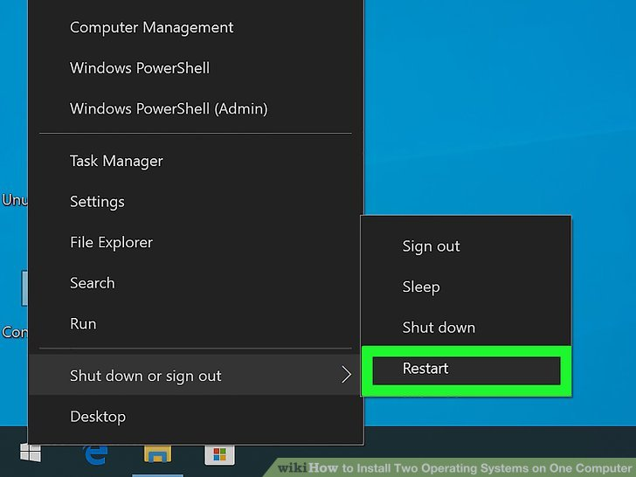

**2 Restart your computer.** If your computer is powered on, go ahead and restart it. Otherwise, press the power button on your computer so that it boots from the install disk.

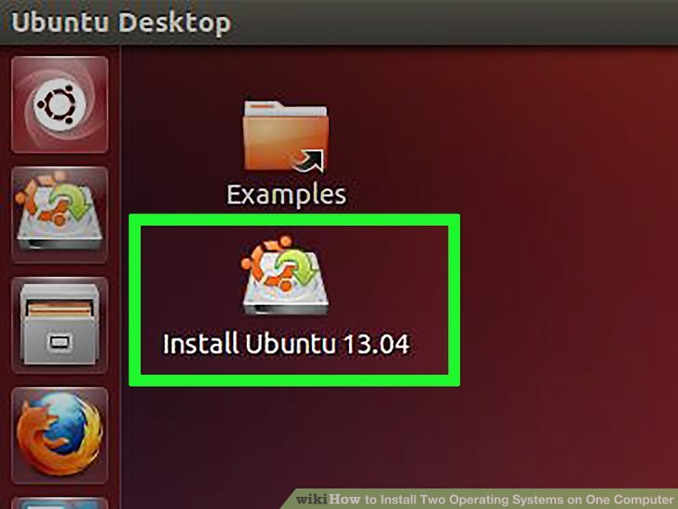

**3 Wait for the setup program to load.** If your computer properly boots from the Install disk, you should see the setup program for the operating system.

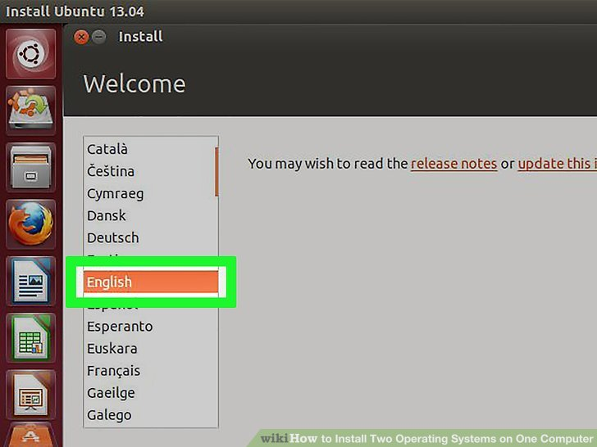

**4 Select your language and keyboard layout.** The setup program for each operating system is a little different. Generally, you will start by selecting your language and keyboard layout.

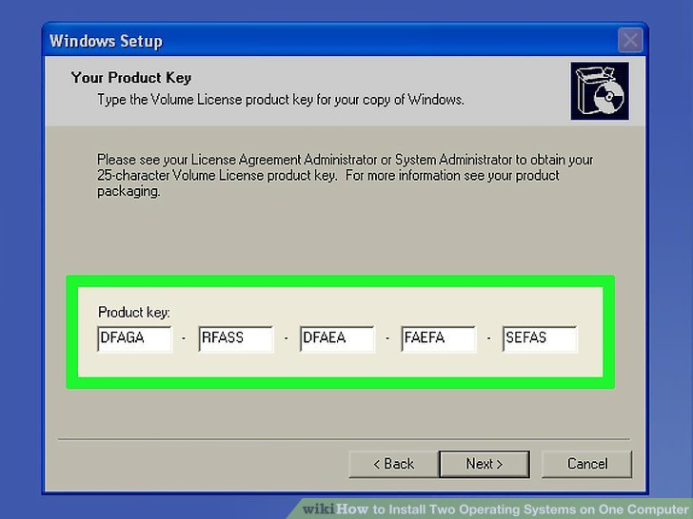

**5 Enter the CD Key or serial number (if needed).** Some operating systems, such as Ubuntu are free to install. Other operating systems, such as Windows, require you to purchase a CD key or serial number. If asked to enter a serial number or CD key, enter the numbers in the space provided.

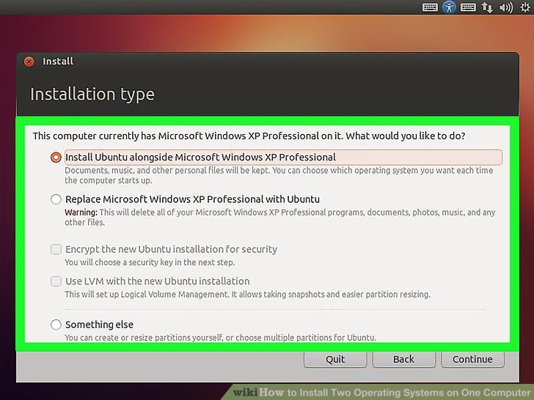

**6 Select the "Custom" or "Other" installation option.** When selecting the installation type, select "Custom", "Other", "Something Else" or similar. Selecting a standard installation may overwrite your current operating system.

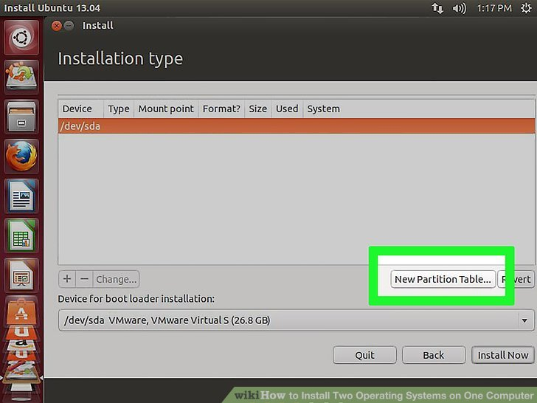

**7 Format the drive you want to install the operating system on.** When installing a new operating system, you will be asked to select which drive you want to install it on and format the drive. Select the unallocated space you partitioned earlier.

* + If you are installing Linux you will need to format the drive as Ext4
  + If you are installing Ubuntu, you will also need to [format a section of the unallocated space as a swap area](https://www.wikihow.com/Dual-Boot-Windows-10-and-Ubuntu-16.04). This area should be equivalent to the amount of RAM you have installed on your computer.

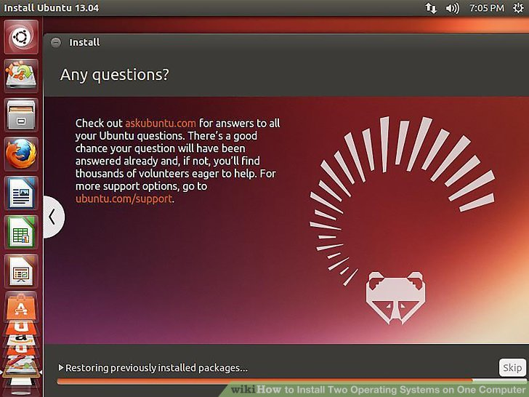

**8 Follow the instructions to complete the installation.** You will most likely be asked to create a username and password for your new operating system as well as set your time & date settings. Follow the instructions to complete the installation.

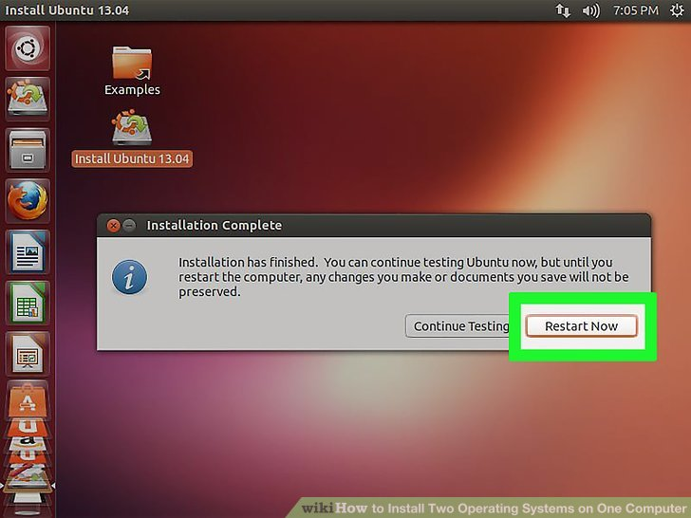

**9 Reboot to switch between operating systems.** Once you install two or more operating systems on your computer, you will see a menu asking which operating system you want to load when you boot up your PC. Restart your computer to switch between operating systems.

**References :** <https://www.wikihow.com/Install-Two-Operating-Systems-on-One-Computer>

**Activity 3**

**Aim:** Install Device Drivers

**Duration:** 2 hours

**Download the driver manually**

To download new drivers, go to PC manufacturer’s website or device manufacturer’s website. Driver updates are often available in the Support section of their website. If you are using a branded computer, it is recommended that you go to the PC manufacturer’s website to check for the latest driver first, as they may customize the driver. You are required to use the **PC model** and the **operating system** that you are using to download the correct driver. Usually, the PC model can be found on the machine. If you need to download the driver from device manufacturer, then you are required to know the device model.

**How to install the driver**

The downloaded driver file will be an executable file (File name ends in “.exe”.) or a zip file (File name ends in “.zip”.).

For executable file, to install the driver, you just need to double-click on the file and follow the on-screen instructions.

For zip file, you need to unzip it and find the executable file in the archive. If you  cannot find an executable file, you need to install the driver step by step using the “.inf” file. Following steps are for your reference how to install the driver in this way.

1. Go to [Device Manager](https://www.drivereasy.com/knowledge/a-common-and-easy-way-to-access-device-manager-in-windows/).

2. Find the device that need to install a driver. (Here let’s take video card for example.)

3. Right-click on the device and select **Update Driver Software…**

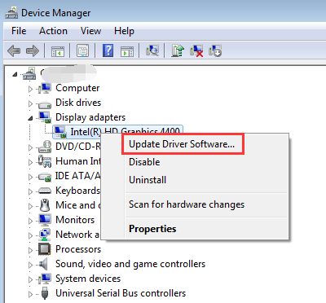

4. Select **Browse my computer for driver software**.

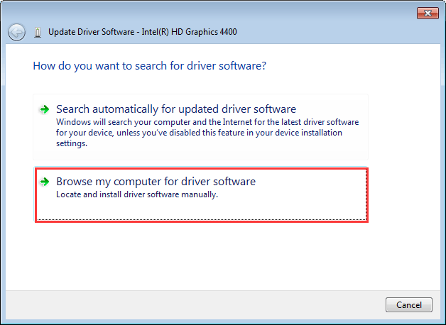

5. Select **Let me pick from a list of device drivers on my computer**.

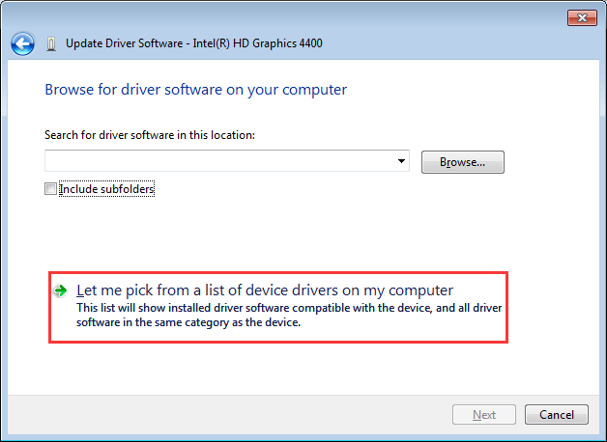

6. Click **Have Disk…** button.

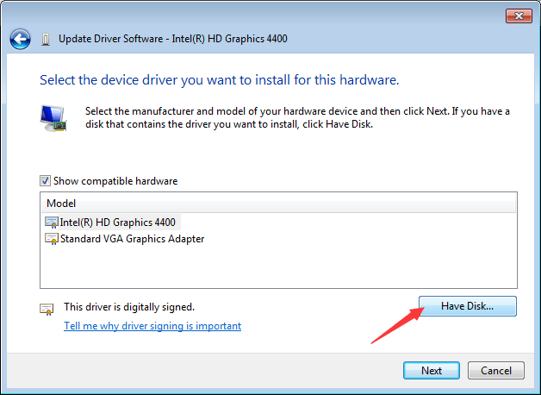

7. Click **Browse…** button. Navigate to the folder where you saved the downloaded driver file and browse the .inf driver file.

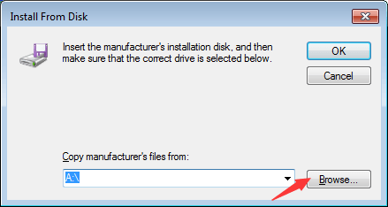

1. Click **OK** button then **Next** button to finish the installation. You might be asked for an admin password or to confirm your choice.

**References**

* <https://www.drivereasy.com/knowledge/how-to-install-drivers/>

**Activity 4**

**Aim:** Install/Uninstall Application software (Office, Multimedia and Antivirus)

**Duration:** 2 hours

**Install Office**

1. Depending on your browser, select **Run** (in Microsoft Edge or Internet Explorer), **Setup** (in Chrome), or **Save File** (in Firefox).

If you see the User Account Control prompt that says, **Do you want to allow this app to make changes to your device?** select **Yes**.

The install begins.

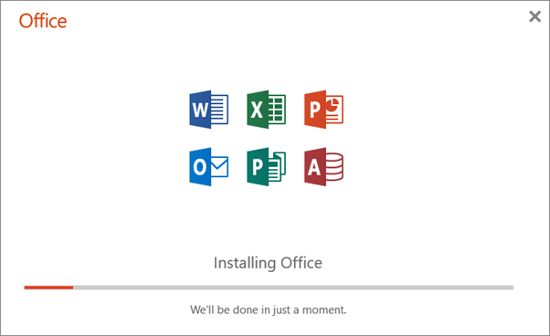

1. Your install is finished when you see the phrase, **"You're all set! Office is installed now"** and an animation plays to show you where to find Office  applications on your computer. Select **Close**.

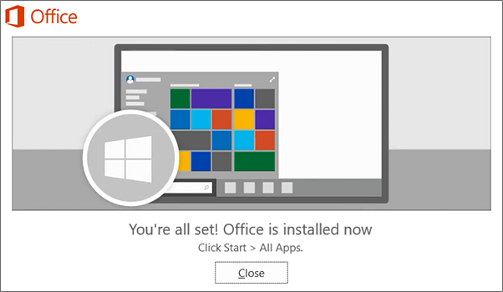

**Installation or sign in issues?**

**Tip:**You can download and install the [Microsoft Support and Recovery Assistant](https://aka.ms/SaRA_OfficeSetup) to help with Microsoft 365 installation issues on a PC. For more information, see [About the Microsoft Support and Recovery Assistant](https://support.microsoft.com/en-us/office/about-the-microsoft-support-and-recovery-assistant-e90bb691-c2a7-4697-a94f-88836856c72f).

If you're having an installation issue such as Office taking long to install, try [Need help?](https://support.microsoft.com/en-us/office/download-and-install-or-reinstall-microsoft-365-or-office-2021-on-a-pc-or-mac-4414eaaf-0478-48be-9c42-23adc4716658#installsteps=need_help) for a list of common issues.

**Activate Office**

1. To open an Office app, select the **Start** button (lower-left corner of your screen) and type the name of an Office app, like **Word**.

If you have Windows 8.1 or 8.0, type the name of an Office app on the **Start** screen. [Can't find your Office apps?](https://support.microsoft.com/en-us/office/can-t-find-office-applications-in-windows-10-windows-8-or-windows-7-907ce545-6ae8-459b-8d9d-de6764a635d6)

1. To open the Office app, select its icon in the search results.
2. When the Office app opens, accept the license agreement. Office is activated and ready to use.

If you have a Click-to-Run or an MSI installation, uninstall Office using the Control Panel or download the uninstall support tool.

**Option 1** - Uninstall Office from the Control Panel

1. Open the Control Panel.

**Tip:**If you installed the Office apps as part of a suite, such as Office Home and Student or Microsoft 365, search for the suite name. For stand-alone apps search by the app name, such as Project or Visio.  
  
In most cases you can't uninstall an individual app if it's included in your Office suite. The only way to uninstall an individual app is if you purchased it as a stand-alone app.

How you open the Control Panel depends on your version of Windows.

**Windows 10**

* 1. In the search box on the task bar, type **control panel**, then select **Control Panel**.
  2. Select **Programs** > **Programs and Features**, then right-click your Microsoft Office product, and choose **Uninstall**.

**Windows 8.1 or 8**

* 1. Right-click the **Start** button  (lower-left corner), and choose **Control Panel**.
  2. Select **Programs and Features**, then right-click your Office product, and choose **Uninstall**.

**Windows 7**

* 1. Click **Start** > **Control Panel**.
  2. Click **Programs** > **Programs and Features**.
  3. Right-click the Office application you want to remove, and then click **Uninstall**.

1. Follow the prompts to complete the uninstall.

**Note:**If Office isn't listed in the Control Panel you could have a [**Microsoft Store installation type**](https://support.microsoft.com/en-us/office/uninstall-office-from-a-pc-9dd49b83-264a-477a-8fcc-2fdf5dbf61d8#bkmk_chkinstall). Select the [Microsoft Store](https://support.microsoft.com/en-us/office/uninstall-office-from-a-pc-9dd49b83-264a-477a-8fcc-2fdf5dbf61d8#officeversion=microsoft_store) tab above and follow those uninstall steps instead.

1. To reinstall Office, select the version you want to reinstall and follow those steps.

**Option 2 -** Completely uninstall Office with the uninstall support tool

1. Select the button below to download the Office uninstall support tool.

[**Download**](https://aka.ms/SaRA-officeUninstallFromPC)

1. Follow the steps to open the download according to your browser, and when you're prompted in the Application Install window, select **Install**, and then **I agree** for the Microsoft Services Agreement.

**Tip:**The tool may take a few minutes to download and install. After completing the installation, the Uninstall Office products window will open.

**Edge or Chrome**

* + In the lower-lower left corner right-click **SetupProd_OffScrub.exe** > **Open**.

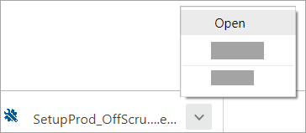

**Edge (older)**

* + At the bottom of the browser window, select **Run** to launch the **SetupProd_OffScrub.exe**.

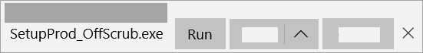

**Firefox**

* + In the pop-up window, select **Save File**and then from the upper-right browser window, select the downloads arrow > **SetupProd_OffScrub.exe**.

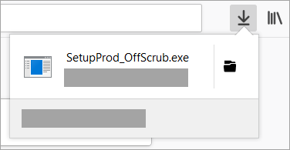

1. From the Uninstall Office products window, select the version of Office you want to uninstall, and then select **Next**.
2. Follow the prompts on the remaining screens and when prompted, restart your computer.

After you restart your computer, the uninstall tool automatically re-opens to complete the final step of the uninstall process. Follow the remaining prompts.

1. If you want to reinstall Office, select the steps for the version you want and follow those steps. Close the uninstall tool.

**Install the antivirus program**

To install an antivirus program on your computer, follow the steps below.

1. If you purchased the antivirus program from a retail store, insert the [CD](https://www.computerhope.com/jargon/c/compactd.htm) or [DVD](https://www.computerhope.com/jargon/d/dvd.htm) into the computer's disc drive. The installation process should start automatically, with a window opening to help guide you through the install process.
2. If you [downloaded](https://www.computerhope.com/jargon/d/download.htm) the antivirus program on the Internet, find the downloaded file on your computer. If the downloaded file is a zip file, [unzip](https://www.computerhope.com/jargon/u/unzip.htm) the file to extract and access the installation files. Look for a file named **setup.exe**, **install.exe**, or something similar, then [double-click](https://www.computerhope.com/jargon/d/doublecl.htm) that file. The installation process should start, with a window opening to help guide you through the install process.
3. In the installation process window, follow the steps provided to install the antivirus program. The install process provides recommended options so the antivirus program will function properly, which in most cases can be accepted as is. The one exception is if the install process recommends to install any toolbars for Internet browsers or other helpful programs for your computer. If prompted to install other software with the antivirus program, uncheck all boxes or decline the install of those extra programs. No additional programs should be needed for the antivirus program to install and run successfully on your computer.
4. When the install process is complete, close out of the install window.
5. If used, remove the CD or DVD from the computer's disc drive.

The antivirus program is now installed and ready to use. While it may not be required, we recommend [restarting](https://www.computerhope.com/jargon/r/reboot.htm) your computer so that any modified settings in the operating system can take effect correctly.

**Update the antivirus program after installation**

Out of the box, antivirus programs are not up-to-date and are missing the latest virus and spyware definitions. Without the latest definitions, the antivirus program will not know about the most recently created viruses and spyware, making your computer vulnerable to an infection.

After installing the antivirus program, we highly recommend you update it with the latest virus and spyware definitions. The updates allow the antivirus program to protect your computer from all viruses and spyware.

In many cases, the antivirus program automatically checks for and installs the latest updates. If prompted to do so, select Yes to update the antivirus program. If it does not prompt you to update immediately.

**Enable automatic updates for the antivirus program**

By default, most antivirus programs enable the automatic update feature. We strongly recommend automatic updates be enabled to keep the antivirus program up-to-date at all times.

To check if automatic updates are enabled in your antivirus program, follow the general steps below.

1. [Open the antivirus program](https://www.computerhope.com/jargon/a/antiviru.htm#open).
2. Look for a **Settings** or **Advanced Settings** button or link in the antivirus program window. If you do not see either option, look for an option like **Updates** or something similar.
3. In the Settings or Updates window, look for an option like **Automatically download and apply updates**. It may also refer to virus definitions instead of updates.
4. For the automatic updates option, check the box for that option, if not already checked.
5. Click the **Save** or **Apply** button to save the settings change.

**Uninstall through the Start menu**

First, try utilizing the built-in uninstall feature of the program by finding the folder for the antivirus program in your Windows [Start menu](https://www.computerhope.com/jargon/s/startmen.htm). To do this, click [Start](https://www.computerhope.com/jargon/s/start.htm), All Programs, and look for the antivirus program in the list of programs.

When you find the antivirus program in the list, locate the uninstall option, which should be in the same folder. If this is available, click the uninstall option and follow the prompts to complete the uninstallation of the antivirus.

**Uninstall through Add or Remove programs**

The second way is to utilize [Add or Remove Programs](https://www.computerhope.com/jargon/a/addremov.htm).

* [Windows Vista, 7, 8, and 10 users.](https://www.computerhope.com/issues/ch001402.htm#win7)
* [Windows XP users.](https://www.computerhope.com/issues/ch001402.htm#winxp)

**Windows Vista, 7, 8, and 10 users**

1. Open the [**Add or Remove Programs**](https://www.computerhope.com/jargon/a/addremov.htm) utility.
2. In the list of installed programs, find the antivirus program and select it by clicking it once with the left [mouse](https://www.computerhope.com/jargon/m/mouse.htm) button. Once the antivirus program is selected, above the column headers, click the Uninstall option as shown in the picture below to initiate the uninstall process.

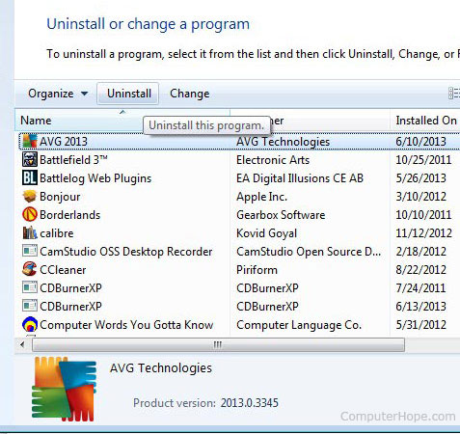

**Note**

Some antivirus programs may be listed several times in the list of programs. Make sure you've uninstalled all associated parts of the antivirus before rebooting the computer or installing another antivirus.

If you're unable to uninstall the antivirus through Add or Remove Programs because of an error, skip to [uninstalling from Safe Mode](https://www.computerhope.com/issues/ch001402.htm#safemode). If the antivirus program is not listed in the Add or Remove Programs, you may have a [bad antivirus install or a rogue antivirus](https://www.computerhope.com/issues/ch001402.htm#bad).

**Windows XP users**

1. Open the [**Add or Remove Programs**](https://www.computerhope.com/jargon/a/addremov.htm).
2. In the list of installed programs, find the antivirus program and select it by clicking it once with the left mouse button. To the right of the program name, click the **Change/Remove** or **Uninstall** button to initiate the uninstall process.

**Note**

Some antivirus programs may be listed several times in the list of programs. Make sure you've uninstalled all associated parts of the antivirus before rebooting the computer or installing another antivirus.

If you're unable to uninstall the antivirus through Add or Remove Programs because of an error, skip to [uninstalling from Safe Mode](https://www.computerhope.com/issues/ch001402.htm#safemode). If the antivirus program is not listed in the Add or Remove Programs, you may have a [bad antivirus install or a rogue antivirus](https://www.computerhope.com/issues/ch001402.htm#bad).

**Uninstalling from Safe Mode**

In some cases, the uninstall process may not be able to proceed because the antivirus program is currently loaded and running in Windows. If the program cannot be disabled, uninstall the antivirus in Windows Safe Mode. In Safe Mode, the antivirus program is not loaded and running, making it possible to uninstall using either method mentioned earlier.

* [How to open Safe Mode.](https://www.computerhope.com/issues/chsafe.htm)

**References**

* <https://support.microsoft.com/en-us/office/download-and-install-or-reinstall-microsoft-365-or-office-2021-on-a-pc-or-mac-4414eaaf-0478-48be-9c42-23adc4716658>
* <https://www.computerhope.com/issues/ch001922.htm>
* <https://www.computerhope.com/issues/ch001402.htm>

# Learning Outcome - Work with Linux Environment

# After completing this module, the student should be able to work with Linux environment by using Linux commands.

To meet the learning outcome, a student has to complete the following activities

1. Read terminal ID using TTY command to know which terminal we are working (1 Hr)
2. Execute the following Linux commands: TTY Command, uname command, Date, cal, Whoami, Man, Pwd, Whatis, Fdisk, Sudo, Ifconfig, Chmod, Umask, Adduser, Ping, Hostname, Dpkg –i (8 Hrs)
3. Execute the following Linux commands: Touch, echo, clear, ls, Dir, Mkdir, Cat, Rmdir, Rm, Cp, Mv, Find, Head, Tail, Tar, Gzip, Bzip2, Alias, Sed, wc, sort. (8 Hrs)

# Activity 1

## Aim: Read terminal ID using TTY command to know which terminal we are working (1 Hr)

**Learning outcome:** Able to work with Linux environment by using Linux commands.

**Duration:** 1 Hour

**List of Hardware/Software requirements:**

1. Computer Desktop/Laptop
2. Linux Operating System

**Code/Program/Procedure (with comments):**

~$ tty [-s, --silent, --quiet] # print nothing, only return an exit status

~$ tty [--help] # display this help and exit

~$ tty [--version] # output version information and exit

~$ tty

**Output/Results snippet:**

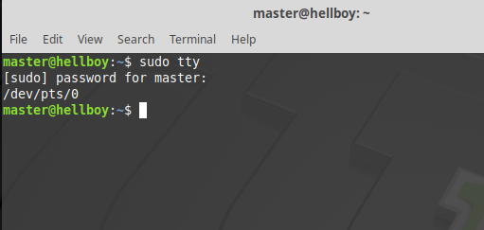

**References:**

* [**https://www.howtoforge.com/linux-tty-command/**](https://www.howtoforge.com/linux-tty-command/)

# Activity 2

## Aim: Execute the following Linux commands: TTY Command, uname command, Date, cal, Whoami, Man, Pwd, Whatis, Fdisk, Sudo, Ifconfig, Chmod, Umask, Adduser, Ping, Hostname, Dpkg –i (8 Hrs)

## Learning outcome: Able to work with Linux environment by using Linux commands.

**Duration:** 8Hours

**List of Hardware/Software requirements:**

1. Computer Desktop/Laptop
2. Linux Operating System

**Code/Program/Procedure (with comments):**

~$ tty # prints the file name of the terminal connected to standard input

~$ uname # prints information about the system

~$ date # display the system date and time

~$ cal # shows current month calendar as output

~$ whoami # displays the username of the current user

~$ pwd # print the full system path of the current working directory to standard output

~$ umask # set permissions mask

~$ hostname # obtain the DNS name and set the system’s hostname or NIS domain name

~$ ping # contains the amount of time it takes for every packet to reach its destination and return

~$ man # It shows the manual pages of the command

~$ whatis # used to get a one-line manual page descriptions

~$ fdisk # It is a command-line partition table editor for Linux

~$ sudo # For any command to be done with administrative or root privileges

~$ ifconfig # Configure the kernel-resident network interfaces

~$ chmod # To make a file executable and to change the permissions granted to it in Linux

~$ adduser # add/create a new user

~$ dpkg -i # sorts through a tree of Debian binary packages and creates a Packages file

**Output/Results snippet:**

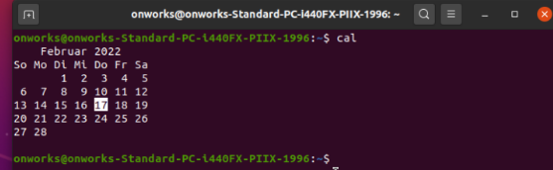

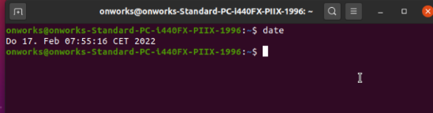

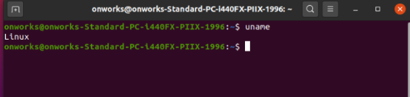

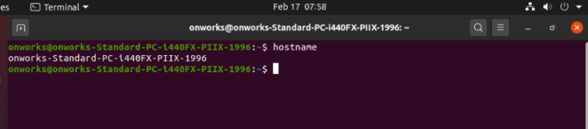

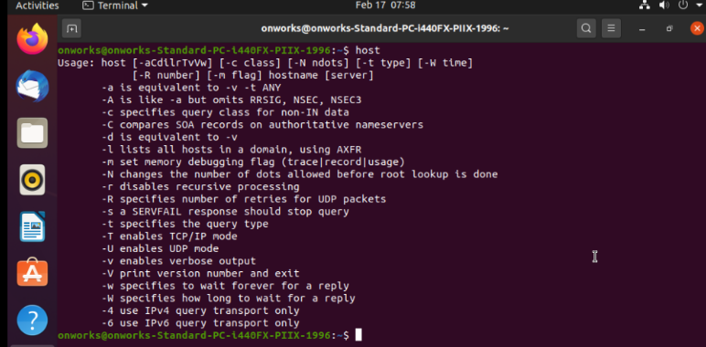

**References:**

* [**https://maker.pro/linux/tutorial/basic-linux-commands-for-beginners**](https://maker.pro/linux/tutorial/basic-linux-commands-for-beginners)

# Activity 3

## Aim: Execute the following Linux commands: touch, echo, clear, ls, Dir, Mkdir, Cat, Rmdir, Rm, Cp, Mv, Find, Head, Tail, Tar, Gzip, Bzip2, Alias, Sed, wc, sort. (8 Hrs)

**Learning outcome:** Able to work with Linux environment by using Linux commands.

**Duration:** 8 Hours

**List of Hardware/Software requirements:**

1. Computer Desktop/Laptop
2. Linux Operating System

**Code/Program/Procedure (with comments):**

~$ touch # create a file without any content

~$ echo # display line of text/string that are passed as an argument

~$ clear # keep screen tidy from filled up commands and outputs of those commands

~$ ls # what files are in the directory you are in

~$ dir # lists the files and folders in columns

~$ mkdir # create a folder or a directory

~$ cat # create a file with any content and display the contents

~$ rmdir # delete an empty directory

~$ rm # delete files and directories

~$ cp # copy files through the command line

~$ mv # move files through the command line

~$ find # find files and directories and perform subsequent operations on them

~$ head # output the first part of files given to it via standard input

~$ tail # output the last part of files given to it via standard input

~$ tar # work with tarballs (or files compressed in a tarball archive) in the Linux command line

~$ Gzip # compresses and decompresses files

~$ Bzip2 # compresses and decompresses files

~$ alias # instructs the shell to replace one string with another string while executing the commands.

~$ sed # perform functions on file like searching, find and replace, insertion or deletion

~$ wc # used for word counting purpose

~$ sort # sort a file, arrange the records in a particular order

**Output/Results snippet:**

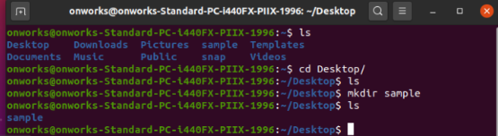

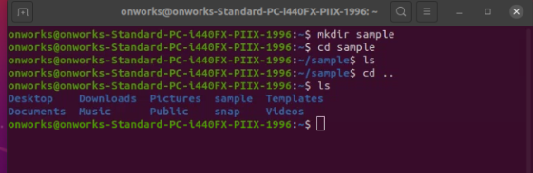

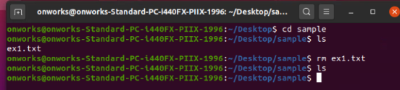

**References:**

* [**https://www.geeksforgeeks.org/linux-commands/**](https://www.geeksforgeeks.org/linux-commands/)

**Learning Outcome - Able to create document, spread sheet and make presentations using open office**

# After completing this module, the student should be able to create document, spread sheet and make presentations using open office.

To meet the learning outcome, a student has to complete the following activities

1. Draw sketches using Paint (2Hrs)
2. Create your resume using edit commands in document (3 Hrs)
3. Create purchase order using tables and images (5 Hrs)
4. Create magazines using columns page borders and header footers (2Hrs)
5. Create an invitation letter using mail merge for n invitees. (3 Hrs)
6. Create mark sheet using spread sheet with data validation (2 Hrs)
7. Create chart for mark sheet (2 Hrs)
8. Create Pay slip using functions and formulae (3 Hrs)
9. Create Pivot table/chart for inventory management (4 Hrs)
10. Create Presentation by inserting charts, tables and images about organization (3 Hrs)

# Activity 1

## Aim: Draw sketches using Paint (2 Hrs)

**Learning outcome:** Able to create document spread sheet and make presentation using open office

**Duration:** 2 hour

**List of Hardware/Software requirements:**

1. Computer Desktop/Laptop
2. Windows Operating System
3. Open Office

**Code/Program/Procedure (with comments):**

To use an Open Office drawing tool:

Step 1: Click in the document where you want the drawing to be anchored. You can change the anchor later, if necessary.

Step 2: Select the tool from the Drawing toolbar. The mouse pointer changes to a drawing-functions pointer DrawFunctIcon.png.

Step 3: Move the cross-hair pointer to the place in the document where you want the graphic to appear and then click-and-drag to create the drawing object. Release the mouse button. The selected drawing function remains active, so you can draw another object of the same type.

Step 4: To cancel the selected drawing function, press the Esc key or click on the Select icon (the arrow) on the Drawing toolbar.

Step 5:You can now change the properties (fill color, line type and weight, anchoring, and others) of the drawing object using either the Drawing Object Properties toolbar or the choices and dialog boxes reached by right-clicking on the drawing object.

**Output/Results snippet:**

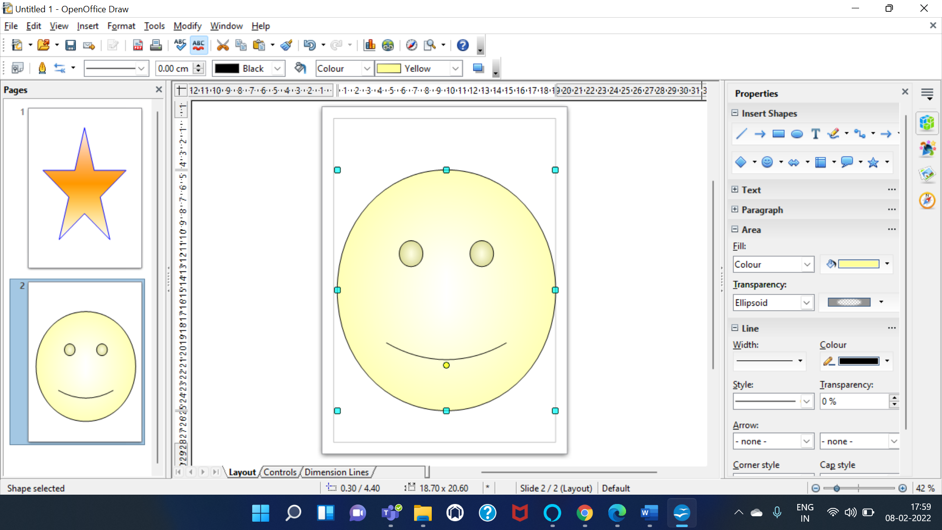

**References:**

* <https://www.openoffice.org/product/draw.html>

# Activity 2

## Aim: Create your resume using edit commands in document (3 Hrs)

**Learning outcome:** Able to create document spread sheet and make presentation using open office

**Duration:** 3 hour

**List of Hardware/Software requirements:**

1. Computer Desktop/Laptop
2. Windows Operating System
3. Open Office

**Code/Program/Procedure (with comments):**

Create a list of the facts you want to include on you resume.

Step 1: Click on the OpenOffice shortcut and from the listed options choose the Writer application.

Step 2: When it opens select "File," click "New" and click "Templates and Documents."

Step 3: Browse though the ones listed and examine the previews.

Step 4: Select the one that best matches your information and click "Open."

Step 5: Adjust the settings of the template if you wish, such as the margins, text color or font size.

Step 6: You might want to use an entirely different font style, in which case highlight the text in the area you want to change, click at the top to view the available fonts and select the one you want.

Step 7: Replace the information in the template with your own.

Step 8: When you are done select "File" and click "Save." Name the file and click "Save."

Step 9: Print out your resume out on stiff, quality paper.

**Output/Results snippet:**

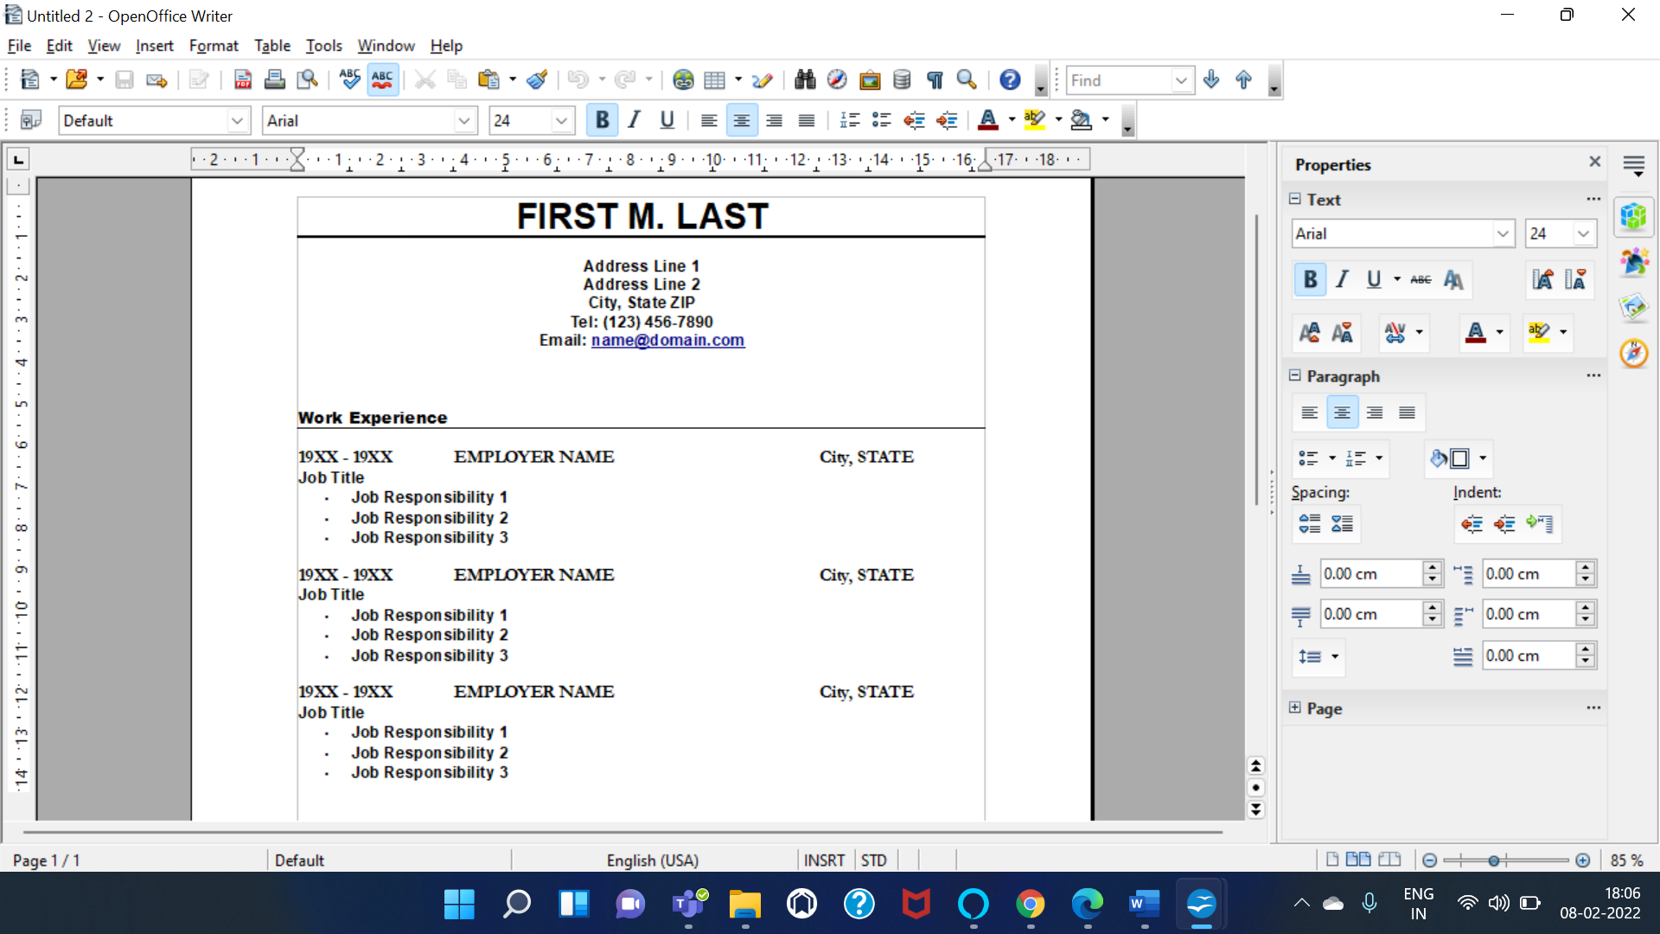

**References:**

* <https://www.openoffice.org/documentation/manuals/oooauthors/working_with_templates.pdf>

# Activity 3

## Aim: Create purchase order using tables and images (5 Hrs)

**Learning outcome:** Able to create document spread sheet and make presentation using open office

**Duration:** 5 hour

**List of Hardware/Software requirements:**

1. Computer Desktop/Laptop
2. Windows Operating System
3. Open Office

**Code/Program/Procedure (with comments):**

* To insert a new table to create a purchase order, position the cursor where you want the table to appear, then use any of the following methods to open the Insert Table dialog box:
* From the main menu, select Table > Insert > Table.
* Press Control+F12.
* From the Standard toolbar, click the Table icon 
* You can create tables within tables, nested to a depth only limited by imagination and practicality.
* Simply click in a cell of an existing table and use any of the methods mentioned in Inserting a new table above.
* It is possible to create a table starting from plain text by means of the Table > Convert > Text to Table menu.
* In order for this command to work effectively, the starting text needs to have clear demarcation between what will become the columns of the table. Paragraph marks indicate the end of a row.
* To convert text to a table, start by selecting the text you want to convert and select Table > Convert > Text to Table to open the dialog box shown below.
* Then create the purchase order table for the desired data.

**Output/Results snippet:**

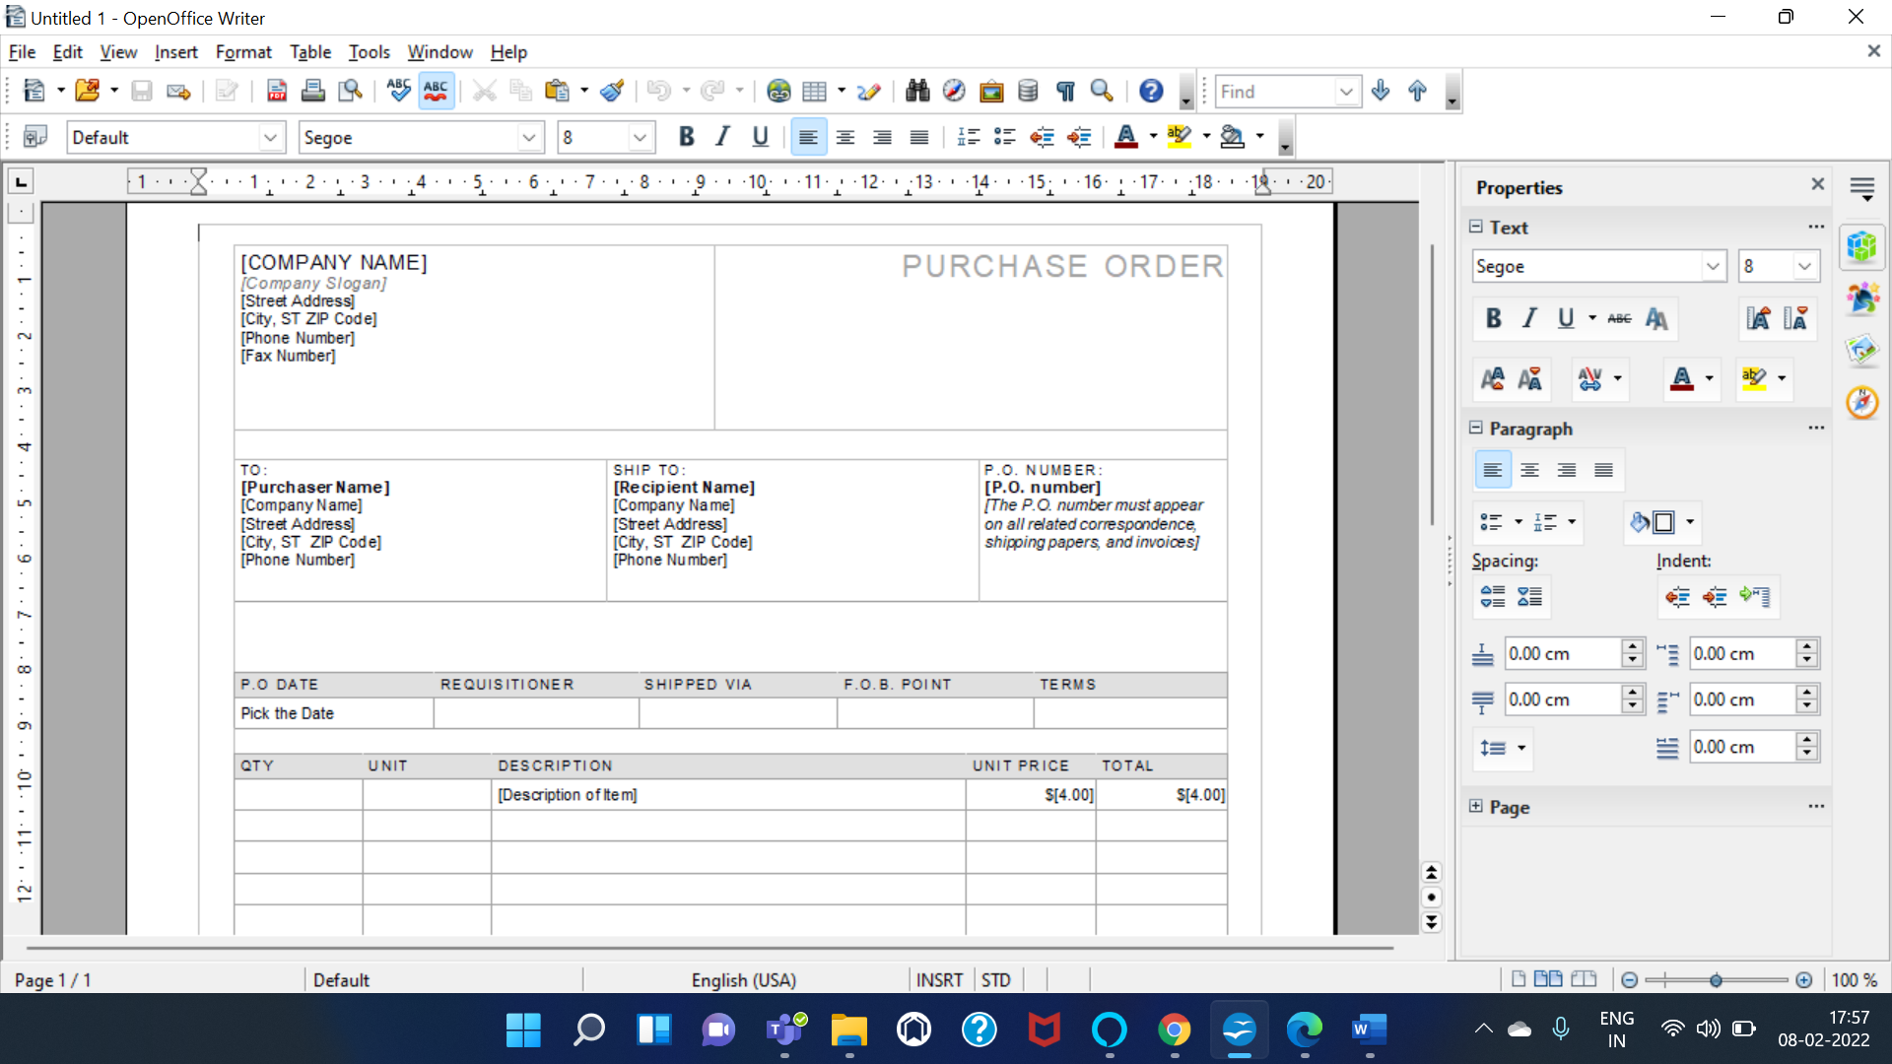

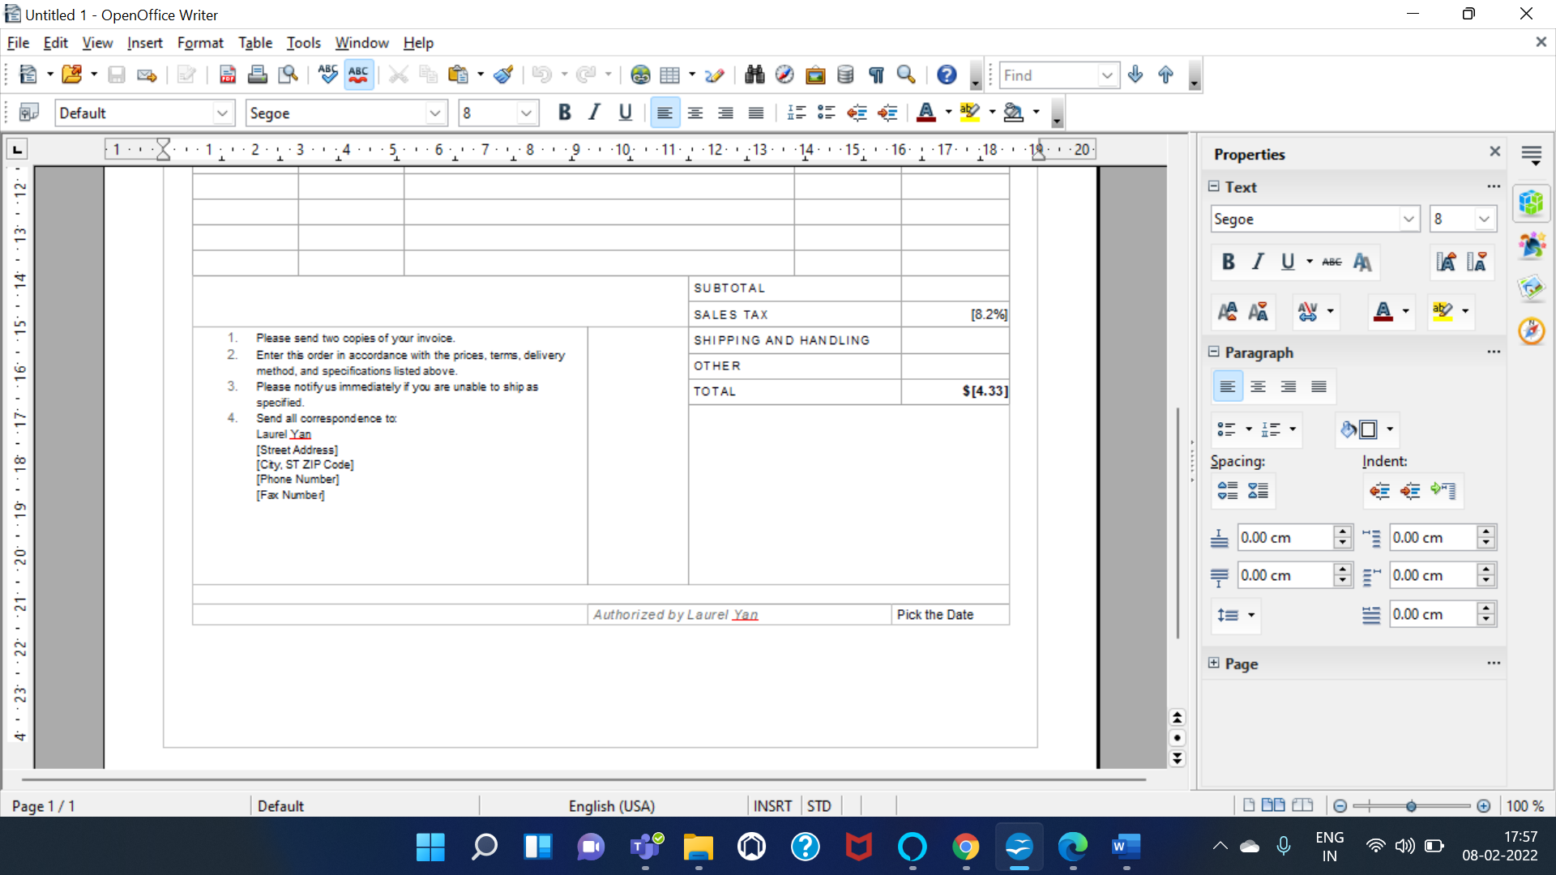

**References:**

* <https://wiki.openoffice.org/wiki/Documentation/OOo3_User_Guides/Writer_Guide/Creating_a_table>

# Activity 4

## Aim: Create magazine using columns page borders, header footers (2 Hrs)

**Learning outcome:** Able to create document spread sheet and make presentation using open office

**Duration:** 2 hour

**List of Hardware/Software requirements:**

1. Computer Desktop/Laptop
2. Windows Operating System
3. Open Office

**Code/Program/Procedure (with comments):**

we will insert a header in the Default pages using manual formatting.

* Select from the main menu Insert > Header > [Page Style]. The submenu contains as many entries as page styles used in your document. In addition the submenu includes the entry All, which activates headers on all the pages of the document.
* Similarly, to insert a footer, choose Insert > Footer.
* Depending on which option you choose, an area will appear at the top or bottom of the page. In this area you can enter text and graphics that will appear on every page.
* Items such as document titles, chapter titles, and page numbers, which often go into headers and footers, are best added as fields. That way, if something changes, the headers and footers are all updated automatically.

**Output/Results snippet:**

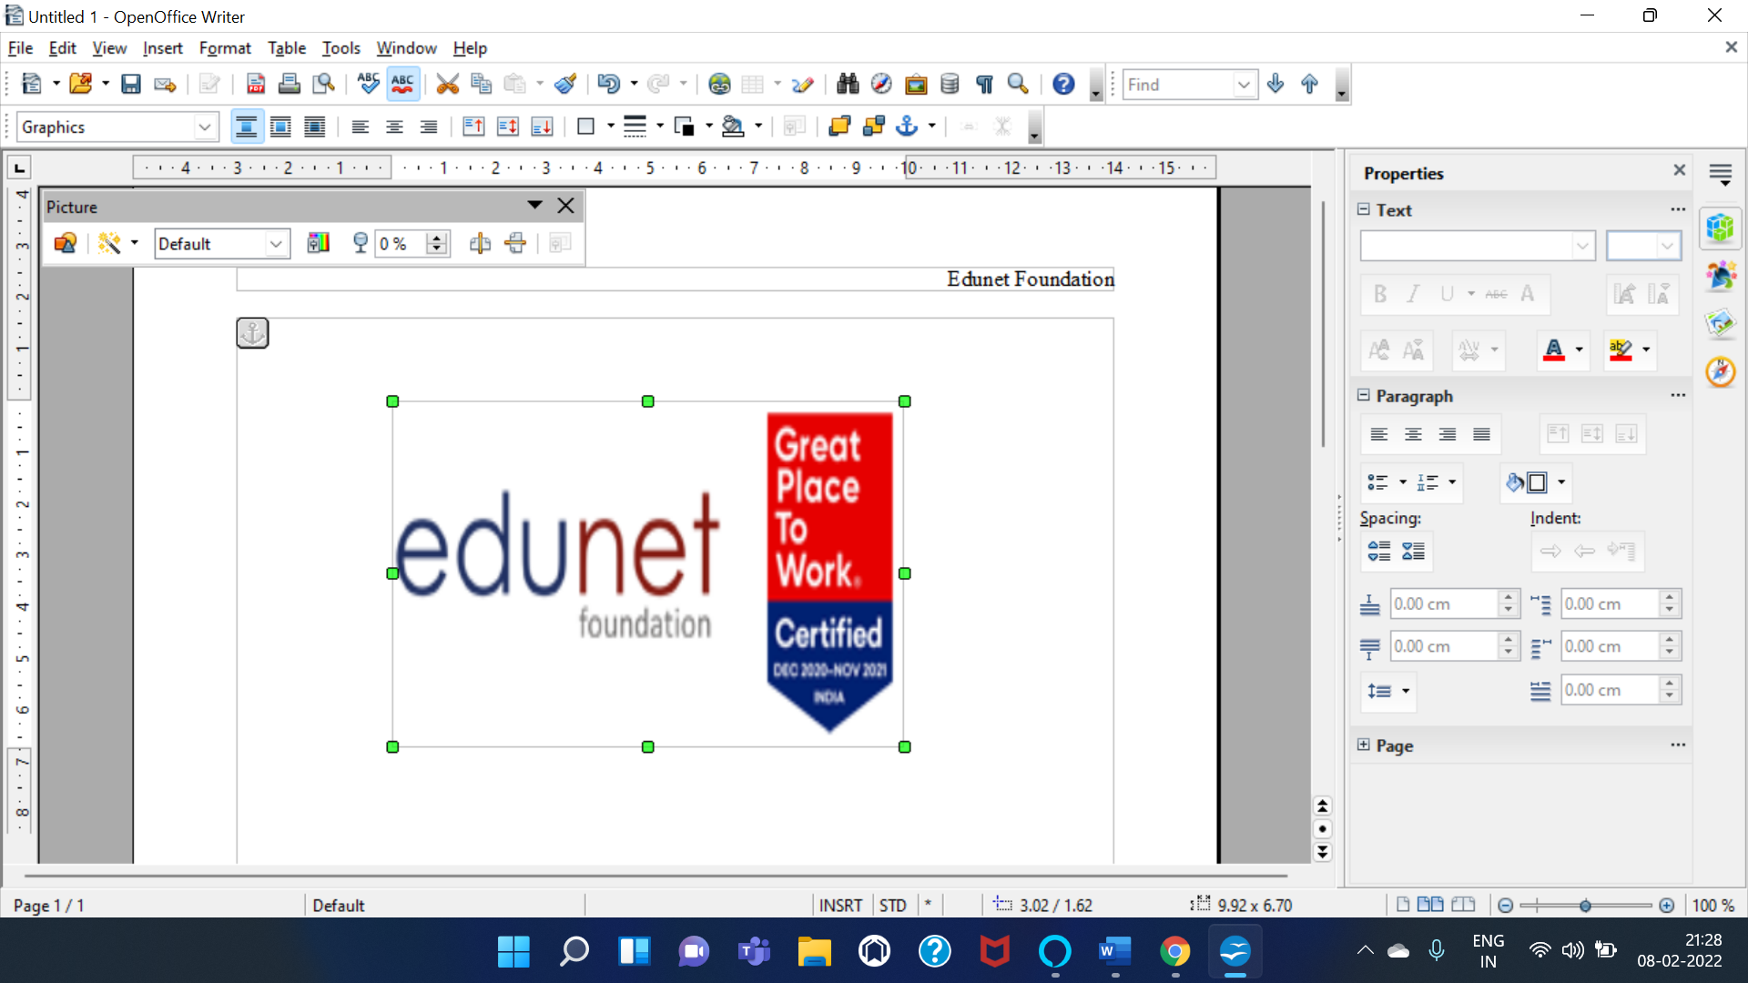

**References:**

* <https://www.linuxtopia.org/online_books/office_guides/openoffice_3_writer_user_guide/openoffice_writer_Creating_headers_and_footers.html>

# Activity 5

## Aim: Create an invitation letter using mail merge for n invitees (3 Hrs)

**Learning outcome:** Able to create document spread sheet and make presentation using open office

**Duration:** 3 hour

**List of Hardware/Software requirements:**

1. Computer Desktop/Laptop
2. Windows Operating System
3. Open Office

**Code/Program/Procedure (with comments):**

Everything you can do in the mail merge wizard, you can pretty much do in the roll-your-own approach, except an email mail merge.

* Create your email the way you want it with the roll-your-own approach.
* Save it. But keep it open.
* In Writer set up email configuration. Choose Tools > Options > OpenOffice.org Writer > Email. Key settings are the outgoing server name and the port number. You just need to do this once. If you have security on your email, like requiring a password to send, you will have to click the Server Authentication button and enter additional information.
* Choose Tools > Mail Merge Wizard and check Use the Current Document. Or else browse to your document, and click Next.
* Choose E-mail message and click Next.
* Select the database you are using and the table. Click OK and click Next.
* Keep clicking Next until you are here. Fill it in by selecting the field from the database that has the emails in it, and anything else you want. Click Send Documents.

**Output/Results snippet:**

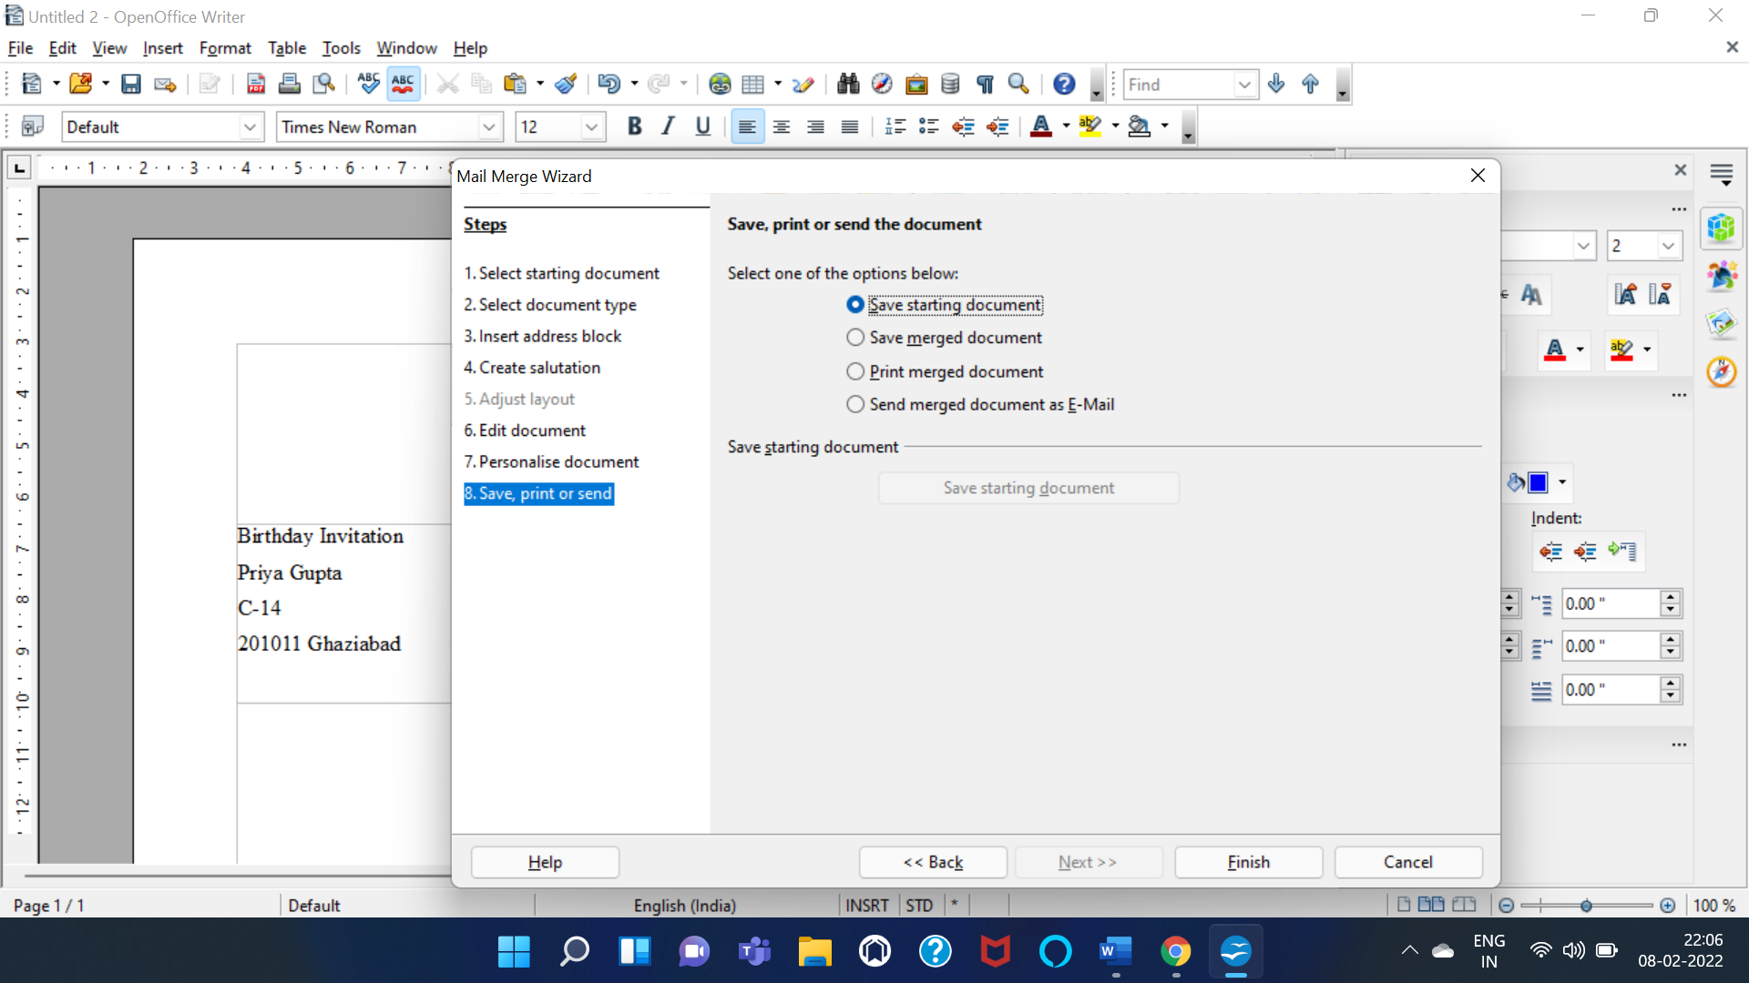

**References:**

* <https://www.openoffice.org/documentation/manuals/userguide3/0200WG3-WriterGuide.pdf>

# Activity 6

## Aim: Create marksheet using spreadsheet with data validation.

**Learning outcome:** Able to create document, spread sheets and make presentations using open office.

**Duration:** 2 hours

**List of Hardware/Software requirements:**

1. Computer Desktop/Laptop
2. Windows Operating system
3. Open Office

**Code/Program/Procedure (with comments):**

1. First open OpenOffice Spreadsheet from start menu in all programs.
2. Click on new from file menu to create a new spreadsheet.
3. Fill the data/information in various rows and columns by selecting the rows and columns one by one.
4. If we need to find sum, average then enter various entries in columns and rows.
5. To find sum enter syntax [=sum] and select the cells of which we need to find sum.
6. Similarly for average we use syntax[=average] and the starting cell separated by colon and ending cell. This will find the average of cells.
7. After creating the worksheet, we need to save it by clicking on file tab and save option in it.
8. Type the name we want to give to sheet and click on save button.
9. In this way we create a marksheet in spreadsheet.

**Output/Results snippet:**

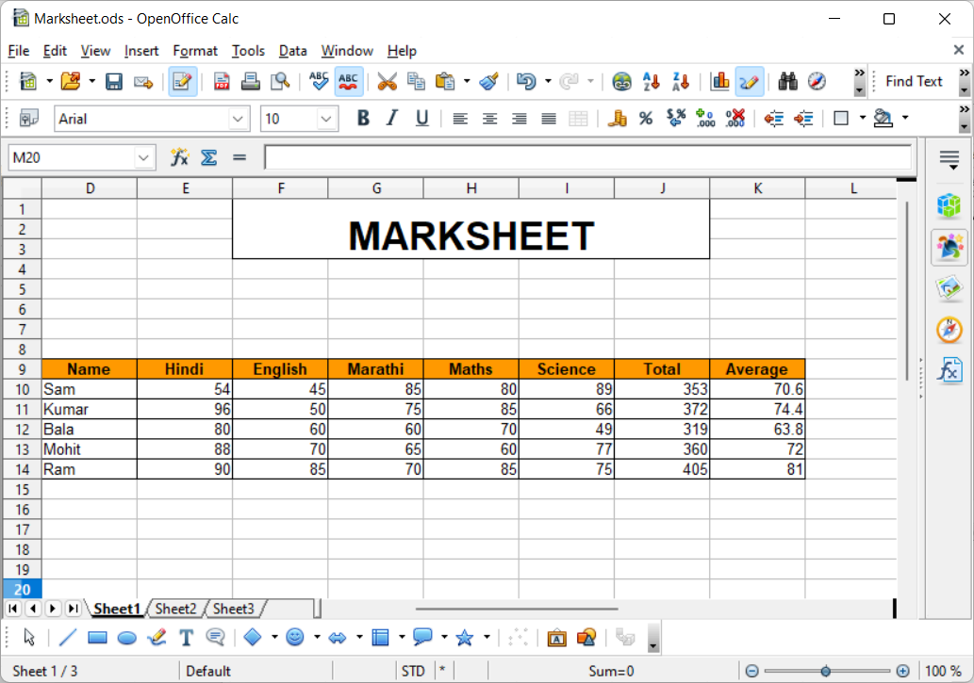

**References:**

* https://www.youtube.com/watch?v=UD9CLxT1i78.

# Activity 7

## Aim: Create chart for mark sheet.

**Learning outcome:** Able to create document, spread sheets and make presentations using open office.

**Duration:** 2 hours

**List of Hardware/Software requirements:**

1. Computer Desktop/Laptop
2. Windows Operating system
3. Open Office

**Code/Program/Procedure (with comments):**

1. Select the data for which you want to create a chart.
2. Next, open the Chart Wizard dialog using one of two methods.

* Select Insert > Chart from the menu bar.
* Or, click the Chart icon on the main toolbar.

1. On the Recommended Charts tab, scroll through the list of charts that is recommends for your data, and click any chart to see how your data will look.
2. If you don’t see a chart you like, click All Charts to see all the available chart types.
3. When you find the chart you like, click it > OK.
4. Use the Data Range, Data Series, Chart Element tabs to add chart elements like axis titles or data labels, customize the look of your chart, or change the data that is shown in the chart.
5. To access additional design and formatting features, click anywhere in the chart to add the CHART TOOLS to the ribbon, and then click the options you want on the DESIGN and FORMAT tabs.

**Output/Results snippet:**

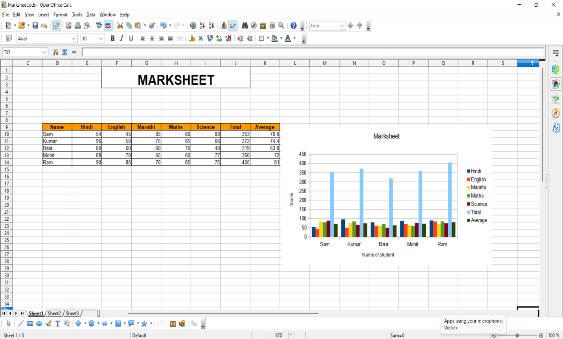

**References:**

* https://wiki.openoffice.org/wiki/Documentation/OOo3_User_Guides/Calc_Guide/Creating_a_chart

# Activity 8

## Aim: Create Pay slip using functions and formulae

**Learning outcome:** Able to create document, spread sheets and make presentations using open office.

**Duration:** 3 hours

**List of Hardware/Software requirements:**

1. Computer Desktop/Laptop
2. Windows Operating system
3. Open Office

**Code/Program/Procedure (with comments):**

**Step 1:** Open a new blank spreadsheet. Go to Search Box. Type “OpenOffice” and click on “Spreadsheet”.

**Step 2:** Save the file on the location you want your payroll to be saved so that it does not get lost and you will always have it with you.

**Step 3:** In this newly created file where all your employee payroll information would be stored, therefore, create some column with names which can hold the values for the certain parameters/variables. Enter the column names in the following hierarchy.

* **Employee Name (column A):** Contains your employee name.
* **Pay/Hour (column B):** Contains per hour pay rate to the employee without any currency symbol.
* **Total Hours Worked (column C):** Contains total hours worked by an employee in a day.
* **Overtime/Hour (column D):** Overtime rate per hour without any currency symbol.
* **Total Overtime Hours (Column E):** Number of hours employees’ overtime in a day.
* **Gross Pay (column F):** Payable amount to the employee without any deductibles.
* **Income Tax (column G):** Tax payable on Gross Pay.
* **Other Deductibles (If Any) (column H):** Deductibles other than Income Tax.
* **Net Pay (column I):** Payment the employee will receive in hand after all the deductions.

**Step 4:** Add the details column-wise like Employee Name in column A, a number of hours worked and hourly paying rate, etc. I will say input the fields with no formula (From column A to column E). See the screenshot below for better understanding.

In this example, if you can see the Total Hours Worked and Total Overtime Hours are considered on a monthly basis (because we pay the employee on a monthly basis, right?). Therefore 160 means total hours worked during the month. Same is the case with total hours overtimed. Also, the Pay/Hour and Overtime/Hour are in USD.

**Step 5:** Formulate Gross Pay. Gross Pay is nothing but the sum of the product of Pay/Hour, Total Worked Hours and Overtime/Hour, Total Overtime Hours. (Pay/Hour * Total Hours Worked) + (Overtime/Hour * Total Overtime Hours). In the payroll sheet, it can be formulated under cell F4 as =(B2*C2)+(D2*E2). It’s a simple formula anyway. However, you can see the screenshot below for a better understanding.

**Step 6:** In order to calculate the Income Tax, you need to check how much percentage of tax your employee pays on the total gross pay. Income Tax is always calculated on Gross Pay. In this case, we will consider 15% of Income-tax on all the Gross Pay. The formula for Income Tax, therefore, becomes as – 0.15 * Gross Pay.

**Step 7:** You have to mention other deductibles if any for a particular employee. These deductibles may contain the premium of health/life insurance, professional taxes, EMI amount if any loan is taken from an organization, etc. add these amount values under column H. If there is no other deductible for a particular employee, you can set the value under column H for that employee to zero.

**Step 8:** Now, finally we come towards Net Pay. Net Pay is nothing but the amount that gets credited into your employee’s bank account after all the deductions from Gross Pay. Therefore, in this case, we will deduct (subtract) Income Tax (column G) and Other Deductibles (Column H) which can be formulated under cell I2 as =F2-(G2+H2). Here, Income Tax and Other Deductibles are summed up and then subtracted from Gross Pay. See the screenshot below for better understanding.

**Step 9:** Add all the employee names working for you in this payroll one by one and set their total worked hours, overtimed hours, deductibles and charges accordingly. For Gross Pay, Income Tax and Net Pay, just drag the 4th cell of respective columns to have the details formulated. Also, add some formatting to the cells and add total at the end of the sheet.

**Output/Results snippet:**

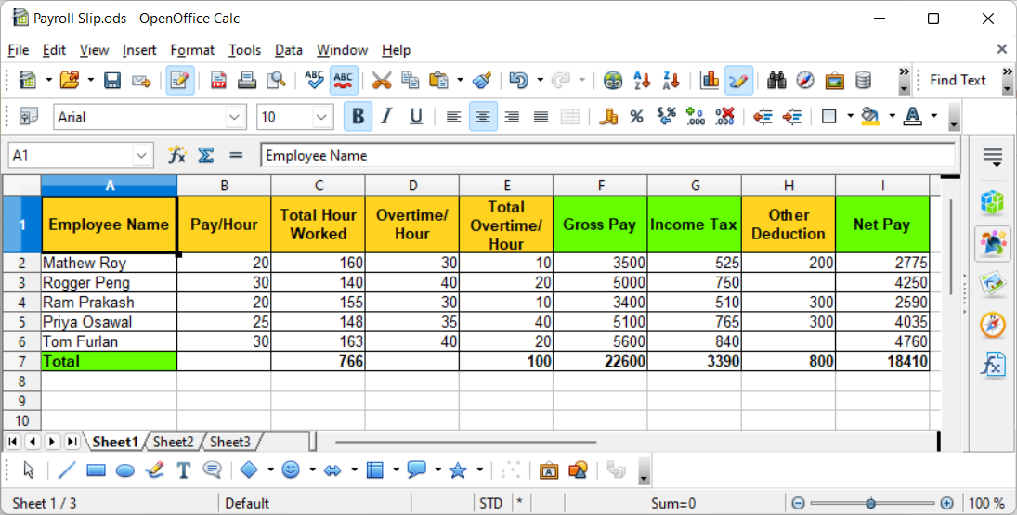

**References:**

* <https://www.educba.com/payroll-in-excel/>

# Activity 9

## Aim: Create Pivot table/chart for inventory management.

**Learning outcome:** Able to create document, spread sheets and make presentations using open **office.**

**Duration:** 4 hours

**List of Hardware/Software requirements:**

1. Computer Desktop/Laptop
2. Windows Operating system
3. Open Office

**Code/Program/Procedure (with comments):**

1. Open a new spreadsheet in OpenOffice Spreadsheet.
2. Name your headings

The first information you need to input into the spreadsheet is the heading for each column. You can customize your headings based on the type of business you are managing and your inventory management priorities. Common headings include:

* Item Name
* Serial Number
* Cost Per Unit
* Number of Units in Stock
* Sale Price
* Minimum Order Quantity
* Order Time
* Supplier

1. Enter items and their corresponding information.
2. Save the sheet and update during inventory
3. To create Inventory Pivot Table, select 'Data', Choose 'Pivot Tables', Click on Create.
4. Choose the Selection and click on Ok.
5. Choose the layout and click ok.
6. Customize your Pivot Table as needed.

**Output/Results snippet:**

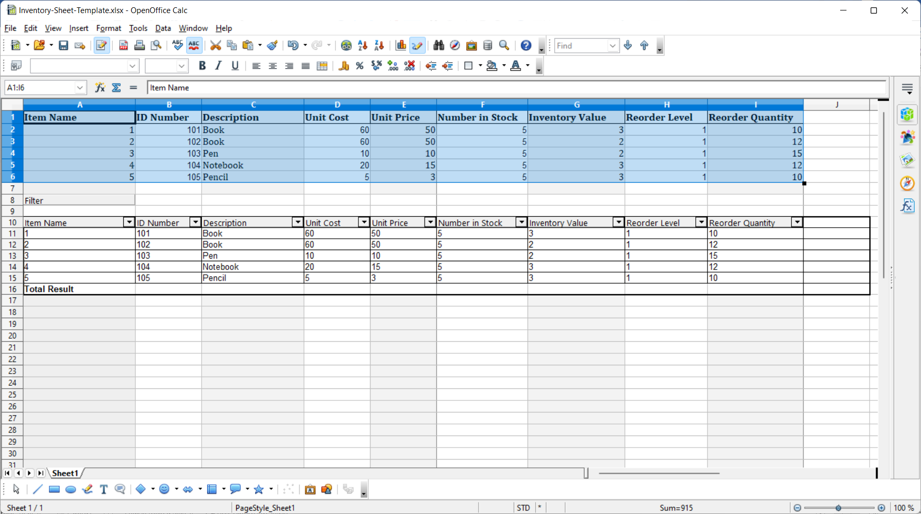

**References:**

* https://www.thesmbguide.com/inventory-sheet#how-to-create-an-inventory-sheet

# Activity 10

## Aim: Create Presentation by inserting charts, tables and images about organization.

**Learning outcome:** Able to create document, spread sheets and make presentations using open office.

**Duration:** 4 hours

**List of Hardware/Software requirements:**

1. Computer Desktop/Laptop
2. Windows Operating system
3. Open Office

**Code/Program/Procedure (with comments):**

**Step1:** Open a new blank Presentation. Go to Search Box. Type “OpenOffice” and click on “Presentation”.

Step 2: Save the file on the location you want your payroll to be saved so that it does not get lost and you will always have it with you.

**Step3:** To Insert Picture in presentation:

Click “insert” choose “pictures” select picture from the location.

**Step 4:** To insert Table into presentation:

Click “Insert” select Table add number of Row’s and Column’s and click on OK.

**Step5:** To insert Chart into presentation:

Click “Insert” select Charts add X- Axis, Y-Axis and Title to the chart.

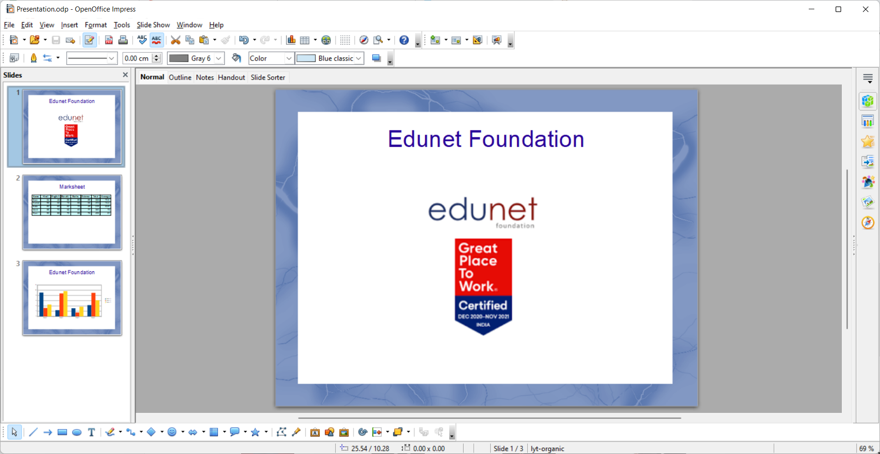

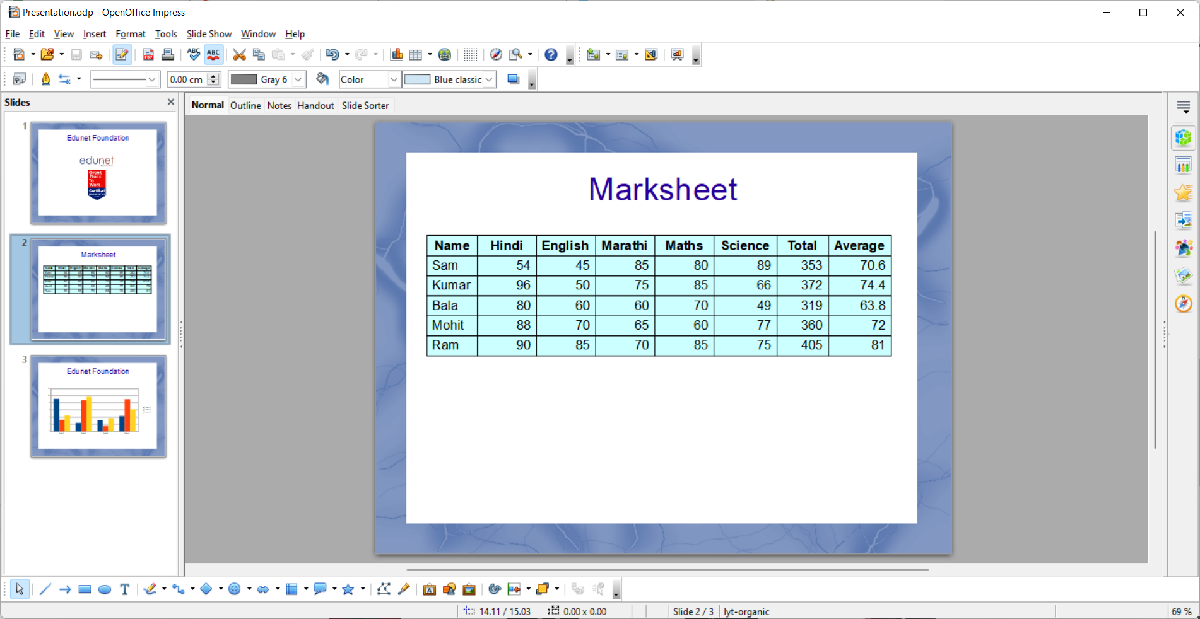

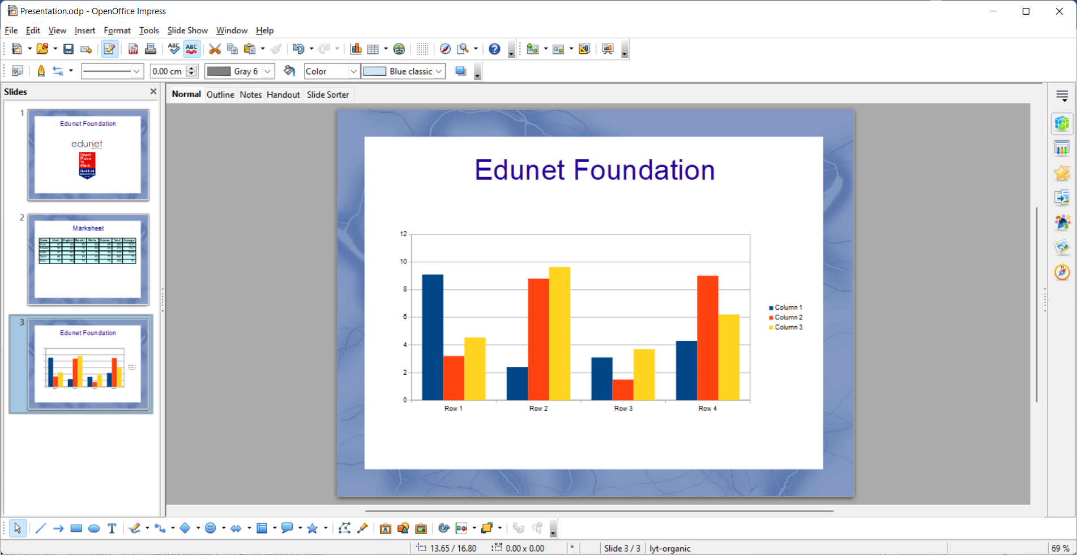

**References:**

* https://www.brainkart.com/article/Inserting-tables-and-charts---OpenOffice-presentation_36816/

# Learning Outcome - Able to install and maintain software for a PC.

# After achieving this learning outcome, a student will be able to install and maintain software for a PC.

To meet the learning outcome, a student has to complete the following activities

1. Prepare Hard disk for OS installation by making partitions (2 Hrs)
2. Install Operating System Windows and Linux in two different partitions (2 Hrs)
3. Install Device Drivers (2 Hrs)
4. Install/Uninstall Application software (Office, Multimedia and Antivirus) (2Hr)

**Activity 1**

**Aim:** Prepare Hard disk for OS installation by making partitions

**Learning outcome:** Able to install and maintain software for a PC.

**Duration: 2** hours

**List of Hardware/Software requirements:**

● PC with Complete Hardware Setup

● PC with Pre- Installed Operating System (Windows)

**Code/Program/Procedure (with comments):**

Partitioning the drive in Windows means to section off a part of it and make that part available to the operating system.

**Windows 10 and 11**

To create a partition from un-partitioned space follow these steps:

1. Right-click This PC and select Manage.
2. Open Disk Management
3. Select the disk from which you want to make a partition.
4. Right-click the Un-partitioned space in the bottom pane and select New Simple Volume.
5. Enter the size and click next, and you are done.

**Windows 8 and 8.1**

To create a partition from unpartitioned space follow these steps:

1. Hold the Windows key on your keyboard and press R.
2. This launches the Run the utility. Type diskmgmt.msc inside the text box and press Enter. This opens the Windows Disk Management utility.
3. To create unallocated space, you need to shrink your hard drive. When you shrink your hard disk, the remaining space becomes unallocated.
4. To do this, right-click your main drive and select Shrink Volume
5. Now you need to enter the amount you want to shrink the hard disk by in megabytes
6. After the Shrink is done, you will then see the region of unallocated space (shaded black). Remember, this space is not yet usable.
7. Right-click the region of unallocated space and select New Simple Volume.
8. This launches the New Simple Volume Wizard. This guides you through the installation process.
9. Assign the disk a drive letter. You can choose any drive letter that is not currently in use.
10. Select a file system for the disk. The file system is basically the type of format or foundation the storage device has. If you plan on installing a Windows operating system to the partition select the NTFS file system.
11. Name the partition in the Volume Label text box. You can choose any name for your partition.
12. Now click Finish to create the new partition.

**Activity 2**

**Aim:** Install Operating System Windows and Linux in two different partitions

**Learning outcome:** Able to install and maintain software for a PC.

**Duration: 2** hours

**List of Hardware/Software requirements:**

● PC with Complete Hardware Setup

**Code/Program/Procedure (with comments):**

Set up your computer to boot into Windows 10 or Ubuntu 18.04 as needed. Before you get started, make sure you've backed up your computer.

**Prerequisites**

To get started, you will need the following five items:

**1. Two USB flash drives (or DVD-Rs)**

I recommend installing Windows and Ubuntu via flash drives since they're faster than DVDs. It probably goes without saying, but creating bootable media erases everything on the flash drive. Therefore, make sure the flash drives are empty or contain data you don't care about losing.

If your machine doesn't support booting from USB, you can create DVD media instead. Unfortunately, because no two computers seem to have the same DVD-burning software, I can't walk you through that process. However, if your DVD-burning application has an option to burn from an ISO image, that's the option you need.

**2. A Windows 10 license**

If Windows 10 came with your PC, the license will be built into the computer, so you don't need to worry about entering it during installation. If you bought the retail edition, you should have a product key, which you will need to enter during the installation process.

**3. Windows 10 Media Creation Tool**

Download and launch the Windows 10 Media Creation Tool. Once you launch the tool, it will walk you through the steps required to create the Windows media on a USB or DVD-R. Note: Even if you already have Windows 10 installed, it's a good idea to create bootable media anyway, just in case something goes wrong and you need to reinstall it.

**4. Ubuntu installation media**

Download the Ubuntu ISO image.

Install Windows and Ubuntu

You should be ready to begin. At this point, you should have accomplished the following:

* Backed up your important files
* Created Windows installation media
* Created Ubuntu installation media

There are two ways of going about the installation. First, if you already have Windows 10 installed, you can have the Ubuntu installer resize the partition, and the installation will proceed in the empty space. Or, if you haven't installed Windows 10, install it on a smaller partition you can set up during the installation process. (I'll describe how to do that below.) The second way is preferred and less error-prone. There's a good chance you won't have any issues either way, but installing Windows manually and giving it a smaller partition, then installing Ubuntu, is the easiest way to go.

If you already have Windows 10 on your computer, skip the following Windows installation instructions and proceed to Installing Ubuntu.

**Installing Windows**

Insert the Windows installation media you created into your computer and boot from it. How you do this depends on your computer, but most have a key you can press to initiate the boot menu. On a Dell PC for example, that key is F12. If the flash drive doesn't show up as an option, you may need to restart the computer. Sometimes it will show up only if you've inserted the media before turning on the computer. If you see a message like, "press any key to boot from the installation media," press a key. You should see the following screen. Select your language and keyboard style and click Next.

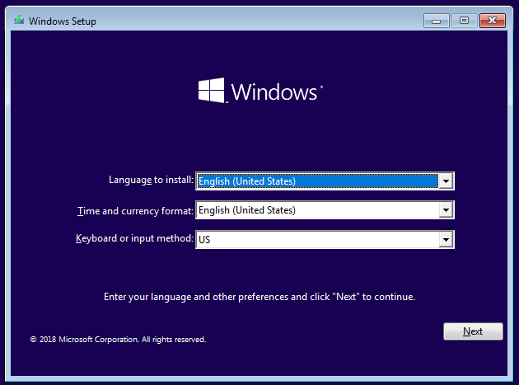

**Windows setup**

Click on Install now to start the Windows installer.

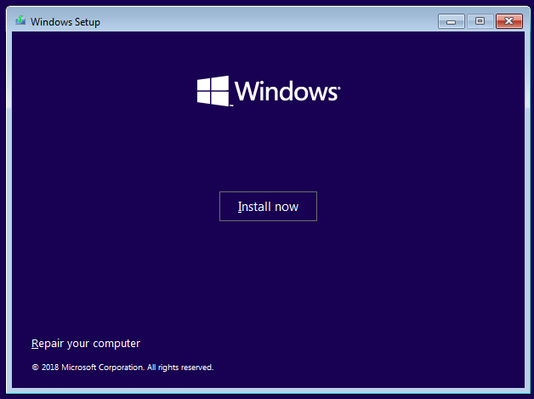

**Install Windows confirmation screen**

On the next screen, it asks for your product key. If you don't have one because Windows 10 came with your PC, select "I don't have a product key." It should automatically activate after the installation once it catches up with updates. If you do have a product key, type that in and click Next.

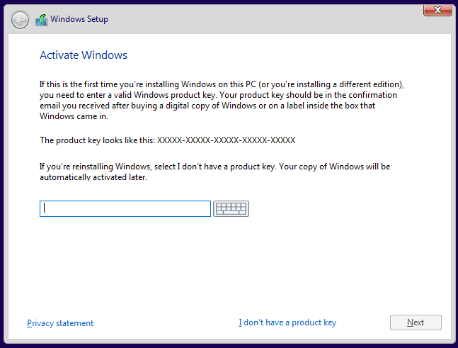

**Enter product key**

Select which version of Windows you want to install. If you have a retail copy, the label will tell you what version you have. Otherwise, it is typically located with the documentation that came with your computer. In most cases, it's going to be either Windows 10 Home or Windows 10 Pro. Most PCs that come with the Home edition have a label that simply reads "Windows 10," while Pro is clearly marked.

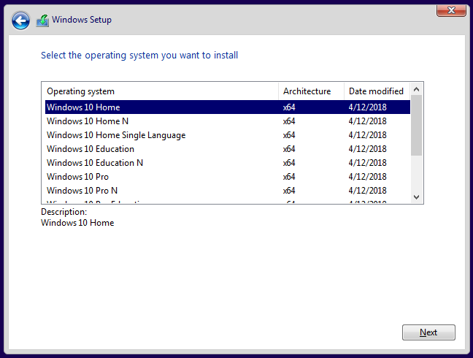

**Select Windows version**

Accept the license agreement by checking the box, then click Next.

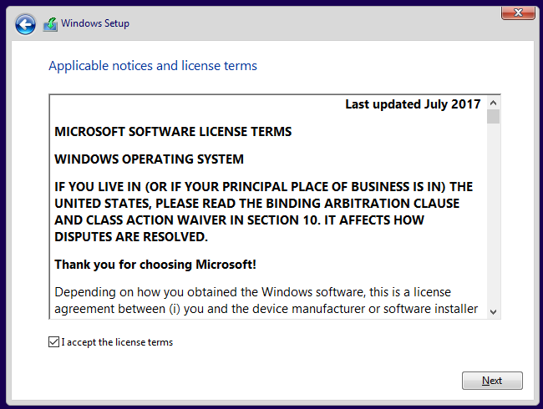

**Accept license terms**

After accepting the agreement, you have two installation options available. Choose the second option, Custom: Install Windows only (advanced).

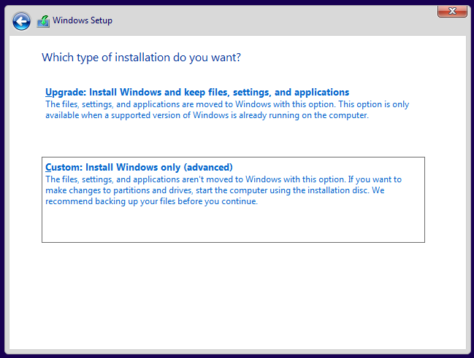

**Select type of Windows installation**

The next screen should show your current hard disk configuration.

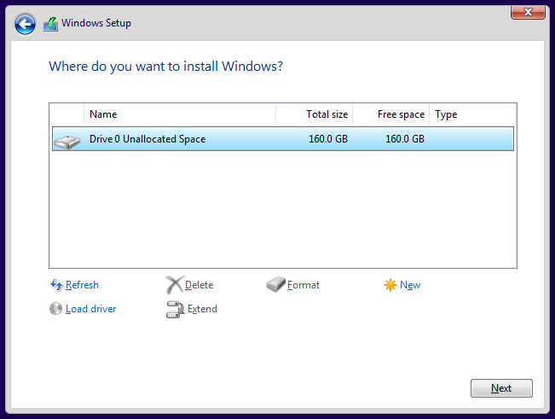

**Hard drive configuration**

Your results will probably look different than mine. I have never used this hard disk before, so it's completely unallocated. You will probably see one or more partitions for your current operating system. Highlight each partition and remove it.

At this point, your screen will show your entire disk as unallocated. To continue, create a new partition.

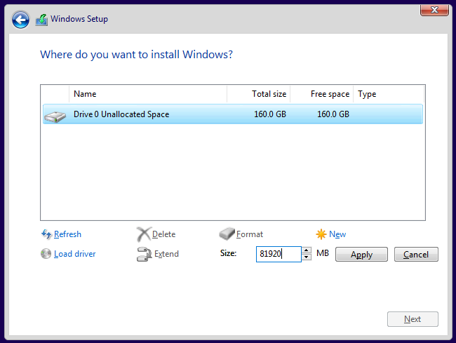

**Create a new partition**

Here you can see that I divided the drive in half (or close enough) by creating a partition of 81,920MB (which is close to half of 160GB). Give Windows at least 40GB, preferably 64GB or more. Leave the rest of the drive unallocated, as that's where you'll install Ubuntu later.

Your results will look similar to this:

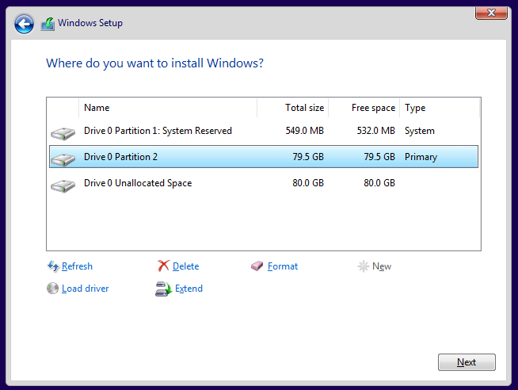

**Leaving a partition with unallocated space**

Confirm the partitioning looks good to you and click Next. Windows will begin installing.

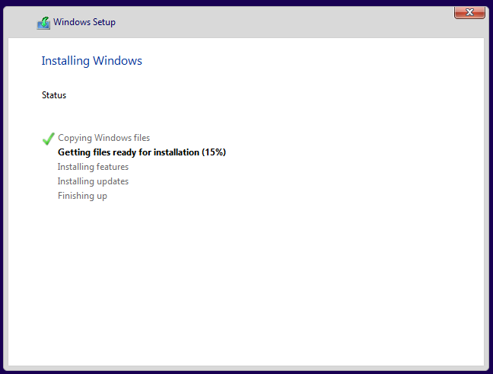

**Installing Windows**

If your computer successfully boots into Windows, you're all set to move on to the next step.

**Install Ubuntu**

Whether it was already there or you worked through the steps above, at this point you have Windows installed. Now use the Ubuntu installation media you created earlier to boot into Ubuntu. Insert the media and boot your computer from it. Again, the exact sequence of keys to access the boot menu varies from one computer to another, so check your documentation if you're not sure. If all goes well, you see the following screen once the media finishes loading:

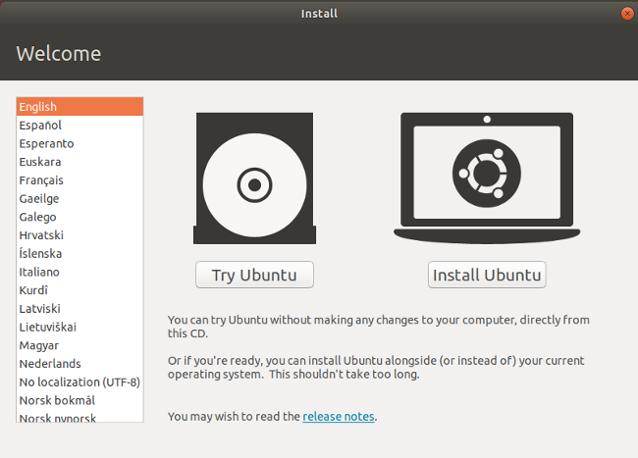

**Ubuntu installation welcome screen**

Here, you can select between Try Ubuntu or Install Ubuntu. Don't install just yet; instead, click Try Ubuntu. After it finishes loading, you should see the Ubuntu desktop.

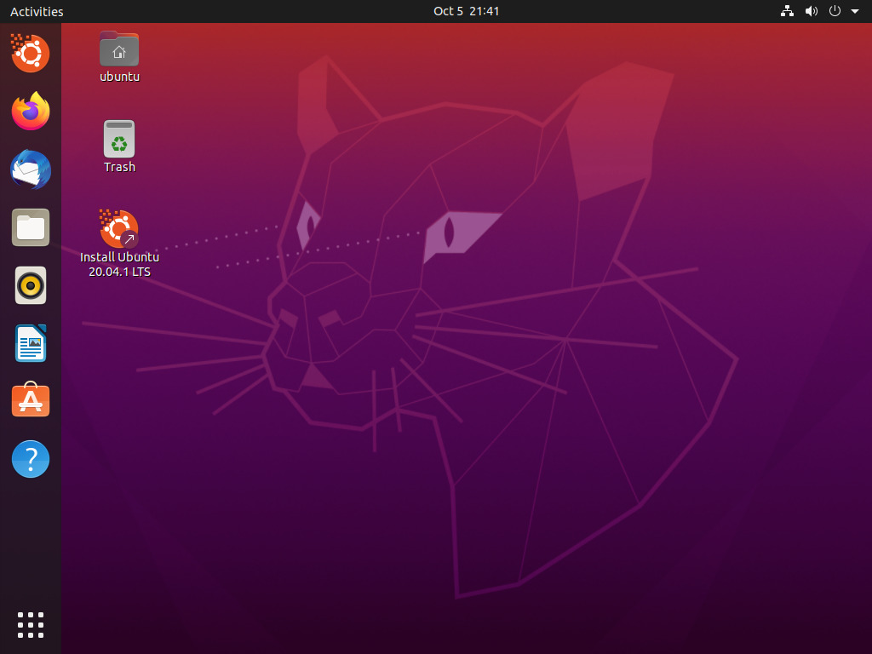

**Ubuntu desktop**

By clicking Try Ubuntu, you opt to try out Ubuntu before you install it. Here, in Live mode, you can play around with Ubuntu and make sure everything works before you commit to the installation. Ubuntu works with most PC hardware, but it's always better to test it out beforehand. Make sure you can access the internet and get audio and video playback. Going to YouTube and playing a video is a good way of doing all of that at once. If you need to connect to a wireless network, click on the networking icon at the top-right of the screen. There, you can find a list of wireless networks and connect to yours.

Once you're ready to go, double-click on the Install Ubuntu 20.04 LTS icon on the desktop to launch the installer.

Choose the language you want to use for the installation process, then click Continue.

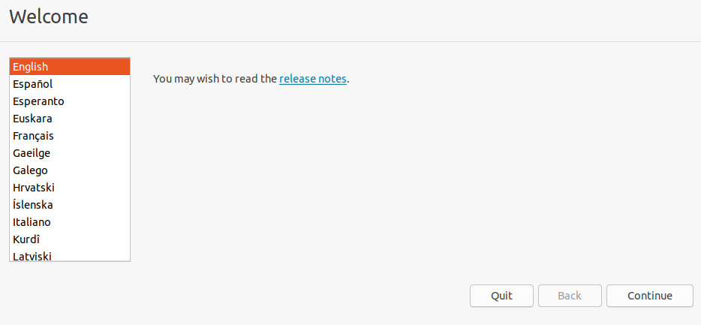

**Install**

Next, choose the keyboard layout. Once you've made your selection, click Continue.

You have a few options on the next screen. You can choose a Normal or a Minimal installation. For most people, Normal installation is ideal. Advanced users may want to do a Minimal install instead, which has fewer software applications installed by default. In addition, you can choose to download updates and whether or not to include third-party software and drivers. I recommend checking both of those boxes. When done, click Continue.

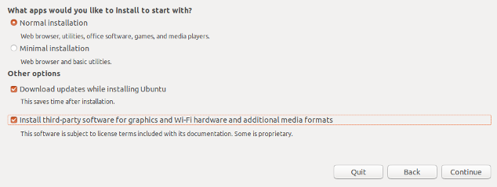

**Options**

The next screen asks whether you want to erase the disk or set up a dual-boot. Since you're dual-booting, choose Install Ubuntu alongside Windows 10. Click Install Now.

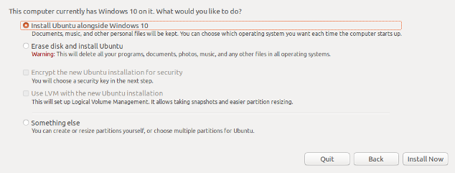

**Installation type**

The following screen may appear. If you installed Windows from scratch and left unallocated space on the disk, Ubuntu will automatically set itself up in the empty space, so you won't see this screen. If you already had Windows 10 installed and it's taking up the entire drive, this screen will appear and give you an option to select a disk at the top. If you have just one disk, you can choose how much space to steal from Windows and apply to Ubuntu. You can drag the vertical line in the middle left and right with your mouse to take space away from one and gives it to the other. Adjust this exactly the way you want it, then click Install Now.

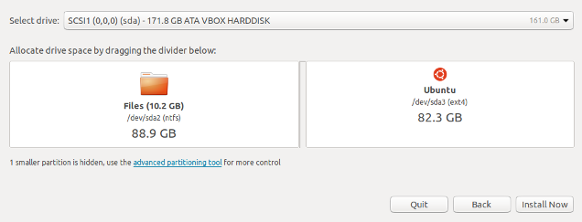

**Partition**

You should see a confirmation screen indicating what Ubuntu plans on doing. If everything looks right, click Continue.

Ubuntu installs in the background, but you still have some configuration to do. While Ubuntu tries its best to figure out your location, you can click on the map to narrow it down to ensure your time zone and other things are set correctly.

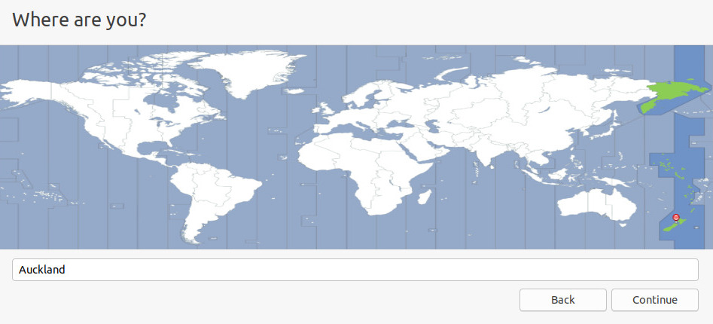

**Location**

Next, fill in the user account information: your name, computer name, username, and password. Click Continue when you're done.

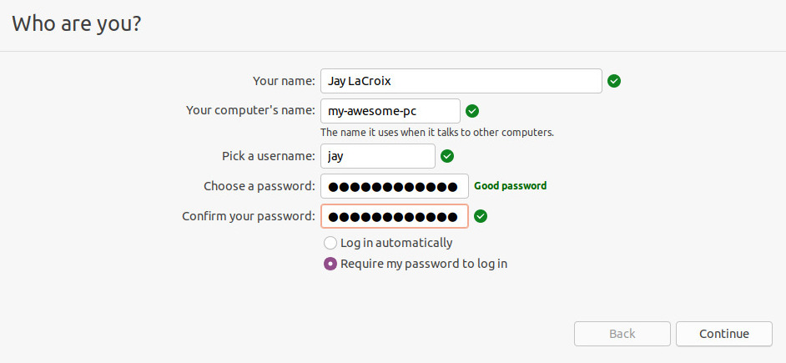

**User creation**

Once the installation finishes, reboot your PC.

If all went according to plan, you should see a screen similar to this when your computer restarts. Choose Ubuntu or Windows 10; the other options are for troubleshooting.

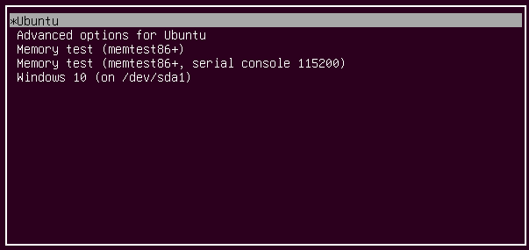

**Choose which OS to use**

Try booting into both Ubuntu and Windows to test them out and make sure everything works as expected. If it does, you now have both Windows and Ubuntu installed on your computer.

**Activity 3**

**Aim:** Install Device Drivers

**Learning outcome:** Able to install and maintain software for a PC.

**Duration: 2** hours

**List of Hardware/Software requirements:**

● PC with Complete Hardware Setup

● PC with Pre- Installed Operating System (Windows)

**Code/Program/Procedure (with comments):**

A driver is software that a device uses to work with your PC. When your device isn’t working properly, you can check if the driver is installed correctly. Faulty driver could always be the cause. To fix the problem, you need to update the driver. For some devices, Windows can update the driver automatically. For some devices especially external devices, you need to install the updated drivers yourself, then you need to download the driver manually.

**Download the driver manually**

To download new drivers, go to PC manufacturer’s website or device manufacturer’s website. Driver updates are often available in the Support section of their website. If you are using a branded computer, it is recommended that you go to the PC manufacturer’s website to check for the latest driver first, as they may customize the driver. You are required to use the PC model and the operating system that you are using to download the correct driver. Usually, the PC model can be found on the machine. If you need to download the driver from device manufacturer, then you are required to know the device model.

**How to install the driver**

The downloaded driver file will be an executable file (File name ends in “.exe”.) or a zip file (File name ends in “.zip”.).

For executable file, to install the driver, you just need to double-click on the file and follow the on-screen instructions.

For zip file, you need to unzip it and find the executable file in the archive. If you cannot find an executable file, you need to install the driver step by step using the “.inf” file. Following steps are for your reference how to install the driver in this way.

1. Go to Device Manager.

2. Find the device that need to install a driver. (Here let’s take video card for example.)

3. Right-click on the device and select Update Driver Software…



4. Select Browse my computer for driver software.



5. Select Let me pick from a list of device drivers on my computer.



6. Click Have Disk… button.



7. Click Browse… button. Navigate to the folder where you saved the downloaded driver file and browse the .inf driver file.



8. Click OK button then Next button to finish the installation. You might be asked for an admin password or to confirm your choice.

**Activity 4**

**Aim:** Install/Uninstall Application software (Office, Multimedia and Antivirus)

**Learning outcome:** Able to install and maintain software for a PC.

**Duration: 2** hours

**List of Hardware/Software requirements:**

● PC with Complete Hardware Setup

● PC with Pre- Installed Operating System (Windows)

**Code/Program/Procedure (with comments):**

**Steps to install application software**

1. Locate and download an .exe file.
2. Locate and double-click the .exe file. (It will usually be in your Downloads folder.)
3. A dialog box will appear. Follow the instructions to install the software.

The software will be installed.

**Steps to uninstall application software**

1. Type Control Panel in the taskbar on your desktop or ask Cortana to open the Control Panel.
2. Click on Programs, then open Programs and Features.
3. Find the program you want to uninstall and right-click on it.
4. Select the Uninstall or Uninstall/Change button, whichever appears.

**Learning Outcome - Able to perform troubleshooting and** **maintenance of PC based on the faulty condition**

After achieving this learning outcome, a student will be able to perform troubleshooting and maintenance of the PC based on the faulty condition.

To meet the learning outcome, a student has to complete the following activities

1. Service of Dead PC (x Hours)
2. Service CPU ON and NO Display (x Hours)
3. Service if system is frequently restarting (x Hours)
4. Service if system gives continuous beep sound (x Hours)
5. Service if System not Booting (x Hours)
6. Service if OS not Loading (x Hours)
7. Service if system gets frequently hanging (x Hours)
8. Service if system is very slow (x Hours)
9. Troubleshoot if paper is jam in printer (x Hours)

**Activity 1**

**Aim:** Service of Dead PC

**Learning outcome:** Able to perform troubleshooting and maintenance of PC based on the faulty condition.

**Duration: 2** hours

**List of Hardware/Software requirements:**

● PC with Complete Hardware Setup

● PC with Pre- Installed Operating System (Windows)

**Code/Program/Procedure (with comments):**

**Check power cable continuity**

In continuity testing the resistance between two points is measured. Low resistance means that the circuit is closed and there is electrical continuity. High resistance means that the circuit is open and continuity is lacking. Continuity testing can also help determine if two points are connected that should not be.

**Check SMPC DC output**

1. Remove the connections that are connected to motherboard from SMPS.
2. Use a paper clip and bend it in U shape. Locate the green and select any one of the black wire of the bigger connector. Locate green and black wire. There will be one green wire and many black wires. You can select any black wire you want.
3. Connect the Power cable and Power on the SMPS.
4. The SMPS Fan Will Spin, if it is working.
5. The same can be confirmed by hearing the fan spinning noise or air coming out of the fan.

Precaution: Make sure that the Power Supply is grounded and use insulated material while performing the operation.

**Check cables and connectors**

The cables and its associated connectors need to be checked, whether they are properly connected with right orientation and correct port.

**Check cabinet power on button**

Start by unplugging the power switch from your motherboard. 2. Take a flat head screw driver and touch it to the two pins the power switch was plugged into for 1-2 seconds. If the unit comes on then the power button is faulty, otherwise you may want to try the paper clip test on your power supply.

**Activity 2**

**Aim:** Service CPU ON and no display

**Learning outcome:** Able to perform troubleshooting and maintenance of PC based on the faulty condition.

**Duration: 4** hours

**List of Hardware/Software requirements:**

● PC with Complete Hardware Setup

● PC with Pre- Installed Operating System (Windows)

**Code/Program/Procedure (with comments):**

Follow the following procedures:

1. Check DC power supply from SMPS to mother board Remove sound cord if any and check for restoration of booting process
2. Check for proper insertion of RAM
3. Check for dust on mother board
4. Replace SVGA cord with new one
5. Check for any crack on mother board PC
6. Check for overheating of any ICs on mother board
7. Replace BIOS

**Activity 3**

**Aim:** Service if system is frequently restarting

**Learning outcome:** Able to perform troubleshooting and maintenance of PC based on the faulty condition.

**Duration: 2** hours

**List of Hardware/Software requirements:**

● PC with Complete Hardware Setup

● PC with Pre- Installed Operating System (Windows)

**Code/Program/Procedure (with comments):**

The following procedures will troubleshoot the system when it is frequently restarting.

1. Replace the RAM
2. Check for any boot virus
3. Check all the connections of mother board

References:

1. <https://www.dell.com/support/kbdoc/en-in/000143677/how-to-create-or-modify-a-partition-in-microsoft-windows>
2. <https://opensource.com/article/18/5/dual-boot-linux>
3. <https://www.drivereasy.com/knowledge/how-to-install-drivers/>
4. <https://www.hp.com/us-en/shop/tech-takes/how-to-uninstall-programs>
5. <https://carelabz.com/learn-continuity-testing-what-how/>
6. <https://support.lenovo.com/in/en/solutions/ht503436-how-to-test-the-smps-switch-mode-power-supply-functionality-lenovo-desktops-all-in-ones>
7. <http://support.antec.com/support/solutions/articles/1000046605-how-to-test-the-power-button#:~:text=Start%20by%20unplugging%20the%20power,test%20on%20your%20power%20supply>

**Activity 4**

**Aim:** Service if system gives continuous beep sound.

**Learning outcome:** Able to understand basic computer network technology.

**Duration: 2** hours

**List of Hardware/Software requirements:**

● PC with Complete Hardware Setup

● PC with Pre- Installed Operating System (Windows)

**Code/Program/Procedure (with comments):**

The POST (power on self-test) is a set of procedures that a computer runs through each time it is turned on. It ensures that all of the system's hardware is working properly before trying to load the operating system. If the computer does not pass POST, it will not boot.

**Remove new hardware**

If any new hardware was recently added to the computer, remove that hardware to make sure it is not causing your issue. If your computer works after removing the new hardware, it can mean a few things. Either the new hardware is not compatible with your computer, a system setting

needs to be changed, or the new hardware is defective.

**Remove any disks or USB devices**

Remove any disks, CDs, or DVDs that are in the computer. If any USB devices (iPods, drives, phones, etc.) are connected, disconnect all of them as well. Reboot the computer and see if anything changes.

**Disconnect external device**

/

Remove everything from the back of the computer, except the power cable. Turn on the computer and see if it beeps normally. If the computer has never beeped, keep the monitor or display connected to see if any change occurs.

**Identify beep code**

If you are receiving a sequence of beeps. You can also check your motherboard or computer documentation for information on the beep codes. These beep codes are meant to help identify which computer component is failing or bad. If your beep code is not listed, continue troubleshooting.

**Check all fans**

Make sure all fans are running on the computer. If a fan has failed (especially the heatsink fan for the CPU), your computer could be overheating or detecting the fan failure, causing the computer not to boot.

**Check all cables**

Verify all the cables are securely connected to the computer and that there are no loose cables by firmly pressing in each cable.

● All disk drives should have a data cable and power cable connected to them.

● Your power supply should have at least one cable going to the motherboard. Many motherboards may also have additional cables connected to them to supply power to the fans.

**Disconnect all expansion cards**

If the above recommendations still have not resolved the irregular POST, disconnect the riser board (if applicable) and each of the expansion cards. If this fixes the problem or allows the computer to POST, connect one card at a time until you determine which card is causing the problem.

**Disconnect all drives**

/

If you cannot diagnose the problem by the beep code (or you do not hear a beep code), power off the computer. Then, disconnect any IDE, SATA, SCSI, or other data cables from the motherboard. When they are disconnected, try booting the computer again.

If this resolves your irregular POST or generates error messages, reconnect each device until you determine which device or cable is causing the issue. In some situations, it can also be a loose cable connection that causes the issue.

**Remove the RAM**

If you continue to experience the same problem with all the above hardware removed, remove the RAM from the motherboard and turn on the computer. If the computer has a different beep code or was not beeping but is now, turn off your computer and try the suggestions below. Make sure to turn off the computer before adding and removing the memory and then turning it back on to see if the suggestion resolves the issue.

1. Re-insert the memory into the same slot.

2. If you have more than one stick of memory, remove all but one stick of memory and try rotating through each stick.

3. Try one stick of memory in each slot.

If you can get the computer to boot with one or more of the sticks of memory installed, you are likely dealing with some bad memory. Try to identify which stick of memory is bad and replace it. if you can get the memory to work in one slot but not another slot, the motherboard is likely defective. You can either workaround the issue by running the memory in a different slot that does work or replace the motherboard.

**Power cycle the computer**

In some situations, a computer may have power related issues often caused by either the power supply or the motherboard. To help determine if this is the issue, try turning the computer on, off, and back on as fast as possible, making sure the computer power light goes on and off. In some situations, you may be able to temporarily get the computer to boot.

**Output/Results snippet:**

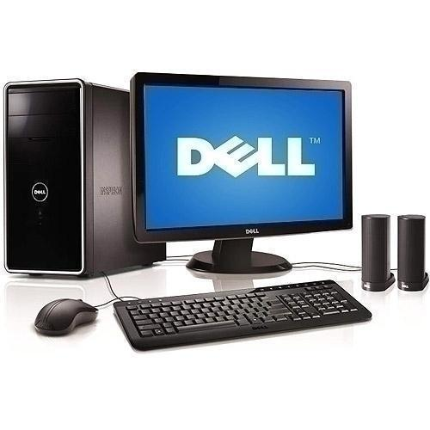**Desktop is ready to use without beep Sound problem**

Image Reference : <https://5.imimg.com/data5/BK/UB/MY-16256729/dell-computer-500x500.jpg>

**References:**

● <https://www.computerhope.com/issues/ch000607.htm>

**Activity 5**

**Aim:** Service if System not Booting

**Learning outcome:** Able to perform troubleshooting and maintenance of PC based on the faulty condition.

**Duration:** 5 Hours

**List of Hardware/Software requirements:**

1. Hand Tools

Flat-head screwdriver, Phillips-head screwdriver, Torx screwdriver, Hex driver, Needle-nose pliers, Wire cutters, Tweezers, Part retriever, Flashlight, Wire stripper, Crimper, Punch-down tool.

1. Cleaning Tools

Soft cloth, Compressed air, Cable ties

1. Diagnostic Tools

A digital multi meter, A loopback adapter

1. Software Tools

Disk Management Tools, Protection Software Tools

**Procedure:**

**Check SATA/IDE cable and SMPS**

**Step 1: Identification of the drive interface type.**

Most modern PCs use the SATA interface for physical connection of hard drives to the computer’s system bus, while the IDE (PATA) standard may be found on older machines. To identify the interface type, you should disassemble the device and examine the drive:

Open the case to access the hard drive. If the device uses removable hard drives in special bays, simply eject the drive from the bay;

Examine the holder of the hard drive: if the back panel is covered with an enclosure, remove it and then check the back panel.

The following examples will acquaint you with what different hard drive interfaces look like:

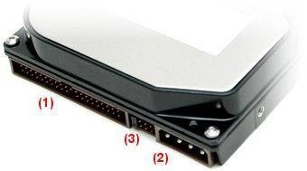

Back panel of an IDE (PATA) drive.

In this picture:

IDE data port. Please pay attention to the small hollow in the top center. It is used as an index for correct cable connection. Incorrect cable connection can damage the connector and the drive.

Power supply port. It also has a "key" form for correct connection of the power cable. Incorrect cable connection can damage the connector and the drive.

These are used for identification of the order of the drives in a paired IDE cable as well as for additional IDE settings.

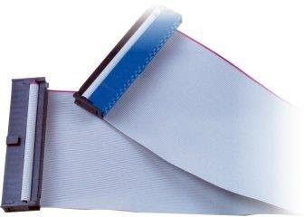

IDE (PATA) data cable.

In this picture, the blue connector is used to connect the cable to the mainboard of the computer/device, while the black one is used to connect the drive. Please pay attention to the "key" on the cable connector that matches the slot of the drive.

IDE cables usually have two drive connectors: a "master" connector (at the end of the cable) and a "slave” connector (in the middle of the cable, closer to the "master" connector).

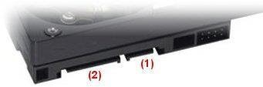

Back panel of a SATA drive

In this picture:

SATA data port. Please pay attention to the "key" form of the slot.

SATA power supply port. In contrast to IDE, a SATA power cable is wider than a

SATA data cable. It has a "key" form as well.

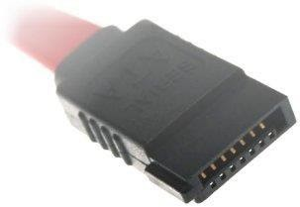

SATA data cable connector.

A SATA cable consists of two equal endpoints on a thin data cable. It makes no difference which of the ends will be used to connect the drive. Please pay attention to the form of the connector that matches the "key" form of the SATA drive data slot.

**Step 2: Choosing the method of connection to the host computer. External adapters**

This is the safest but at the same time the most expensive method. You need USB/Firewire adapters for each drive to connect them to the host PC If the host computer provides enough disk space, you can create an image of your disk and avoid using an adapter for this disk

/

You can find external adapters for both SATA and IDE hard drives; some of them fit both interfaces:

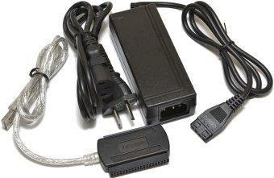

USB to IDE hard disk adapter with an external power supply.

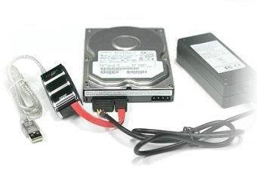

USB to SATA hard disk adapter with an external power supply.

Please note that some USB to SATA adapters have a pair of SATA interfaces, thus, to connect two SATA drives you need only one adapter.

Pay attention to the external power supply: some adapters are powered via USB and don't match 3.5" hard drives used in NAS and desktop computers.

**Mainboard connectors**

This is the cheapest but not the safest method to connect the drives. Besides, the mainboard is able to place a very limited number of drives. Before choosing this method, make sure that the computer power supply provides at least 15 Watts of additional power per drive. Also, see to it that you have a sufficient number of data cables: one cable per two IDE drives and one SATA data cable per one SATA drive.

To check if the method is suitable, examine your motherboard connectors. To do this: Remove the screws from the back panel of your computer that hold the Removing two screws that hold the left-side cover is enough (for a tower-type computer); Open the left cover panel: pull it a little back and put it aside; Examine the expansion slots on the mainboard.

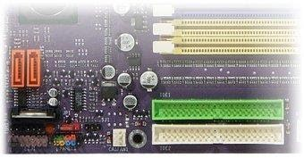

IDE connectors.

In this picture, you can see two IDE connectors marked as IDE 1 and IDE 2 at the right bottom. As a rule, IDE 1 is colored while IDE 2 is usually black or white.

/

Each IDE connector is capable of hosting two IDE hard drives.

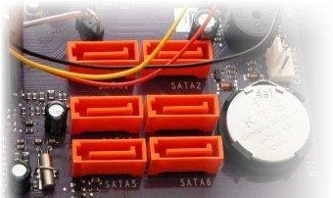

SATA connectors.

Above Picture shows SATA connectors. They are usually black, red or orange and are numbered as SATA1, SATA2, etc. Each connector is capable of hosting one SATA drive.

Make sure that the mainboard provides enough free slots. For example, for four disks of your NAS with IDE hard drives you need two free IDE slots on the mainboard: two drives per interface. For four drives with a SATA interface four free SATA slots are needed.

If the mainboard doesn't provide a sufficient number of free slots, use external adapters or expansion cards. If you decide to free up some mainboard slots for extra drives, make sure you don't unplug the system boot drive or RAID.

**Expansion cards**.

/

This method of connection is quite efficient, however, is not 100% safe. Before choosing this method make ensure that the computer power supply is capable of providing at least 15 Watts of additional power per drive plus about 10 Watts for the expansion card. Expansion cards are available for both SATA and IDE drives.

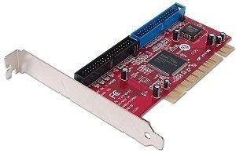

PCI IDE expansion card with two IDE channels.

Please note that IDE expansion cards have one or more IDE channels. Each channel is capable of hosting two IDE drives. It is recommended to use one card for all the drives.

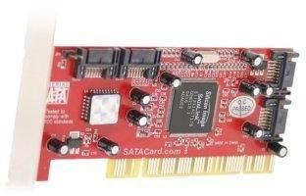

PCI SATA expansion card with four SATA channels.

/

SATA expansion cards have two or more SATA channels. Each channel is capable of hosting one SATA drive. It's recommended to use one card for all the drives. But as

multi-port cards are more expensive, you may consider using several cards to save costs. Besides, there are no requirements to expansion cards for hardware RAID, thus, you can choose an inexpensive one.

Expansion cards can be installed to any free PCI (or PCI Express) slots on the mainboard.

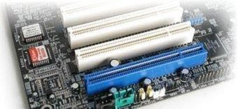

PCI slots on the mainboard.

Please refer to the expansion card installation manual for more details. Make sure that the expansion card kit contains a sufficient number of data cables: one cable per 2 IDE drives and one SATA data cable per one SATA drive. You might need additional cables.

**Check HDD partition problem**

Manually check and repair Windows hard disk partition errors

Note: Please do remember to backup important personal files first.

Step 1: Open Computer, right-click the partition or drive that you want to check and click “Properties”.

Step 2: Click "Tools" under Error-checking, click "Check now" to see whether there exist any errors in your drive.

Step 3: Select "Automatically fix file system errors and Scan for and attempt recovery of back sectors".

Step 4: Click "Start".

Note: If your hard drive, USB drive, SD card or memory card etc storage devices cannot work, we also suggest you to apply the above two methods to check and repair bad sectors and errors so to make your devices reusable again.

/

**Check CMOS battery voltage**

Step 1: Detect CMOS Battery Failure Of Your Computer

CMOS Battery Failure, Every computer has a small battery on its motherboard used to provide power to the CMOS on the computer. The CMOS (Complementary Metal Oxide Semiconductor) chip on your computer remembers everything like the disk drive, time and date, etc., so you don’t want to have a CMOS battery failure. The CMOS battery always provides power to the CMOS chip – i.e., even when your computer is OFF – to save all the settings. So, it is very important at the time of booting your computer and other tasks.

Detect a CMOS Battery Failure

The CMOS battery is a small battery fitted on the motherboard of your computer. It has a life of around five years. You need to use the computer regularly to extend the life of the CMOS battery. The computer power supply increases the availability of a standby current and hence increases the life of the battery.

If the computer is not plugged in regularly, the life of the battery is normally 3 years. However, the life of the battery gets extended to 5 years when you use it regularly. The battery provides power to CMOS memory and the real-time clock.

Step 2: Signs of a CMOS Battery Failure

/

It is a 3V battery. If the voltage drops between certain levels, your computer loses the memory. The CMOS settings like date and time get changed. In some instances, the date and time get set to factory default. For example, your computer date will be set to factory settings, something like 12/01/2008.

All of the settings like drive type, FDD, NUMs lock, etc., in the computer setup will be changed. It may be causing booting problems since your computer does not remember information about the disk drive. Your computer will show a message such as “Booting Error, unable to detect disk drive.” The computer may be shutting down and will not allow you to perform any task.

Your computer may be too slow. It may be due to wrong time and date. It is time to replace the CMOS battery to correct these issues.

Some of the drivers may be missing or may not work properly. So, you may not be able to print out on the printer. Even if you install the printer driver correctly, your computer may keep on showing the message “can’t find printer.”

Your mouse may not respond properly. You may feel that your mouse might have gotten damaged and be ready to replace the mouse. But it might be solved by simply replacing the CMOS battery. Therefore, before ordering a mouse you can try the same mouse on another computer to check if it is actually defective.

You may not be able to connect to the internet. It keeps on showing error when connecting to the internet. You need to check whether time and date are correct. If the date and time are wrong, try correcting. Then, check again; if the computer is still not connecting to the internet, you need to replace the CMOS battery.

If you hear a constant beeping sound when working with your computer, it is a sign that you need to replace the CMOS battery.

The computer will also display CMOS battery failure, CMOS read error, or CMOS checksum error, etc. If this happens, you need to switch on your computer and leave it on for a day. If the computer is not showing the errors after rebooting, the CMOS battery is charging. Otherwise, you need to replace the CMOS battery.

Step 3: After Verifying CMOS Battery Failure

/

Replacing a CMOS battery in your laptop or computer is easy. If you are new to the computer or laptop, you can also seek the help of a local computer technician to replace the computer battery.

Step 4: Steps to replace the CMOS battery

First, switch off the computer or laptop and remove the power cord from the computer. It is also suggested to remove the battery pack from a netbook or laptop.

Remove the cover of the CPU or laptop using a star bit (Torx) screwdriver.

You can find a button type CMOS battery on the motherboard of your computer or laptop. Use the flat-head type screwdriver to slowly lift the button cell from the motherboard.

Use the multimeter to check the voltage of the battery (use a digital multimeter). If the voltage is less than 3V, your computer will not remember the CMOS settings, so it is time to replace the old battery with the new CMOS battery.

After replacing the battery in the same orientation, you can replace the computer cover and tighten the screws.

Plug in the power cord and switch the computer ON to check if it is working properly. However, after replacing the CMOS battery you need to enter the correct BIOS settings. So, after booting your computer, you need to enter the correct date and time.

**Check HDD parameters in CMOS setup**

Step 1: To enter the CMOS Setup, you must press a certain key or combination of keys during the **initial startup sequence**. Most systems use "Esc," "Del," "F1," "F2," "Ctrl-Esc" or tells you "Press to Enter Setup.

/

Step 2: Change your setting for your convenience in following methods

List of option to change.

**System Time/Date** - Set the system time and data

**Boot Sequence** - The order that BIOS will try to load the operating system

**Plug and Play** - A standard for auto-detecting connected devices; should be set to "Yes" if your computer and operating system both support it

**Mouse/Keyboard** - "Enable Num Lock," "Enable the Keyboard," "Auto-Detect Mouse".

**Drive Configuration** - Configure hard drives, CD-ROM and floppy drives **Memory** - Direct the BIOS to shadow to a specific memory address **Security** - Set a password for accessing the computer

**Power Management** - Select whether to use power management, as well as set the amount of time for **standby** and **suspend**

**Exit** - Save your changes, discard your changes or restore default settings

**Note** : Be very careful when making changes to setup. Incorrect settings may keep your computer from booting. When you are finished with your changes, you should choose "Save Changes" and exit. The BIOS will then restart your computer so that the new settings take effect.

The BIOS uses **CMOS** technology to save any changes made to the computer's settings.

Step 3: Save all changes and exit the BIOS.

This is done with the "F10" key motherboard. The computer reboots after saving the changes. The computer will boot from the optical drive, starting the Data Lifeguard Diagnostics utility.

/

**Check for boot virus**

Step 1: Start Menu or press windows button

Step 2: click to All Programs

Step 3: then click to Accessories

Step 4: Now, Right click on Command Prompt

Step 5: then click on Run as administrator

Step 6: After performing above operation, you will watch a new cmd box will come out to ask for confirmation. Press Yes. Now your command prompt window will be opened as shown in figure below.

Step 7: scan computer using cmd

Step 8: Now type sfc /scannow in the cmd box as show in figure below

Step 9: Now press ENTER after typing it. Your computer Verification will starts

**Note:** Wait until your verification will complete. After completing your verification. Your computer scan completed. And the output in the command prompt will come out like (given in the following figure) if your computer will not contain any virus.

**Output/Results snippet:**

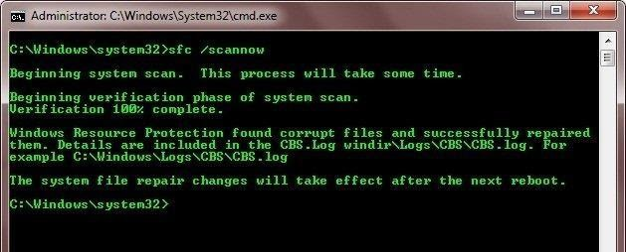

**Activity 6**

**Aim:** Service if OS not Loading

**Learning outcome:** Able to perform troubleshooting and maintenance of PC based on the faulty condition.

**Duration: 3** Hours

**List of Hardware/Software requirements:**

1. Hand Tools

Flat-head screwdriver, Phillips-head screwdriver, Torx screwdriver, Hex driver, Needle-nose pliers, Wire cutters, Tweezers, Part retriever, Flashlight, Wire stripper, Crimper, Punch-down tool.

1. Cleaning Tools

Soft cloth, Compressed air, Cable ties

1. Diagnostic Tools

A digital multi meter, A loopback adapter

1. Software Tools

Disk Management Tools, Protection Software Tools

**Procedure: Check RAM**

**Method 1: Check RAM via msinfo32.exe**

Since Windows 98, Microsoft includes a built-in tool called Microsoft System Information (msinfo32.exe), which enables you to gather information about your computer. Here’s how to use it:

Step1: On your keyboard, press the Windows logo key and R at the same time to invoke the Run box.

Step2: Type msinfo32.exe and click OK.

Step3: You can check your RAM in Installed Physical Memory (RAM). You can also browse other system information from this window.

**Method 2: Check RAM via Task Manager**

You can also check your RAM on Windows 10 from Task Manager. To do so,

follow the steps below:

On your keyboard, press the Ctrl key, Shift key, and Esc key at the same time to invoke Task Manager.

Click Performance, then click Memory, and you will see the RAM in use and the available memory in your Windows 10 computer.

Control Panel is a powerful feature where you can check information and diagnose the issues in your Windows 10 computer.

Type Control Panel in the search bar from the Start menu, then click Control Panel to open it.

View Control Panel items by category, then click System and Security. Click View amount of RAM and processor speed in the System section.

You can check your RAM information in Installed memory under the System section.

**Output/Results snippet:**

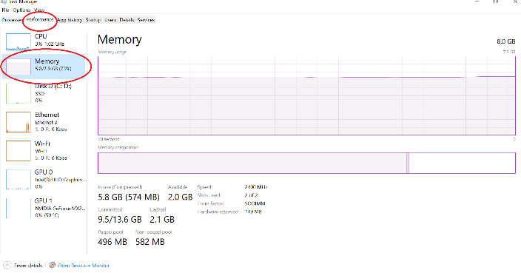

**Check proper installation of Driver Software in device manager**

Method 2: Installing driver from manufacturer (Offline)

In the case that the driver isn't available through Windows Update, because it's too recent or available only in beta, you'll need to download and install the package from the manufacturer's support website manually.

When getting an update from a manufacturer support website, you should always attempt to follow their instructions first. However, if there are no instructions, double- click the ".exe" self-extracting package, or use this guide to extract the content of the ".zip" compressed file, and then continue with these steps:

* Open Start.
* Search for Device Manager and click the top result to open the tool. Double-click the branch with the hardware you want to update. Right-click the hardware and select the Update driver option.
* Device Manager update driver option
* Click the Browse my computer for driver software option. Device Manager update driver manually option
* Click the Browse button.
* Device Manager update driver manually option
* Select the main folder with the driver files you have extracted earlier. Click the OK button.
* Check the Include subfolders option to allow the wizard to find the correct ".inf" file with the instructions to update the driver.
* Click the Next button.

**Note**: Once you complete the steps, the wizard will detect and install the new driver on your computer to improve the overall experience with fixes, new functionalities, or new support depending on the update and device.

**Output/Results snippet:**

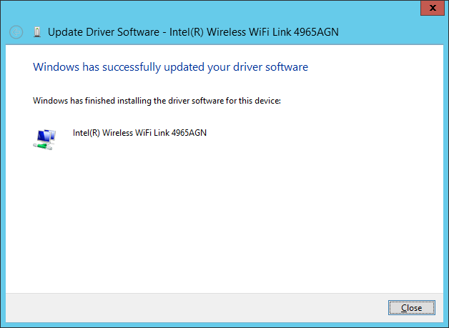

**Uninstall recently performed drivers**

**Step 1**. Try to delete a driver by using the device's uninstaller

Before anything else, you should check whether the driver that you want to remove has an uninstaller. A typical example is graphics cards from Nvidia and AMD, which have complex driver kits that also include other software. Regardless of the device, if you installed its drivers using an installer, it should also provide an uninstaller.

To find if you have this option, open the Settings app from Window 10, go to Apps, and check whether your device’s software is shown in the list of Apps & features. For example, if you want to uninstall Nvidia drivers, all you have to do is find them in the list and click or tap on Uninstall.

Removing the NVIDIA Graphics Driver from Windows 10 In Windows 7, the steps are similar: open the Control Panel, go to Programs, then to Programs and Features, and find the device drivers that you want to uninstall. Then, click or tap Uninstall and remove those bad drivers.

If your device doesn't come with a driver uninstaller, follow the next steps to get rid of it.

**Step 2**: Open the Device Manager

Open the Device Manager: a quick way to do that, both in Windows 10 and Windows 7, is to search for the words "device manager" and click or tap the appropriate search results.

Opening Device Manager in Windows 10.

**Step 3:** Find the device or hardware component with the faulty drivers

The Device Manager shows a list of all the hardware components that are inside your computer or connected to it. It also includes emulated hardware by the apps that you have installed. They are organized by type.

Browse the list of hardware and find the device for which you want to uninstall the driver because it's causing you troubles.

Browsing to the device or hardware component with bad drivers.

**Step 4**: Open the properties of the hardware device with the bad drivers

Right-click or press-and-hold (on a touchscreen) the name of the component with the problematic driver. In the menu that opens, choose Properties.

Opening the Properties of the device

You can also select the device and then press Alt + Enter on your keyboard.

**Step 5:** Uninstall and delete the drivers completely

* Now, Windows opens a window with the properties of the hardware device that you've selected. To completely remove its driver, go to the Driver tab and click or tap on the Uninstall Device button.
* Choosing to Uninstall Device
* In the Uninstall Device dialog window, make sure that you check the box that says: "Delete the driver software for this device." Then, click or tap Uninstall. If you don't check the box we mentioned, Windows does not completely delete the driver for that device. Instead, it keeps the driver files on your PC and uses them the next time it detects your device.
* Uninstall and Delete the driver software for this device
* The faulty driver is now deleted, and the device is gone from the Device Manager. You should be able to resume using your computer without the problems that you had.

**Note:** In Windows, you could try to hide the bad driver update and block it from ever installing, using the steps from this tutorial: Use the Show or Hide Updates tool to block unwanted Windows updates, including drivers.

However, that only works in some situations, and it's not an option for those of you who are still using Windows 7. If you need a more radical way of stopping Windows 10 or Windows 7 from automatically installing drivers on your PC, follow the next steps:

Use the Search from Windows 10's taskbar, or the search field from the Start Menu in Windows 7, to look for "advanced system settings." In the list of results, click or tap on "View advanced system settings."

Searching for advanced system settings

This opens the System Properties window. In it, select the Hardware tab and click or tap on the "Device Installation Settings" button.

Device Installation Settings on the Hardware tab from System Properties

The previous action opens a window called “Device installation settings." On it, Windows asks you if "[...] you want to automatically download manufacturers' apps and custom icons available for your devices." Select "No (your device might not work as expected)" and push the Save Changes button.

Choosing not to let Windows download drivers automatically.

IMPORTANT: Enabling this setting means that none of your devices, connected right now or which you will connect at a later time, will get driver updates from Microsoft via windows update.

**Output/Results snippet:**

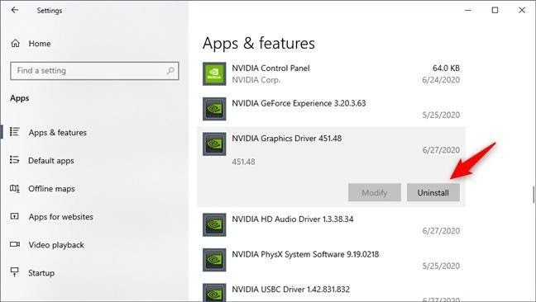

**Boot in safe mode**

**Method 1**

To access the Boot Manager of your system, please press the key combination Ctrl + F8 during the startup process. Select the desired Safe Mode to start your PC.

**Note**: With computers that start quickly or which are equipped with a fast SSD, it may be difficult to hit Ctrl + F8 at exactly the right time to catch the dialog. Therefore, it might take several attempts to access the Boot Manager this way.

Alternatively, Safe Mode can also be launched directly from Windows or via the Windows System Configuration Utility described in the following video or in the text below.

**Method 2**: Start Safe Mode directly from Windows

* Click the Windows-button → Power.
* Hold down the shift key and click Restart.
* Click the option Troubleshoot and then Advanced options. Go to “Advanced options” and click Start-up Settings. Under “Start-up Settings” click Restart.
* Various boot options are displayed.
* The relevant options for booting in Safe Mode are numbers, 4,5, or 6.
* Select an option by pressing one of the numbers or function keys F4, F5 or F6
* Enable Safe Mode

o In this mode, the operating system is started with the bare minimum of installed drivers and only the main Windows functions are used.

**Enable Safe Mode with Networking**

In this mode, the network drivers are also started.

**Enable Safe Mode with Command Prompt**

o In this mode, the operating system is started in text mode. This mode requires knowledge of computer commands and is, therefore, more suitable for professional users.

o Windows 10 starts in Safe Mode.

**Note:** You can tell you're in Safe Mode as the words Safe Mode are displayed in the four corners of the screen.

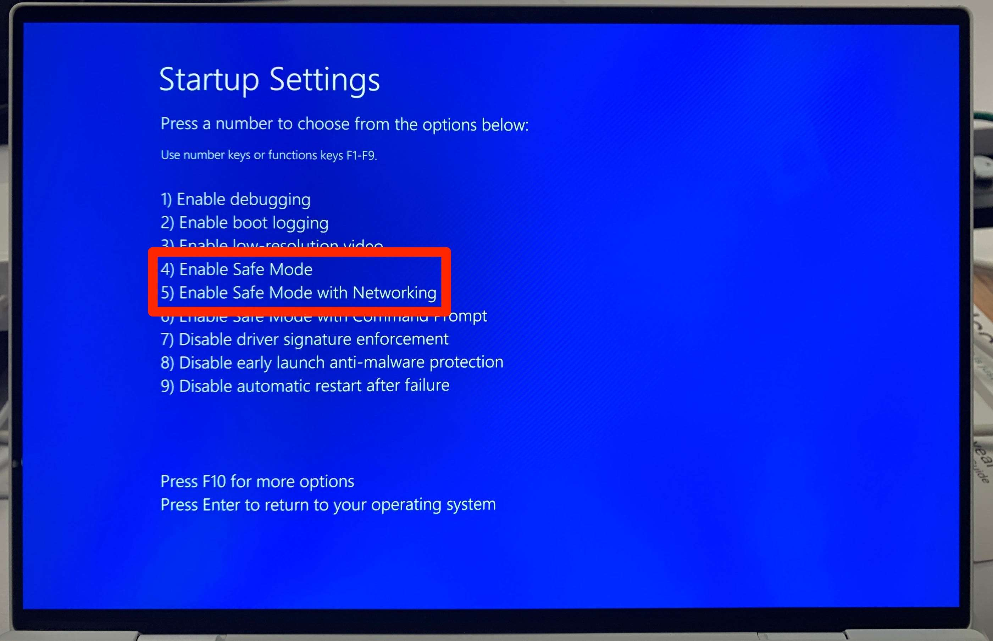

**Reference:**

[**https://winaero.com/how-to-boot-windows-11-in-safe-mode/**](https://winaero.com/how-to-boot-windows-11-in-safe-mode/)

**Activity 7**

**Aim:** Service if system gets frequently hanging

**Learning outcome:** Able to perform troubleshooting and maintenance of PC based on the faulty condition.

**Duration:** 3 Hours

**List of Hardware/Software requirements:**

1. Hand Tools

Flat-head screwdriver, Phillips-head screwdriver, Torx screwdriver, Hex driver, Needle-nose pliers, Wire cutters, Tweezers, Part retriever, Flashlight, Wire stripper, Crimper, Punch-down tool.

1. Cleaning Tools

Soft cloth, Compressed air, Cable ties

1. Diagnostic Tools

A digital multi meter, A loopback adapter

1. Software Tools

Disk Management Tools, Protection Software Tools

**Procedure:**

**Method 1: Testing an Installed Fan**

Download and install Speed Fan. This program uses data provided by sensors in your computer's hardware to display information about the temperatures of various components and the speed at which the cooling fans for those components are rotating.

Launch Speed Fan and wait a few minutes for it to retrieve data.

Examine the information presented in the main program window. The speed at which your computer's fans are rotating, measured in revolutions per minute, is on the left side of the window, while temperatures of various components are on the right side. The RPM data for the CPU fan is listed first, but may be labeled differently depending on the data sent by your hardware.

Check the RPM data for your CPU fan and compare it with the normal RPM range listed in the manual or specifications sheet for it. A particularly low RPM number may indicate your fan is failing.

Click the "Charts" tab, select "Fan Speeds" using the drop-down menu and place a check mark next to the label corresponding to your CPU fan to begin generating a chart of the variation in the fan's speed. Leave the program running for some time while you use your computer. Later, check the chart; a significant variation in the RPM number, in the order of 1000 to 2000, may also indicate a failing fan.

**Method 2: Testing a Fan Separately**

Remove the power supply from your computer, disconnecting all cables. If you have access to a spare working power supply, using that one instead will save you the time spent disconnecting it and reconnecting it.

Check the power supply for a three-pin fan connector. Many modern power supplies have this connector; if your power supply lacks it, you will need to purchase a four- pin Molex to four-pin Molex plus three-pin fan splitter cable.

Bend or cut a metal paper clip to create a "U" shape.

Identify the 24-pin main power connector and locate a green wire and a black wire.

Insert one end of the U-shaped paper clip into the pin corresponding to the green wire and the other into the pin corresponding to the black wire.

Connect the fan you want to test to the power supply using the three-pin fan connector and, if necessary, the splitter cable.

Plug the power supply into an electric socket using the appropriate power cable and, if necessary, turn it on using the switch on the back of it. Check whether the fan on the power supply is spinning to ensure it is on.

Check if the fan you are testing is spinning, if it's making any odd noises, stuttering or abruptly changing speeds.

**Check for dust in motherboard**

**Note:** Depending on your environment, you may need to clean your computer more or less often. Computer placement is one important variable. Keeping your computer on the floor allows for dust, hair, skin cells, and carpet particles to get inside easier. If you keep your computer above the floor—say, on your desk—particles are less prone to getting inside.

If you smoke near your computer, tar, ash, and other gunk can build up in your computer’s fans and on inside surfaces. Ridding your computer of these things every 6 months can increase your computer’s performance.

If you’re the owner of a pet that sheds, you might want to clean your computer more often. The inside of your computer is just as susceptible to fur clogging fans and other areas of your computer.

In short, if you keep your computer off the floor, don’t smoke, and don’t have shedding pets, you can probably get away with cleaning your computer once per year. If any of those things do pertain to you, you might want to clean your computer every 6, or even 3, months. And, as always, if your computer starts getting hotter than usual, open it up to check for any dust or hair buildup and then clean it.

**Step 1: Preparation**

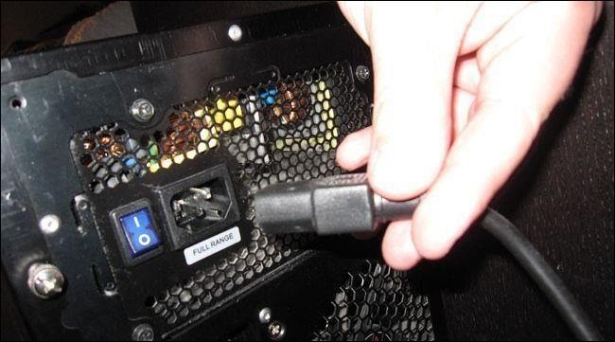

Remove Power coed from CPU

Do not open your computer while it is running or with any cables attached to it. It is always safer to remove all peripherals such as USB cables, audio cables, video cables, and *especially* the power cable. Yes, keeping the power cable connected does ground the PC and it’s often okay to leave it connected while working inside the case. But, even the tiny trace of moisture from canned air can cause trouble if the components are getting power.

Next, move your computer to a well-ventilated area such as your backyard or garage. This is especially important to consider if your computer has built up a lot of dust that will be blowing around. Breathing all that old, accumulated dust isn’t good for you and if you’re in an enclosed space, the dust is just going to settle back on your stuff— including back on your computer.

If you’re limited on space just be sure to keep a vacuum (**not** for cleaning the inside of the computer; more on that soon) nearby for a quick clean up afterwards. And if you’re worried about inhaling dust, you can always stop at your local hardware stop to pick up a cheap dust mask for less than $5.

**Step 2: Gather Your Tools**

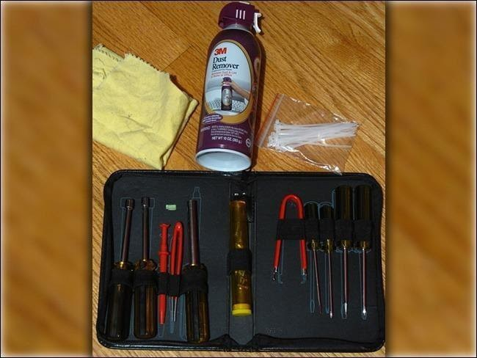

Before you begin opening your computer’s case, you’ll need to gather your cleaning tools. We highly recommend not using a vacuum to clean dust off your computer components. This can create a static buildup and could potentially fry important electrical components on your motherboard, video card, and other places. It’s just a bad idea, so spare yourself the agony and pick up a compressed air can.

That said, a vacuum can come in handy if you’re dusting out your computer inside. Run the vacuum and hold the hose near—but *not touching*—your PC. Blow the dust out of the PC in the direction of the vacuum hose, so the vacuum can suck most of it right up.

There are a few tools you will need to clean your computer:

* Hardware set that includes screw drivers.
* Can have compressed air
* Cleaning cloth
* Zip ties (optional)
* Scissors (optional)
* Cotton swabs (optional)
* Thermal paste (optional)
* Pencil or pen (optional)

**Step 3: Open Your Case**

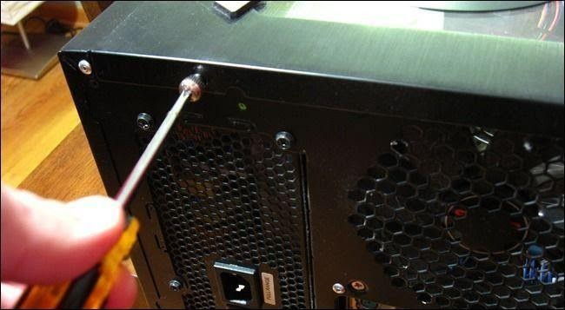

Now that you’re in a well-ventilated area with all your tools gathered, we can start the preparation process by opening up your computer’s case. All computer cases are different. If you’ve never opened yours before and are having trouble opening it, consult your computer’s manual or try searching online for guides specifically about your opening your model.

The case we’re using is a Sigma Luna WB, and, just like most cases, all it takes is unscrewing two screws, and then sliding the side-panel outward. Note that if your side panel has an attached fan, you may have to disconnect a power cable to get the panel completely off.

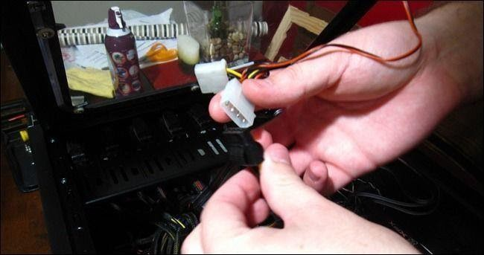

To make the cleaning process easier, it’s best to take out any components that can be easily removed. Most desktop computers allow you to remove RAM sticks, video cards, and hard drives. You don’t need to do this, but you can clean more thoroughly if you do.

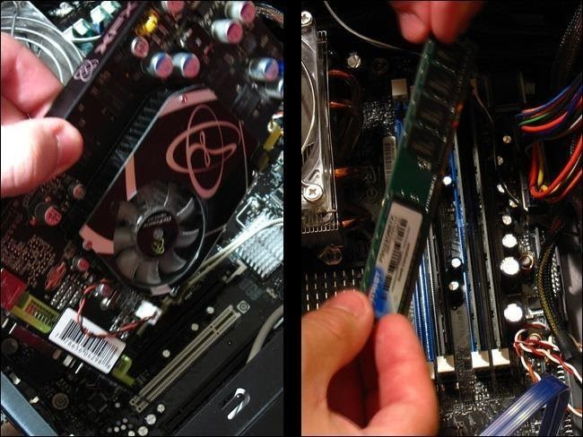

We recommend not removing your CPU because thermal paste that is used to transfer heat from the top of the processor to the fan needs to be replaced every time the fan is removed. If you *are* equipped with thermal paste and want to remove your CPU, just be sure to clean off the old thermal paste on your CPU with rubbing alcohol and a soft cloth. Then apply a fresh coat of thermal paste once you’re done cleaning your computer.

Most people shouldn’t need to remove their CPU and CPU fan. It just doesn’t make sense considering barely any dust makes its way into the CPU socket. Then again, if you’re cleaning your computer, why not go all the way? The choice is yours.

**Step 4: Cleaning**

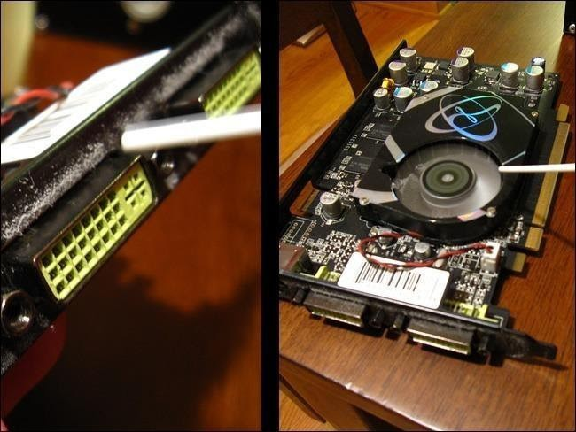

To start the cleaning process, begin with the peripherals we just removed. Grab your can of compressed air and hold the trigger to release a burst of air onto an area with a lot of dust buildup. We’re cleaning an old video card that never got a lot of attention, so there were some dust clumps accumulating around the DVI ports. If you’re cleaning a video card with a fan, you can use a pen or pencil to prevent the blades from spinning while you blow the compressed air.

Next, we move inside the computer case. Start by removing any dust particles that may have found their way inside the RAM slots. Take your compressed air can, aim it at a RAM slot, hold the trigger, and move it down the entire slot. Repeat this for every slot in your computer case.

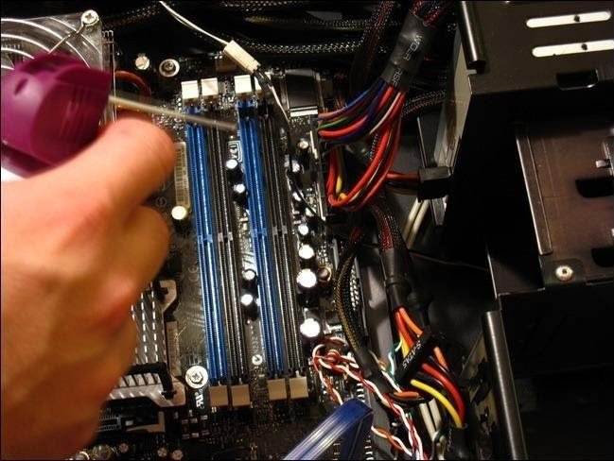

Now we’ll move onto the bigger equipment inside such as your CPU fan and power supply unit. Again, it’s recommended to use a pen or pencil when cleaning fans to prevent the blades from spinning. Use your compressed air can to blow out any loose dust particles.

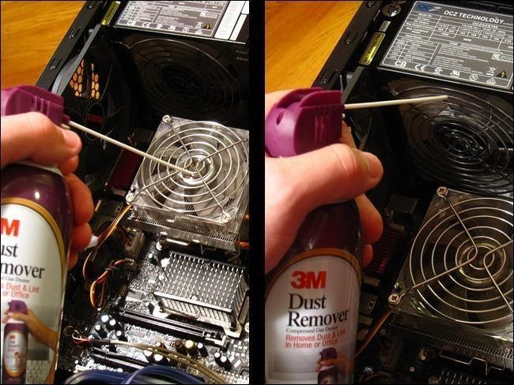

3M dust Remover

You can also use a cotton swab to clean the fan by rubbing the swab against the blades to stick the dust particles. It’s a little tedious, but it makes for a nice, clean fan in the end.

The bottom of your case will undoubtedly have dust buildup. You can begin with blowing the dust away with your compressed air. If there is still dust stuck to the case, you can use a damp cloth to wipe it. Make sure your cloth is not *wet*, but *damp*. Repeat this step for all the nooks of your case.

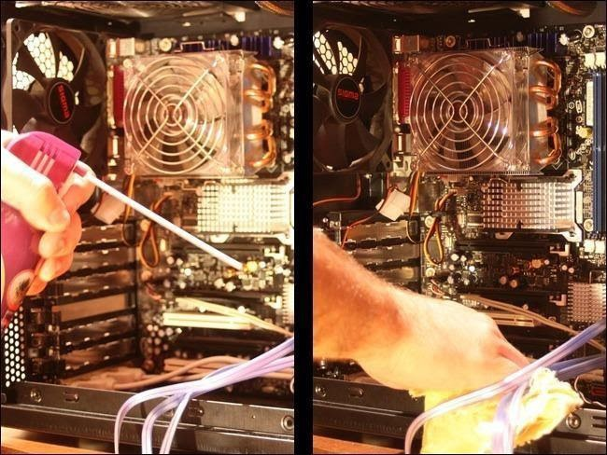

Finally, don’t forget to also clean out any other fans, ports, or enclosures as described above.

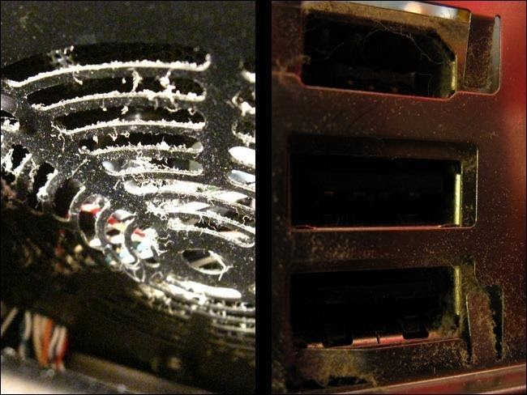

If you’ve got a fan that’s particular junked up, don’t be afraid to use a cotton swab with a bit of isopropyl alcohol to get the blades clean. Give the fans a quick spin to make sure that the blades move freely after cleaning. If they don’t, it’s probably best to go ahead and replace those fans.

**Step 5: Decluttering Cables (Optional)**

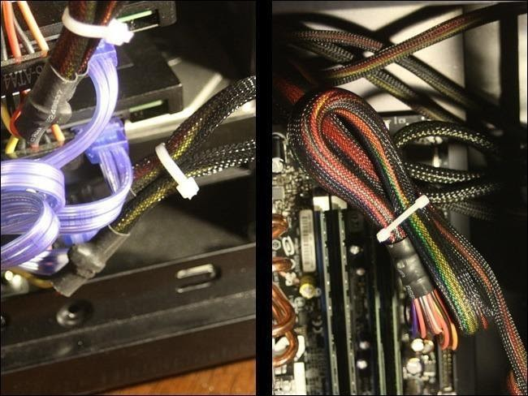

This next step is optional and is recommended for custom built computers. Unlike professionally manufactured computers, custom built computers don’t arrive with nicely tucked away cabling that fits just right. The best way to make your case more

secure and organized is to use zip ties. You also don’t want your CPU fan or any other fans scraping away at cables if they’re not neatly tucked away.

To start you’ll need a pack of zip ties. It doesn’t matter what size or color they are, as long as they can fit around all your cables. We’ll be using 4-inch zip ties. 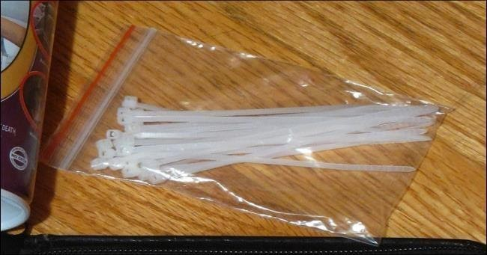

Begin by disconnecting all cables that need to be tied. Be sure to write down how they were connected for reference later and take pictures.

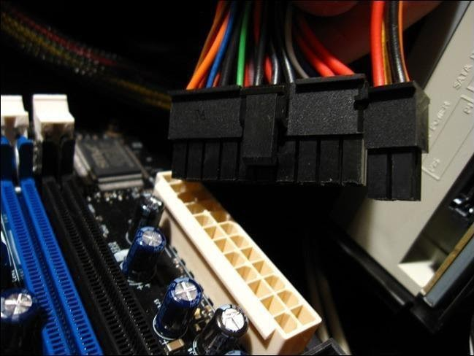

When you have a cable or set of cables grouped to your liking, wrap a zip tie around it and run the thin end through the fastener. Then tighten the zip tie by pulling the thin end until you can no longer tighten it. Grab your scissors and cut off the excess.

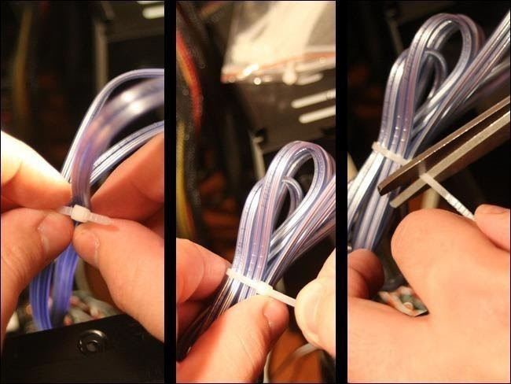

Repeat this step for as many cables as possible. You can then tuck them away to reduce their visibility and give your computer’s guts a cleaner look.

**Step 6: Final**

Plug your cables back into their correct sockets. Refer to your document or pictures from earlier if you don’t remember where each cable goes. Also remember to put back any removed peripherals, such as a video card or sticks of RAM, back into their appropriate sockets.

**Output/Results snippet:**

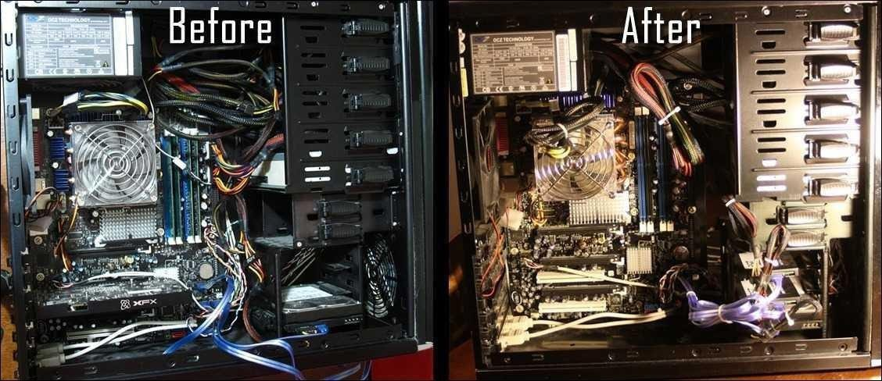

**Check for Boot virus**

**Important:** These infect at BIOS level and usually spread through DOS commands. Due to minimized use of DOS commands now, such malware are harder to come across. Yet, there are ‘boot kits’ that infect the MBR (Master Boot Record) as a means of loading early in the boot process and then concealing the actions of malware running under Windows.

Removing a boot sector virus can be difficult because it may encrypt the boot sector. One of the best options is to use a rescue disc for detection and disinfection. There can be associated risk or failure possible and the only option then will be complete reformatting of the Hard Disc.

In order to remove boot sector virus and scan computer for other malware, we are going to use

Kaspersky Rescue Disk. Perform the following actions carefully:

Boot your computer from Kaspersky Rescue Disk using Graphic Mode. For instructions booting in graphic mode visit here.

After booting in Graphic mode, first of all update Antivirus database. Navigate to My Update Center tab and click on Start Update button. After updating the Antivirus database, Navigate to Objects Scan tab.

You could choose drives to scan for infection. By default Kaspersky Rescue Disk scans

Disk boot sector and hidden startup objects. Now, click on Start Objects Scan.

Wait for the scan to complete.

After completing the scan, the application will ask you to perform some actions with detected threats. You can select one the following actions:

Disinfect: Select this option to repair or disinfect the selected file. Delete: Delete infected files if disinfection fails.

Quarantine: Quarantine contains those files that are detected as threat but its not confirm

that they are malicious or not.

**Output/Results snippet:**

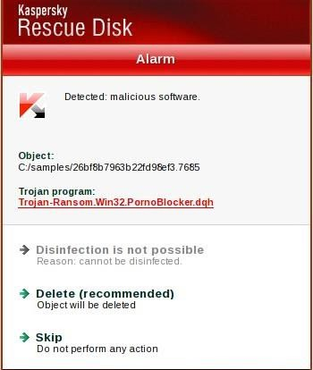

**Reload OS**

**Step 1:** Make copies of all the personal files on your computer.

Remember that a complete reinstallation wipes the hard drive clean, removing all software and all your personal files. You don’t need to make backup copies of your software programs; you’ll need to reinstall those programs anyway when Windows is back in place.

**Step 2:** Choose Start→Turn Off Computer→Restart to restart your computer and watch the screen carefully.

You should see a message to press a function key (F2 probably) or another key combination to enter the BIOS (Basic Input Output System) screen.

**Step 3:** Press the designated key or key combination.

You have only a few seconds to press this key to interrupt the startup process and enter the BIOS screen.

**Step 4**: Look for an option called First Boot Device, Boot Sequence, or something similar;

press the arrow keys on your keyboard to select this field and then press Enter.

You may have to select Advanced Options or another submenu to find it.

**Step 5:** In the resulting screen, select CDROM/DVD and then press the Esc key until you

return to the main BIOS screen. Follow the onscreen instructions to save your new settings and exit BIOS setup.

Your computer will restart from the CD/DVD drive.

**Step 6:** Insert your Windows installation CD into the drive and then restart your computer.

Windows XP, Vista, and Windows 7 present slightly different startup screens. These steps describe the Windows 7 procedure, but the procedures in Windows XP and Vista are similar. The object is to get through the opening screens to the custom install screen, where you can reformat your hard drive and begin a clean installation.

**Step 7:** In the startup screen, select the Install Now option. In the next screen, select I Accept the

License Terms and click the Next button.

You’re asked what kind of installation you want to do.

**Step 8:** Select Custom (Advanced). If you’re given a choice of partitions, select the larger partition for your Windows installation.

In most cases, you have only one or two choices: maybe a small partition (200MB or so) and a large one (30GB–100GB or larger).

**Step 9:** In the next screen, click Advanced to expand the options at the bottom of the screen and choose the option to reformat your drive. Follow the onscreen instructions to reformat your drive and install Windows.

You’re prompted to enter the Windows product key. This key — a set of 25 letters and numbers — may be on the Windows CD/DVD case or on a separate sheet of paper that came with the software. Some manufacturers also place a copy of the key on a sticker affixed to the computer case.

**Step 10:** Follow the onscreen instructions to complete the installation.

You’re all done! After reload successfully you can very version of installed OS like shown below in output screen.

**Output/Results snippet:**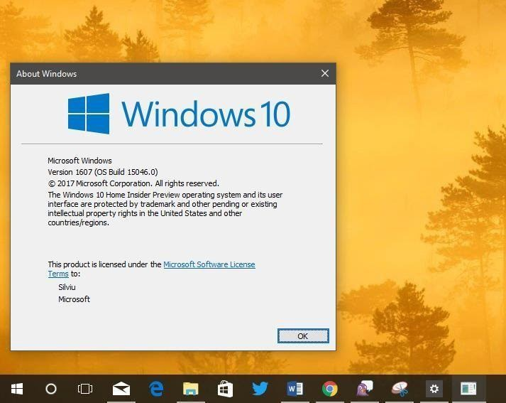

**Activity 8**

**Aim:** Service if system is very slow

**Learning outcome:** Able to perform troubleshooting and maintenance of PC based on the faulty condition.

**Duration:** 3 Hours

**List of Hardware/Software requirements:**

1. Hand Tools

Flat-head screwdriver, Phillips-head screwdriver, Torx screwdriver, Hex driver, Needle-nose pliers, Wire cutters, Tweezers, Part retriever, Flashlight, Wire stripper, Crimper, Punch-down tool.

**Procedure:**

**Close all opened applications**

**Method 1: Alt + F4**

**Step 1:** Simply press the Alt + Tab key once if all programs and windows are in minimized state.

**Step 2:** Next, start pressing Alt + F4 hotkey to start running apps and windows until you see the Shutdown Windows dialog.

**Step 3:** If all programs and windows have been closed, you can press the Enter key when you see the Shut Down dialog to commence shutting down Windows.

**Step 4:** If the Shut Down dialog appears even before closing all open windows and programs, simply press Alt + Tab key once to select an open window or program and then start pressing Alt + F4 hotkey again to kill remaining programs and windows.

Once all windows and programs are closed, you’ll see Shut Down Windows dialog. Simply press Enter key to shut down your PC. Hope this tip helps you in quickly closing all windows and programs.

**Method 2: Close a Group of Windows**

When you have numerous files open in the same program, like a bunch of emails in Outlook, Word files, or several spreadsheets in Excel, you can close all of them at once using the mouse.

Right-click the program in the Windows taskbar and select Close all windows (or Close Group in older versions of Windows).

**Method 3: Use the Task View window**.

Step 1: Click the taskbar task view Image titled Taskview.png icon. It's to the right of the search

bar/icon. Alternatively, press ⊞ Win+Tab ↹ together.

Step 2: Locate the app you wish to close.

Step 3: Move your pointer to the top-right of the app preview, parallel to the title.

Step 4: Click the ✕ button. It'll turn red when highlighted.

**Output/Results snippet:**

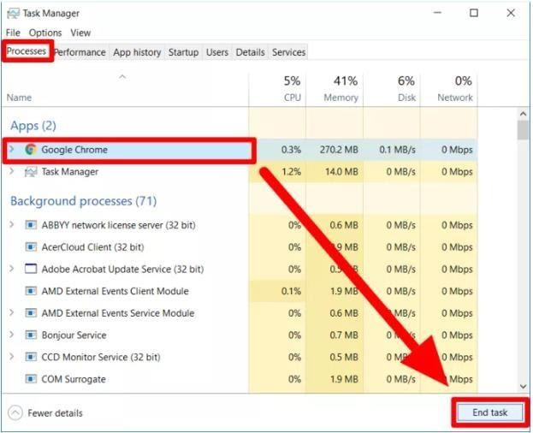

**Run MSConfig and remove all unwanted startup applications**

Step 1: Click Start, point to Run or directly press Windows key + R

Step 2: Type in: msconfig

Step 3: Click on the Startup tab

Step 4: A list of options indicate the programs that start up each time you load Windows.

Step 5: Tick only those that are necessary and click OK

Step 6: You'll be prompted to restart your computer. Click Restart

**Output/Results snippet:**

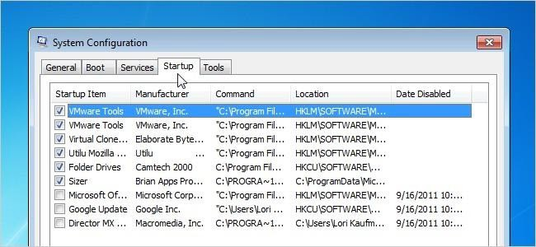

**Check virus affect on OS**

**Scan your PC with Windows Defender**

**Step 1:** Open Windows Defender by swiping in from the right edge of the screen, and then tapping Search (or if you're using a mouse, pointing to the upper-right corner of the screen, moving the mouse pointer down, and then clicking Search), entering defender in the search box, and then tapping or clicking Windows Defender.

**Step 2:** Under Scan options, pick the type of scan you want to run:

o A Quick scan checks only the areas on your PC that malicious software is most likely to infect, and any apps currently running.

o A Full scan checks all the files on your PC. Depending on your PC, this scan might take an hour or more.

o A Custom scan checks only the files and locations that you choose.

**Step 3:** Tap or click Scan now.

**Remove a virus manually**

Windows Defender will typically remove viruses automatically. However, in some cases you might need to remove a virus manually. This can be a technical process that you should try only if you've exhausted all other options, you're familiar with the Windows registry, and you know how to view and delete system and program files in Windows.

First, run your antimalware app to identify the virus by name. If you don't have an antimalware app or if your app doesn't detect the virus, you might still be able to identify it by looking for clues about how it behaves.

Write down the words in any messages it displays, or, if you received the virus in email, write down the subject line or name of the file attached to the message.

Then search an antivirus provider's website or the Microsoft Malware Protection Center for references to what you wrote down or to try and find the name of the virus and instructions for how to remove it.

After the virus is removed, you might need to reinstall some software or restore lost info. Making regular backups of your files can help you avoid data loss if your PC gets infected again. If you haven't made backups in the past, it's a good idea to start now. For more info, see Restore files or folders using File History.

In Windows 7, click Start. In the Search programs and files box, type appwiz.cpl, and then press Enter.

In the list of installed programs, uninstall any other Internet security programs. Restart your PC.

**Output/Results snippet:**

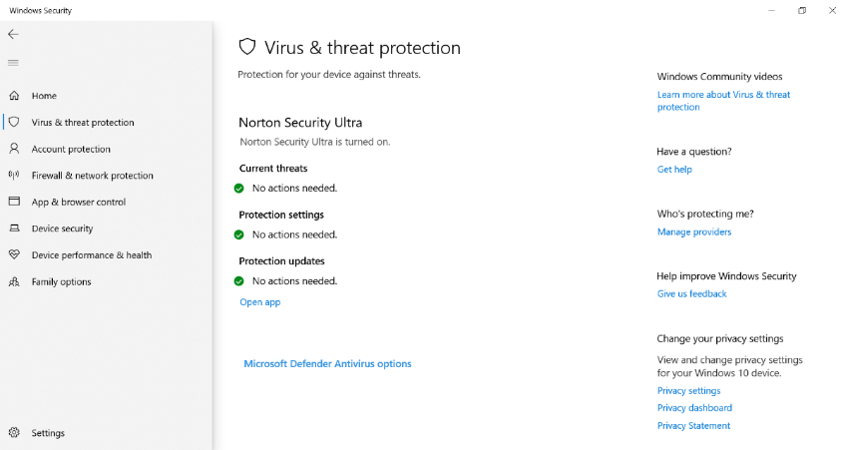

**Activity 9**

**Aim:** Troubleshoot Printer – ( if paper JAM in Printer)

**Learning outcome:** Able to perform troubleshooting and maintenance of PC based on the faulty condition.

**Duration:** 3 Hours

**List of Hardware/Software requirements:**

1. Printer and PC
2. Hand Tools

Flat-head screwdriver, Phillips-head screwdriver, Torx screwdriver, Hex driver, Needle-nose pliers, Wire cutters, Tweezers, Part retriever, Flashlight, Wire stripper, Crimper, Punch-down tool.

1. Cleaning Tools

Soft cloth, Compressed air, Cable ties

1. Diagnostic Tools

A digital multi meter, A loopback adapter

1. Software Tools

Disk Management Tools, Protection Software Tools

Procedure

**Method 1:** Desktop Inkjet Printer

**Step 1:** Turn off the printer. This reduces the chance of damaging the printer or injuring yourself. Wait for the printer to finish shutting down. Unplug the printer for additional safety.

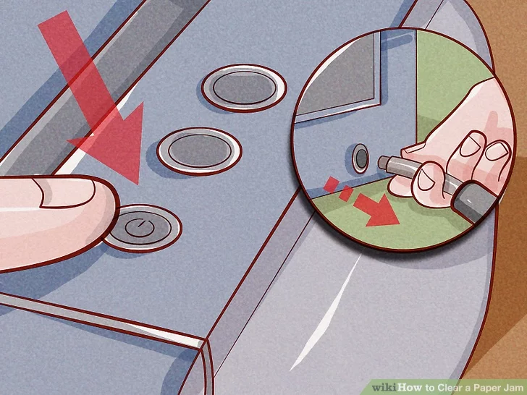

Turn off the Printer

**Step 2 : Open up the main cover.**

Remove all loose paper from the

* Using force may permanently damage the print head.

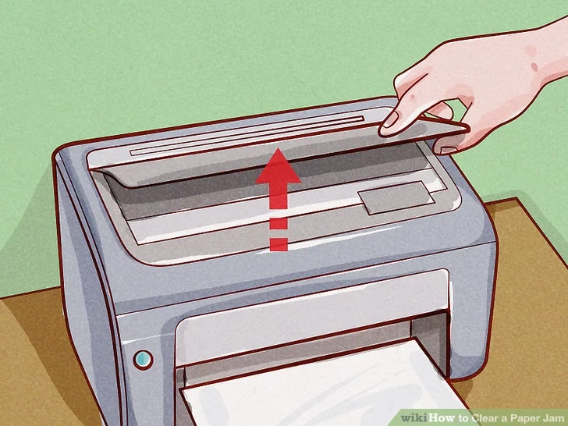

**Step 3: Slowly remove paper.**

To remove paper, grasp it firmly and pull very slowly. If the paper tears, it can spread paper fibers that interfere with printing. Pulling too roughly can also cause injury, as even a powered-off printer may pinch or scrape your fingers.

* Use tweezers to reach narrow areas. Pull even more slowly when using tweezers, and alternate tugging from the left and right ends of the paper.
* Whenever possible, pull in the direction the paper would travel through the printer.
* If there's no way to avoid tearing, grab the paper from both ends of the jam. Try to catch hold of all torn pieces.

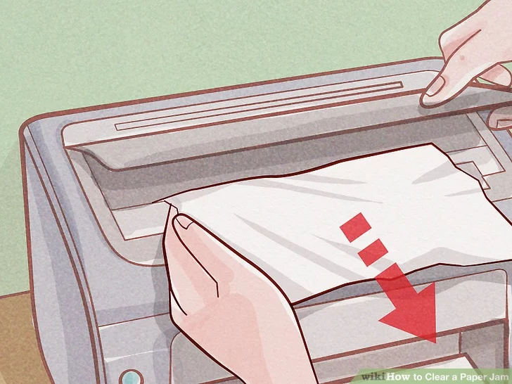

**Step 4: Remove the print head and try again.**

If the paper is still stuck, follow the instructions for your printer model to remove the print head or the ink cartridges. Gently tug out torn paper scraps, or grasp intact crumpled paper with both hands and pull gently downward.

* If you don't have your printer manual, search online for "manual" and the name of your printer model.

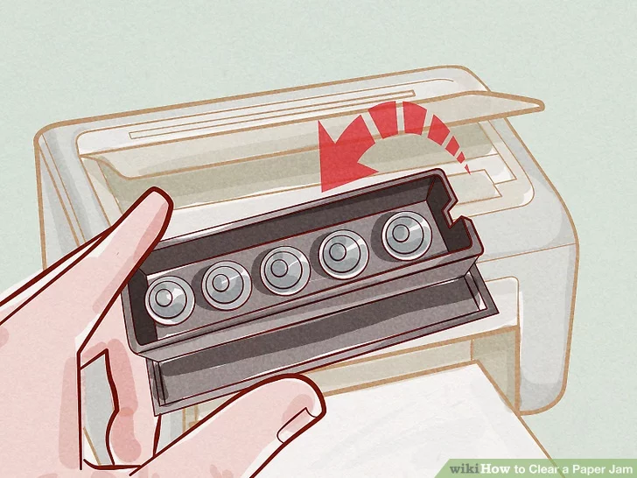

**Step 5: Check the output tray.**

On inkjet printers, paper sometimes gets stuck in mechanisms near the output tray. Look into the slot feeding the output tray and gently remove any visible paper.

* Some models have a knob that will enlarge this slot, making removal easier.

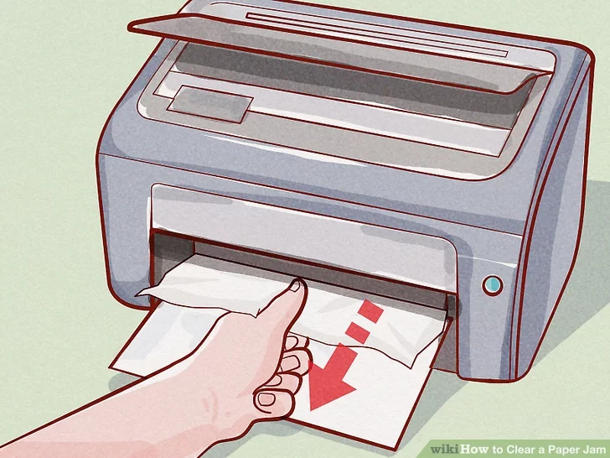

**Step 6: Try further disassembly.**

If the printer still will not function, you can try taking it all apart to search for paper. Because there are many different models of printer, you should look for specific instructions in your user manual. Search online or contact the printer manufacturer if you do not have a manual.

* Many printers have a basic way to remove the back panel and/or the input tray, which are good places to start. Check for movable access panels on the back, and a plastic tab deep inside the input tray.

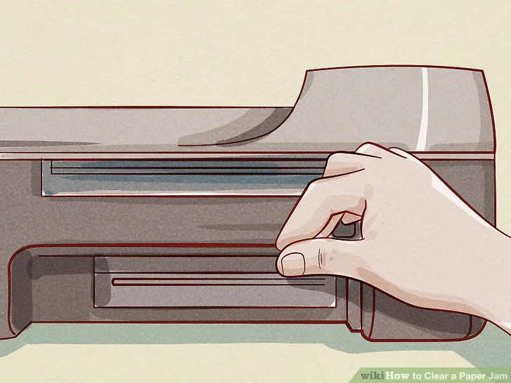

[**Step 7: Clean the print heads**](https://www.wikihow.com/Clean-Print-Heads)**.**

If you've removed the bulk of the paper but still have printing issues, [run a print head cleaning process](https://www.wikihow.com/Clean-Print-Heads). This should get rid of paper microfibers clogging the nozzles.

* Close all access panels and return all trays before you print again.

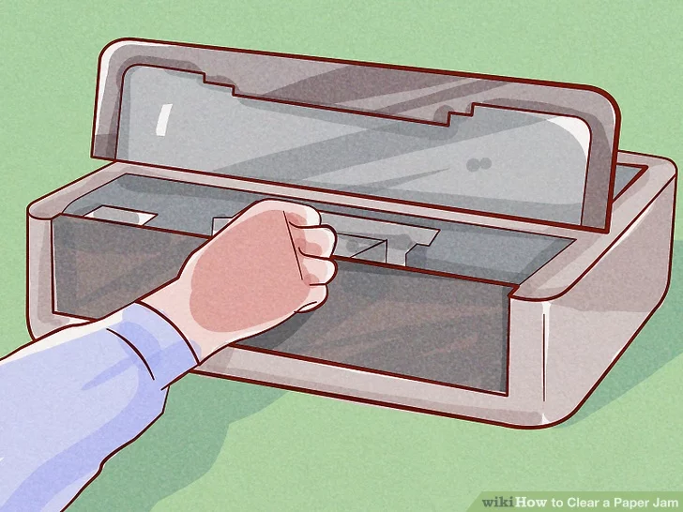

Clean the Printer Head

**Step 8: Look for repair or replacement.**

If the printer still won't work, consider contacting a printer repair service. In some cases, buying a new desktop inkjet printer may be the cheaper option.

**Method 2: Desktop Laser Printer**

**Step 1: Turn off, unplug, and open the printer**.

Turn off the printer and wait for it to finish shutting down. Unplug the printer. Open the main cover, where you would normally put in your toner cartridge.

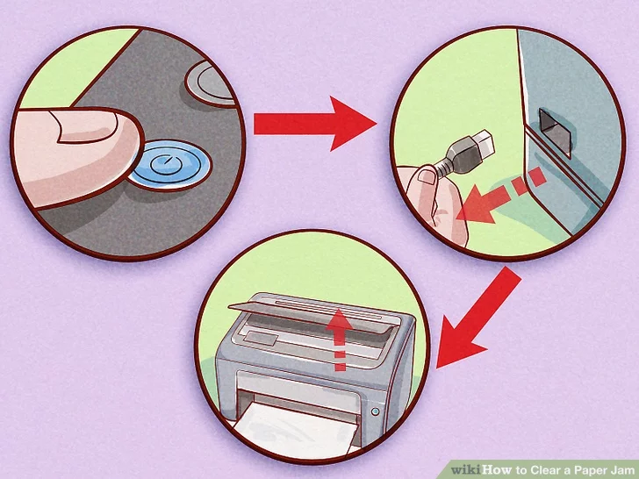

**Step 2: Wait 30 minutes for the printer to cool down.**

During laser printing, the paper passes between two heated rollers, called the "fuser." If the paper has jammed in or near the fuser, wait at least thirty minutes for it to cool down. The fuser reaches dangerously high temperatures.

* Some printer models recommend waiting at least thirty minutes.

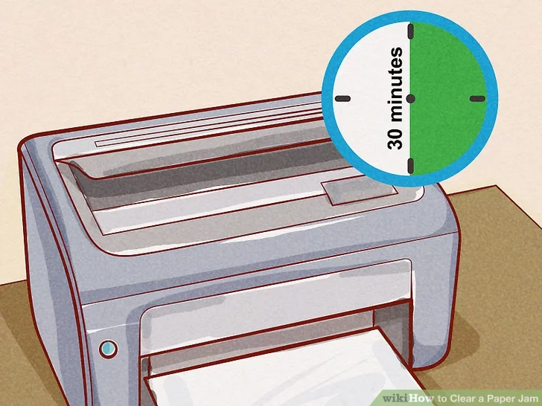

**Step 3: Pull out the print cartridge if you do not see the paper jam.**

In a laser printer, one of the front or top covers will usually expose the print cartridge. If you have not yet found the paper, pull out the cartridge carefully. Pull very slowly, to avoid tearing the paper. Continue patiently until the paper is freed. If the paper does not move, move on to the next step. Do not use force. Most just pull out. A few may require disengaging a latch or a pair of latches.

* If you can't reach the paper, use wide grip tweezers.

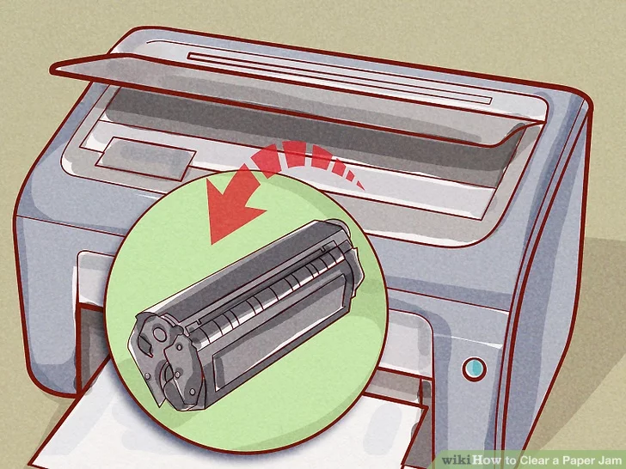

**Step 4: Inspect the rollers.**

Paper jams often occur as the paper passes between the two rollers. If the rollers turn easily when touched, rotate them slowly until the paper is free. If the jamming is complex, with multiple folds or tears, look for the mechanism attaching the roller to the rest of the printer. Carefully remove one roller and lift it out of the printer, freeing the paper.

* It's best to follow user manual instructions. Do not try to force the mechanism.
* Many models use rollers attached with a "hole and pin" latch. Push down on the pin to release the roller.

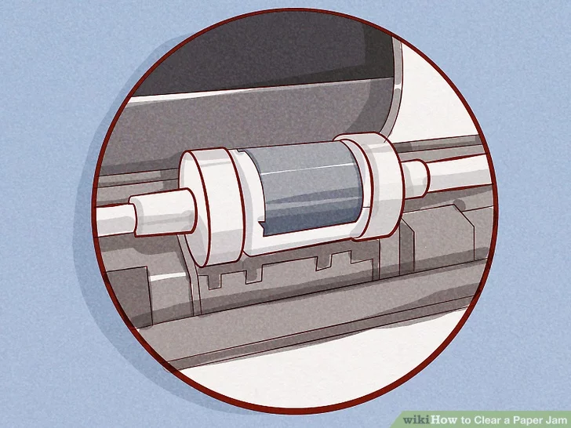

**Step 5: Seek help from a manual or repairman.**

If the paper still won't come out, refer to your printer manual for instructions on further disassembly. If you've removed all the paper but the printer still won't print, hire a printer repair service to inspect parts for replacement.

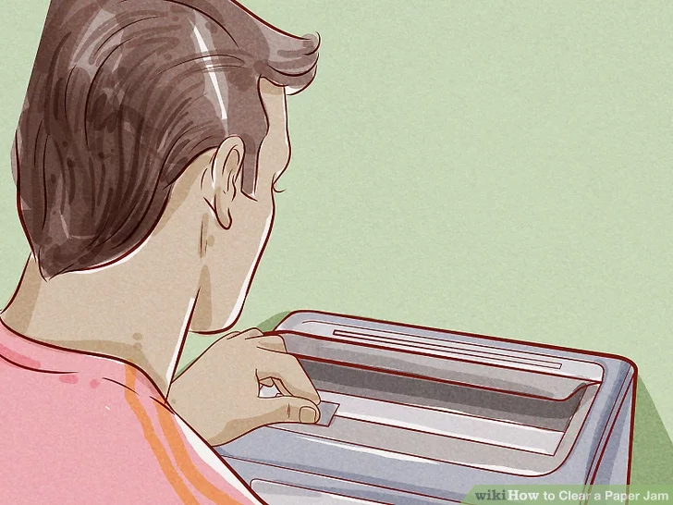

Reference:

<https://www.wikihow.com/Clear-a-Paper-Jam>

/

# Learning Outcome - Able to perform basic troubleshoot of PC

After achieving this learning outcome, a student will be able to perform basic troubleshoot of PC. In order to achieve this learning outcome, a student has to complete the following:

1. Check PC Power Supply. (1 Hrs)
2. SMPS cables and connection to the motherboard. (1Hrs)
3. Check connection of I/O devices to PC. (1 Hrs)
4. Remove and reinsert RAM and reinsert CMOS battery.(1 Hrs)
5. Check HDD/DVD Cables.(1 Hrs)

/

# Activity 1

**Aim:** Check PC Power Supply. (1 Hrs)

**Learning outcome:** Able to perform basic troubleshoot of PC..

**Duration:** 1 hour

## List of Hardware/Software requirements:

1. PC/Laptop
2. Windows/Linux Operating System

## Code/Program/Procedure (with comments):

The power supply is often forgotten when it comes to diagnosing computer problems, but testing your power supply first can save you a lot of troubleshooting headaches down the road. If your computer experiences Blue Screen of Death crashes, hard drive errors, or just plain won’t boot, you may be dealing with a faulty power supply. Run these quick tests before you start swapping out expensive hardware.

## Testing if it Powers On

1. **Shut down your computer:** Once the computer has been shut down, or if it isn’t starting to begin with, flip the switch on the back of the power supply. Unplug the power supply from the outlet.

/

1. **Open your computer case:** Disconnect the power supply cables from all of the components inside the case. Follow each cable from the power supply to the component to make sure that everything is properly unplugged.

Make note of where everything was plugged into for when you reassemble the case.

1. **Make a paper clip tester:** You can use a paper clip to help test your power supply and trick it into thinking that it has been switched on. To do this, straighten a paperclip and then bend it into a “U” shape.
   * This paperclip will act as the pins that are inserted into the power supply that give it the “Power ON” signal.

/

1. **Find the 20/24 Pin connector that normally attaches to your computer’s motherboard:** It is typically the largest connector for the power supply.
2. **Find the green pin and a black pin (pins 15 & 16**): You will be inserting the ends of the paperclip into the green pin (there should be only one) and a neighboring black pin. Before you do this, double check to make sure that the power supply is completely disconnected from any power outlet, that it is switched off, and that it is not connected to any computer components.
   * The green pin is typically pin 15 on a pin chart.

/

1. **Insert the paperclip:** Once you have placed the paperclip into each of the pins, place the cable somewhere where it won’t be disturbed. Plug the power supply back into the outlet, and flip the switch in the back.
2. **Check the fan:** Once the power supply is receiving power, you should be able to hear and/or see a fan moving. This will let you know that the power supply is at least working. If the power supply does not turn on at all, double check your pins (after unplugging) and try again. If it still does not turn on, then it is most likely dead.[1]
   * This test will not tell you if the power supply is functioning as it should, just that it is turning on. You will need to perform the next test to ensure that it is outputting correctly.

/

## Testing the Output

1. **Check the output through software:** If your computer is functional and you can load your operating system, try using software to check your power supply’s output. SpeedFan is a freeware program that will read your computer’s diagnostics and report back your temperatures and voltage’s. Check the readouts to ensure that they fall within accepted tolerances.
   * If your computer does not work, skip to the next step.

/

1. **Shut down the computer:** Unplug the power supply from the outlet. Turn off the power switch on the back of the power supply. Open the computer and disconnect all of the components from the power supply. Follow the cables from the power supply to each component to ensure that everything has been properly disconnected.
2. **Test the power supply with a power supply testing unit:** These are available online and from computer stores, and are not very expensive. Find the 20/24 pin connector on the power supply. This is typically the largest cable for the power supply.

* Connect the power supply testing unit to the 20/24 pin connector.
  + Plug the power supply back into the outlet and turn it on. Your power supply should turn on automatically and your power supply tester will light up.
    - Some power supply testers require you to turn on the power supply using a switch or button on the tester. Others will turn on automatically.
  + Check the voltages. The 20/24 pin connector will have multiple readouts, but there are 4 essential measurements you need to look for:

○ +3.3 VDC

○ +5 VDC

○ +12 VDC

* + - -12 VDC

/

* + Ensure that the voltages are within normal accepted tolerances. +3.3, +5, +12 can all be within +/- 5%. The -12 can be within +/- 10%. If any of the readings are outside that range, than the power supply is bad and needs to be replaced.
  + Test the other connectors. Once you’ve verified that the main connector is outputting power properly, test each of the other connector cables one by one. Unplug and turn off the power supply between each test.

1. **Test the power supply with a multimeter:** Straighten a paperclip and then bend it into a “U” shape. Find the green pin on the 20/24 pin connector. Plug the paperclip into the green pin (pin 15) and into one of the neighboring black pins. This will trick the connector into thinking it’s plugged into the motherboard.

* Plug the power supply back in and turn it on.
  + Find a pinout chart for your power supply. This will let you know which pins provide which voltages.
  + Set your multimeter to the VBDC setting. If your multimeter does not auto-range, set the range to 10V.
  + Connect the negative probe of the multimeter to a ground (black) pin on the connector.
  + Connect the positive probe to the first pin that you want to test. Make a note of the voltage displayed.

/

* + Check the voltages to make sure they fall within the tolerance threshold. If any of the voltages are outside of the tolerance range, then the power supply is defective.
  + Repeat the process for each of the peripheral connectors. Refer to the specific pinout charts for each connector to see which pins to test.

1. **Reassemble your computer:** Once you’ve tested and verified all of the power connectors, you can reassemble your computer. Ensure that all of your devices are properly plugged back in, and that all of the motherboard connectors are properly seated. Once you have finished reassembling the computer, you can try powering it on.
   * If you are still having computer errors, or your computer will not start, move on to other troubleshooting steps.
   * The first place to check will be your motherboard.

/

**Activity 2**

/

**Aim:** SMPS cables and connection to the motherboard. (1Hrs) **Learning outcome:** Able to perform basic troubleshoot of PC.. **Duration:** 1 hour

## List of Hardware/Software requirements:

1. PC/Laptop
2. Windows/Linux Operating System

## Code/Program/Procedure (with comments):

**What is an SMPS?**

SMPS is referred to as Switched Mode Power Supply. It is a device that efficiently provides a regulated voltage, from a different level of input voltage. The device transfers the power from a source (basically an electrical grid) to the computer system. Technically briefing, an SMPS in a desktop system that converts 220V AC and 50HZ into +5V, -5V, +12V and +3.3 V DC at various electrical components in the computer.

## How to keep the SMPS healthy?

* Be sure that SMPS collects voltage at 120V or 220V (household frequency)
* Don’t use a splitter on the source of power
* Be sure that each output is within tolerance (Non-fluctuating Voltage)
* Check the AC Input voltage with the help of a Multimeter.

Common problems appearing from a faulty SPMS

1. The power is not reaching the computer system –

/

Solutions:-

* + Check the power from the source
  + Check the setting of the voltage in CPU
  + Check the front panel of motherboard
  + Check the power supply connections to the motherboard
  + Check the SMPS without connecting to the motherboard.

This step may require the help of professionals and thus, you need to hire a computer repair service in Bunbury.

1. Computer getting started after second or third try – Solutions:-
   * Check the power supply switch on the cabinet
   * Consider replacing SM
2. Display comes to monitor and becomes black – Solutions:-
   * Replace SMPS and try again
   * The problem may arise from Motherboard
3. The PC powers on without display – Solutions:-
   * Check the VGA cable and monitor connections
   * Discard the SMPS, it has been damaged badly by voltage fluctuation
   * Check the Display Card Modem
4. There is a whistling/squealing/motor like noise from SMPS when PC starts – Solutions:-
   * Check the SMPS fan
   * Genuine SMPS problem, consider replacing

/

1. The PC freezes or reboots suddenly – Solutions:-
   * Overheating problem of SMPS

All these solutions need to be applied through professionals to prevent further problems.

## Output/Results snippet:

/

# Activity 3

**Aim:** Check connection of I/O devices to PC. (1 Hrs) **Learning outcome:** Able to perform basic troubleshoot of PC.. **Duration:** 1 hour

## List of Hardware/Software requirements:

1. PC/Laptop
2. Windows/Linux Operating System

## Code/Program/Procedure (with comments):

These parts of the computer are part of a general category of computers called **Input/Output**

**Devices**. When you turn on your computer and push the power button on the computer monitor, you are interacting with an I/O device. When you show your students a video on a flash video site with audio, you are using the speakers, another I/O device. When these parts of the computer are not functioning properly, usage of the computer becomes severely compromised. This section of site will focus on troubleshooting Input/Output Devices.

This section will be broken down into the four major categorical Input/Output decives on the computer that many teachers and students encounter problems with in the school setting. They are:

* + Monitors
  + Keyboards
  + Mice
  + Speakers

**Monitors:** troubleshooting includes discussion of the various settings on the monitor including horizontal and vertical size and position, color hue, degaussing, and connectivity issues.

/

**Keyboard:** includes troubleshooting keyboard devices including dealing with sticky keys, cleaning procedures, and connectivity issues.

**Mice:** includes troubleshooting basic mice devices including erratic mouse movement, cleaning procedures for optical and ball mice, and connectivity issues.

**Speakers:** Includes troubleshooting for computer speakers including lack of sound, on screen volume controls, and connectivity issues.

/

**Activity 4**

/

**Aim:** Remove and reinsert RAM and reinsert CMOS battery.(1 Hrs)

**Learning outcome:** Able to perform basic troubleshoot of PC..

**Duration:** 1 hour

## List of Hardware/Software requirements:

1. PC/Laptop
2. Windows/Linux Operating System

## Code/Program/Procedure (with comments):

CMOS stands for “Complementary Metal Oxide Semiconductor.” The CMOS battery powers the BIOS firmware in your laptop..

BIOS needs to remain operational even when your computer isn’t plugged into a power source. That’s where the battery comes in. When your computer gets unplugged, BIOS relies on the CMOS battery for power.

You’ll find CMOS batteries in both laptops and desktop PCs, but it’s used more frequently in a laptop. That’s because laptops are usually unplugged for a longer amount of time than desktop PCs. Most desktop PCs are unplugged from their power source very infrequently.

The CMOS battery gets charged whenever your laptop is plugged in. It’s only when your laptop is unplugged that the battery loses charge. Most batteries will last 2 to 10 years from the date they’re manufactured. The more you leave your laptop plugged in, the longer your battery will last.

## Here are the CMOS battery failure symptoms:

* + The laptop has difficult booting up

/

* + There’s a constant beeping noise from the motherboard
  + The date and time have reset
  + Peripherals aren’t responsive or they don’t respond correctly
  + Hardware drivers have disappeared
  + You can’t connect to the internet

## boot up problems and incessant beeping

As we mentioned previously, BIOS is largely responsible for booting up your computer. Without the battery, your laptop may have a very difficult time booting up or it may not boot up at all.

You also might hear a constant beeping noise from the motherboard, another indication of a battery failure.

## Time and date from long, long ago

If your laptop manages to boot, you might notice that the date and time have reset. Most likely, they’ve reset to a date long in the past. Even when your computer is shut off, BIOS maintains a real-time clock that tracks the date and time. CMOS (which is sometimes referred to as a

real-time clock, in and of itself) is responsible for maintaining that procedure. So if the date and time have mysteriously reset, that’s a very good sign that the CMOS battery died.

## Keyboard acting wonky

It’s possible that your peripherals don’t respond - you can’t move your cursor or click on any icons or the laptop won’t read any of your keyboard inputs.

Or, your peripherals could be thrown out of whack; your cursor is inaccurate and your key inputs prompt strange responses from the operating system.

Or, your customized keyboard configuration has reset to the default one. These are all signs of CMOS failure, since BIOS is responsible for managing peripherals at startup.

## Drivers disappear

/

If you’ve installed any drivers on your computer, like those used for your home printer, a CMOS failure may cause those drivers to disappear (you’ll have to re-download and re-install them).

## No internet connection

Battery failure may also prevent you from connecting to the internet. BIOS is tasked with maintaining hardware and network drivers.

One thing you should be relieved about is that CMOS failure typically won’t cause you to lose any of your personal files. Nothing in storage is affected. You’ll still have all of your pictures, videos, and documents waiting for you as soon as you’ve replaced the battery.

## How to remove and replace the CMOS battery

Let’s remove that pesky ol’ CMOS battery and replace it with a new one. It’s a relatively simple process. You’ll only need a few supplies:

* + Screwdriver (Phillips or flathead, depending on the type of laptop you have)
  + Compressed air
  + New CMOS battery
  + ESD mat

You can purchase a new CMOS battery online for a very reasonable price, usually between $1 and $10. They are also available, along with ESD pads, at many local retailers like Target, Fry’s Electronics, Best Buy, and office supply stores.

## Find a good workspace

Your laptop components can be damaged by electrostatic discharge (ESD). To avoid building up a charge, don’t work on a carpeted surface. Work on a flat, hard surface. In fact, it’s best to work on a conductive foam pad, if possible. These pads will prevent ESD.

It’s possible that there’s static electricity in your hands. Before you start working, rub your hands on a metal surface to get rid of the charge. Better yet, if you have an anti-static wrist band you probably want to put that on for this DIY project.

/

## Disconnect everything

Shut down your computer and unplug it from its power source. Unplug any and all cables from the laptop, including peripherals.

## Remove the laptop casing

Flip the laptop over. Use the screwdriver to remove the screws holding the laptop casing in place. Remove the casing once you’ve unscrewed it.

Note that on some laptops, there’s only one large casing that needs to be removed. On other laptops, there are several smaller casings that give you access to different computer components. If you’re not sure which casing gives you access you what, you might need to unscrew all the casings and do some exploring.

## Remove the battery

You don’t want the computer to accidentally turn on while you’re working on it. Usually, the battery is long, heavy, and shaped something like a brick.

## Remove the CMOS battery

battery’s orientation so you know which way to put in the new one.By this point, you should see the motherboard. Be very careful when you’re working around the motherboard. This is the most important hardware in your computer and you could seriously damage the laptop if you damage the motherboard.

The CMOS battery is shiny and round. It looks like a button or coin, and it’s usually placed within a small holding socket. Remove the CMOS battery - it slides out of the socket just like the batteries in your mouse.

Pro tip: Before you remove it, make sure to take note of the

## Insert the new battery

Place the new battery in the same location. Make sure you place the new battery in the exact same orientation as the old one.

/

## Reattach the casings

Rescrew each of the casings within the computer. Reinstall the battery. Replace the exterior casing.

1. Test the laptop

Plug your laptop back into its power source and turn it on. BIOS should have defaulted back to its original settings, so don’t be alarmed if the date and time are still incorrect, or if there are drivers missing. You will need to reset the time and reinstall the drivers.

Pro tip: Your laptop shouldn’t have any problem booting up now. If it does, it might be your and not your CMOS.

How to replace the CMOS battery in a desktop computer

. It’s even easier to replace the battery in a desktop because desktop computers usually have a more accessible motherboard.

Use BIOS to overclock your computer

All computers have a programmed “clock speed.” Clock speed refers to how fast a computer processor can read incoming electric pulses of information. The most powerful processors have fast clock speeds.

If you’re a PC gamer or a creative professional, you want an ultra-fast processor. PC games and creative applications, like the Adobe Creative Suite, require your CPU to process and render large quantities of information in a short amount of time. If your processor isn’t fast enough to handle all this data, you might. Obviously, lag is a real killer when you’re gaming.

Some processors allow for overclocking. Overclocking is when your processor operates at a faster speed than what it was programmed for. Hardcore gamers love overclocking because it improves game performance. You can activate overclocking via BIOS. Since we’ve been discussing all things BIOS, we might as well share some overclocking secrets to help you boost your processor speed.

/

Be warned: overclocking may void your PC’s warranty. It may also cause your computer to overheat, which is why you must pay attention to how hot your computer gets when you’re running intensive programs.

It the heat being ventilated from the computer is very noticeable, you should take a break and turn the computer off for a while so it can cool down. Overheating can damage your interior components.

To activate overclocking on Windows 10:

1. Go to Settings —> Update & Security —> Recovery
2. Under “Advanced Startup,” click “Restart now”
3. Your computer will restart, and it will give you access to BIOS settings when it starts back up
4. You need to change the CPU frequency; depending on your computer, there will be an option for “Cell Menu,” “Ai Tweaker,” “CPU Settings,” “Frequency Controller,” or “MB Intelligent Tweaker. Click whichever one appears on your BIOS settings tab.
5. Click the “Adjust CPU Ratio” option
6. Click on the “Auto” setting and press “Enter”
7. You’ll be given a list of alternate settings; choose a number higher than the existing setting and press “Return”

Again, these settings may look entirely different depending on the computer you’re using. No matter what computer you have, just know that you need to access the settings that allow you to increase your CPU frequency/clock speed. You may need to do some experimenting. Be sure not to push your processor until you know that you adjusted the settings correctly.

Some CPU manufacturers, and they may include “auto-overclocking” options you can select. Read this for more information.

/

**Activity 5**

Aim: Check HDD/DVD Cables.(1 Hrs)

**Learning outcome:** Able to perform basic troubleshoot of PC..

**Duration:** 1 hour

## List of Hardware/Software requirements:

* 1. PC/Laptop
  2. Windows/Linux Operating System

## Code/Program/Procedure (with comments):

**Opening the computer**

Open your computer and locate the CD-ROM and each of the cables connected to it. Below is an example of a disc drive, including where each of the cables should connect to the drive.

/

## Verify connections

Your CD-ROM should have at least two cables connected to it: a Molex power cable and an ATAPI / IDE or SATA cable. The IDE or SATA cable should also connect to the motherboard or another interface card, and the power cable should connect to the power supply. Disconnect the cable from the back of the CD-ROM and reconnect it. Do the same on the opposite end of the cable, if possible.

Next, if your CD-ROM drive is not getting any power, disconnect the power cable from the back of the drive and reconnect it.

/

Finally, some computers may have a third cable to interface the CD-ROM with the sound card. If the audio for your audio CDs is not working correctly, verify this cable connects to the CD-ROM and sound card.

## Check jumpers

If you recently installed any new disk drives, such as a new hard drive, verify that the jumpers are correctly set on the back of the CD-ROM. Having the jumpers set improperly to primary or secondary can cause the CD-ROM not to work. If no jumper settings are on the back, remove the drive and get the jumper settings from the sticker on top of the disc drive.

## References:

* <https://www.neweggbusiness.com/smartbuyer/components/how-to-troubleshoot-a-pc-p> [ower-supply/](https://www.neweggbusiness.com/smartbuyer/components/how-to-troubleshoot-a-pc-power-supply/)….
* <https://www.wikihow.com/Check-a-Power-Supply>
* <https://www.gogeomart.com/how-to-connect-or-replace-smps/>
* <https://www.akshatblog.com/smps-psu-power-connectors-or-cables-explained-in-detail/>
* <https://www.tutorialspoint.com/operating_system/os_io_hardware.htm>
* <https://www.computerhope.com/jargon/i/iodevice.htm>

/

* [https://www.quora.com/What-happens-when-the-CMOS-battery-is-removed-and-put-bac k](https://www.quora.com/What-happens-when-the-CMOS-battery-is-removed-and-put-back)
* <https://store.hp.com/us/en/tech-takes/what-is-cmos-battery-how-to-remove-and-replace>

/

# Learning Outcome – Configure Network Protocols

After completing this course, student would be able to configure and use various network protocols

1. Install and Configure DNS service
2. Install and Configure DHCP Services
3. Install and Configure FTP Services
4. Install and Configure HTTP Services

# Activity 1

**Aim:** Installation and Configuring DNS Services

**Learning outcome:** Able to configure different protocol services

**Duration:** 3 hour

## List of Hardware/Software requirements:

1. Windows Server 2012 R2
2. VMWare Workstation
3. Computer with 8GB RAM/500 GB HD **Code/Program/Procedure (with comments): Installing DNS Server Role**

Step 1: From task bar, open server manager dashboard

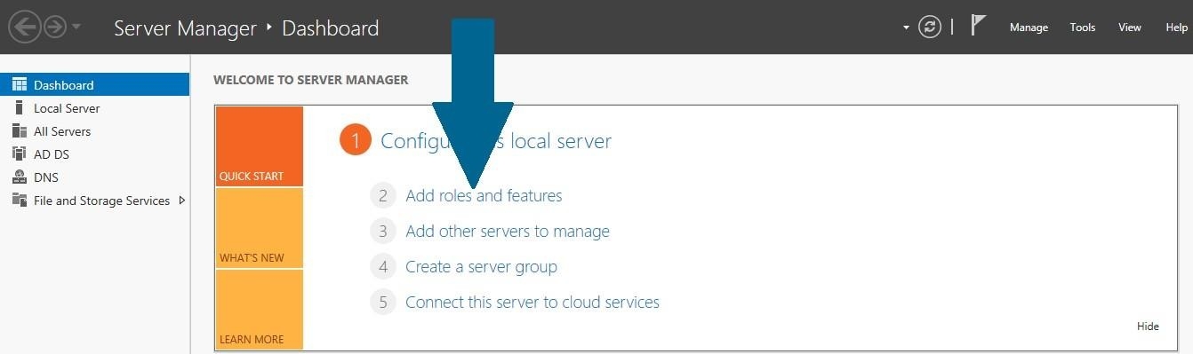

1. Read the notes and meet the prerequisites. Click Next when you are done

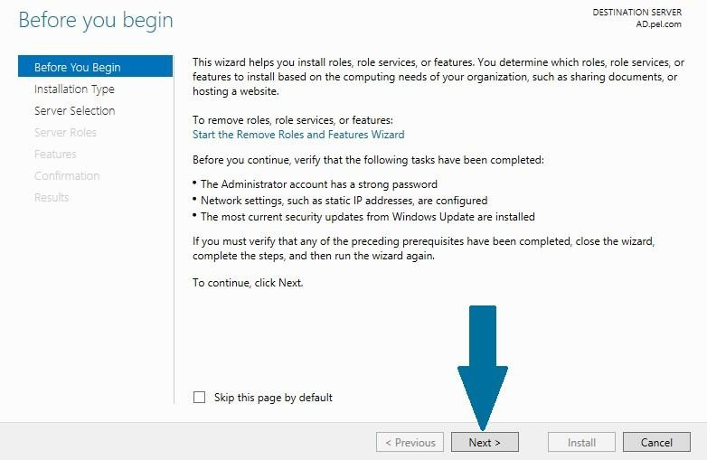

1. Choose **Role-based or feature-based installation** and click **Next**

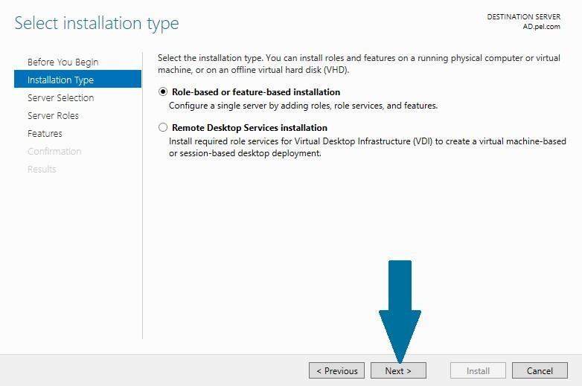

1. Select the destination server from server pool on which you want to configure DNS and click **Next**

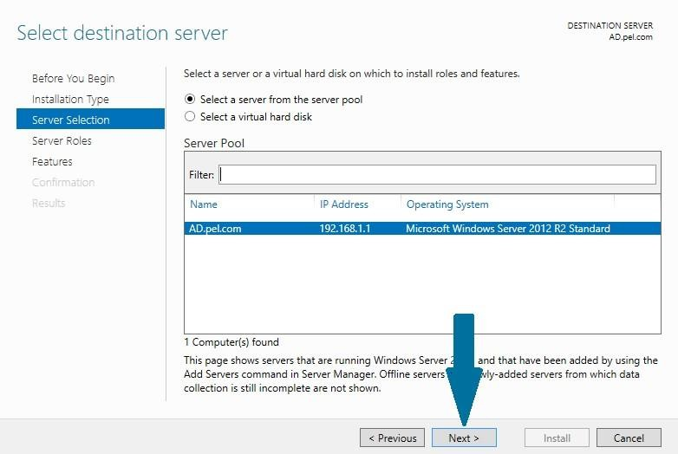

1. Choose DNS Server from server roles. When prompted to install additional necessary features along with DNS server, click **Add Features**

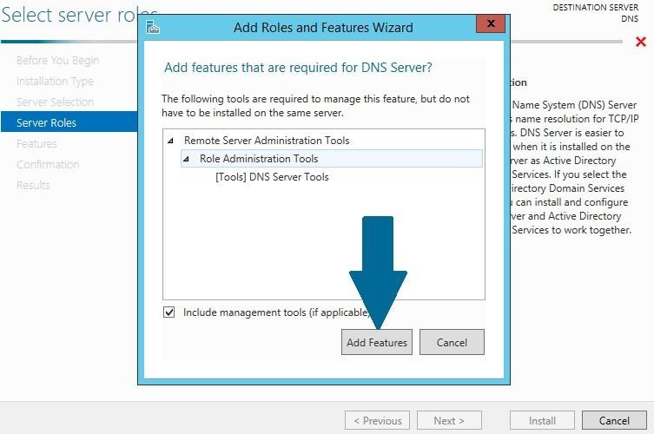

1. Click **Next**

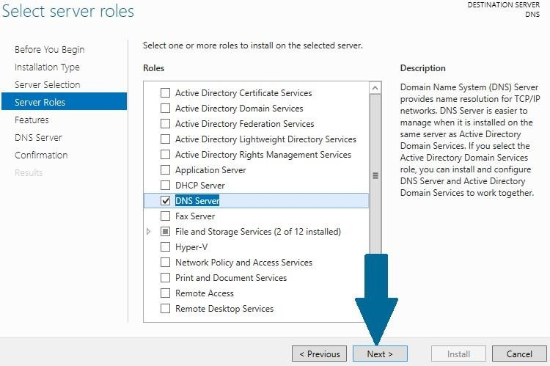

1. Keep default selections and click Next

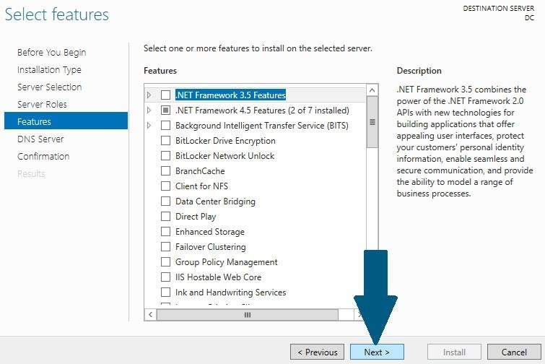

1. Read the important notes and click **Next**

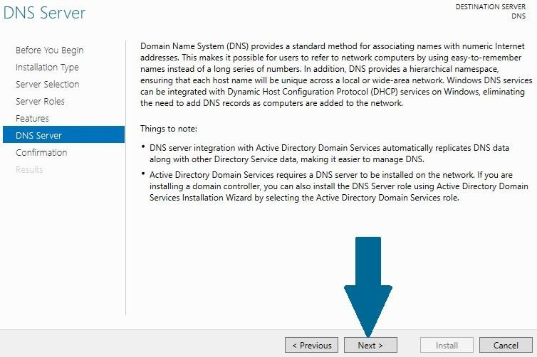

1. Click **Install.** Wait for a moment before DNS role is installed

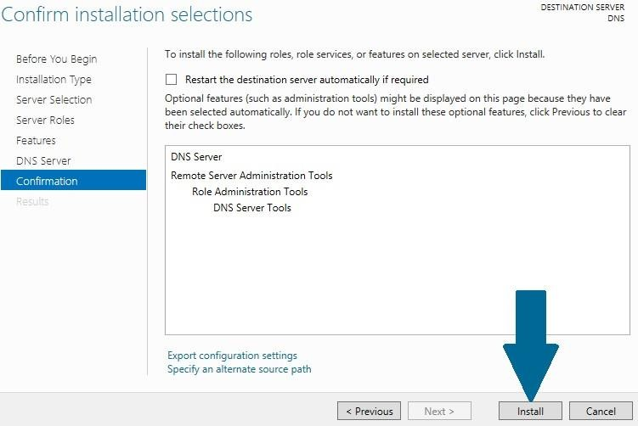

## Configuring Forward Look Up Zone:

1. Open server manager dashboard, and then open tools. Scroll to DNS and click it

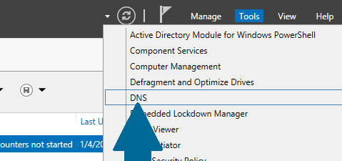

1. Right-click **Forward Lookup Zones** and click **New Zone**

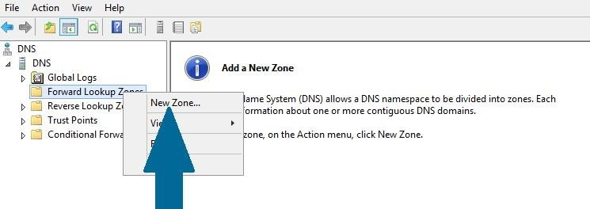

1. Click **Next**

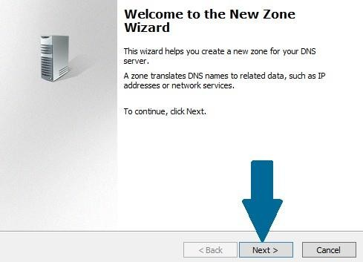

1. Provide the zone name and click **Next**

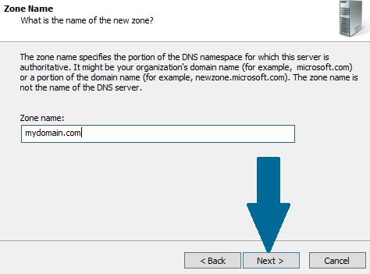

1. Choose **Create a new file with this file name** and click **Next**

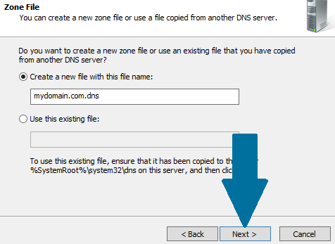

1. Choose **Do not allow dynamic updates** and click **Next**

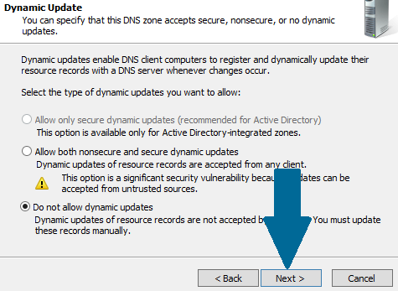

1. Click **Finish** to successfully create the new zone

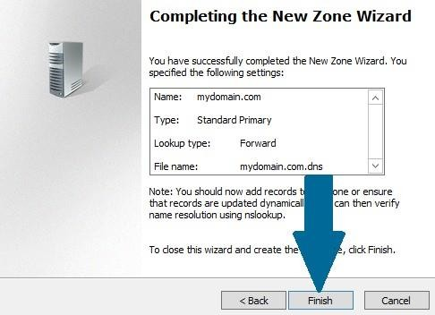

## Configuring Reverse Look Up Zone

1. Open server manager from task bar and click on Tools. Scroll to DNS and then click on it

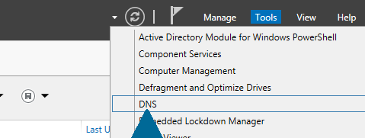

1. Right-click Reverse Lookup Zones and then click New Zone

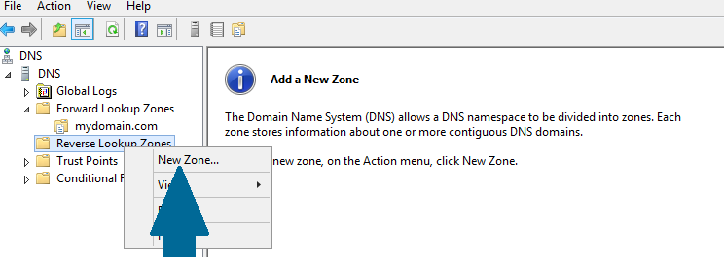

1. Click **Next**

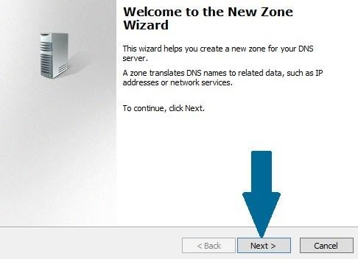

1. Choose **Primary zone** and click **Next**

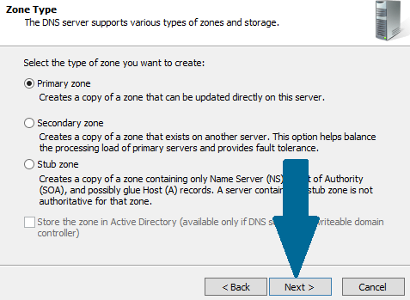

1. Choose **IPv4 Reverse Lookup Zone** and click **Next**

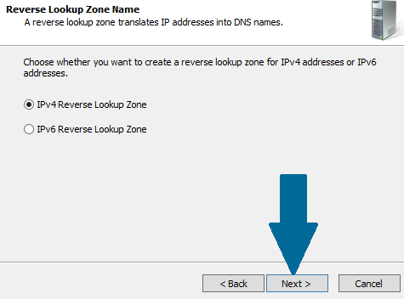

1. Provide **network ID** and click **Next**

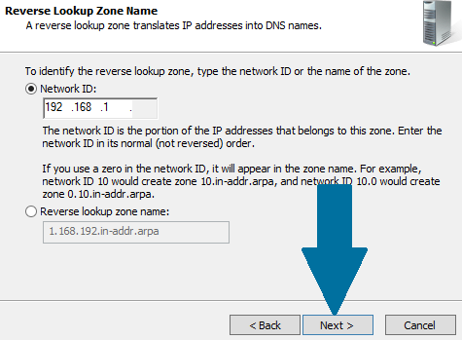

1. Choose **Create a new file with this file name:** and click **Next**

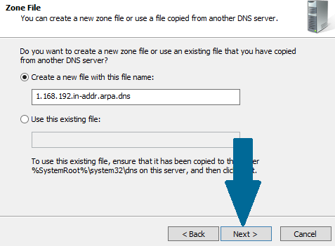

1. Choose Do not allow dynamic updates and click Next

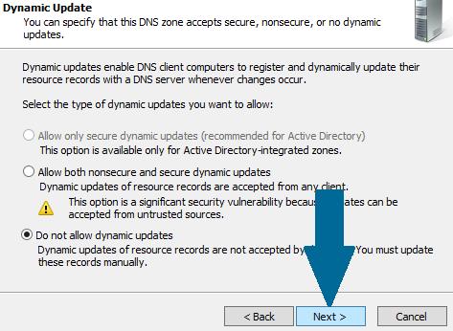

1. Click **Finish** to end the wizard

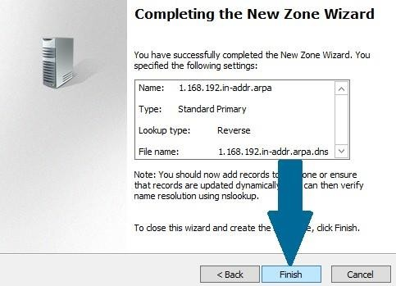

## Adding a New Host Record in Forward Look Up Zone

1. Locate the zone in forward lookup zones and right-click on it. Scroll to New Host (A or AAAA) and click on it

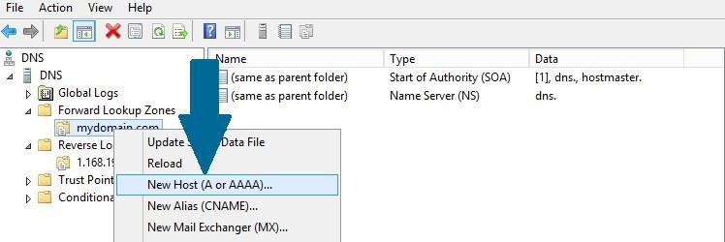

1. Provide the **name** and click **Add Host**

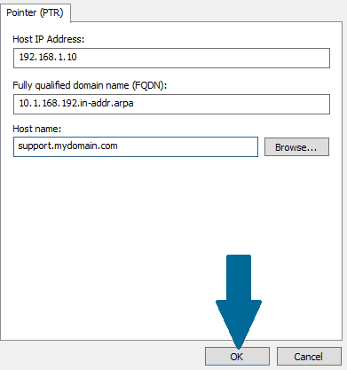

1. To determine DNS Server ->Open **Command Prompt** in Windows Server and type **ipconfig /all.**

## Output/Results snippet:

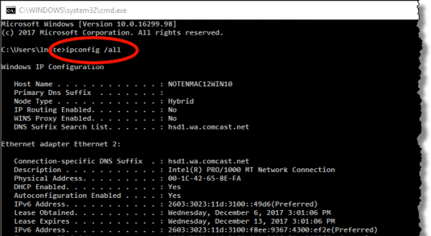

**References:**

* [https://www](http://www.faqforge.com/windows/configure-dns-windows-server-2012-r2-2/).faqfor[ge.com/windows/configure-dns-windows-server-2012-r2-2/](http://www.faqforge.com/windows/configure-dns-windows-server-2012-r2-2/)

# Activity 2

**Aim:** Installation and Configuring DHCP Services

**Learning outcome:** Able to configure different protocol services

**Duration:** 2 hour

## List of Hardware/Software requirements:

1. Windows Server 2012 R2
2. VMWare Workstation
3. Computer with 8GB RAM/500 GB HD

## Code/Program/Procedure (with comments):

**Installing DHCP Server**

1. Open **Server Manager** from task bar and click **Add roles and features**



1. Before you run the installation wizard, make sure that an administrator account has a strong password, static IP is configured, and security updates from Windows updates are installed. When you are done, click **Next**
2. Select **Role-based or feature-based installation** and click **Next**



1. Select a destination server on which you want to install the DHCP server. In our case, there is only one server which is local server and it is selected by default. Click **Next**
2. 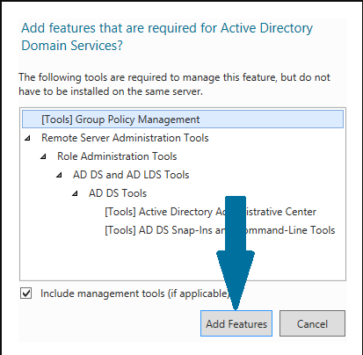Select DHCP server role by checking the appropriate box. As soon as you check the box, a small window will pop up alerting you that there are some other features which are also required to be installed along with DHCP server. Click **Add Features**
3. Click **Next**

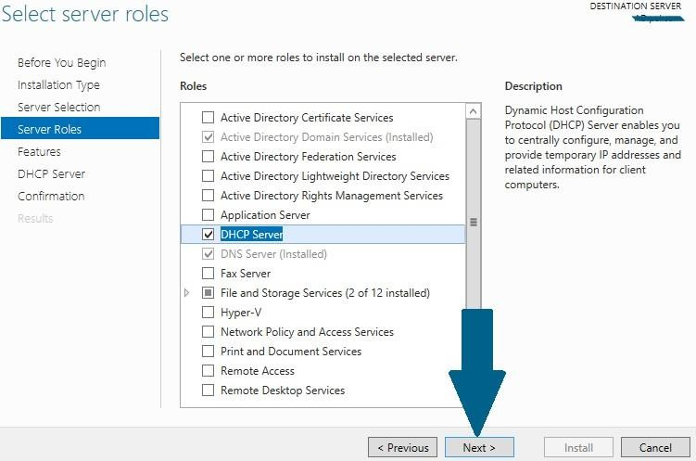

1. Click **Next**

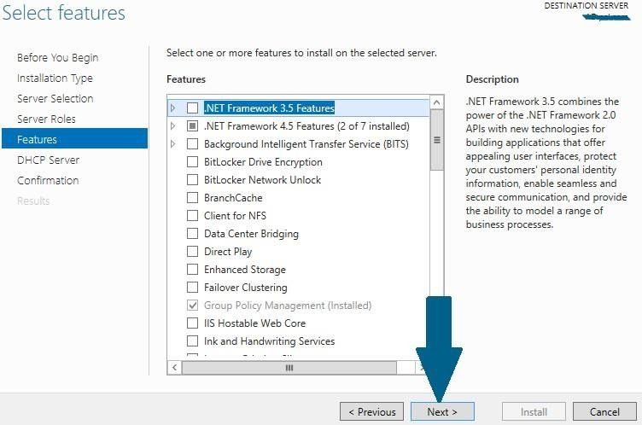

1. Note the things outlined in the screen and click **Next**

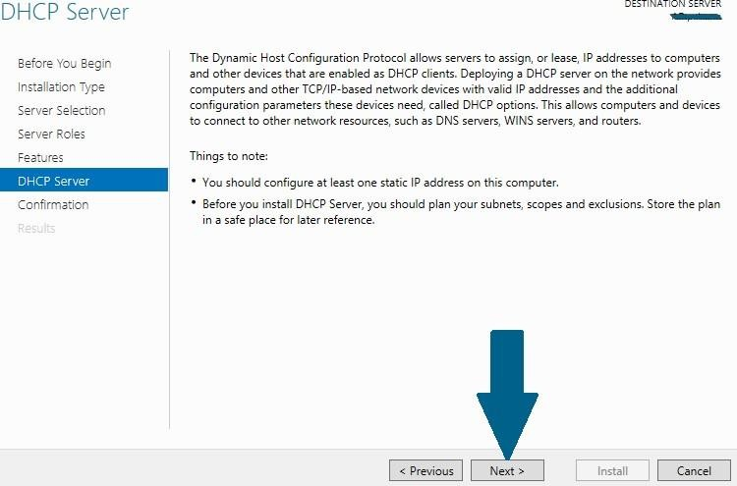

1. Confirm your installation selections and click **Install**

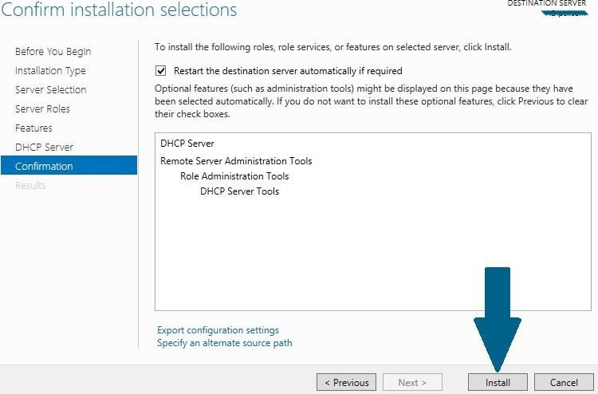

1. Click **Close** to finish the installation

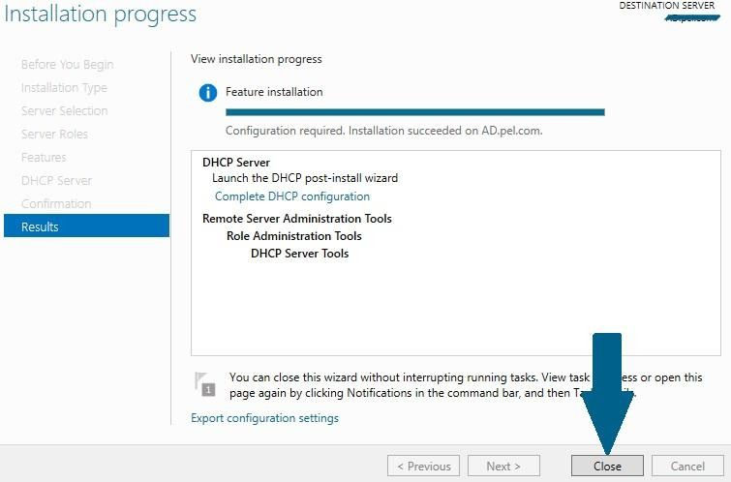

## Configuring DHCP Server and Creating Scope

1. Open Server Manager and click **notifications icon.** A small window will appear. Click **Complete DHCP configuration**

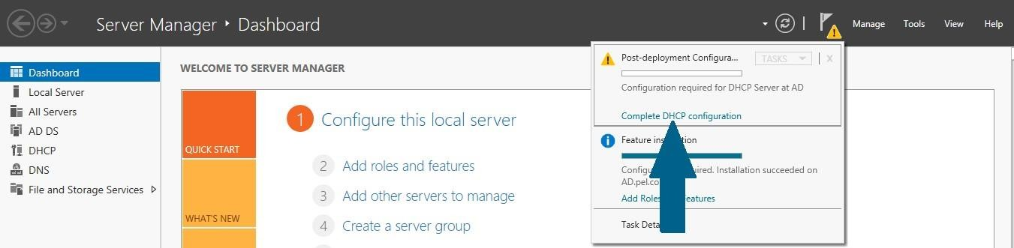

1. Click **Next**

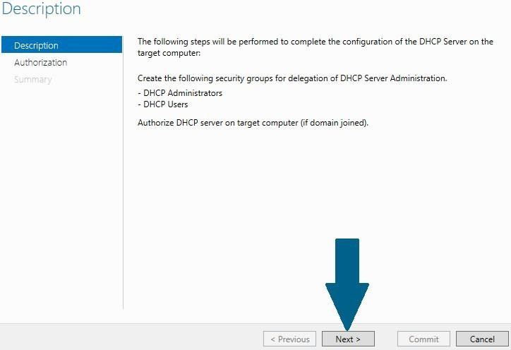

1. Choose Skip AD authorization since we do not have any AD configured and click **Commit**

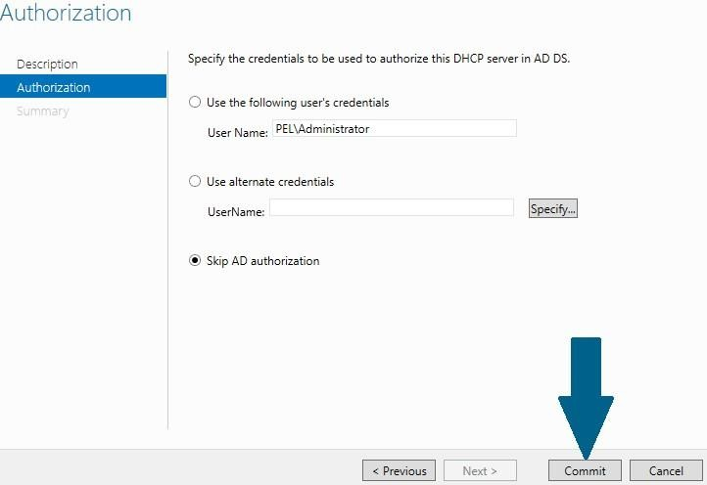

1. Read the summary and click **Close**

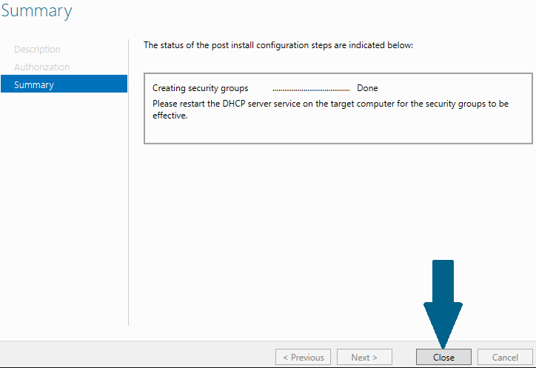

1. Open Server Manager and click on **Tools**. When a small window appear, scroll to **DHCP** and click it

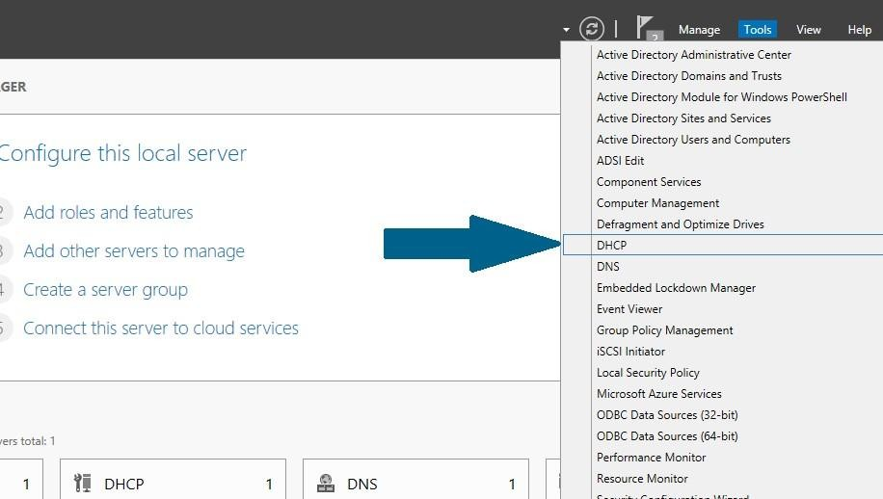

1. In management console, right click on **IPv4** and scroll to **New Scope** and click it.

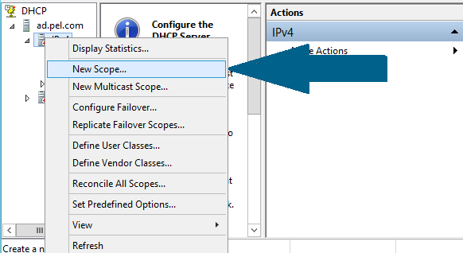

1. Click **Next**

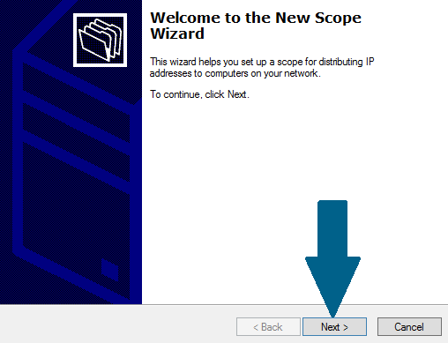

1. Provide name and meaningful description of this new scope and click **Next**

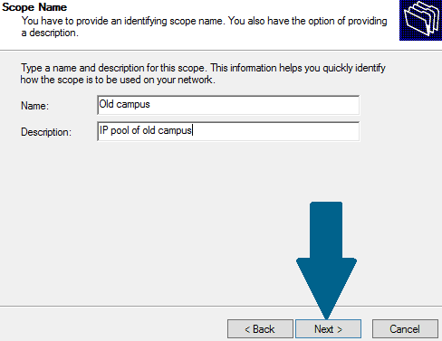

1. 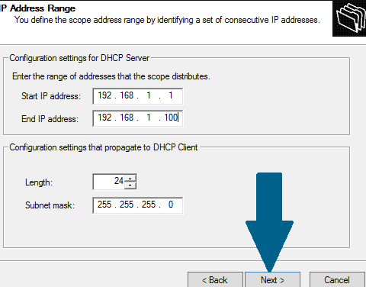Provide IP address range along with sub net you need to distribute to client machines and click **Next**
2. Provide any IP addresses you need to exclude from pool and click **Add**. I have excluded a first IP address which is statically assigned to my DHCP server. Click **Next**

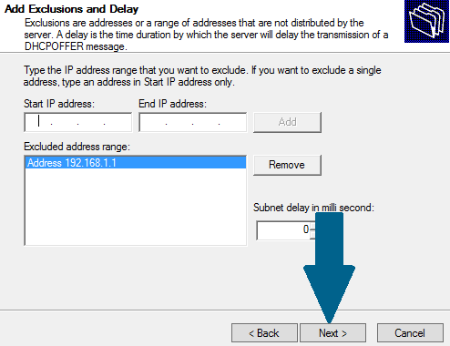

1. Keep lease duration as 8 days and click **Next**

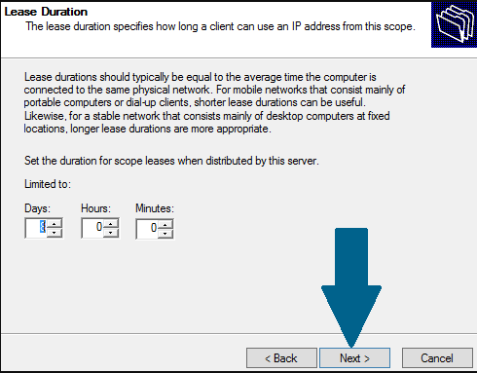

1. Choose **No, I will configure these options later** and click **Next**

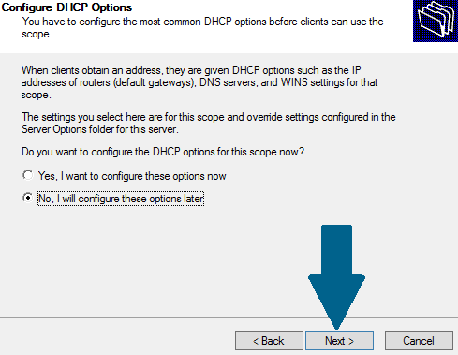

1. Click **Finish** to end the new scope wizard

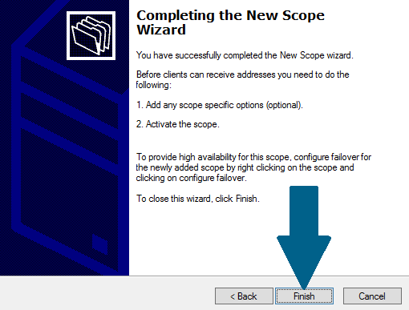

1. Right-click on new scope you just created in above step and click **Activate**

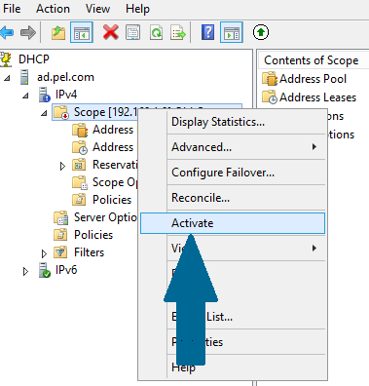

1. Right-click on your server, scroll to **All Tasks** and then click **Restart** to finish with configuration

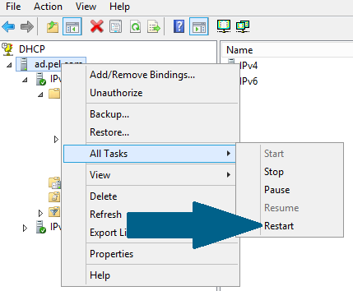

## Output:

**Open Command Prompt and Type : ipconfig /all**

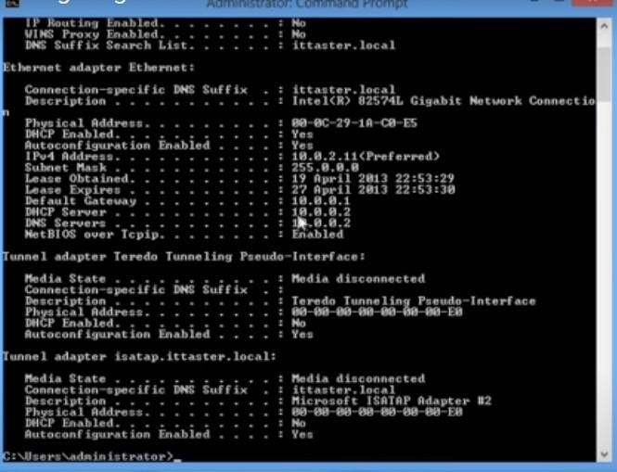

**References:**

* <https://www.faqforge.com/windows/configure-dhcp-server-windows-server-2012-r2/>

# Activity 3

**Aim:** Install and Configure FTP Services.

**Learning outcome:** Able to configure different protocol services

**Duration:** 3 hour

## List of Hardware/Software requirements:

1. Windows Server 2012 R2
2. VMWare Workstation
3. Computer with 8GB RAM/500 GB HD

## Code/Program/Procedure (with comments):

1. Open the Windows Server Control Panel and find the **Add roles and features**.

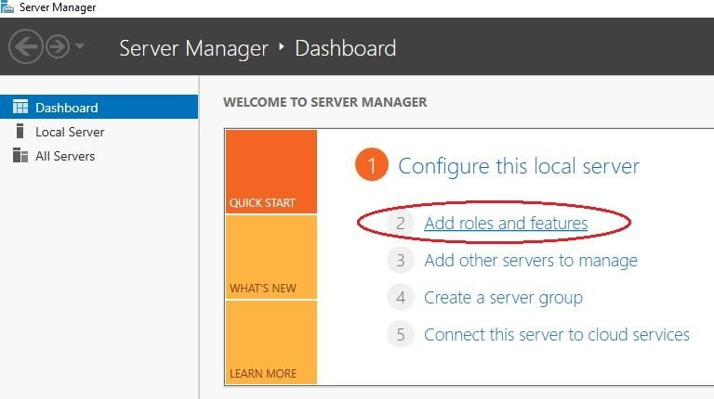

1. As the installation type, specify **Role-based or feature-based installation**.

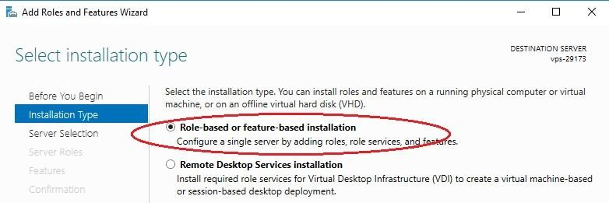

1. Select your server from the server pool.

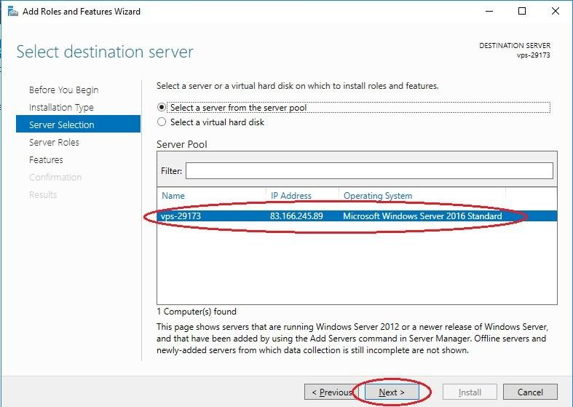

1. In the next window, check the **IIS web server**

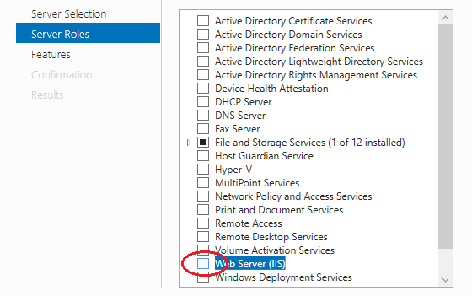

1. In the window that opens, click **Add features**.

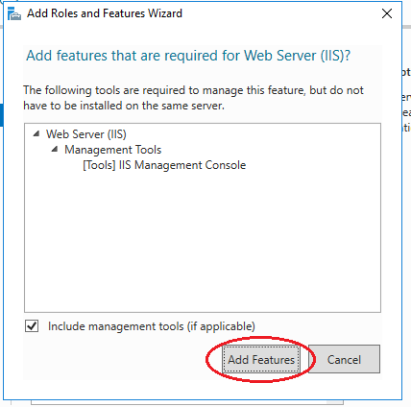

1. In the next window **Features** do not select anything.

Next in the **Role services** window, check the **FTP server**.

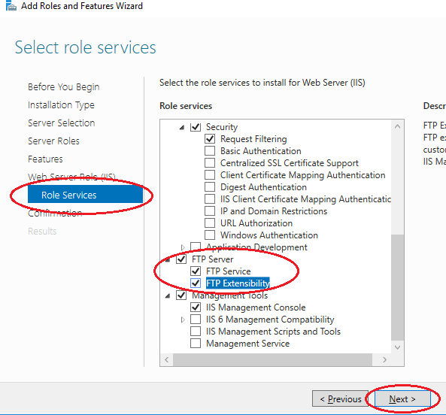

1. Install all selected features on the server using the **Install** button.

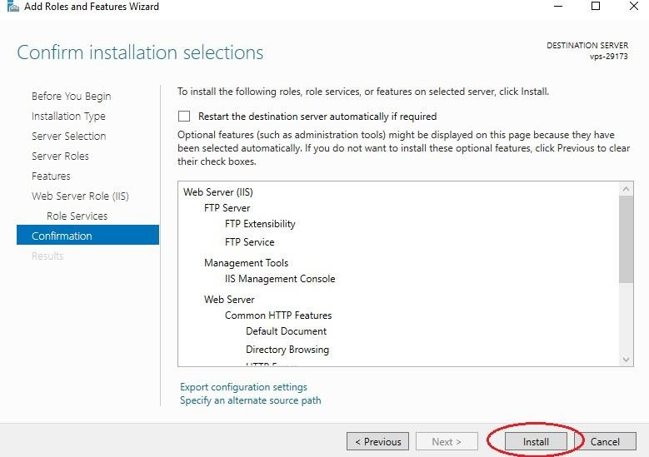

## Creating an FTP site on a Windows server

1. Open IIS Manager.

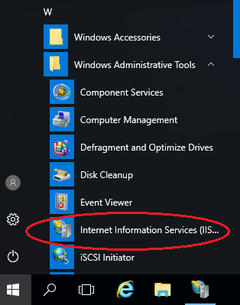

1. Right-click on Sites and select **Add FTP Site** from the menu.

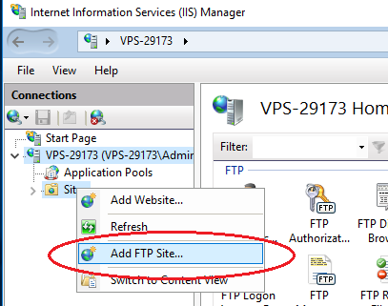

1. Enter the site name and path to the directory.

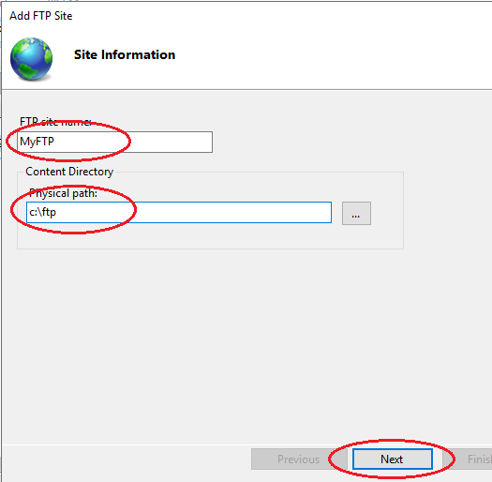

1. Next, select your IP address in the drop-down list. For encryption, check No SSL.

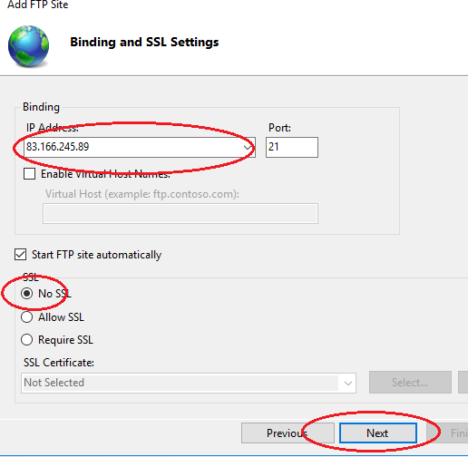

1. In the next window, select Basic for authentication. **Authorization** - Specified roles or groups, enter the name of the group of FTP users (example of creation below). Check the desired read and write permissions and click the **Finish** button.

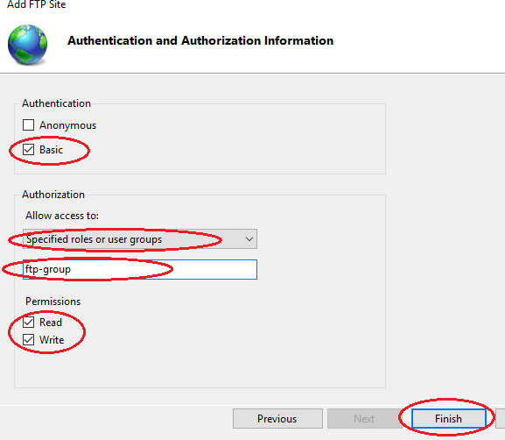

1. Your website will appear in the tree structure of the Windows web server

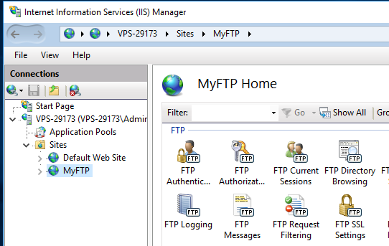

## Create user group

1. Creating a Windows group is necessary to determine the users who will have access to the ftp server. Open Computer Management. In the menu on the right, select Groups. Use the right mouse button to create a new group (New Group).

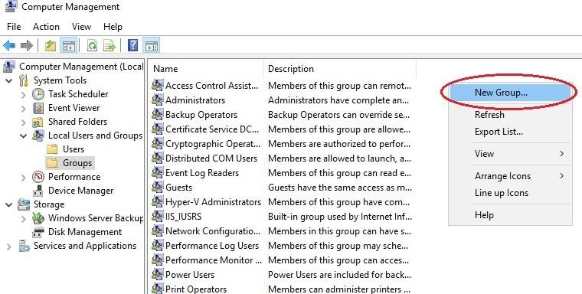

1. 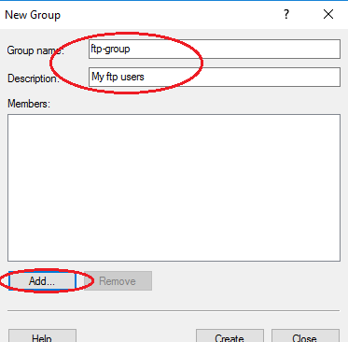In the window that opens, enter the name of the group, a description if necessary. To add a user, click **Add**.
2. Enter a name in the input field, to check it, click **Check Names**. If Windows users exist, click **Ok**.

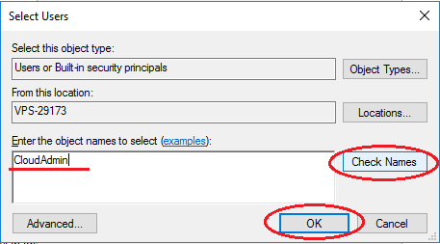

## User isolation

1. 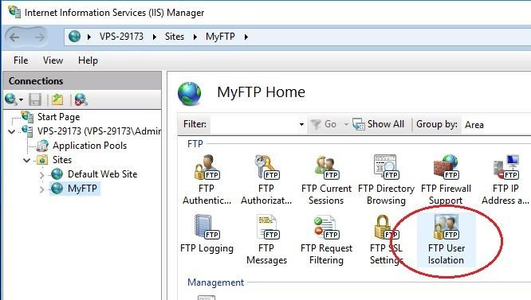In order for each user to get to his own directory and not have access to other files after connecting to the server, it is necessary to set up isolation. To do this, open your ftp site settings and select FTP User **Isolation**.
2. Select the **User name directory** and click **Apply**.

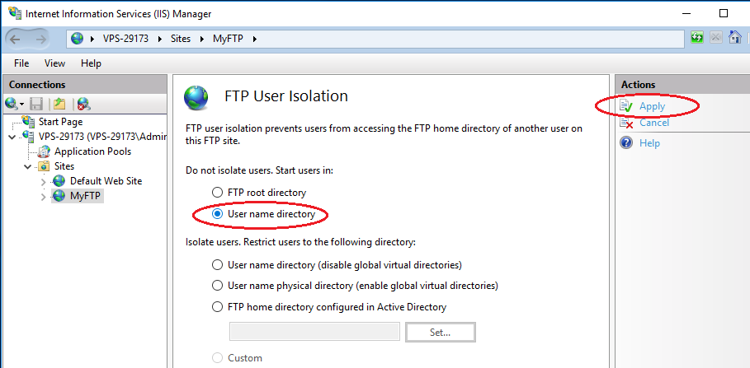

1. 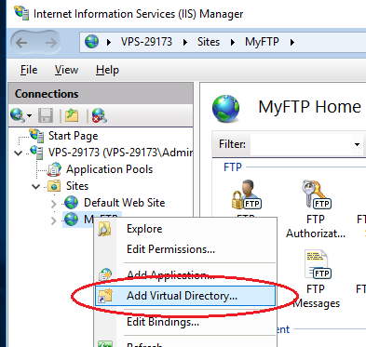Then, using the right mouse button, open the menu of your ftp site and select Add Virtual Directory.
2. In the Alias field, enter a nickname or name, in the path field enter the path to the user directory, to do this, create a subdirectory in the ftp site directory on your Windows server. Click Ok.

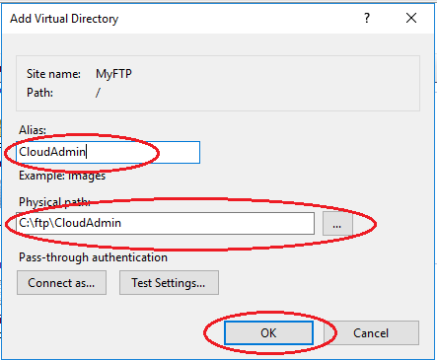

1. 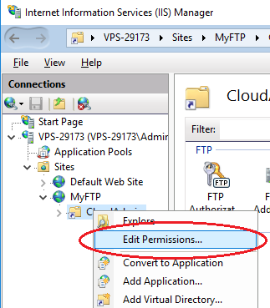To configure permissions in IIS Manager, expand the hierarchical structure of your ftp server. Using the right mouse button, open the Windows virtual directory menu and select **Edit Permission**.
2. Click the **Security** tab and click the **Advanced** button.

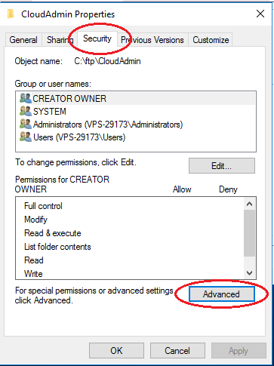

1. 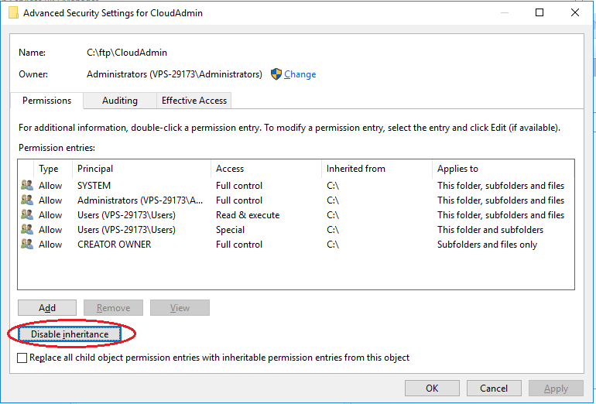In the window that opens, click the **Disable inheritance** button, select the first option in the new window, and then click **Apply - Ok.**

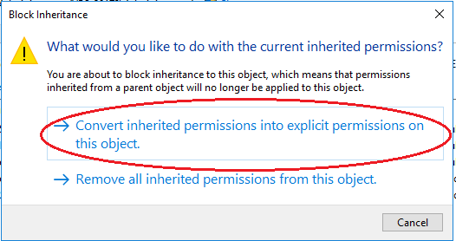

1. Return to the **Security** tab and click the **Edit** button.

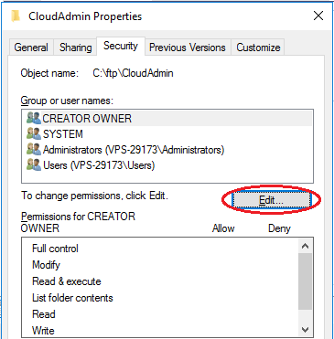

1. Select the Users group in which all users are located and click the **Remove** button. This is necessary so that only the owner of the directory has access to it.

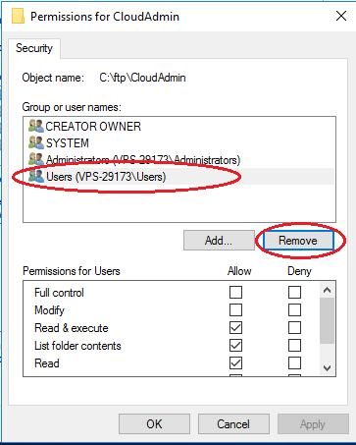

1. 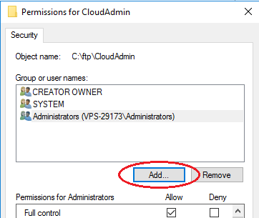Now add a Windows user who will have full access to the directory. Click the **Add** button.
2. Enter the username of the virtual directory in the input field, to check it, click **Check**

**Names**. If users exist, click **Ok**.

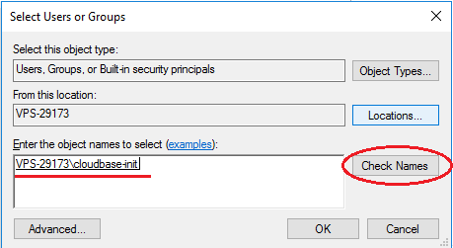

1. Next you need to add rights for complete control of the directory. Select the created user

and check all fields Allow (Permissions).

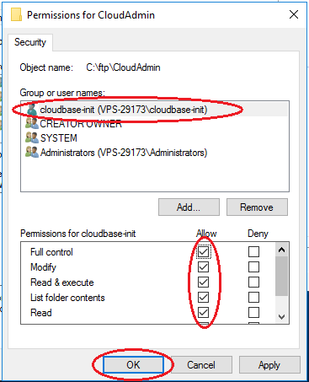

1. Next, click **Apply - Ok**.

## Firewall Setup

1. For an external connection to the ftp server, you must configure the firewall. To do this, open **Windows Firewall with Advanced Security**. In the vertical menu on the left, select **Inbound rules**, then in the vertical menu on the right **New Rule**.

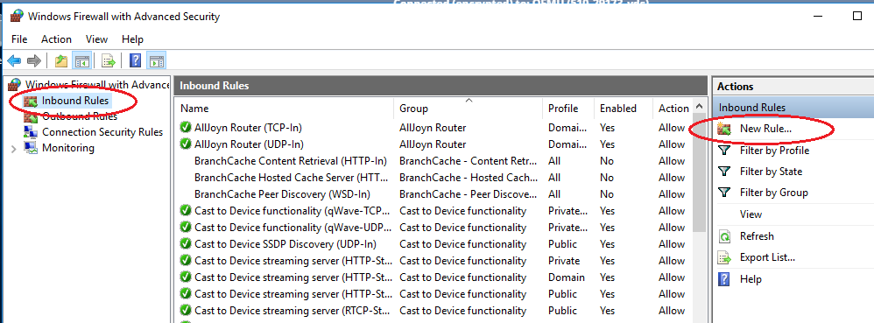

1. 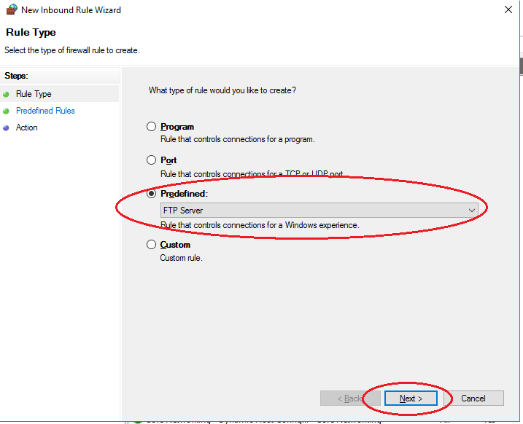In the window that opens, check the **Predefined** type and select FTP Server from the drop-down list. Click **Next**.
2. Select and Mark all the lines and click **Next**.

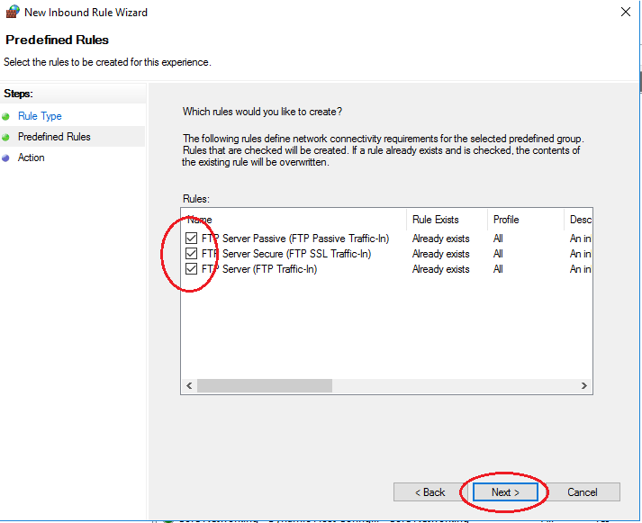

1. 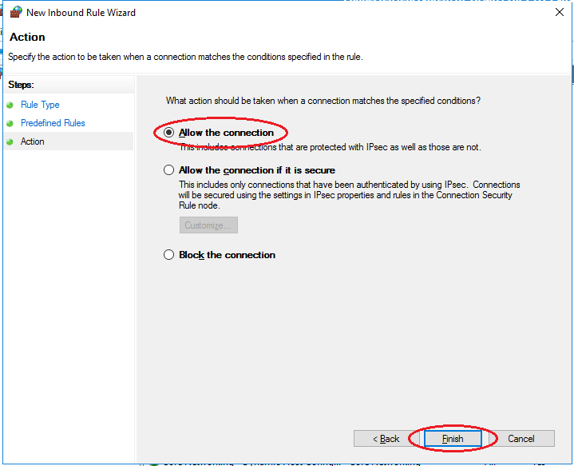In the next step, select **Allow the connection** and click **Finish**. For these rules to take effect - restart the server.

## Connect to an FTP server

1. You can connect to an FTP server in several ways, for example, through the standard Windows utility - Explorer, or through the FileZilla program.

Consider connecting through Explorer. In the address bar, enter: ftp://ipaddress

For example,

ftp://83.166.245.89

1. 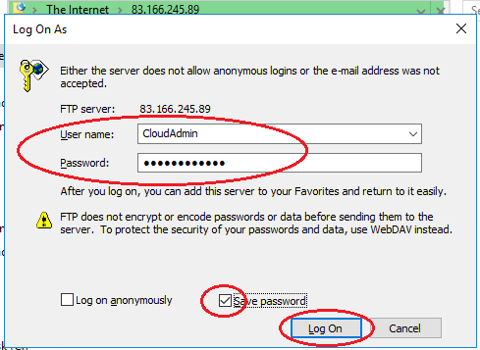The login and password input window will open, specify the connection data from the server control panel.

## Output:

As a result, you will see the contents of the FTP server folder:

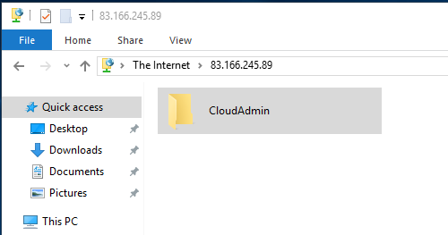

References:

* + <https://neoserver.site/help/setting-ftp-server-windows-server-2016>

# Activity 4

**Aim:** Install and Configure HTTP Services

**Learning outcome:** Able to configure different protocol services

**Duration:** 2 hour

## List of Hardware/Software requirements:

1. Windows Server 2012 R2
2. VMWare Workstation
3. Computer with 8GB RAM/500 GB HD

## Code/Program/Procedure (with comments):

1. Download the Apache Software form <https://www.apachelounge.com/download/>and

select the Operating system type 32-bit or 64-bit.

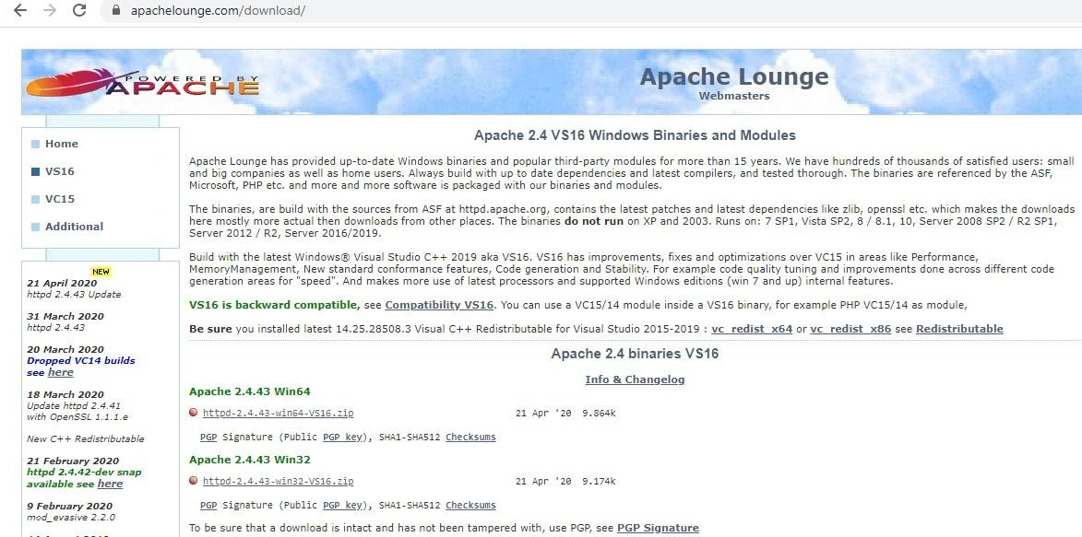

1. Go to Downloads and extract the ZIP file to the root of the C: drive

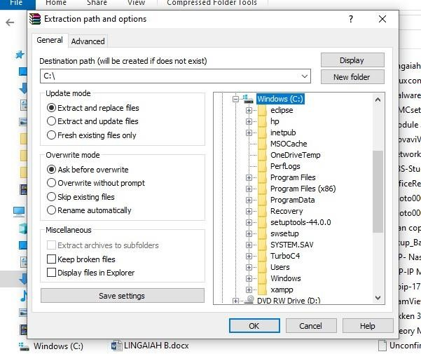

1. Open ” C:/Apache24/conf “and select httpd.conf and open with notepad.

If there is no any other web services running on your machine then keep “Listen 80” otherwise change it to “Listen 81”.

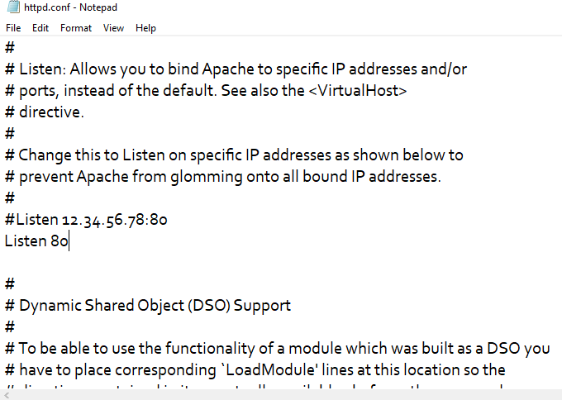

1. Test your installation open command prompt and type C:\Apache24\bin press enter and Next-> type httpd –t in command prompt.

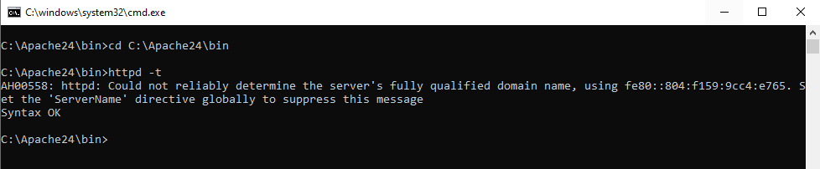

1. To Start Apache in the command prompt type: httpd.exe

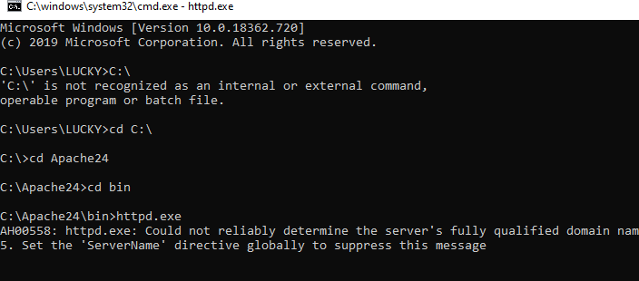

1. We can test your installation by opening up your Browser and typing in the address:

[http://localhost](http://localhost/)



1. To stop the apache service press Ctrl+C in Command Propmpt.

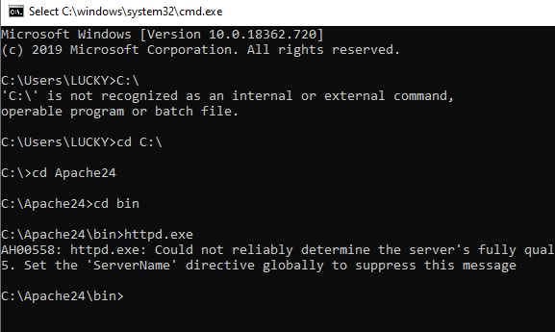

1. To install as a service. Open command prompt as Administrator and type:

>httpd.exe -k install

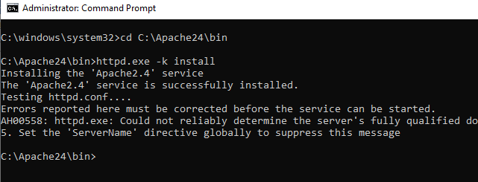

1. we can start/stop the service with the command:

>services.msc

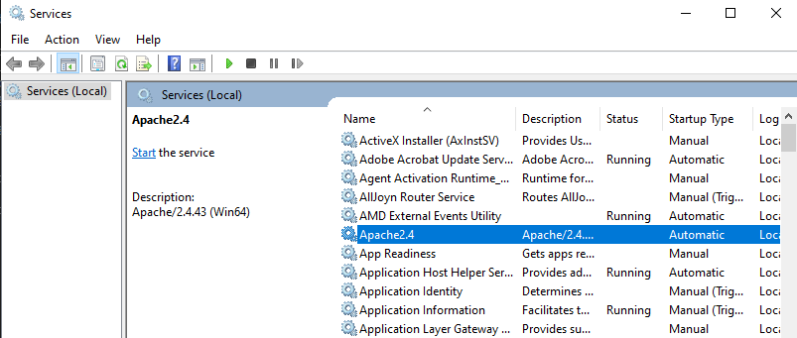

## Output:



**Reference:**

* + <https://www.sitepoint.com/how-to-install-apache-on-windows/>

**Learning Outcome - Able to install & configure the different types of network devices in a network**

*/*

After achieving this learning outcome, a student will be able to install & configure the different types of network devices in a network. In order to achieve this learning outcome, a student has to complete the following:

* 1. Configure & Implement Unmanageable Network Switch (3Hrs)
  2. Configure & Implement Manageable Network Switch (2Hrs)
  3. Install and configure router, bridges and HUB (3Hrs)
  4. Configure Wireless Access Point ( 2Hrs)
  5. Install and Configure Wire Network ( 2Hrs)
  6. Install and Configure Wireless Network ( 2Hrs)
  7. Install of AD-hoc Wireless Network ( 1Hr)
  8. Configure Gateway Service for Internet Connectivity (3 Hrs)
  9. Configure ADSL+2 Router for ISP Internet Connectivity (2Hrs)
  10. Troubleshoot Internet Connectivity (5Hrs)

*/*

# Activity 1

**Aim:** Configure & Implement Unmanageable Network Switch.

**Learning outcome**: Able to install & configure the different types of network devices in a network.

**Duration:** 3 hours

## List of Hardware/Software requirements:

1. Unmanaged network switch
2. Ethernet cables with connectors
3. Computers/Digital Devices with pre-installed operating system (Windows, Linux, etc)

## Code/Program/Procedure (with comments):

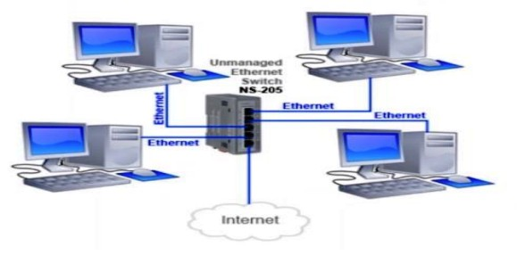

Figure 1: Configure & Implement Unmanageable Network Switch

* It allows for networking of Ethernet devices for data communication.

*/*

* The dedicated path between the sender and the receiver for the exchange of data at full speed.
* Forward broadcasts.
* No user configuration.
* Compatible with other switches.

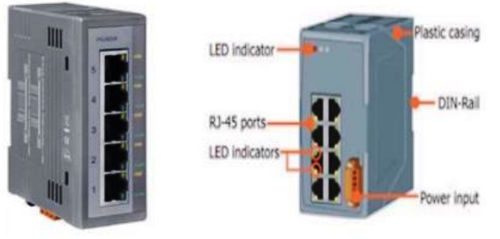

Figure 2: Ethernet Devices for data communication

* Five Ethernet ports 10/100 Base-TX.
* Din rail mountable.
* Automatic MDI//MDI-X crossover for plug-and-play.
* Supports=10~+30 VDC voltage input reverse polarity protection.
* Supports operating temperatures from -40~+75*C (-40F~ 167F).
* Full-duplex IEEE 802.3x and half-duplex backpressure movement control.
* Each port reinforcement 10/100mbps speed auto negotiation store-and-forward architecture.

*/*

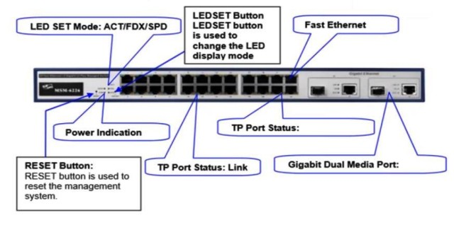

Figure 3: Ethernet ports

## References:

[https://ipc2u.com/articles/knowledge-base/what-is-the-difference-between-managed-and-unmana](https://ipc2u.com/articles/knowledge-base/what-is-the-difference-between-managed-and-unmanaged-switch/) [ged-switch/](https://ipc2u.com/articles/knowledge-base/what-is-the-difference-between-managed-and-unmanaged-switch/)

*/*

# Activity 2

**Aim:** Configure & Implement Manageable Network Switch.

**Learning outcome**: Able to install & configure the different types of network devices in a network.

**Duration:** 2 hours

## List of Hardware/Software requirements:

1. Managed network switch
2. Ethernet cables with connectors
3. Computers/Digital Devices with pre-installed operating system (Windows, Linux, etc)

## Code/Program/Procedure (with comments):

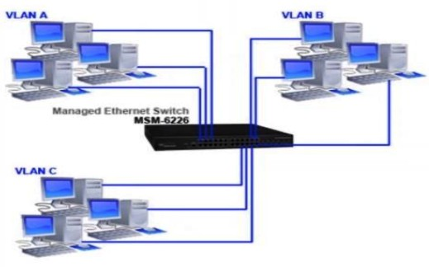

Figure 9: Configure & Implement Manageable Network Switch

*/*

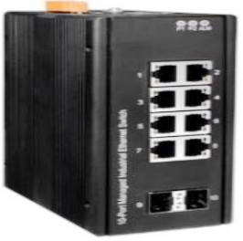

Figure 10: Manageable Network Switch

* IEEE 802.3ab 10000BASE-T Gigabit Ethernet.
* L2+features provide good manageability, security, QoS, and performance.
* Network redundant ring failover protection.
* Multicasting support IGMP v1/v2/v3, proxy and snooping.
* Multicast/flooding/broadcast storm control.

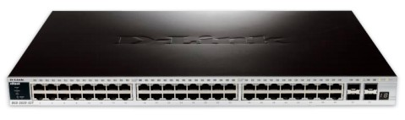

Figure 11: Ethernet ports

* Two dual-media for flexible fiber connection.
* Port mirroring helps supervisor monitoring network.
* IEEE802.1Q tag base VLAN for performance and security and 4094 VLAN entries.
* IEEE802.1X access control improves network security.
* IEEE802.1D compatible, IEEE802.1w rapid spanning tree and IEEE802.1s multiple spanning tree.

*/*

* Unknown unicast/broadcast/multicast storm control.
* Multicast VLAN management for IPTV.
* IP-MAC port binding for LAN security.
* QCL based on application traffic for QoS and speed limitation management.
* Support IGMPv3 snooping and IGMP proxy.
* Support DHCP snooping.

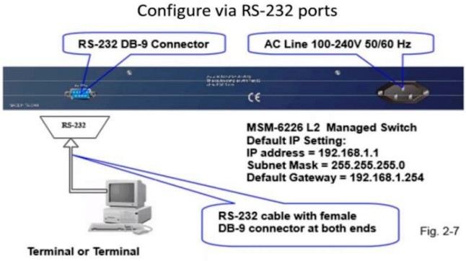

Figure 12: RS-232 Ports

Port-Based VLAN Configuration

*/*

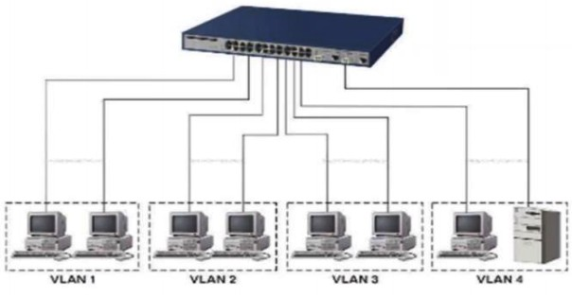

## Procedure:

**Step 1:** Connect the computer to the unmanaged switch (e.g. Dlink DGS 1210) with ethernet cable connected to any port of the switch.

**Step 2:** Set the IP address of the computer with a static IP address of the range 10.90.90.X

**Step 3:** Power on the switch. Type the default IP address of the switch (Dlink DGS 1210) – 10.90.90.90 in the URL of the browser to open the login of the switch.

## Output/Results snippet:

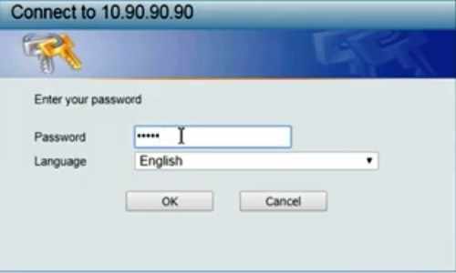

Figure 4: Type the default password as ‘admin’ to get into the dashboard of the configuration page of the switch.

*/*

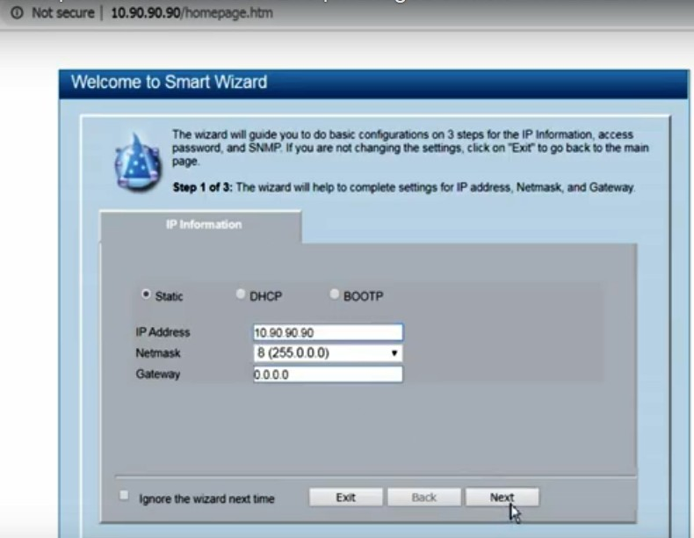

Figure 5: After logging in to the homepage of Dlink DGS 1210 switch

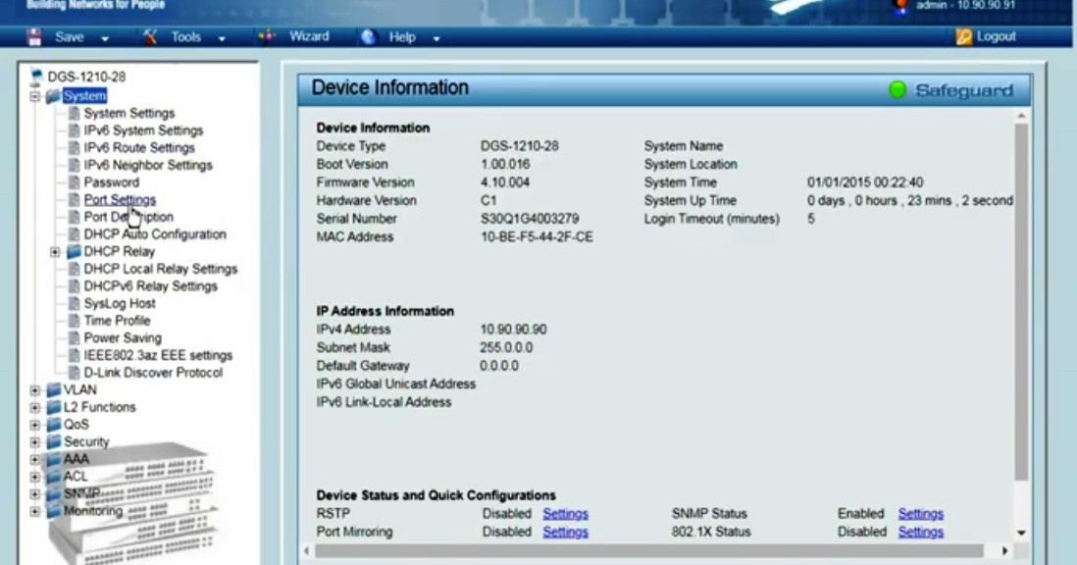

Figure 6: The system contains many options like Port Settings where the different ethernet ports of the switch could be configured.

*/*

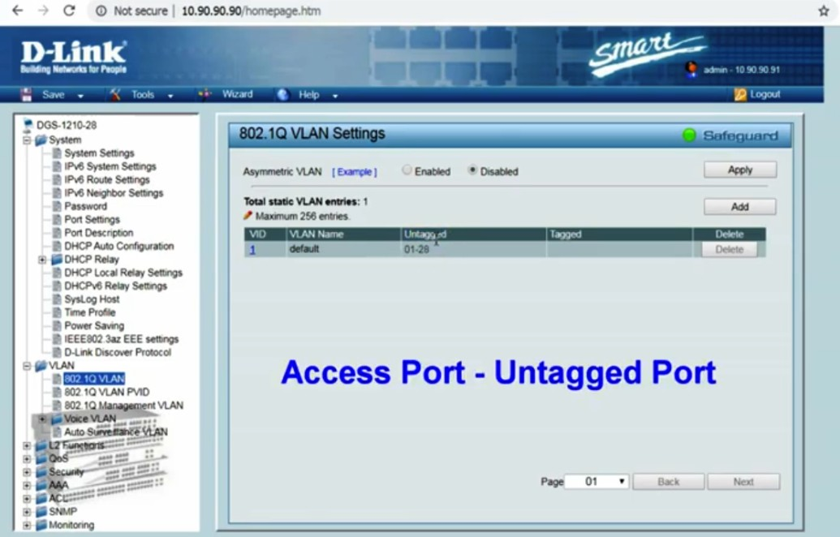

Figure 7: 802.1Q VLAN settings

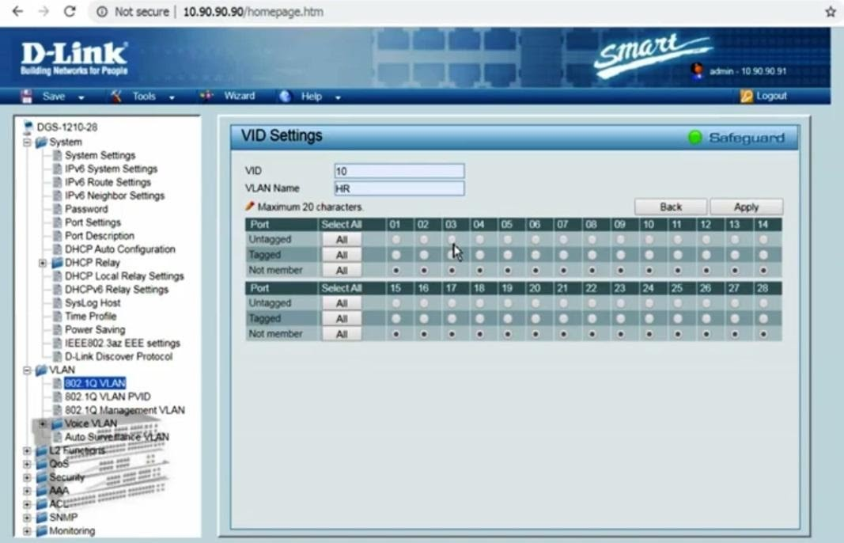

Figure 8: The VLAN options could be used to setup vlans.

## References:

* + <https://youtu.be/mYJInHyhU-s>

*/*

# Activity 3

**Aim:** Install and configure router, bridges and HUB.

**Learning outcome**: Able to install & configure the different types of network devices in a network.

**Duration:** 3 hours

## List of Hardware/Software requirements:

1. Router, Bridge, HUB
2. Ethernet cables with connectors
3. Computers/Digital Devices with pre-installed operating system (Windows, Linux, etc)
4. Cisco Packet Tracer Software

## Code/Program/Procedure (with comments):

1. Provide power to the switch, if required. For a stand-alone switch, this means plugging in the power supply. For rack-mounted switches, this means using a slot that has power provided to it.
2. Connect the incoming network cable to the switch. Although any time can be used on most network switches, it is a good idea to use the first slot so anyone can quickly identify the incoming cable. For home and small office software, the incoming cable will be the one coming from your modem.
3. Connect a Cat5 or Cat6 cable to another slot in the network switch. Connect the other end to a computer you want to be connected to the network. Provide power to the switch, if required. For a stand-alone switch, this means plugging in the power supply.

*/*

For rack-mounted switches, means using a slot that has power supplied to it.

1. Connect the incoming network cable to the switch. Although any time can be used on most network switches, it is a good idea to use the first slot so anyone can quickly identify the incoming cable. For home and small office applications, the arriving cable will be the one coming from your modem.
2. Connect a Cat5 or Cat6 cable to another slot in the network switch. Connect the other end to a computer you want to be connected to the network.

## Need to install pocket tracer software

* Press RETURN to get started
* Router>Enabled
* Router#configure t
* Enter configuration commands, one per line. End with CNTL/Z
* Router? (? select which router from 0 to many)(config-if)#shot down.

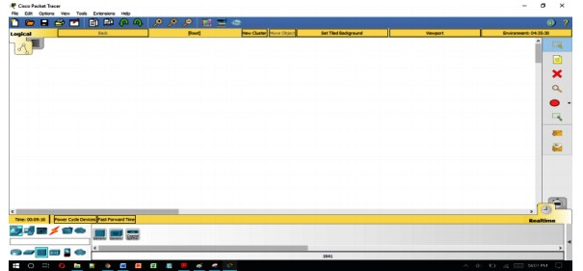

Figure 9: Packet Tracer Software

*/*

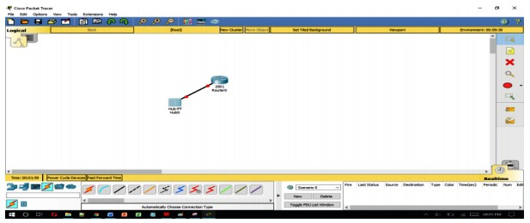

Figure 10: configure router, bridges, and HUB

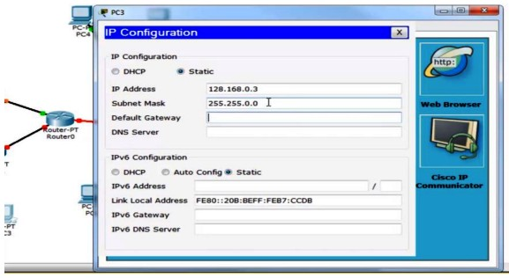

Figure 11: IP Configure

## References:

* + [https://www.examcollection.com/certification-training/network-plus-how-to-install-and-c onfigure-routers-and-switches.html](https://www.examcollection.com/certification-training/network-plus-how-to-install-and-configure-routers-and-switches.html)
* <https://electricalacademia.com/computer/install-configure-routers-switches/>

*/*

# Activity 4

**Aim:** Configure Wireless Access Point.

**Learning outcome**: Able to install & configure the different types of network devices in a network.

**Duration:** 2 hours

## List of Hardware/Software requirements:

* 1. Computer with pre-installed operating system (Windows, Linux, etc)
  2. Access point

## Code/Program/Procedure (with comments):

Configure a wireless access point (By taking DLink access point). These guidelines are provided for illustrative purposes and do not represent an endorsement of the DLink access point over other competing products.

Please take the following steps:

1. Change the default admin password.
2. Change the default SSID to something of your picking.
3. Enable encryption.
4. Disable the DHCP Server task, if your access point has this feature.
5. Register the hardware (MAC) address of the wireless card.

By using these steps while connecting wireless access point there will be no problem.

*/*

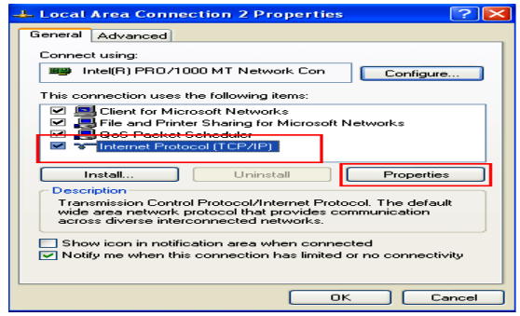

Figure 12: TCP/IP Properties

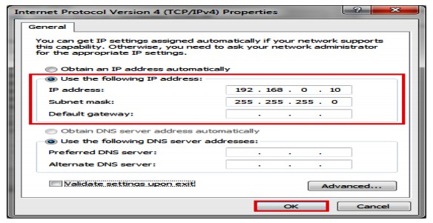

Figure 13: IP Address

*/*

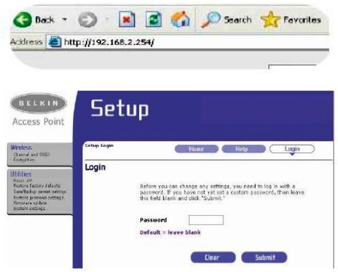

Figure 14: Wireless access point Setup

## References:

* + <https://www.linksys.com/us/support-article?articleNum=136548>
* [https://www.dummies.com/programming/networking/configuring-a-wireless-access-point](https://www.dummies.com/programming/networking/configuring-a-wireless-access-point/)

[/](https://www.dummies.com/programming/networking/configuring-a-wireless-access-point/)

*/*

# Activity 5

**Aim:** Install and Configure Wire Network.

**Learning outcome**: Able to install & configure the different types of network devices in a network.

**Duration:** 2 hours

## List of Hardware/Software requirements:

1. Computer with pre-installed operating system (Windows, Linux, etc)
2. Ethernet cable with connector
3. Router

## Code/Program/Procedure (with comments):

1. Take the router to connect the Modem and router with the help of cables.

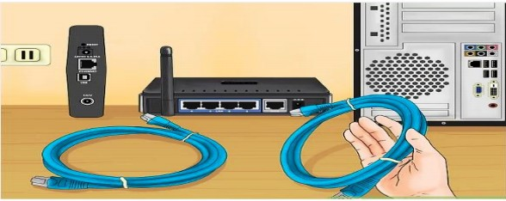

Figure 15: Connection between Modem and Router

1. Connect the router to the modem. Routers and wireless routers enable to share broadband internet connection with multiple devices. Will need to connect broadband modem to the router. For better results, place your router near your

*/*

modem. Fix the router and the modem with an Ethernet cable.

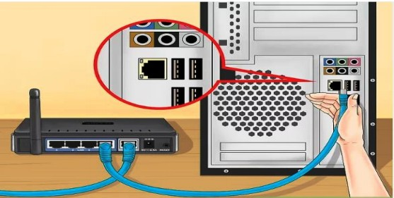

Figure 16: Modem with an Ethernet cable

1. 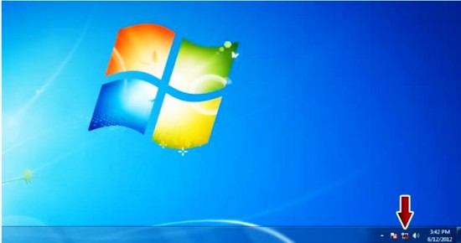The arrow mark shows the LAN is not connected, Or a problem with your LAN connection.

Figure 17: LAN connection

1. Select the Local area connection, right click on that and select the status option.

*/*

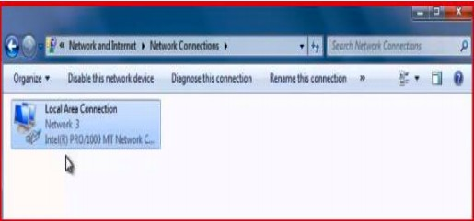

Figure 18: Status Option

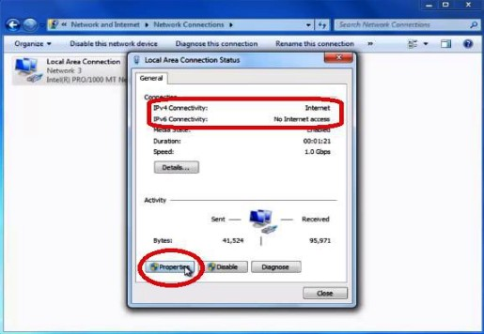4. Check the IPv4 connection and click on properties.

Figure 19: IPv4 connection

1. After that select the internet protocol version TCP/IPv4 and click on ok.

*/*

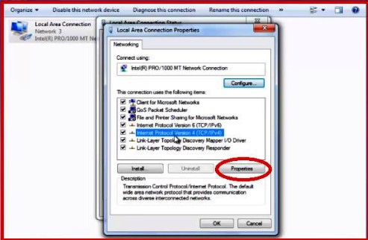

Figure 20: Version of TCP/IPv4

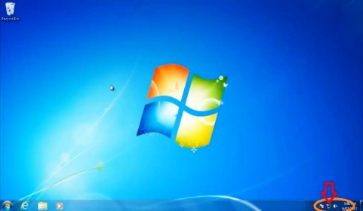

Figure 21: LAN Status Icon

## References:

* + [https://www.dummies.com/computers/operating-systems/windows-xp-vista/install-a-wire d-network/](https://www.dummies.com/computers/operating-systems/windows-xp-vista/install-a-wired-network/)
  + <https://stevessmarthomeguide.com/build-home-network/>

*/*

# Activity 6

**Aim:** Install and Configure Wireless Network.

**Learning outcome**: Able to install & configure the different types of network devices in a network.

**Duration:** 2 hours

## List of Hardware/Software requirements:

1. Computer with pre-installed operating system (Windows, Linux, etc)
2. Wireless router

## Code/Program/Procedure (with comments):

1. When you power on the router, it will only generate its wi-fi network, and the device will be connected to the router's wi-fi connection, not the internet. To connect the

router to the internet need a MAC address to the internet service provider's website.

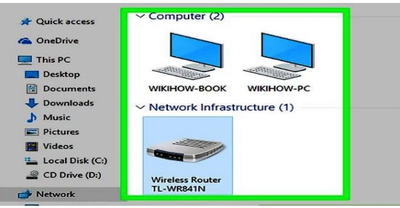

Figure 22: MAC address

1. The MAC address will display already the old one need to Reset the MAC address

*/*

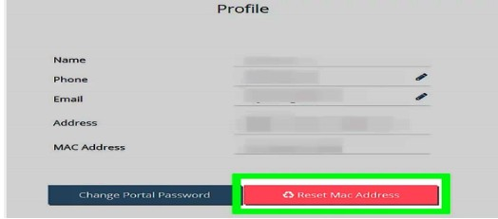

Figure 23: Reset MAC Address

1. Enter the administrator name and password and click on login

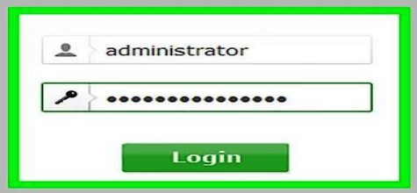

Figure 24: Administrator Name and Password

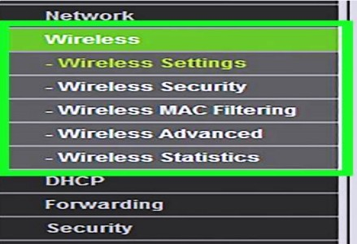

*/*

Figure 25: Wireless Tools

1. Select the wireless network name and select the enable the wireless router radio and SSID broadcast

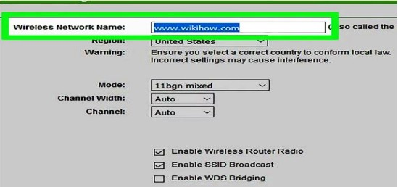

Figure 26: Wireless Router Radio and SSID broadcast

1. Select the WPA/WPA2 and fill all the fields.

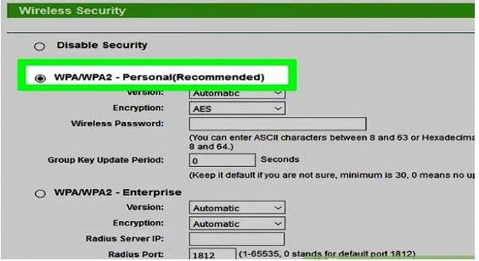

Figure 27: WPA/WPA2

1. Enter the wireless password and click on the save button.

*/*

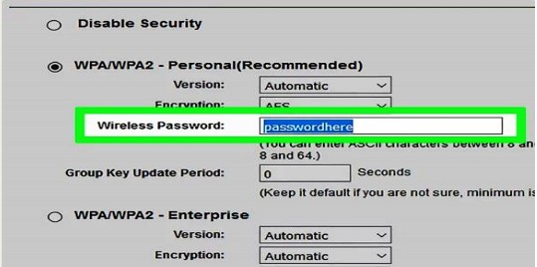

Figure 28: Wireless Password

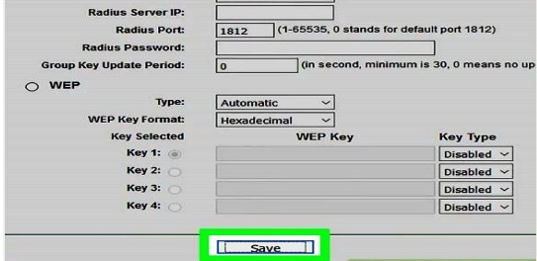

Figure 29: Save the Features

1. Gave old administrator name and password and a new username and password then click on save.

*/*

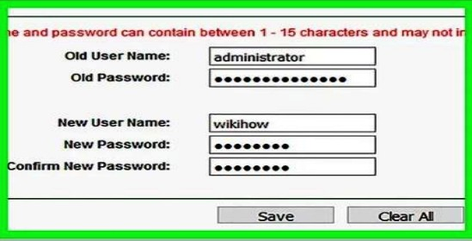

Figure 30: Administrator Name and Password

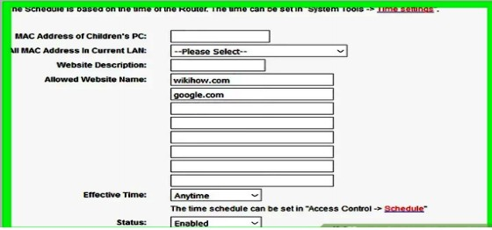

Figure 31: Administration Information

1. Open the WIFI portal see the name is displaying then click on connect.

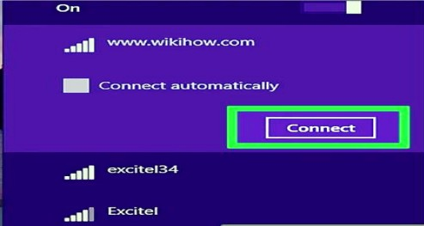

*/*

Figure 32: WIFI portal

1. Enter the password0r security key which was given before and click on next button.

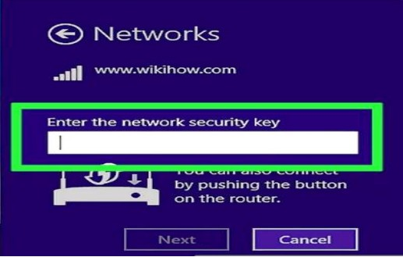

Figure 33: Password/Security Key

1. The WIFI is connected finally it is displaying in WIFI portal.

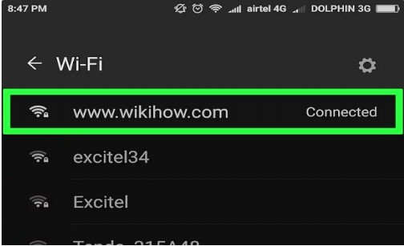

Figure 34: Check Connected or not

## References:

* + <https://support.microsoft.com/en-in/help/17137/windows-setting-up-wireless-network>

*/*

* + <https://www.wikihow.com/Set-up-a-Wireless-Network-(WiFi)-Connection>

# Activity 7

**Aim:** Installation of AD-hoc Wireless Network.

**Learning outcome**: Able to install & configure the different types of network devices in a network.

**Duration:** 1 hour

## List of Hardware/Software requirements:

1. Computer with pre-installed operating system (Windows, Linux, etc)
2. WinLAN software

## Code/Program/Procedure (with comments):

First, need to install WinLAN.exe software, and double-click on that it will open WinLAN.exe.

1. Give your network name and password in the fields SSID and PASS respectively.

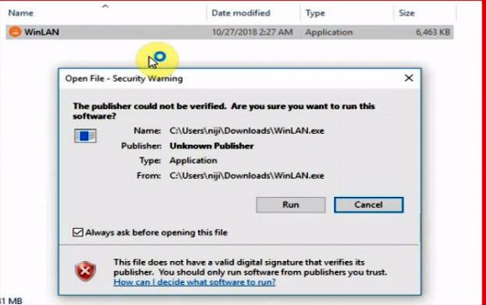

Figure 35: AD-hoc Wireless

1. Enter the SSID and PASS and click on create button.

*/*

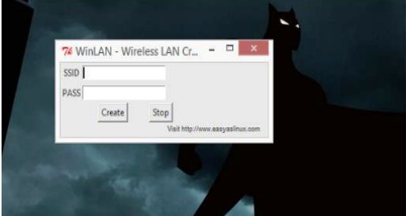

Figure 36: Enter the SSID and PASS

1. See in the network and security center portal and will get the created LAN.

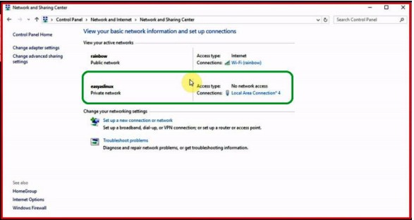

Figure 37: Network and Security Center Portal

## References:

* + [https://www.dummies.com/computers/computer-networking/wireless/how-to-set-up-a-wi reless-ad-hoc-network/](https://www.dummies.com/computers/computer-networking/wireless/how-to-set-up-a-wireless-ad-hoc-network/)
  + <https://www.lifewire.com/set-up-an-ad-hoc-peer-wifi-network-818272>

*/*

# Activity 8

**Aim:** Configure Gateway Service for Internet Connectivity.

**Learning outcome**: Able to install & configure the different types of network devices in a network.

**Duration:** 3 hours

## List of Hardware/Software requirements:

1. Router
2. Broadband modem
3. Computer with pre-installed operating system (Windows, Linux, etc)
4. Ethernet cables

## Code/Program/Procedure (with comments):

To configure your NETGEAR router (gateway) for cable internet connection with Smart Wizard:

* 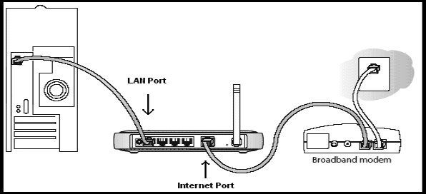Connect your modem to the internet port of the NETGEAR router and your PC to any of the four LAN ports.

*/*

Figure 38: NETGEAR router

* Change the computer, router, and broadband/cable modem, off and on again. Pause for them all to finish booting up.
* Open a web browser and sort the router's IP address which would be either [http://192.168.0.1](http://192.168.0.1/) or [http://192.168.1.1](http://192.168.1.1/) in the address bar and press Enter.
* You are pressed to log into the router.
* The defaulting username is admin and the default password is password.
* The username and password are case-sensitive.
* If the default username and password are not functioning, you might have changed the password. Please try additional passwords that you might have changed too.
* Click the Setup Wizard.
* The Setup Wizard monitor displays.
* Select the Yes button and click Next.

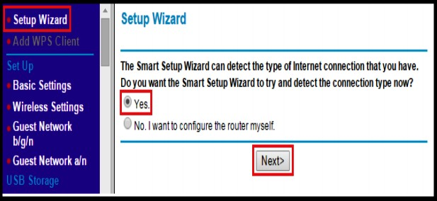

Figure 39: Setup for NETGEAR router

The Setup Wizard identifies the type of internet connection. For cable internet connections, the Setup Wizard identifies Dynamic IP.

*/*

* Click the Next. The router saves the settings.

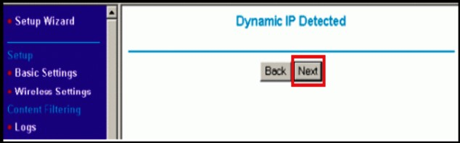

Figure 40: Save the settings

* Check that the internet connected, select Router Status under Maintenance.

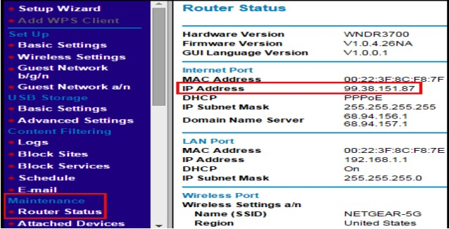

Figure 41: Router Status

* Appearance at the IP Address field to see if you have a valid IP address (that is, not blank or filled with zeroes, such as 0.0.0.0).

## References:

[https://media.distributordatasolutions.com/Leviton/files/File_47611-GT4_Programming_Guide.p](https://media.distributordatasolutions.com/Leviton/files/File_47611-GT4_Programming_Guide.pdf) [df](https://media.distributordatasolutions.com/Leviton/files/File_47611-GT4_Programming_Guide.pdf)

*/*

# Activity 9

**Aim:** Configure ADSL+2 Router for ISP Internet Connectivity.

**Learning outcome**: Able to install & configure the different types of network devices in a network.

**Duration:** 2 hours

## List of Hardware/Software requirements:

1. Computer with pre-installed operating system (Windows, Linux, etc)
2. ADSL+2 Router
3. Broadband modem
4. Ethernet cables

## Code/Program/Procedure (with comments):

1. Open a web browser and enter the IP address of the DSL-300T. Press Enter.
2. Type the Login name and password. Click on login.
3. Click on the Setup at the top. Click on Connection on the left.
4. Configure the following for your connection:

* Type - Set the connection to PPPoA
* Name – Enter the name on name field for the connection.
* Encapsulation - set the encapsulation as suggested by ISP.

*/*

* Username - Enter ISP login username
* Password – Enter the login password
* Keep alive - leave the default
* MAX Fail - left the field as default
* MTU - leave as default
* MRU - leave the default
* Set Route - enable set route(default)
* VPI - set to ISP suggested settings (i.e. 0)(UK ADSL commonly uses VPI=0 and VCI=38)
* VCI - set to ISP recommended settings (i.e.38) (UK ADSL usually uses VPI=0 and VCI=38)
* QoS - leave the default
* PCR - leave the default
* SCR - leave default Click on Apply when done.

1. Click on the Status tab at the top and then click on Connection Position on the left side. The Connection data can be seen in the WAN section of the page. After connecting, the machine will now get the IP address from the ISP.
2. Click on Tools at the top. Click on System Commands on the left. Click on Save to permanently save the changes.

## References:

*/*

* + [https://eu.dlink.com/uk/en/support/faq/modems/dsl-modems/dsl-series/how-do-i-setup-m y-adsl-router-for-internet-access](https://eu.dlink.com/uk/en/support/faq/modems/dsl-modems/dsl-series/how-do-i-setup-my-adsl-router-for-internet-access)
  + <https://www.tp-link.com/lk/support/faq/618/>

*/*

# Activity 10

**Aim:** Troubleshoot Internet Connectivity

**Learning outcome:** Able to configure and manage network security.

**Duration:** 5 hour

## List of Hardware/Software requirements:

* + Computer with 500GB Hard Disk
  + 8 GB Ram
  + Windows Server 2016 / 2019

## Procedure:

Troubleshooting using IPCONFIG Command

If you are trying to diagnose and fix a network problem, you should know about the Ipconfig program as one of the troubleshooting arrows in your quiver.

Ipconfig can be used to display TCP/IP network configuration values, discard the current IP and DHCP settings for a device, and renew the DHCP settings for a device.

If your computer is connecting to the Internet or your local network properly, an easy thing to try is to use Ipconfig to release (meaning, discard) its current settings and then renew itself with new settings.

Ipconfig is a command-line program. To see the results of the program, you should run it from a Command Prompt box. To open a Command Prompt box, select the Command Prompt icon in the Accessories program group from the Windows XP Start menu.

Next, at the command line, type the command you want to run. Here are some of the most important ways you can use Ipconfig. The command Ipconfig /? displays all the Ipconfig commands and the syntax of the program. So this is the command to run if you want to learn more about what Ipconfig can do, and how to use it.

*/*

The command Ipconfig /all displays the network settings for a TCP/IP device on the network, as you can see in Figure 15.10. You can use this information to track the IP addresses assigned to computers on your network, and make sure that there is no conflict caused by two computers having been assigned the same address. You can also use the IP address of a device on the network to access the device directly without knowing its name.

The command Ipconfig /release sends a message to the DHCP server to release the current IP address for a device on the network.

The command Ipconfig /renew sends a message to the DHCP server to renew the IP address of your computer, provided your computer is set up to automatically obtain its IP address. The results of running this command on my computer are shown in Image.

Troubleshooting using PING Command

1. Open a DOS command window. To do this, click Start, click Run, type cmd, and then press Enter.
2. At the command prompt, type the following command. Replace *example.com* with the domain that you want to test:
3. “ping example.com” write on the command prompt.
4. Interpret the output from ping.

Troubleshooting using TRACERT Command

1. Open a DOS command window. To do this, click Start, click Run, type cmd, and then press Enter.
2. At the command prompt, type the following command. Replace *example.com* with the domain that you want to test:

“tracert example.com”

*/*

1. Interpret the output from tracert:
   * Tracert displays each hop, indicated by a number in the left column. It also displays the domain and IP address at each hop, as well as the time spent.

Troubleshooting using NSLOOKUP Command

Run the following command and check whether the DNS server is reachable from client computers.

Cmd

nslookup <client name> <server IP address>

* + If the resolver returns the IP address of the client, the server does not have any problems.
  + If the resolver returns a "Server failure" or "Query refused" response, the zone is probably paused, or the server is possibly overloaded. You can learn whether it's paused by checking the General tab of the zone properties in the DNS console.

If the resolver returns a "Request to server timed out" or "No response from server" response, the DNS service probably is not running. Try to restart the DNS Server service by entering the following at a command prompt on the server:

Cmd

net start DNS

*/*

If the issue occurs when the service is running, the server might not be listening on the IP address that you used in your nslookup query. On the **Interfaces** tab of the server properties page in the DNS console, administrators can restrict a DNS server to listen on only selected addresses. If the DNS server has been configured to limit service to a specific list of its configured IP addresses, it's possible that the IP address that's used to contact the DNS server is not in the list. You can try a different IP address in the list or add the IP address to the list.

1. In rare cases, the DNS server might have an advanced security or firewall configuration. If the server is located on another network that is reachable only through an intermediate host (such as a packet filtering router or proxy server), the DNS server might use a

non-standard port to listen for and receive client requests.

## Output/Results snippet:

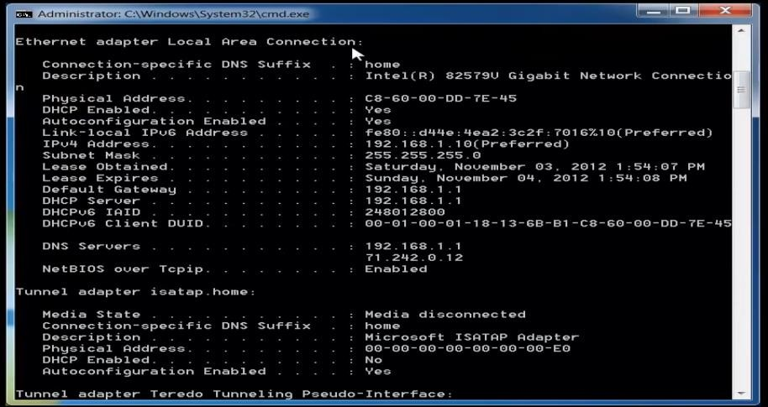

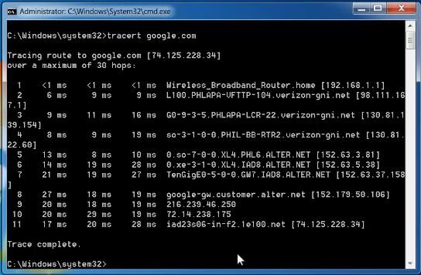

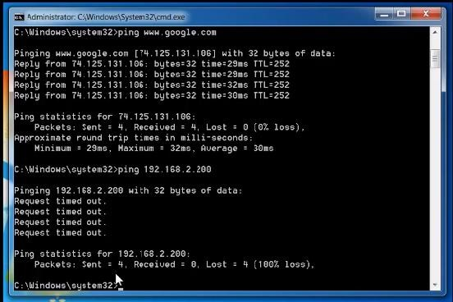

*/*

*/*

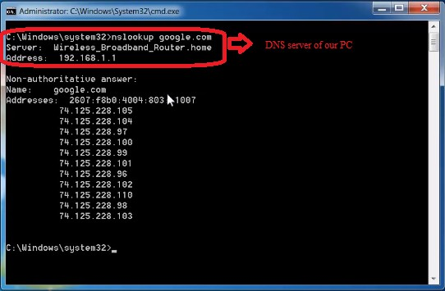

## References:

* + [etutorials.org/Networking/](http://etutorials.org/)
  + <https://www.thewindowsclub.com/>

*/*

# Learning Outcome - Able to configure and manage network security

After achieving this learning outcome, a student will be Able to configure and manage network security. In order to achieve this learning outcome, a student has to complete the following:

* Managing Server Network Security (3Hrs)
* Set up security base line (2 Hrs)
* Configure Audit Policy (2 Hrs)
* Monitor and Troubleshoot Network protocol (3Hrs)
* Configure Protocol Security (2 Hrs)
* Plan security for Wireless Network (1Hr)
* Install and Configure Different Antivirus Software (2 Hrs)
* Install and Configure Admin Console ( 3Hrs)
* Configure a Local Security Policies ( 2Hrs)
* Configure Domain Security Policies ( 3Hrs)
* Configure RRAS Policies ( 2Hrs)

*/*

# Activity 1

**Aim:** Managing Server Network Security

**Learning outcome:** Able to configure and manage network security.

**Duration:** 3 hour

## List of Hardware/Software requirements:

* + Computer with 500GB Hard Disk
  + 8 GB Ram
  + Windows Server 2016 / 2019

## Procedure:

There are two important things to understand about virtual secure mode. First, virtual secure mode doesn't really provide any security by itself. Instead, virtual secure mode is more of an infrastructure- level component of the operating system, and is the basis for other security features which will be discussed later on.

The other thing that must be understood about virtual secure mode is that the word virtual is there for a reason. As you probably know, modern CPUs include on-chip virtualization extensions. Historically, these virtualization extensions have been the basis of server virtualization. The hypervisor sits on top of the CPU and acts as an intermediary between the virtual machines and the hardware.

One of the big advantages to using this approach to server virtualization is that the hypervisor is able to ensure that virtual machines are truly isolated from one another. Virtual secure mode uses a similar technique to create a virtualized space on top of the hypervisor. Sensitive operations can be securely performed within this space, without being exposed to the host operating system.

Feature No. 1: Credential Guard

*/*

As previously noted, virtual secure mode is not a security feature itself, but rather a platform that can be used by other security features. Credential Guard is one of the security features that relies on virtual secure mode. As its name implies, Credential Guard is designed to prevent user credentials from being compromised.

The authentication process used by the Windows operating system is a function of the Local Security Authority (LSA). Not only does the LSA provide interactive authentication services, but it also generates security tokens, manages the local security policy and manages the system's audit policy. Credential Guard works by moving the LSA into Isolated User Mode, the virtualized space created by virtual secure mode.

Although the operating system must be able to communicate with the LSA in order to perform authentication services, Microsoft has designed the operating system to protect the integrity of the LSA. First, the memory used by the LSA is isolated, just as a virtual machine's memory is isolated. Microsoft also limits the LSA to running only the bare minimum binaries, and strict signing of those binaries is enforced. Finally, Microsoft prevents other code, such as drivers, from running in Isolated User Mode.

Feature No. 2: Device Guard

Device Guard is another operating system feature that leverages virtual secure mode. Device Guard isn't really a feature per se, but rather a collection of three security features that fall collectively under the Device Guard label. These three features include Configurable Code Integrity, VSM Protected Code Integrity, and Platform and UEFI Secure Boot (which has been around since Windows 8). Collectively, these three features work together to prevent malware infections.

The Device Guard component that is designed to work with virtual secure mode is VSM Protected Code Integrity. This component ensures the integrity of code running at the kernel level. Although moving kernel mode code integrity into virtual secure mode goes a long way toward protecting the operating system, the Configurable Code Integrity feature is equally noteworthy. This feature is designed to ensure that only trusted code is allowed to run.

Administrators can use the PowerShell New-CIPolicy cmdlet to create integrity policies that essentially act as whitelists for applications.

*/*

In case you are wondering, these policies are based on application signatures. Since not all applications are signed, Microsoft provides a tool called SignTool.exe that can create a catalog (a signature) for unsigned applications.

Feature No. 3: Host Guardian and Shielded Virtual Machines

Although server virtualization has been proven to be relatively secure, it has always had one major Achilles heel: virtual machine portability. Today, there is little to prevent a virtualization administrator, or even a storage administrator for that matter, from copying a virtual machine's virtual hard disk to removable media.The rogue administrator would then be able to take the media home, mount the virtual hard disks on his own computer and gain full access to the virtual hard disk's contents. If necessary, the administrator could even go so far as to set up their own host server and actually boot the stolen virtual machine. Microsoft's Host Guardian Service is designed to prevent this from happening by allowing the creation of shielded virtual machines.

The Host Guardian Service is a Windows Server 2016 attestation and key protection service that allows a Hyper-V host to be configured to act as a guarded host. A guarded host must be positively identified on the network and attested at the Active Directory and/or TPM level. If TPM trusted attestation is being used, then Windows goes so far as to verify the host's health by comparing its configuration against a known good baseline configuration. It is worth noting, however, that Active Directory trusted attestation does not support host configuration verification.

The Host Guardian Service enables the use of shielded virtual machines. A shielded virtual machine is a virtual machine whose virtual hard disks are encrypted via virtual TPM. This encryption prevents a shielded virtual machine from running on any Hyper-V server other than a designated guarded host. If a virtual hard disk is removed from the organization, its contents cannot be accessed and the virtual machine cannot be run.

Shielded virtual machines are BitLocker encrypted. BitLocker makes use of a virtual TPM device, residing on the host server. The virtual TPM is encrypted using a transport key, and the transport key is in turn protected by the Host Guardian Service.

*/*

## Output/Results snippet:

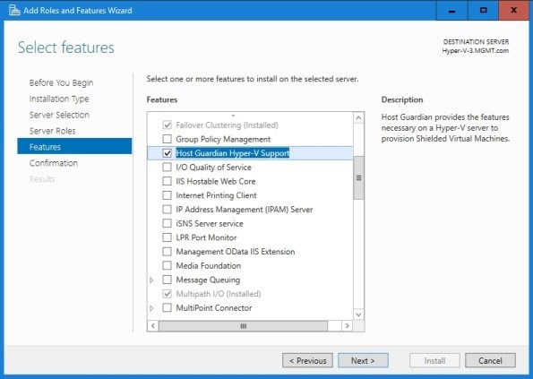

**References:**

* [etutorials.org/Networking/](http://etutorials.org/)
* <https://www.thewindowsclub.com/>

*/*

# Activity 2

**Aim:** Set up security baseline

**Learning outcome:** Able to configure and manage network security.

**Duration:** 2 hour

## List of Hardware/Software requirements:

* + Computer with 500GB Hard Disk
  + 8 GB Ram
  + Windows Server 2016 / 2019

## Procedure:

Copy the ADMX from the Templates to the GPO Central Store

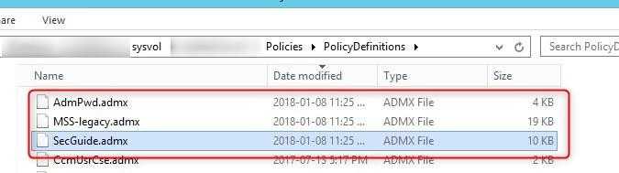

Duplicate the ADML from the templates to the GPO Central Store EN-US subfolder

*/*

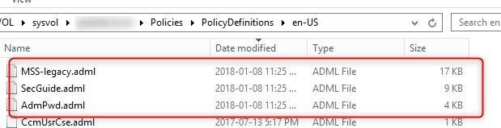

IMPORT GPOS

* + Create a new blank GPO

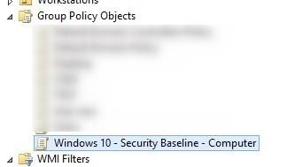

* + Right-click on the GPO, and click on Import Settings

*/*

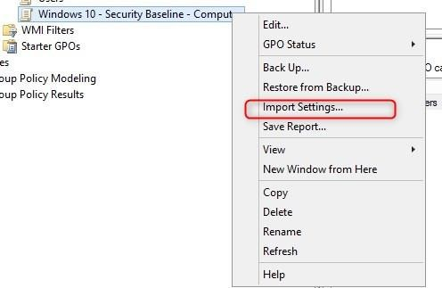

* + Click Next

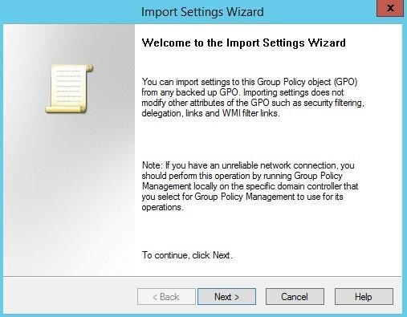d. 344

© Edunet Foundation. All rights reserve

*/*

* + Click Next, no need of backup of a new blank GPO.

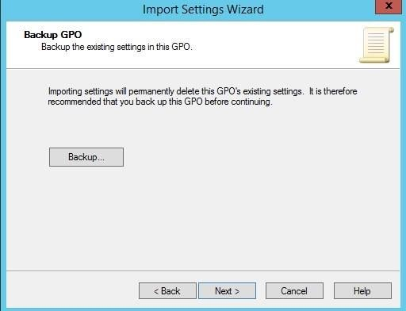

* + Browse to the GPOs file and click Next.

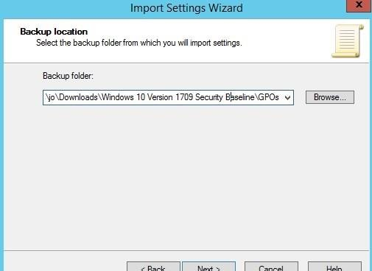d. 345

© Edunet Foundation. All rights reserve

*/*

* + Select the GPO to be imported, built on the name and click Next.

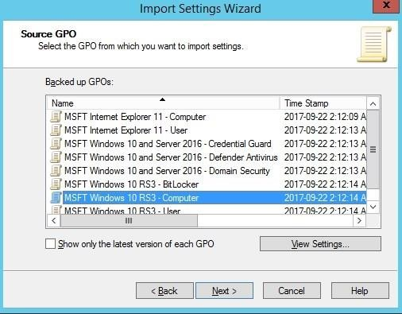

* + Click Next

© Edunet Foundation. All rights reserved. 346

*/*

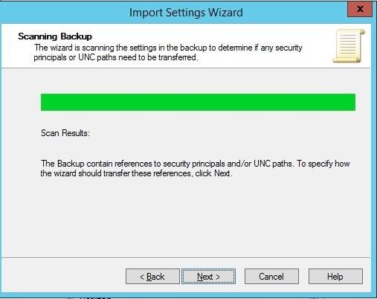

* + Select Copying them identically from the source and click on next

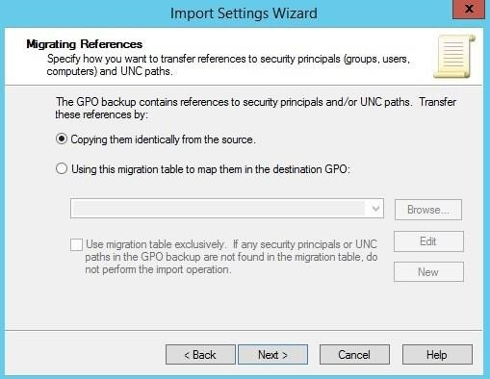. 347

© Edunet Foundation. All rights reserved

*/*

* + Click Finish

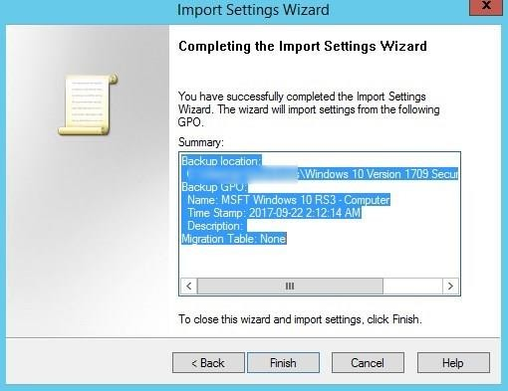

## Output/Results snippet:

The Output as follows in the security baseline.

*/*

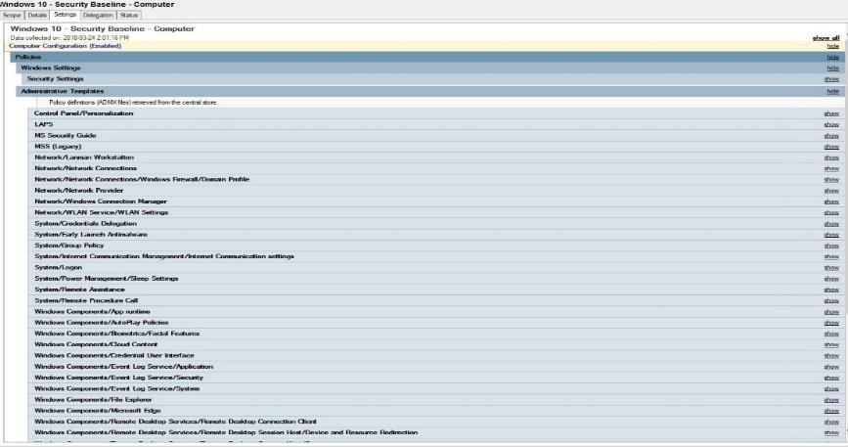

## References:

* [etutorials.org/Networking/](http://etutorials.org/)
* <https://www.thewindowsclub.com/>

*/*

**Activity 3**

**Aim:** Configure Audit Policy

**Learning outcome:** Able to configure and manage network security.

**Duration:** 2 hour

## List of Hardware/Software requirements:

* + Computer with 500GB Hard Disk
  + 8 GB Ram
  + Windows Server 2016 / 2019

## Procedure:

Open the server manager, click on tools and select the group policy management.

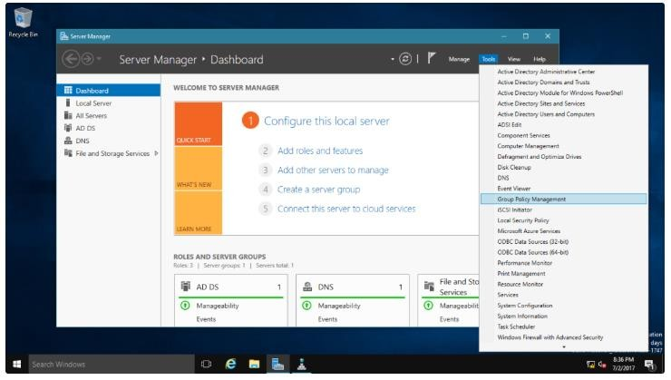

*/*

Select forest windows ae from group policy management, then select domain from their windows ae from their select default domain controller policy then right-click and select edit.

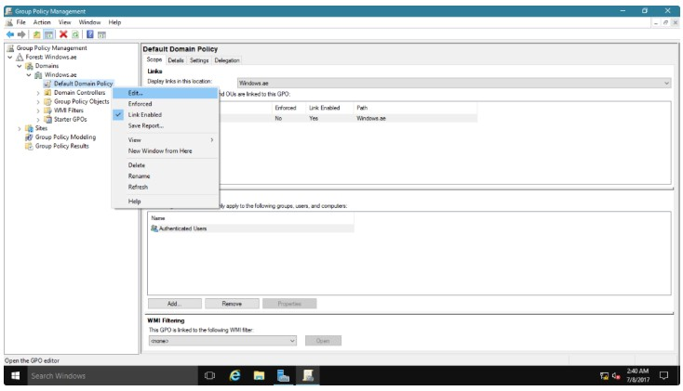

After that select the computer configuration.

*/*

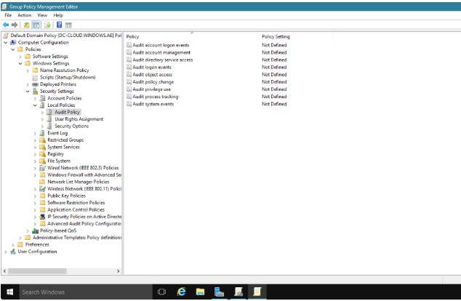

Double click on audit account logon events,

* If you select the Define these policy settings check box, the policy is applied.
* If you select Success, only success audits are logged.
* If you select Failure, only failure audits are logged.

*/*

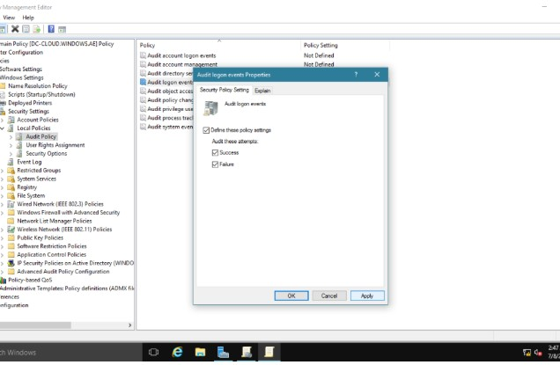

Repeat the step 1 and 3, then click Audit policies.

*/*

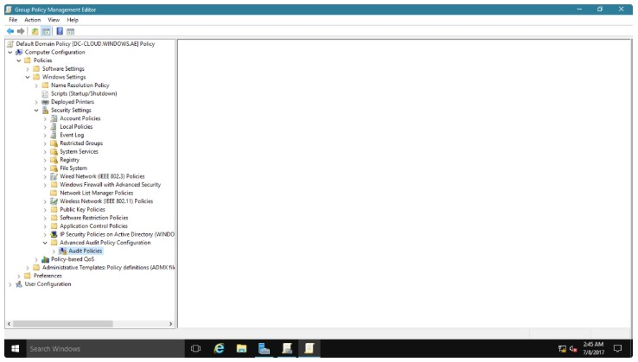

After that ten categories will display, then select account logon

*/*

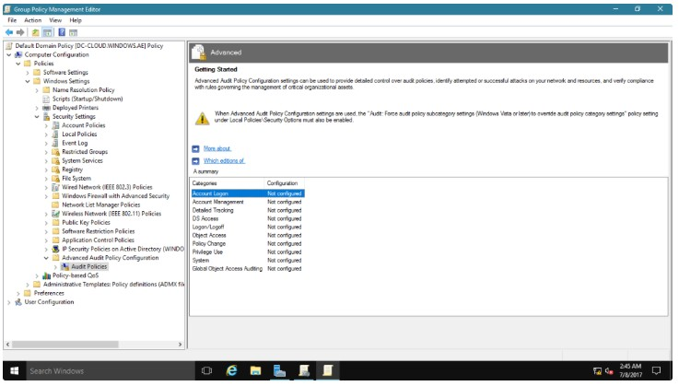

In that four subcategories will display

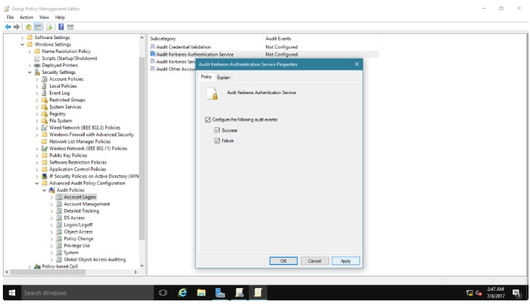

*/*

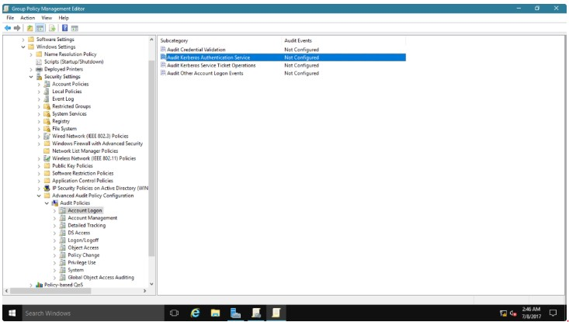

Select Configure the following audit events, select Success, select Failure, and then click Apply.

6

© Edunet Foundation. All rights reserved. 35

*/*

Close the Audit Kerberos Authentication Service Properties dialog box, click OK.

## Output/Results snippet:

On DC-CLOUD, in the Right-Click Start, then click Command Prompt.

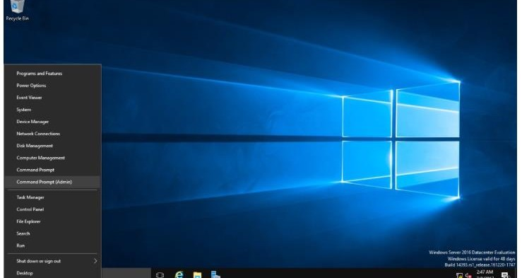

*/*

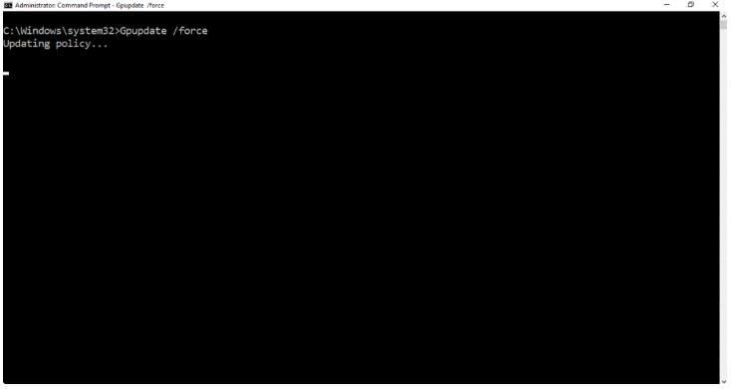

## References:

* [etutorials.org/Networking/](http://etutorials.org/)
* <https://www.thewindowsclub.com/>

*/*

# Activity 4

**Aim:** Monitor and Troubleshoot Network protocol

**Learning outcome:** Able to configure and manage network security.

**Duration:** 3 hour

## List of Hardware/Software requirements:

* + Computer with 500GB Hard Disk
  + 8 GB Ram
  + Windows Server 2016 / 2019

## Procedure:

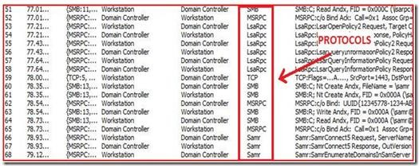This is from the Frame Summary pane and is a general overview of each frame sent on the wire.

These are the connection points involved in a domain join between a workstation and a domain controller.

*/*

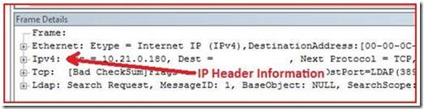

Expand the IPv4 header information, the attribute named Identification with a value of 3201.

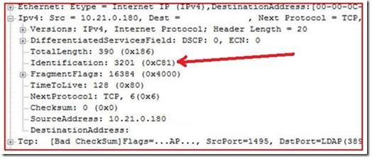

Line up the conversation of two traces taken simultaneously is to compare the Sequence and Acknowledgement numbers.

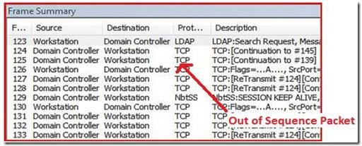

*/*

© Edunet Foundation. All rights res

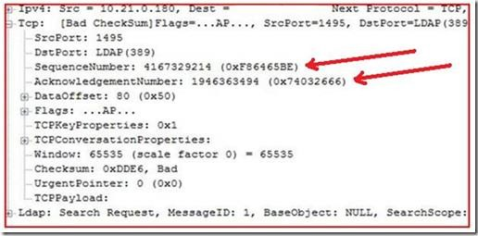

The last packet sequence number sent in this frame is 4167329214, and the last packet that received from a partner in this communication is 1946363494.

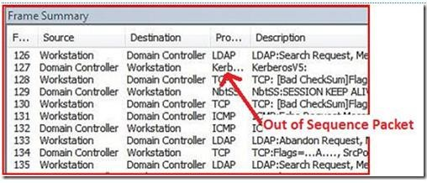

*/*

## Output/Results snippet:

By using Network Monitor, you can avoid time spent troubleshooting the wrong component.

## References:

* [etutorials.org/Networking/](http://etutorials.org/)
* <https://www.thewindowsclub.com/>

*/*

# Activity 5

**Aim:** Configure Protocol Security

**Learning outcome:** Able to configure and manage network security.

**Duration:** 2 hour

## List of Hardware/Software requirements:

* + Computer with 500GB Hard Disk
  + 8 GB Ram
  + Windows Server 2016 / 2019
  + RV34x Series Cisco Router

## Procedure:

Step 1. Log in to the web-based utility of the router and choose **VPN > IPSec Profiles**

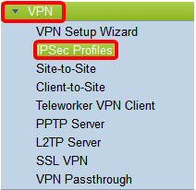

Step 2. The IPsec Profiles Table shows the existing profiles. Click Add to create a new profile.

*/*

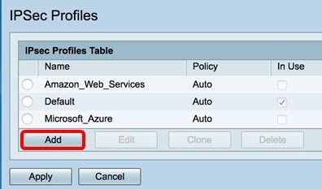

Step 3. Create a name for the profile in the *Profile Name* field. The profile name must contain only alphanumeric characters and an underscore (_) for special characters.

**Note:** In this example, IPSec_VPN is used as the IPSec profile name.

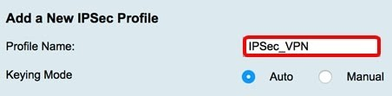

Configure the Auto Settings

Step 1. In the Phase 1 Options area, choose the appropriate Diffie-Hellman (DH) group to be used with the key in Phase 1 from the DH Group drop-down list. Diffie-Hellman is a cryptographic key exchange protocol which is used in the connection to exchange

pre-shared key sets. The strength of the algorithm is determined by bits. The options are:

* + - Group2 - 1024 bit — Computes the key slower, but is more secure than Group1.
    - Group5 - 1536-bit — Computes the key the slowest, but is the most secure.

**Note:** In this example, Group2-1024 bit is chosen.

*/*

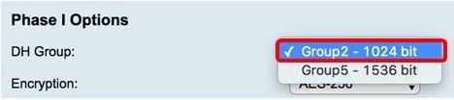

Step 2. From the Encryption drop-down list, choose the appropriate encryption method to encrypt and decrypt Encapsulating Security Payload (ESP) and Internet Security Association and Key Management Protocol (ISAKMP). The options are:

* + - 3DES — Triple Data Encryption Standard.
    - AES-128 — Advanced Encryption Standard uses a 128-bit key.
    - AES-192 — Advanced Encryption Standard uses a 192-bit key.
    - AES-256 — Advanced Encryption Standard uses a 256-bit key.

**Note:** AES is the standard method of encryption over DES and 3DES for its greater performance and security. Lengthening the AES key will increase security with a drop-in performance. For this example, AES-256 is chosen.

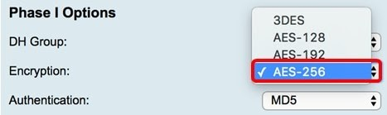

Step 3. From the Authentication drop-down menu, choose an authentication method that will determine how ESP and ISAKMP are authenticated. The options are:

* + - MD5 — Message Digest Algorithm has a 128-bit hash value.
    - SHA-1 — Secure Hash Algorithm has a 160-bit hash value.
    - SHA2-256 — Secure Hash Algorithm with a 256-bit hash value.

*/*

**Note:** MD5 and SHA are both cryptographic hash functions. They take a piece of data, compact it, and create a unique hexadecimal output that is typically not reproducible. In this example, SHA2-256 is chosen.

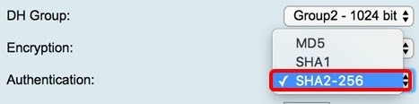

Step 4. In the *SA Lifetime* field, enter a value ranging between 120 to 86400. This is the length of time the Internet Key Exchange (IKE) Security Association (SA) will remain active in this phase. The default value is 28800.

**Note:** In this example, 28801 is used.

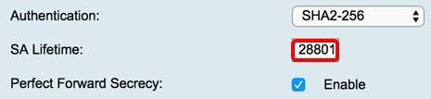

Step 5. (Optional) Check the **Enable Perfect Forward Secrecy** check box to generate a new key for IPSec traffic encryption and authentication.

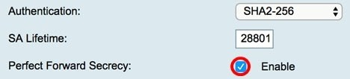

Step 6. From the Protocol Selection drop-down menu in the Phase II Options area, choose a protocol type to apply to the second phase of the negotiation. The options are:

* + - ESP — If this is chosen, skip to [Step 7](https://www.cisco.com/c/en/us/support/docs/smb/routers/cisco-rv-series-small-business-routers/smb5518-configure-an-internet-protocol-security-ipsec-profile-on-an.html#Step7) to choose an encryption method on how the ESP packets will be encrypted and decrypted. A security protocol which provides data privacy services and optional data authentication, and anti-replay services. ESP encapsulates the data to be protected.

*/*

* + - AH — Authentication Header (AH) is a security protocol which provides data authentication and optional anti-replay services. AH is embedded in the data to be protected (a full IP datagram). Skip to [Step 8](https://www.cisco.com/c/en/us/support/docs/smb/routers/cisco-rv-series-small-business-routers/smb5518-configure-an-internet-protocol-security-ipsec-profile-on-an.html#Step8) if this was chosen.

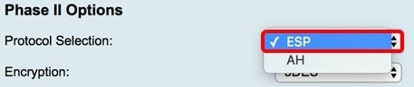

Step 7. If ESP was chosen in Step 6, choose the appropriate encryption method to encrypt and decrypt ESP and ISAKMP from the Encryption drop-down list. The options are:

* + - 3DES — Triple Data Encryption Standard.
    - AES-128 — Advanced Encryption Standard uses a 128-bit key.
    - AES-192 — Advanced Encryption Standard uses a 192-bit key.
    - AES-256 — Advanced Encryption Standard uses a 256-bit key.

**Note:** In this example, AES-256 is chosen.

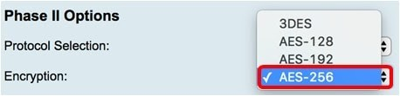

Step 8. From the Authentication drop-down menu, choose an authentication method that will determine how ESP and ISAKMP are authenticated. The options are:

* + - MD5 — Message Digest Algorithm has a 128-bit hash value.
    - SHA-1 — Secure Hash Algorithm has a 160-bit hash value.
    - SHA2-256 — Secure Hash Algorithm with a 256-bit hash value.

*/*

**Note:** In this example, SHA2-256 is used.

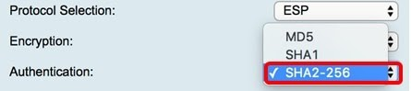

Step 9. From the DH Group drop-down list, choose the appropriate Diffie-Hellman (DH) group to be used with the key in Phase 2. The options are:

* + - Group2 – 1024 bit — Computes the key slower, but is more secure than Group1.
    - Group5 – 1536 bit — Computes the key the slowest, but is the most secure.

**Note:** In this example, Group5 – 1536 bit is chosen.

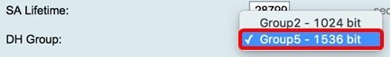

## Output/Results snippet:

**Note:** You will be taken back to the IPSec Profiles Table and the newly-created IPSec profile should now appear.

*/*

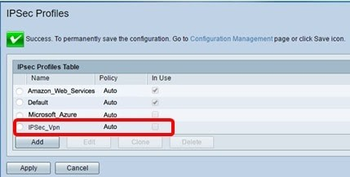

## References:

* [etutorials.org/Networking/](http://etutorials.org/)
* <https://www.cisco.com/>
* <https://www.thewindowsclub.com/>

*/*

# Activity 6

**Aim:** Plan security for Wireless Network

**Learning outcome:** Able to configure and manage network security.

**Duration:** 1 hour

## List of Hardware/Software requirements:

* + Computer with 500GB Hard Disk
  + 8 GB Ram
  + Hathway Wifi Router

## Procedure:

* + Ensure that no one can easily connect to your wireless network and use the Internet without any permission.
  + Personalize access on who can configure your wireless settings.
  + Protect all data that is transmitted through the wireless network

1. Open the browser enter url on Address bar, enter your router’s local IP Address then press enter. When the login credential appears, enter your router’s Username and Password.

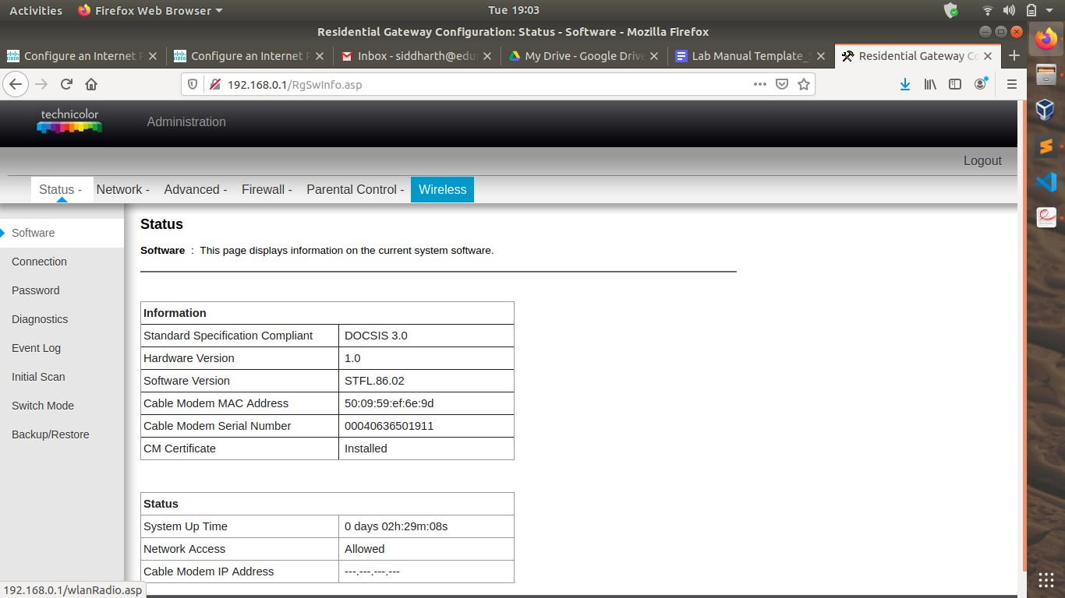

*/*

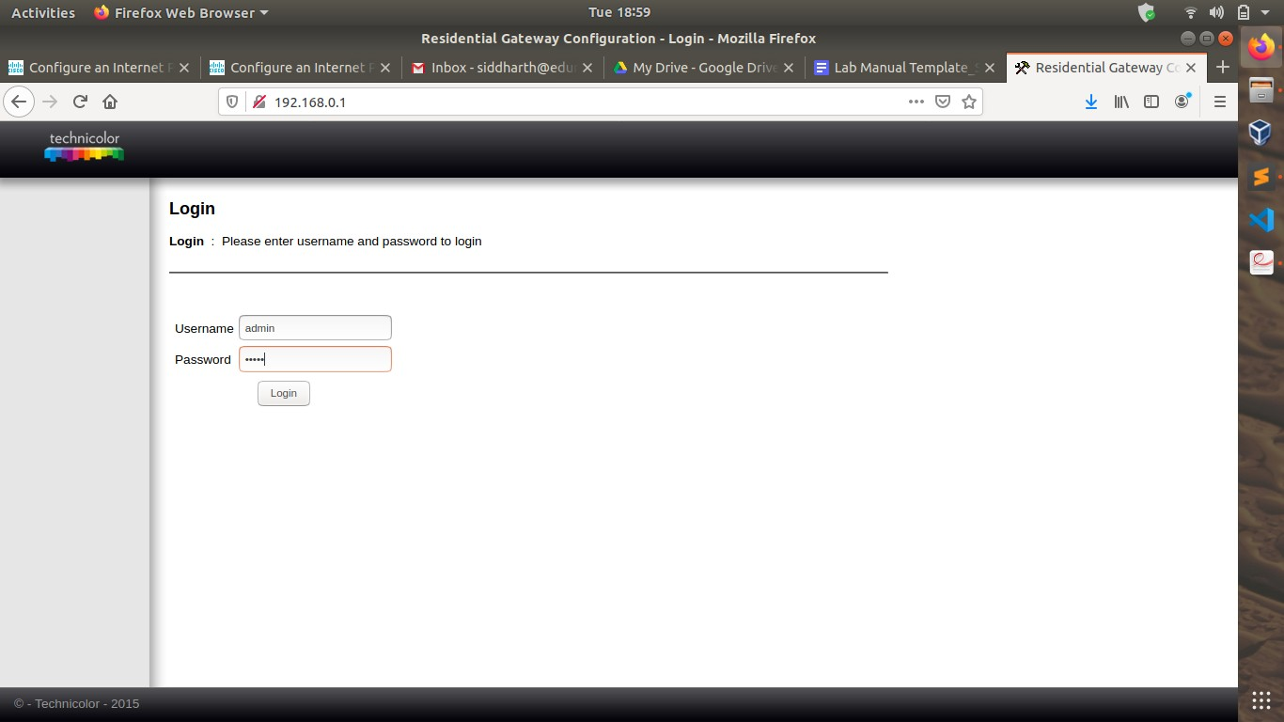

You will now be redirected to the main screen of the status page.

371

© Edunet Foundation. All rights reserved.

*/*

After clicking on the Wireless Tab

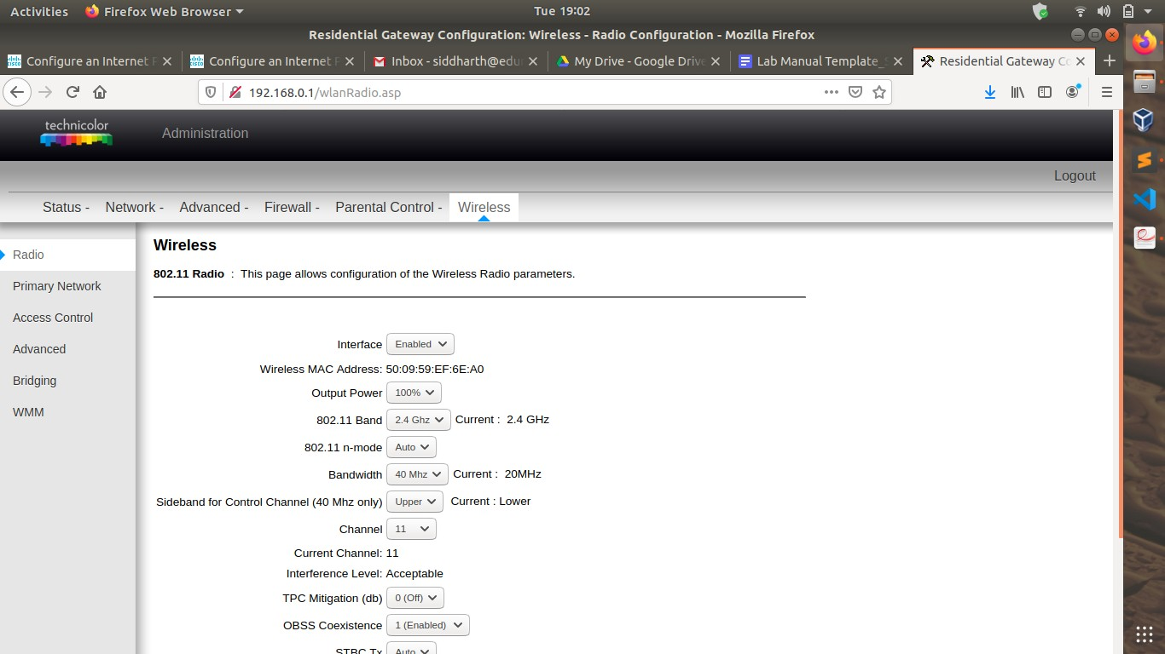

You can now select Primary Network. modes which you can choose from WEP, WPA Personal, WPA2 Personal, and WPA2/WPA Mixed Mode.

*/*

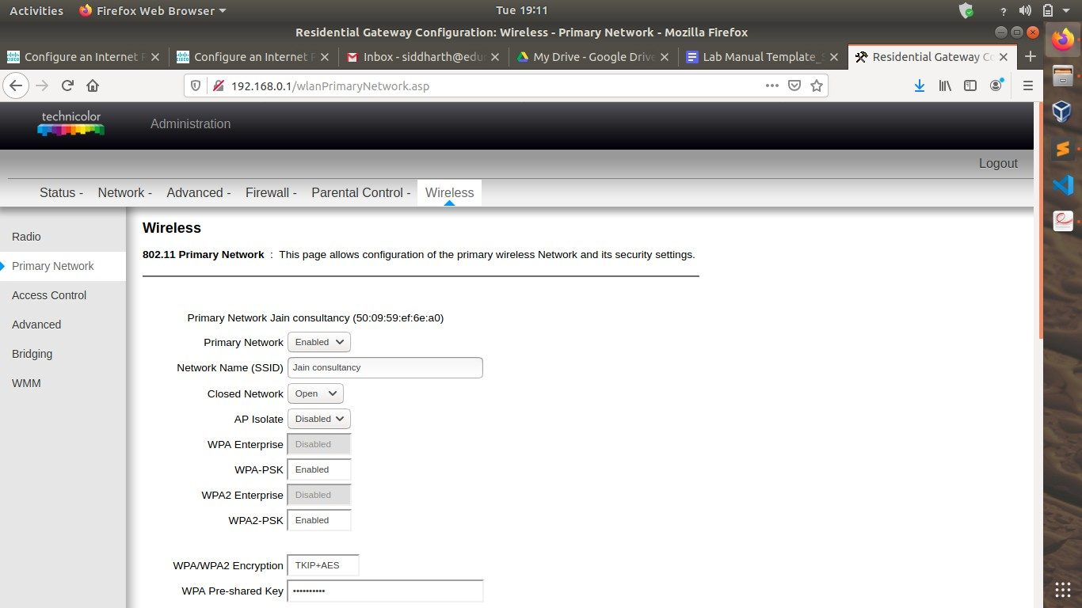

## Output/Results snippet:

**Note:** Your wifi Network will appear as secured when you set password.

*/*

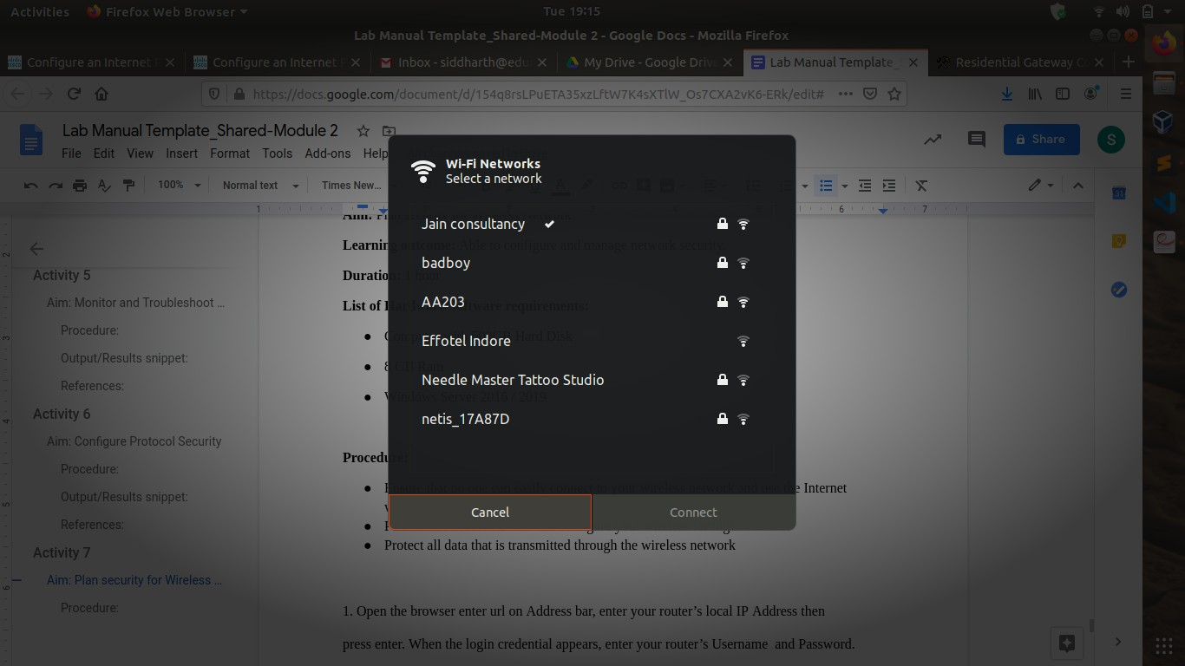

## References:

1. [etutorials.org/Networking/](http://etutorials.org/)
2. <https://www.hatway.com/>
3. <https://www.thewindowsclub.com/>

*/*

# Activity 7

**Aim:** Install and Configure Different Antivirus Software

**Learning outcome:** Able to configure and manage network security.

**Duration:** 2 hour

## List of Hardware/Software requirements:

* + Computer with 500GB Hard Disk
  + 8 GB Ram
  + Windows Server 2016 / 2019

## Procedure:

Browse for the antivirus software and click on any software which you feel comfort



*/*

Click on free download and save the file. After that double click on that file.

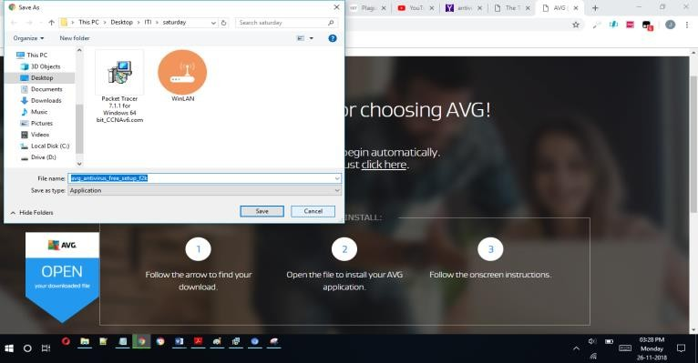

Click on install, it will ask to restart the computer.

## Output/Results snippet:

**Note:** Now the antivirus software is installed in your computer.

*/*

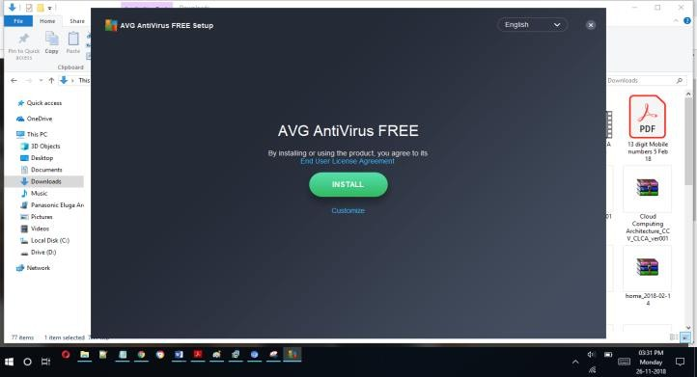

## References:

1. [etutorials.org/Networking/](http://etutorials.org/)
2. <https://www.avast.com/>
3. <https://www.thewindowsclub.com/>

*/*

# Activity 8

**Aim:** Install and Configure Admin Console

**Learning outcome:** Able to configure and manage network security.

**Duration:** 3 hour

## List of Hardware/Software requirements:

1. Personal Computer
2. Microsoft Windows 10 operating system

## Code/Program/Procedure (with comments):

1. First need to Login the Admin console, enter valid credential and click on login.

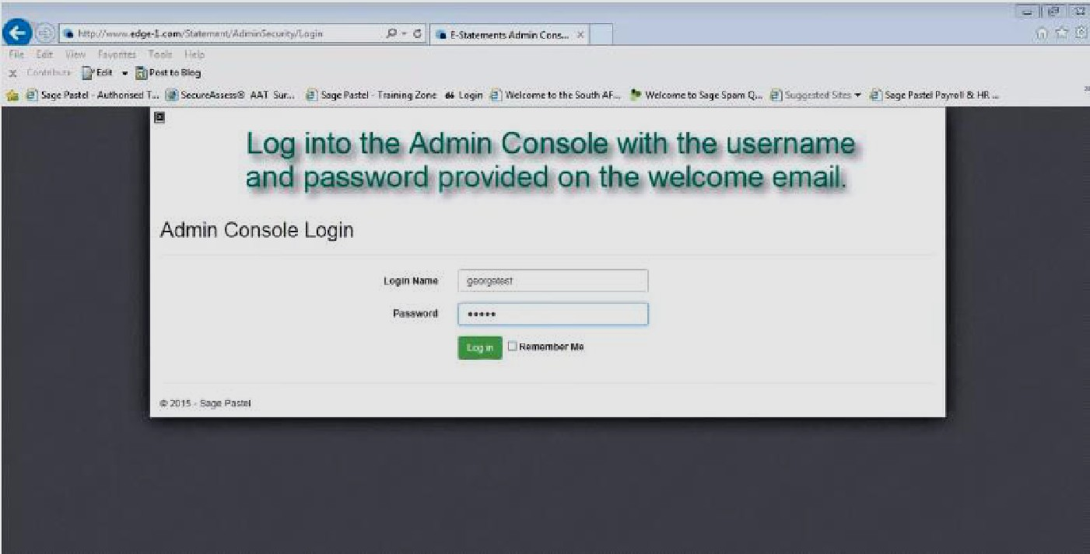

*/*

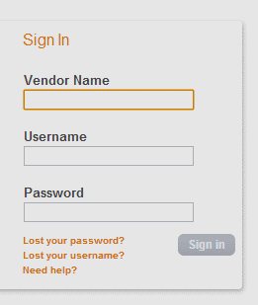

1. Select the sage pay from the menu and then select the settings.

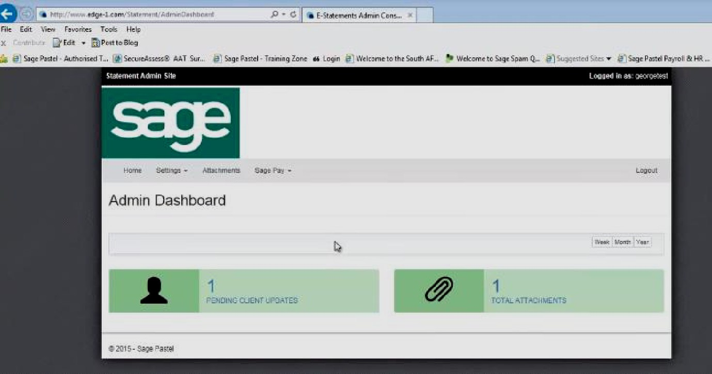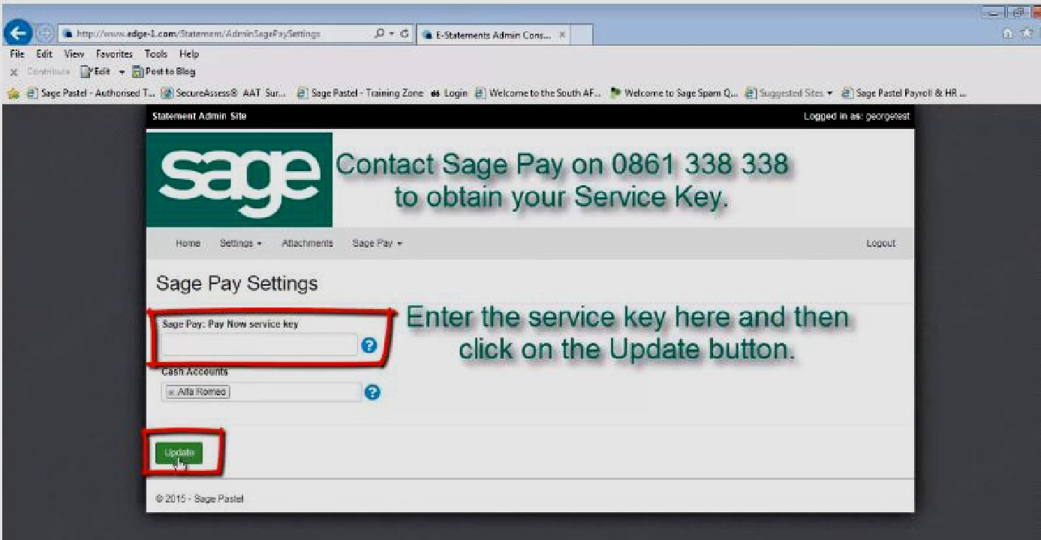

*/*

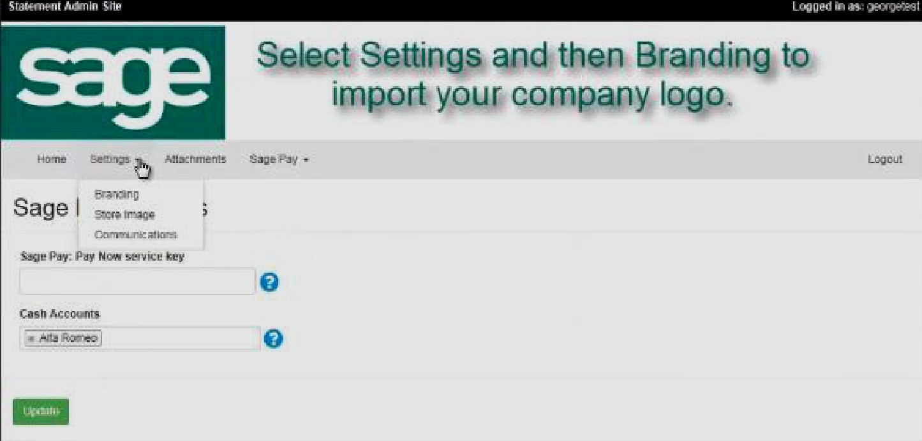

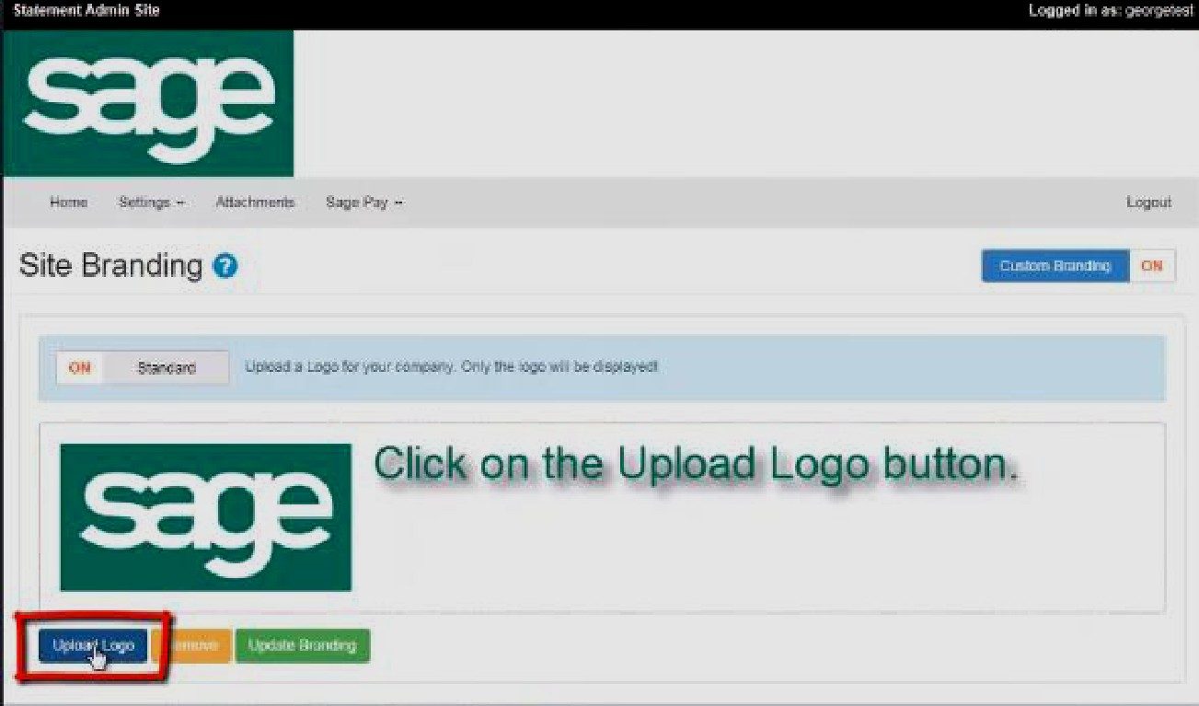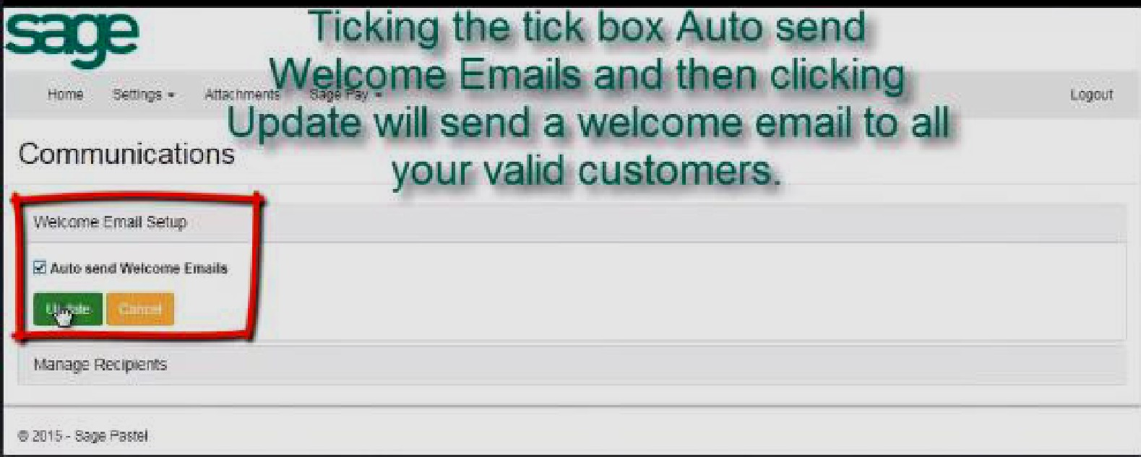

*/*

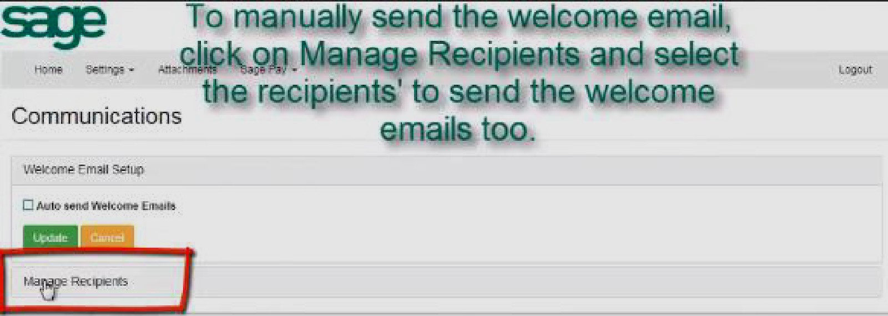

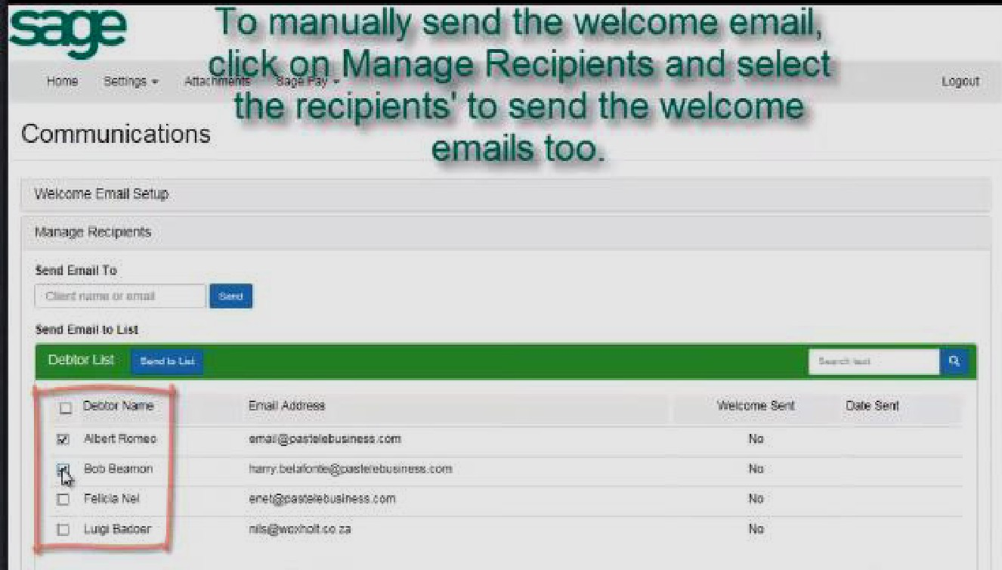

## Output/Results snippet:

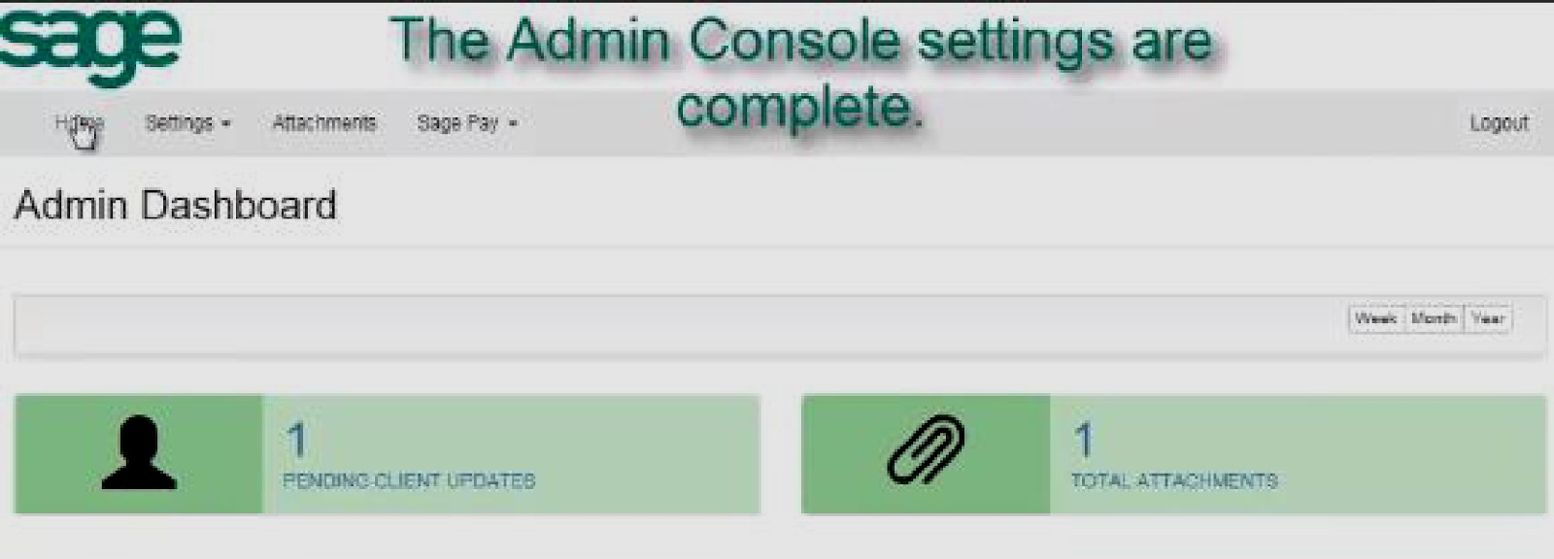

**References:**

29. <https://www.sagepay.co.uk/support/test-your-integration/log-in-to-test-my-sage-pay>

*/*

# Activity 9

**Aim:** Configure a Local Security Policies

**Learning outcome:** Able to configure and manage network security.

**Duration:** 2 hour

## List of Hardware/Software requirements:

1. Personal Computer with minimum 4 GB RAM & 50 GB HDD
2. Microsoft Windows 10 operating system

## Code/Program/Procedure (with comments):

1. Open Control Panel.
2. 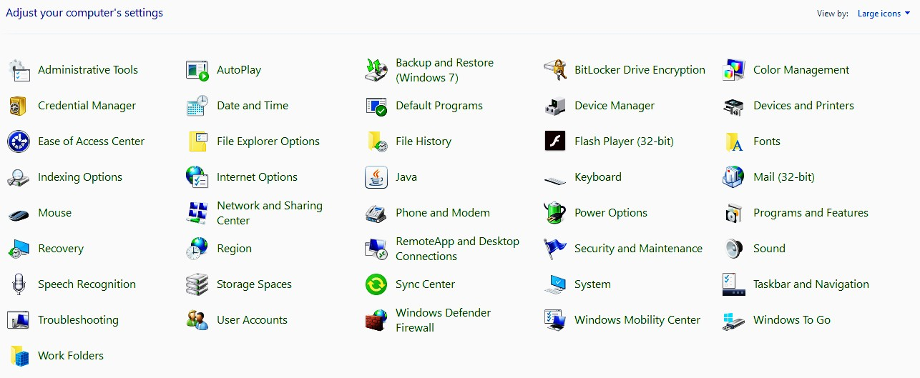The Control Panel items should be listed as "Large" or "Small icons", click on Administrative Tools.

*/*

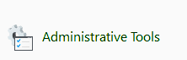

1. 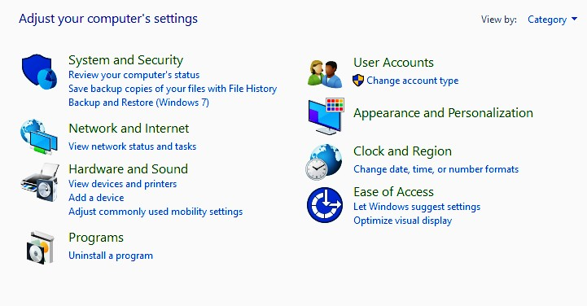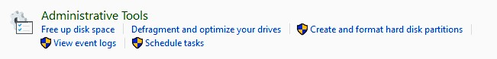If the Control Panel items are displayed by "Category", click System and Security, and then click Administrative Tools.
2. In the list of the tools find and double-click the Local Security Policy shortcut.

*/*

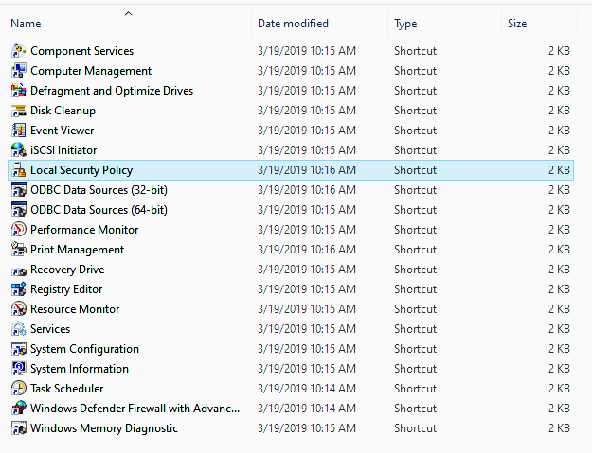 

1. 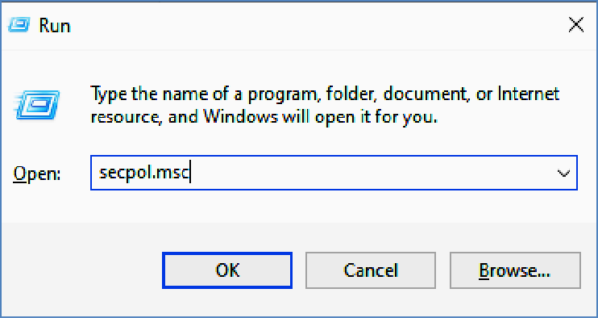Also, as a shortcut you can open Run or Command Prompt and type **secpol.msc** and press enter.
2. You will get Local Security Policy access for further activities of configuration.

## Output/Results snippet:

*/*

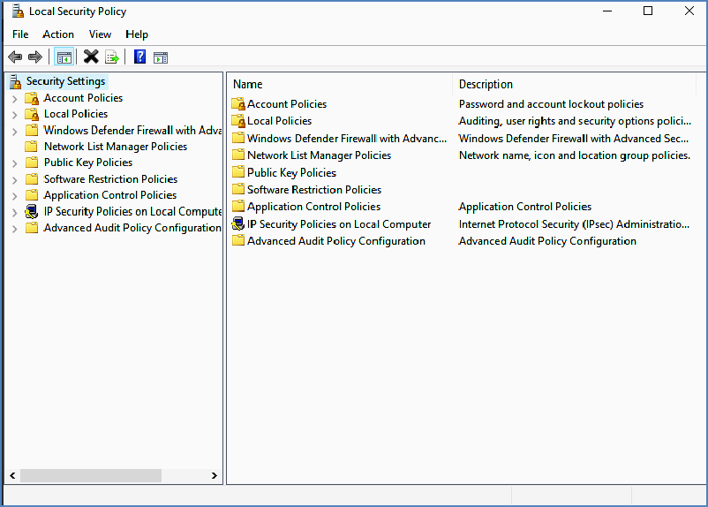

## References:

30. [https://docs.microsoft.com/en-us/windows/security/threat-protection/security-policy-setti ngs/how-to-configure-security-policy-settings](https://docs.microsoft.com/en-us/windows/security/threat-protection/security-policy-settings/how-to-configure-security-policy-settings)

*/*

# Activity 10

**Aim:** Configure Domain Security Policies

**Learning outcome:** Able to configure and manage network security.

**Duration:** 3 hour

## List of Hardware/Software requirements:

1. Personal Computer
2. Microsoft Windows operating system

## Code/Program/Procedure (with comments):

The following procedure describes how to configure a security policy setting for only a domain controller (from the domain controller).

1. To open the domain controller security policy, in the console tree, locate GroupPolicyObject [ComputerName] Policy, click Computer Configuration, click Windows Settings, and then click Security Settings.
2. 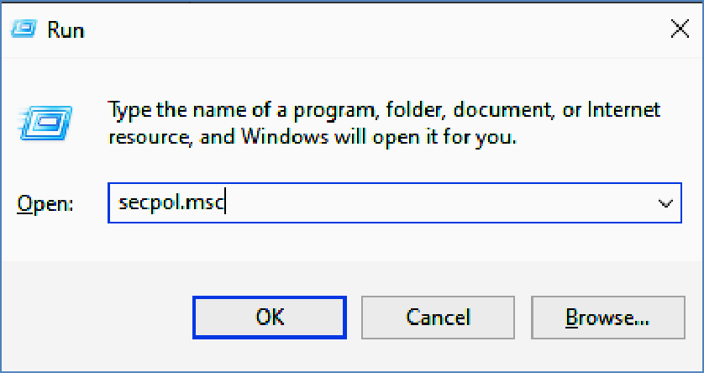Alternatively, open Run and type **secpol.msc** and press enter.

*/*

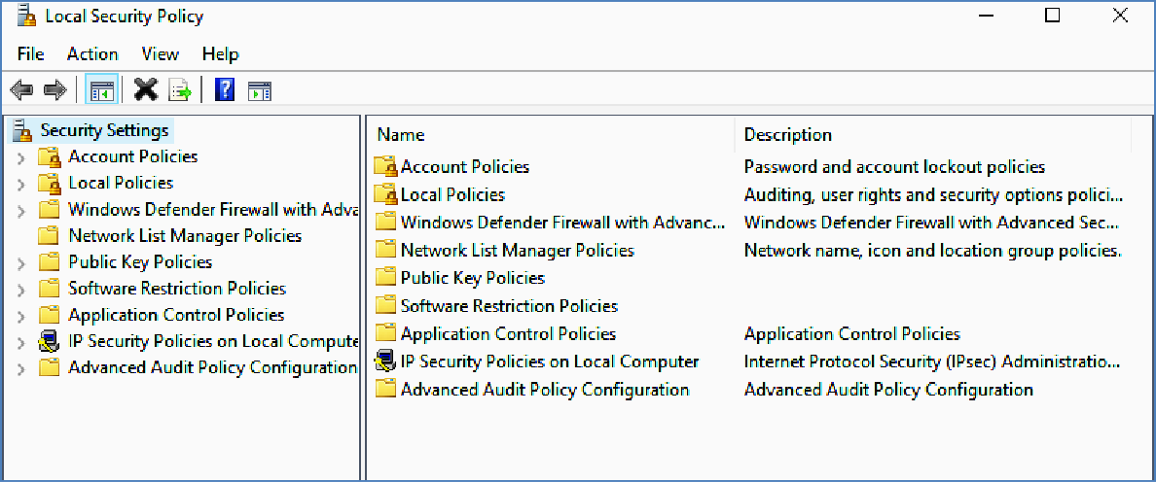

1. Do one of the following:
   * Double-click Account Policies to edit the Password Policy, Account Lockout Policy, or Kerberos Policy.

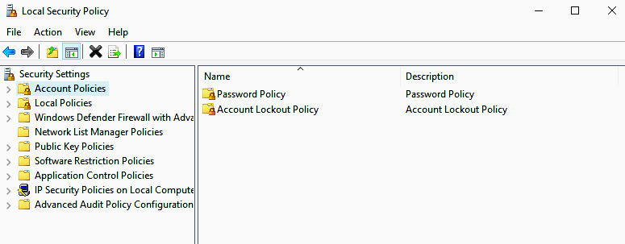

*/*

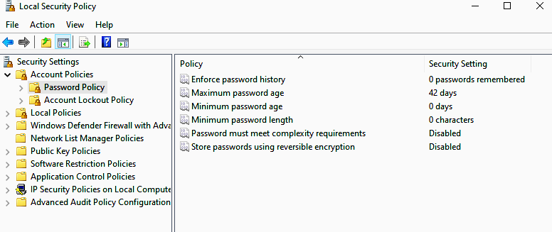

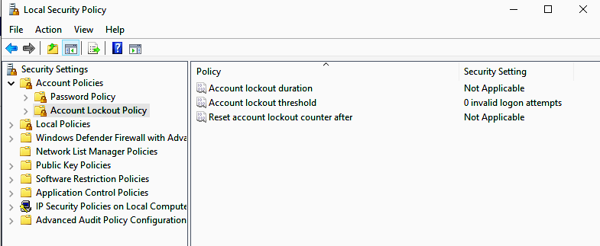

* + Click Local Policies to edit the Audit Policy, a User Rights Assignment, or Security Options.

*/*

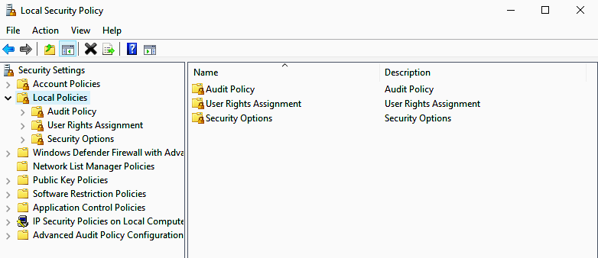

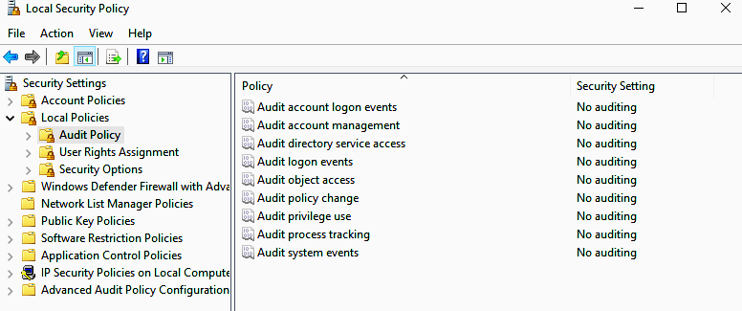

*/*

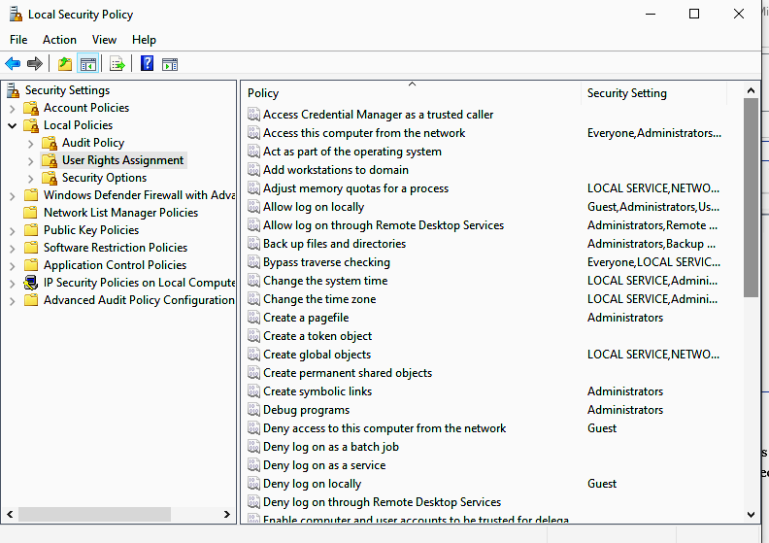

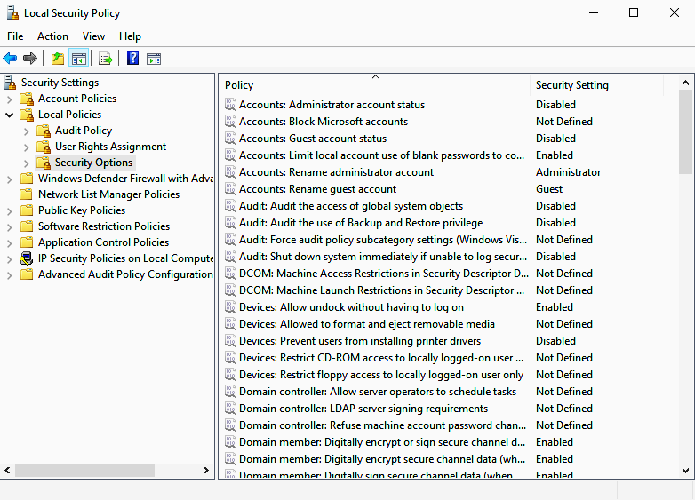

*/*

1. In the details pane, double-click the security policy that you want to modify. If this security policy has not yet been defined, select the Define these policy settings check box.
2. Modify the security policy setting, and then click OK.

## Output/Results snippet:

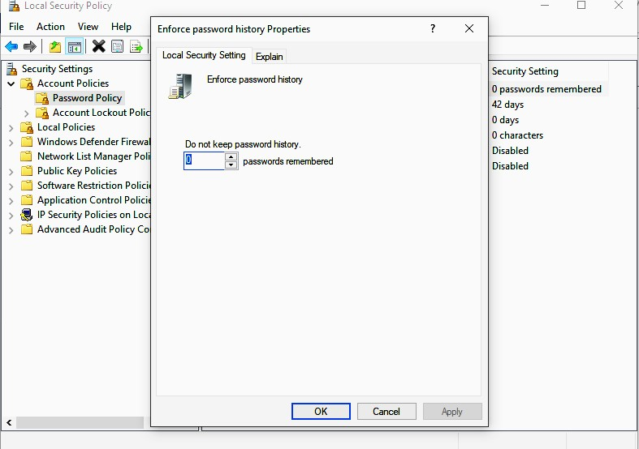

**References:**

31. [https://docs.microsoft.com/en-us/windows/security/threat-protection/security-policy-setti ngs/how-to-configure-security-policy-settings](https://docs.microsoft.com/en-us/windows/security/threat-protection/security-policy-settings/how-to-configure-security-policy-settings)

*/*

# Activity 11

**Aim:** Configure RRAS Policies

**Learning outcome:** Able to configure and manage network security.

**Duration:** 2 hour

## List of Hardware/Software requirements:

1. Personal Computer
2. Microsoft Windows 10 operating system

## Code/Program/Procedure (with comments):

It uses policies to create and stored in Network Policy Server to finely control remote access.

1. Configure the user accounts to use remote access policy for dial-in access.
2. Click Start > Programs > Administrative Tools > Active Directory Users and Computers.

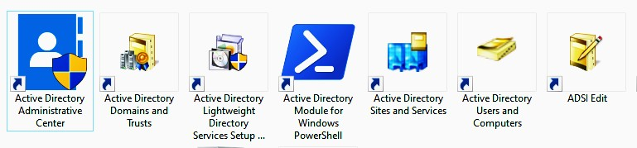

1. Verify that the user accounts have the Remote Access Permission (Dial-in or VPN) option set to Control access through Remote Access Policy.
2. Open the Routing and Remote Access management console to configure the policy, then click Start > Programs > Administrative Tools > Routing and Remote Access.

*/*

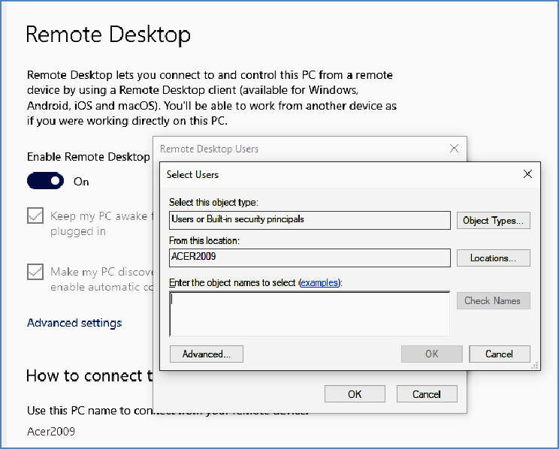

1. If necessary, double-click Routing and Remote Access and the server name.
2. In the left pane, right-click Remote Access Policies, then click New Remote Access Policy.
3. Select the appropriate policy settings as discussed above.
4. Delete the default policies.
5. Head over to Programs and Features in the Control Panel and click on Turn Windows features on or off.

*/*

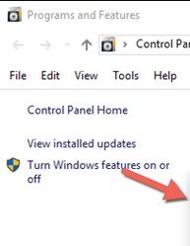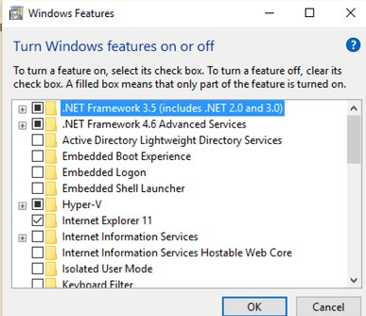

1. At this point, scroll down until you see the Remote Server Administration Tools section. Under this, you'll see lots of different tools to enable.

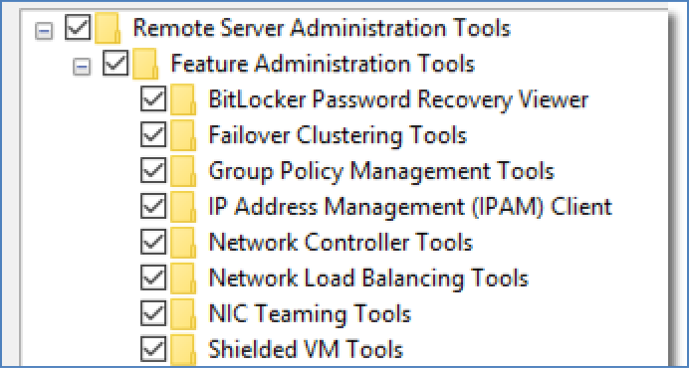

1. From here, you can enable and disable any of the toolsets that you want or would rather not have. Once you've done this, you can then find any of these tools by typing a subset of the name into the Cortana search bar.

*/*

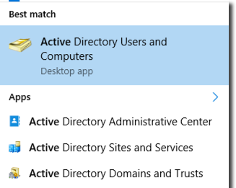

## Output/Results snippet:

**References:**

* [https://docs.microsoft.com/en-us/windows-server/remote/remote-access/ras/manage-remo te-clients/install/step-1-configure-the-remote-access-infrastructure](https://docs.microsoft.com/en-us/windows-server/remote/remote-access/ras/manage-remote-clients/install/step-1-configure-the-remote-access-infrastructure)
* [https://www.businessnewsdaily.com/10996-windows-10-remote-server-administration-to ols-rsat.html](https://www.businessnewsdaily.com/10996-windows-10-remote-server-administration-tools-rsat.html)

*/*

* <https://blog.netwrix.com/2017/01/30/active-directory-users-and-computers-aduc/>

# Learning Outcome

After achieving this learning outcome, a student will be Able to configure and perform remote accessing & routing. In order to achieve this learning outcome, a student has to complete the following:

1. Manage TCP/IP Routing (5 Hrs)
2. Configure Remote Access Authentication Protocol (5 Hrs)
3. Connect remote Desktop using Remote Assistance(5 Hrs)
4. Connect Remote Desktop using Telnet (3Hrs)
5. Connect Remote Desktop using HyperTerminal ( 2 Hrs)
6. Connect Remote Desktop using Team Viewer (5Hrs)

# Activity 1

**Aim:** Manage TCP/IP Routing

**Learning outcome:** Able to configure and perform remote accessing & routing.

**Duration:** 5 hour

### **List of Hardware/Software requirements:**

1. Personal Computer
2. Microsoft Windows Server

### **Code/Program/Procedure (with comments):**

Instead of spending a hardware-based router from a vendor like Cisco, Windows Server 2003 can be used as a software-based router. It supports both static routing and dynamic routing with Open Shortest Path First (OSPF) which uses link state routing and Routing Information Protocol (RIP V2) which uses distance vector routing.

One of the advantages is that a hardware-based router usually has over a Windows router is the number and types of interfaces offered. A Windows router is narrow by its number of network cards, and other interfaces, that may be installed. Before to use Windows Server 2003 as a router, the user must enable Routing and Remote Access. All of the routing utilities in Windows can be configured with the RRAS MMC snap-in.

1. Open PowerShell, type 'control panel' and press enter. Select network and sharing center.
2. Click on change adapter settings. Right click on the Ethernet adapter that's connected to your switch and select rename. Change its name to LAN.
3. Now double click on the LAN adapter and select properties. Next, highlight TCP/IPV4 and change the configuration to the one shown below. Note: Do not enter a default gateway for the LAN. Only the WAN should have a default gateway. Make sure the LAN interface is connected to a switch.

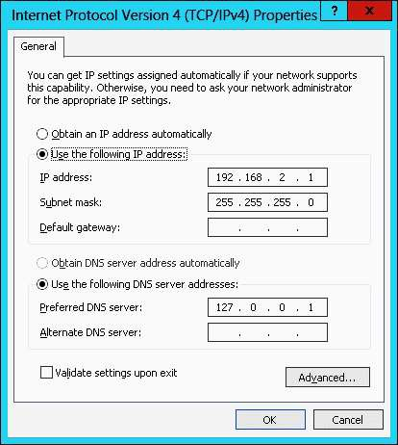

1. Next, click on the server manager icon on the bottom left hand side of the desktop.

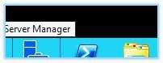

1. In the server manager, click on manage > add roles and features.
2. From the server list, select your server. Finally, add the server roles:
   1. DHCP Server
   2. DNS Server
   3. Remote Access
3. Click next until you reach Remote Access role services. Place a checkmark by DirectAccess and VPN as well as by Routing. Finish the installation.

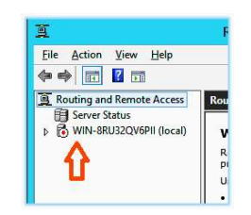

1. Right click on the server name and select configure and enable routing and remote access.
2. In the setup wizard, select network address translation (NAT)

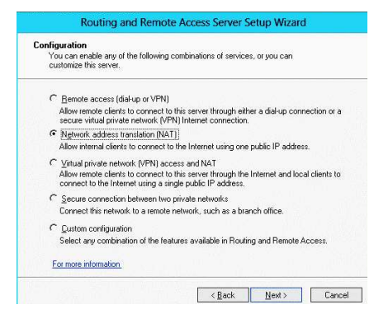

1. Open PowerShell and type firewall and press enter. Windows firewall console will display. Click Advanced Settings.

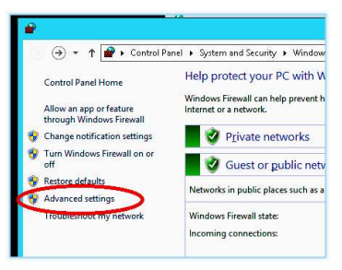

1. In Windows Firewall with Advanced Security, click on inbound rules.

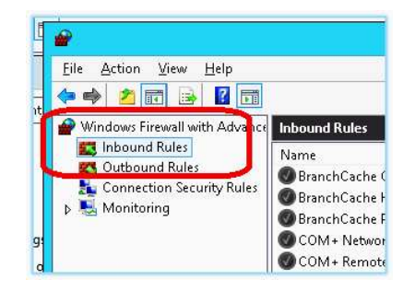

1. To add an inbound rule, highlight inbound rule and select new rule from the actions pane.

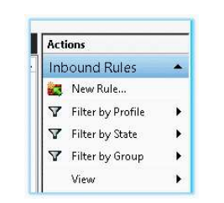

1. The new inbound rule wizard will appear. Follow these steps to add a rule for Remote Desktop: Select a port to allow.

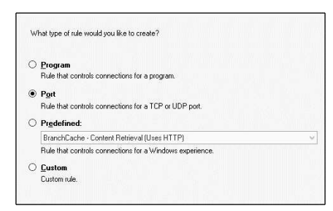

## Select the protocol and port number.

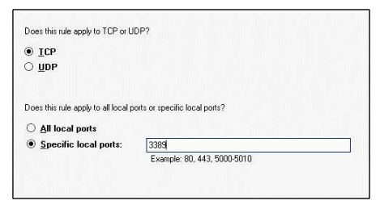

1. Select the zone where the firewall will allow traffic to traverse.

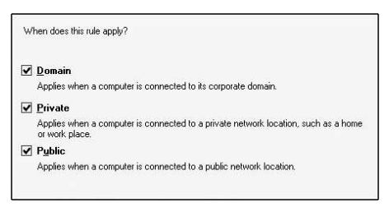

1. Give the rule a friendly name and click finish.

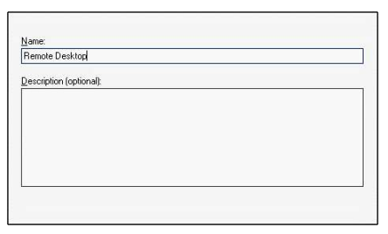

1. After finishing, it's a good idea to run NMap to make sure that only the specified ports are open.

### **Output/Results snippet:**

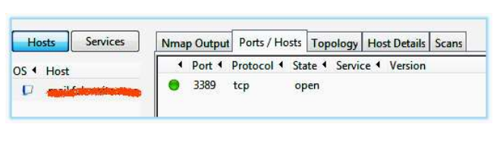

### **References:**

* [**https://www.pearsonitcertification.com/articles/article.aspx?p=1823690&seqNum=3**](https://www.pearsonitcertification.com/articles/article.aspx?p=1823690&seqNum=3)
* [**https://docs.pivotal.io/application-service/2-7/adminguide/enabling-tcp-routing.html**](https://docs.pivotal.io/application-service/2-7/adminguide/enabling-tcp-routing.html)

# Activity 2

**Aim:** Configure Remote Access Authentication Protocol

**Learning outcome:** Able to configure and perform remote accessing & routing.

**Duration:** 5 hour

## List of Hardware/Software requirements:

1. Personal Computer
2. Microsoft Windows Server

## Code/Program/Procedure (with comments):

The authentication methods can be selected from the Routing and Remote Access > Remote Access Policies folder by double-clicking a policy, then selecting to edit that policy's settings, and finally working to the Authentication tab for the policy as shown below.

Configuring Authentication Protocols:

1. Open the RRAS MMC snap-in by selecting Start > Administrative Tools > Routing And Remote Access.

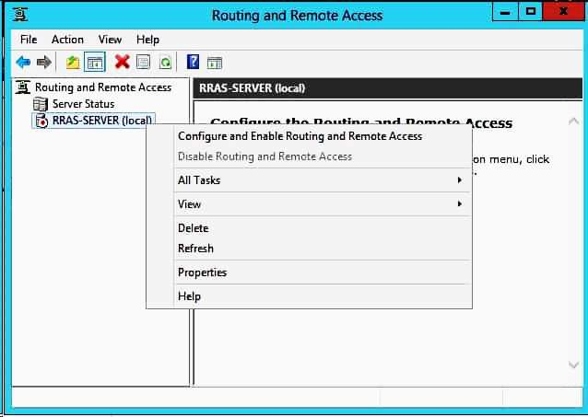

1. Navigate to the server whose authentication support you want to change. Choice the server and then select Action > Properties to open the server Properties dialog box.
2. Switch to the Security tab and make sure that Windows Authentication is selected in the Authentication Provider drop-down.
3. Click the Authentication Methods button. When the Authentication Methods dialog box looks, Extensible Authentication Protocol (EAP).
4. Select the two MS-CHAP checkboxes, then select the CHAP checkbox and verify that the SPAP and PAP checkboxes are cleared.
5. Verify that Allow Remote Systems To Connect Without Authentication checkbox is cleared and click OK.
6. When the server Properties dialog box reappears, click OK.
7. When asked if you want to view the help files associated with configuring authentication protocols click No to finish this activity.

## Output/Results snippet:

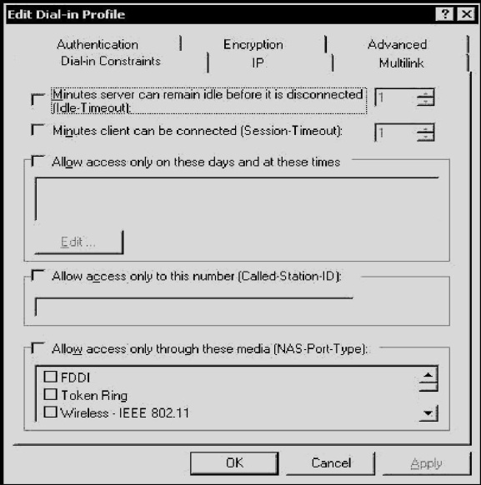

**References:**

* <https://www.serverbrain.org/security-administration-2003/configuring-rras-authentication-protocols.html>

# Activity 3

**Aim:** Connect remote Desktop using RemoteAssistance.

**Learning outcome: Able to configure and perform remote accessing & routing. Duration:** 5 hour

**List of Hardware/Software requirements:**

1. Any kind of Laptop / Desktop with internet connection
2. Windows 8 OS

**Code/Program/Procedure (with comments):**

1 - On the Computer That the user Wants To CONNECT TO Open the Windows 8 System folder. In Windows 8, swipe in from the right edge of the screen. Tap Search.

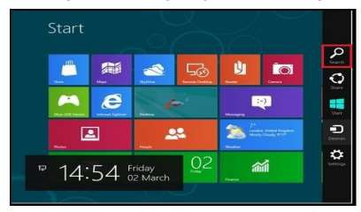

Image: Desktop

1. Type remote in the Search Text Box field.
2. Click Settings, located on the right.
3. Click Allow Remote Access to your computer, located on the left

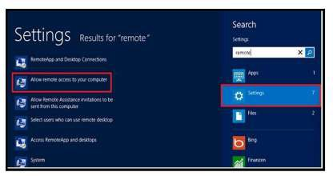

Image: Settings

1. Enter the system Admin Password or confirm your Choice, if requested.
2. Select the checkbox - Allow users to connect remotely to this computer, located **in** the lower section.
3. Uncheck the checkbox option, allow connection only from computers running Remote Desktop with Network Level Authentication (recommended).
4. Click the Select Users button of the window. (FWindow Remote Assistance)

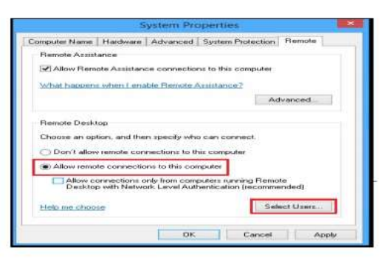

1. Add your PAWS ID and any other users that need access to remotely connect to your computer using Remote Desktop.
2. Click the OK button to save your changes that have added all necessary Remote Desktop Users.

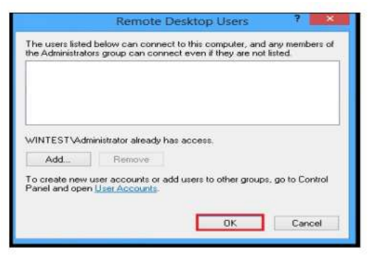

### **Output/Results snippet:**

The connection will now be established. According to the Quick Assist dialog, it may take a few minutes before the devices connect, so you may have to be patient.

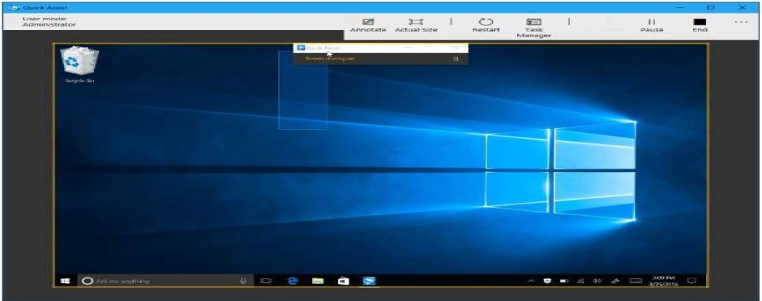

### **References:**

* [**http://www.ctimls.com/Support/KB/How%20To/Use_Windows_Remote_Assistance.htm**](http://www.ctimls.com/Support/KB/How%20To/Use_Windows_Remote_Assistance.htm)

# Activity 4

**Aim:** Connect Remote Desktop using Telnet

**Learning outcome: Able to configure and perform remote accessing & routing. Duration:** 3 hour

**List of Hardware/Software requirements:**

1. Any kind of Laptop / Desktop with internet connection
2. Windows 8 OS

**Code/Program/Procedure (with comments):**

Step 1: Press Windows- X and select the search from the context menu and enter the control panel in the search field.

Step 2: Click the Programs and features and then click Turn Windows Features On or Off. Step 3: Select the Telnet Client checkbox and then click OK to install telnet to Windows 8.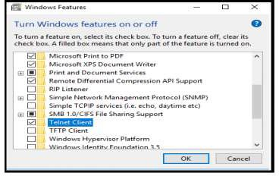

It may take some time to install telnet.

Step 4: Enter cmd in the search field and click Command Prompt from the context menu. Step 5: Type the command- telnet [IP Address or host name] [port-number] Determine the IP

Address or hostname of the server and the TCP port number required to establish a connection and press enter.

Step 6: Type the username and password, if applicable, to log in to the computer.

### **Output/Results snippet:**

The connection will now be established. The telnet screen appears as follows:

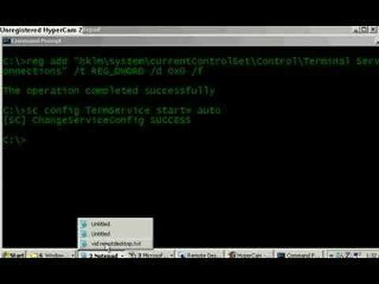

### **References:**

* <https://yourbusiness.azcentral.com/reset-zebra-printer-dhcp-11665.html>
* <https://support.na.sage.com/selfservice/viewContent.do?externalId=11120&sliceId=1>

# Activity 5

**Aim:** Connect Remote Desktop using HyperTerminal

**Learning outcome: Able to configure and perform remote accessing** & **routing. Duration:** 2 hour

**List of Hardware/Software requirements:**

1. Any kind of Laptop / Desktop with internet connection
2. Windows XP OS

**Code/Program/Procedure (with comments):**

Step 1: Open HyperTerminal by clicking the Windows Start button, clicking "All Programs," clicking "Accessories," clicking "Communications" and clicking "HyperTerminal."

Step 2: Create a connection by clicking the "File" menu, selecting "New Connection" and entering your connection information. Open an existing connection by clicking the File menu and selecting "Open."

Step 3: Connect to the remote computer by clicking the "Call" icon. Alternatively, wait for the remote computer to call you by clicking the Call menu and selecting the "Wait for a Call" option.

Step 4: Send a file to the remote computer by clicking the Transfer menu and selecting the "Send File..." option. This opens the Send File window. Click the "Browse..." button to select a file, choose a transfer protocol and click the "Send" button.

Step 5: Click the "Transfer" menu and select the "Receive File..." option to receive a file from the remote computer. Click the "Browse..." button and select a location to which you want to save the file. Select the same receiving protocol that the remote computer is using to send the file and click the "Receive" button.

**References:**

* <https://smallbusiness.chron.com/transferring-files-trillian-33270.html>
* <http://tutorial.wmlcloud.com/windows_xp/Using-HyperTerminal-for-Modem-to-Modem-Connections---Connecting-to-a-Remote-System---Performing-File-Transfers.aspx>

**Activity 6**

**Aim:** Connect Remote Desktop using Teamviewer

**Learning outcome:** Able to configure and perform remote accessing & routing.

**Duration:** 5 hour

**List of Hardware/Software requirements:**

1. Any kind of Laptop/ Desktop with internet connection
2. Windows 8 OS
3. Teamviewer Software

**Code/Program/Procedure (with comments):**

Step 1 First, install the team viewer software. Just open this team viewer page. Select Download Now button. It will automatically download the software for the particular user OS.

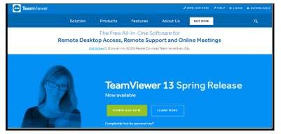

Step 2 After downloaded, install it and click on the run which appears as a pop-up window to start the setup program.



 

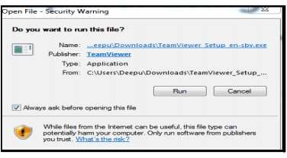

Step 3 The setup window will open and select the necessary option and click the Accept-finish button.

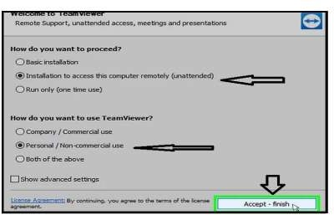

Image: Accept to Finish Setup

Step 4 Finally installing is done and Wait for the setup to finish downloading the files on your C: drive. Then, TeamViewer will automatically generate a random ID and password to be used to connect to other computers.



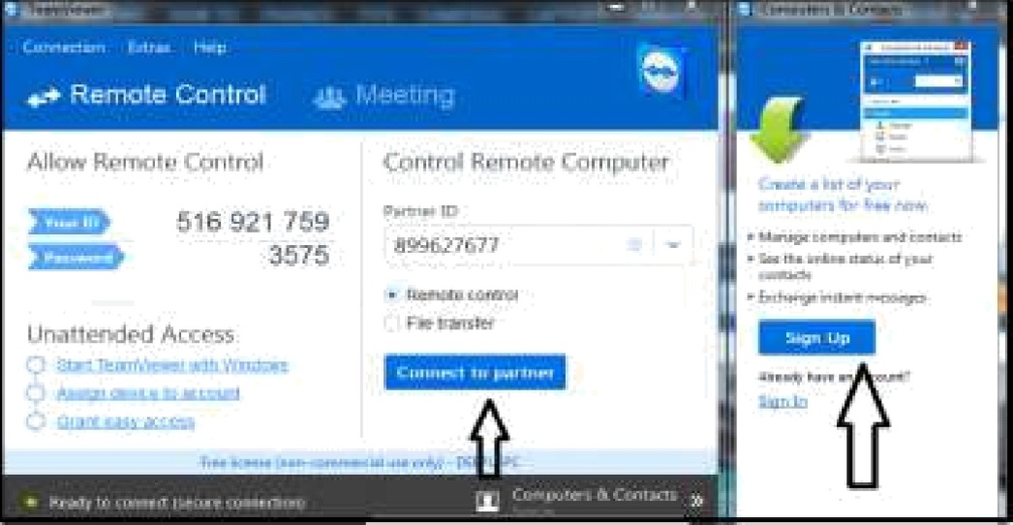

Image:Connect to other Computer

Step 5 It will take some time to connect and the screen blurs. After the while, the user can be able to see your panner screen, and the user can make changes to it as well.

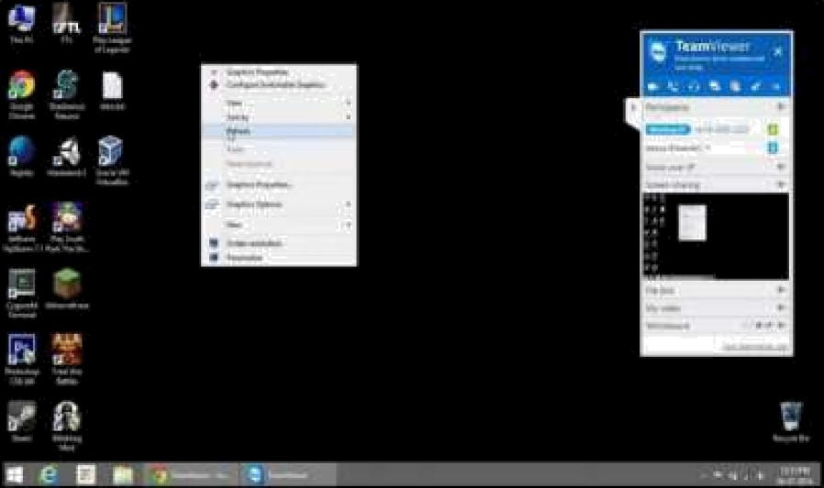

 

Step 6 Share a file remotely by using a team viewer. Just tick on “file transfer” instead of “remote control” and then connect to the partner by using his/her ID and Password. Just drag the files which are to be referred.

Step 7 And can have a conversation with the partner by using the simple chat box at the bottom of the right side. Once connected to the partner, the user can use chat effectively.

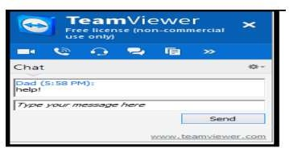Step 8 And even allowed to adjust the visuals of the screen by heading over to the “view” which is at the top of the screen

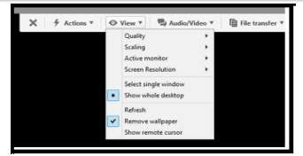

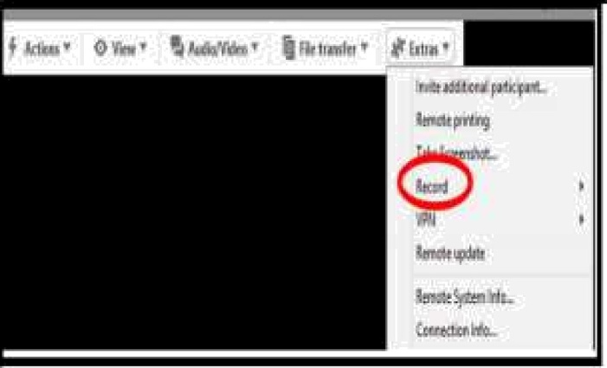Step 9 And the user may feel better to add some recorded videos of that team viewer session and it provides it too.

**Output/Results snippet:**

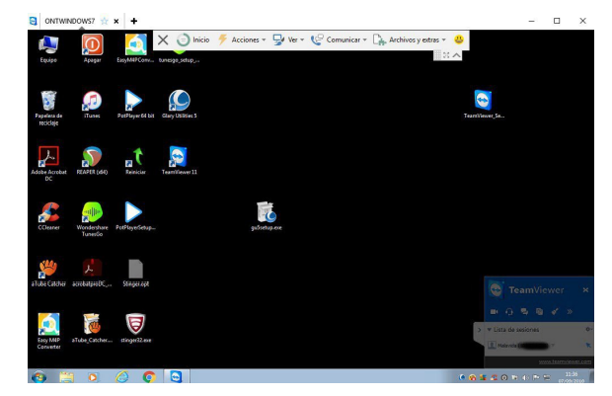

**References:**

* <https://www.techrepublic.com/article/how-to-remotely-access-any-pc-using-teamviewer/>
* <https://www.wikihow.com/Use-Remote-Desktop-With-TeamViewer>

*/*